Angela's Tools · Chapter 1: Atoms and Elements · Worksheet 2 of 10

Atom, Element, Table: Words That Fit Together (Teacher answer key)
Learning target: I can explain how the words atom, element, matter, atomic mass, periodic table, group, period, chemical symbol, criteria, constraint and scale relate to one another, and use each one correctly in a new situation.
Vocabulary in action · about 30 minutes · individual · Standards: MS-PS1-1 (supports), MS-ETS1-1 (practice)

Standards connections
MS-PS1-1 (supports): Modeling the atomic composition of molecules requires a firm grip on what an atom is, what an element is, and how the periodic table names them. This sheet builds that language; it is background for the PE rather than evidence of it.
MS-ETS1-1 (practice): Students practice telling criteria from constraints in short engineering situations, the first step toward defining them with precision.

Answers with reasoning
matter: Anything that has mass and takes up space: solids, liquids and gases, including air you cannot see. Light and sound are not matter.
atom: One single particle of an element. It is far too small to see, even with a magnifying glass or a light microscope.
element: A substance made of only one kind of atom. Iron, neon, carbon and oxygen are elements. Fewer than one hundred kinds occur in nature.
atomic mass: How much mass one atom of an element has, given in daltons (Da). The number on the periodic table is an average for that element's atoms.
periodic table: A chart of all known elements arranged so that elements with similar properties line up in the same column.
group: A vertical column of the periodic table. Elements in one group tend to behave alike.
period: A horizontal row of the periodic table. Atomic mass generally increases from left to right along a row.
chemical symbol: A one- or two-letter shorthand for an element's name, used by scientists in every country. The first letter is always a capital.
criteria: The things a design must do to count as a success (for example, 'must show single atoms').
constraint: A limit that a design has to work inside (for example, time, money, available technology, or the need to avoid vibration).
scale: A size range. Things on the same scale are roughly the same size and are measured with the same units; atoms live on the atomic scale, measured in picometers.

Part A: Complete the concept map
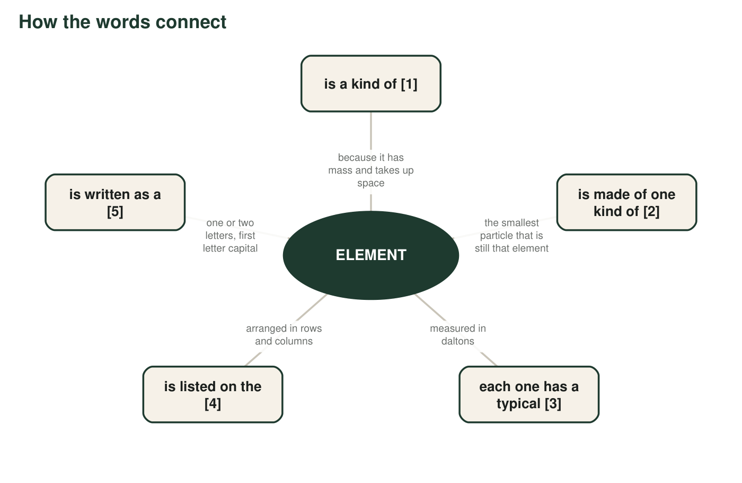
Five boxes are missing a word. Each missing word is in the word bank. The hub is already filled in.
1. Write the five missing words: [1] ______ [2] ______ [3] ______ [4] ______ [5] ______
Answer: [1] matter [2] atom [3] atomic mass [4] periodic table [5] chemical symbol
Reasoning: Each branch's description points to exactly one bank word: mass and space = matter; smallest particle = atom; daltons = atomic mass; rows and columns = periodic table; letters = chemical symbol.
Also acceptable: Accept 'periodic table of the elements' for [4].
2. Two more words from the bank, group and period, could be attached to box [4]. Write one sentence that connects all three words correctly.
Answer: Example: 'On the periodic table, a group is a column of elements that behave alike and a period is a row along which atomic mass generally increases.'
Reasoning: Full credit requires all three words used correctly in one sentence, with group tied to column and period tied to row.
Also acceptable: A sentence such as 'The periodic table is organized into groups (columns) and periods (rows)' is sufficient.
Full credit must include:
• Uses periodic table, group and period
• Group = column, period = row (or the equivalent)

Part B: Sort the examples
For each example below, decide which one vocabulary word it best illustrates. Some words are used more than once; some are not used at all. Write the word on the line.
3. The column that holds helium, neon and argon: ______
Answer: group
Reasoning: A column of the table is a group; helium, neon and argon share it.
Also acceptable: Accept 'group (column)'.
4. The invisible air that makes a pumped basketball heavier: ______
Answer: matter
Reasoning: Air has mass and takes up space, so it is matter even though it is invisible.
Also acceptable: Accept 'element' only if the student explains that the air is a mixture of elements; the best single word is matter.
5. 'The microscope must show details as small as 100 picometers': ______
Answer: criteria
Reasoning: A requirement a successful design must meet is a criterion. Students may write the singular 'criterion.'
Also acceptable: Accept 'criterion'.
6. 'The lab can only use parts that already exist, and must measure at night to avoid vibrations': ______
Answer: constraint
Reasoning: Available technology and the need to avoid vibration are limits on possible solutions, not measures of success.
Also acceptable: Accept 'constraints'.
7. Fe, which stands for iron: ______
Answer: chemical symbol
Reasoning: Fe is the shorthand for iron, from the Latin ferrum.
Also acceptable: None.
8. The single smallest piece of gold you could ever cut from a ring: ______
Answer: atom
Reasoning: The smallest piece of gold that is still gold is a single gold atom.
Also acceptable: A student who writes 'element' has confused the substance with the particle; mark it and discuss.
9. The row that begins with lithium and ends with neon: ______
Answer: period
Reasoning: A row of the table is a period; lithium through neon make up the second row.
Also acceptable: Accept 'period (row)'.
10. Measuring a hair's width in micrometers but an atom's width in picometers: ______
Answer: scale
Reasoning: Choosing a unit to fit the size range of the object is the idea of scale.
Also acceptable: None.

Part C: Apply the terms
11. A classmate says, 'A diamond is one element, so a diamond is one atom.' Use the words atom and element to explain what is right and what is wrong in that sentence.
Answer: Right: a diamond is made of only one element, carbon. Wrong: it is not one atom; it is an enormous number of carbon atoms joined together. An element is a substance; an atom is a single particle of that substance.
Reasoning: This is the lesson's central distinction. The textbook's vocabulary box blurs it, so insist on 'substance' versus 'single particle.'
Also acceptable: A student who says 'a diamond is made of carbon atoms, and carbon is the element' earns full credit.
Full credit must include:
• Identifies that a diamond is the element carbon
• States that a diamond contains many atoms, not one
• Uses both words correctly
12. Sodium has an atomic mass of 23 Da and sits in the same group as potassium (39 Da) and lithium (7 Da). Use the words group and atomic mass to say one thing these three elements share and one way they differ.
Answer: Shared: they are in the same group, so they have similar properties (soft metals that react with water). Different: their atomic masses are different, 7 Da, 23 Da and 39 Da, so each atom of potassium has more mass than each atom of sodium or lithium.
Reasoning: Full credit needs one similarity tied to 'group' and one difference tied to 'atomic mass.'
Also acceptable: A student may note that sodium's mass is about the average of the other two; that is correct and welcome.
Full credit must include:
• Uses group to name a shared property
• Uses atomic mass to name a difference
13. A team is designing a drone that must carry a 2 kg package for 20 minutes, must cost less than $400 to build, and must be finished in three weeks. Label each of the three requirements as a criterion or a constraint, and explain your choice for one of them.
Answer: Carrying 2 kg for 20 minutes is a criterion (it describes what the drone must do to succeed). Costing under $400 is a constraint (a money limit). Finishing in three weeks is a constraint (a time limit). Explanation example: 'The cost is a constraint because it limits which parts the team can choose; it does not describe what a successful drone does.'
Reasoning: Students sometimes label the cost as a criterion because it is a 'requirement.' The distinction taught here: criteria describe success; constraints describe limits on the solutions allowed.
Also acceptable: Accept an argument that a strict cost cap is also a measure of success if the student explains that reasoning clearly; note that engineers usually call it a constraint.
Full credit must include:
• Three correct labels
• One explanation that uses the success-versus-limit distinction
14. Is the red glow of a neon sign matter? Is the neon gas inside the tube matter? Explain both answers using the definition of matter.
Answer: The red glow is light, which has no mass and does not take up space, so it is not matter. The neon gas is matter: it has mass and fills the tube, even though you cannot see it when the sign is off.
Reasoning: Students must apply the definition (mass and space) to both parts.
Also acceptable: A student who says the glow is 'energy' is correct; the key point is that it is not matter.
Full credit must include:
• Glow = not matter, with the definition
• Neon gas = matter, with the definition
15. Why do scientists bother with a special scale and unit for atoms instead of just writing their size in meters? Give the unit's name in your answer.
Answer: An atom is about a ten-billionth of a meter across, so writing its size in meters needs many zeros and is hard to compare. Scientists use the picometer (one trillionth of a meter) because the unit fits the atomic scale, just as kilometers fit road trips and centimeters fit hair growth.
Reasoning: The answer should name the picometer and give the reason: a unit should match the size range of the thing being measured.
Also acceptable: Accept 'pm' for the unit if it is clearly the picometer.
Full credit must include:
• Names the picometer
• Gives a reason tied to fitting the size range

Teacher notes
Items q8 and q11 are the diagnostic ones: students who write 'element' for the smallest piece of gold hold the textbook's blurred definition. Correct it with the pairing 'atom = particle, element = substance.' The atomic mass definition deliberately says 'average'; if a student asks why, say that atoms of one element can differ very slightly in mass, which later science classes explain. Part B can be done aloud with a partner for multilingual learners before writing.

