Angela's Tools · Chapter 2: Molecules and Extended Structures · Worksheet 1 of 10

Pencil Core and Saw Blade: Two Solids Made of the Same Atoms (Teacher answer key)
Learning target: I can record observations about materials built from the same kind of atom, draw on what I already know, and write a first explanation of how so few kinds of atoms can make so many different substances.
Phenomenon exploration · about 25 minutes · individual · Standards: MS-PS1-1 (supports)

Standards connections
MS-PS1-1 (supports): This sheet surfaces the puzzle that the PE's models will solve: the same atoms, connected in different patterns, make different materials. Students only observe and explain in words here; the model-building comes in later worksheets.

Answers with reasoning

Two things on Mr. Okafor's desk
Mr. Okafor holds up a pencil with the wood shaved away so that the gray core shows. He drags it across paper: it leaves a dark line, and a little gray dust comes off on his fingers. Then he holds up a tile saw blade. Its edge is dotted with tiny, hard, glittering chips. He scrapes the edge across a piece of glass, and it leaves a scratch. He drags the same edge across the paper, and it leaves no mark at all. Then he says the thing that makes the class go quiet: 'The pencil core is graphite. The chips on the blade are diamond. Both are made of nothing but carbon atoms.'
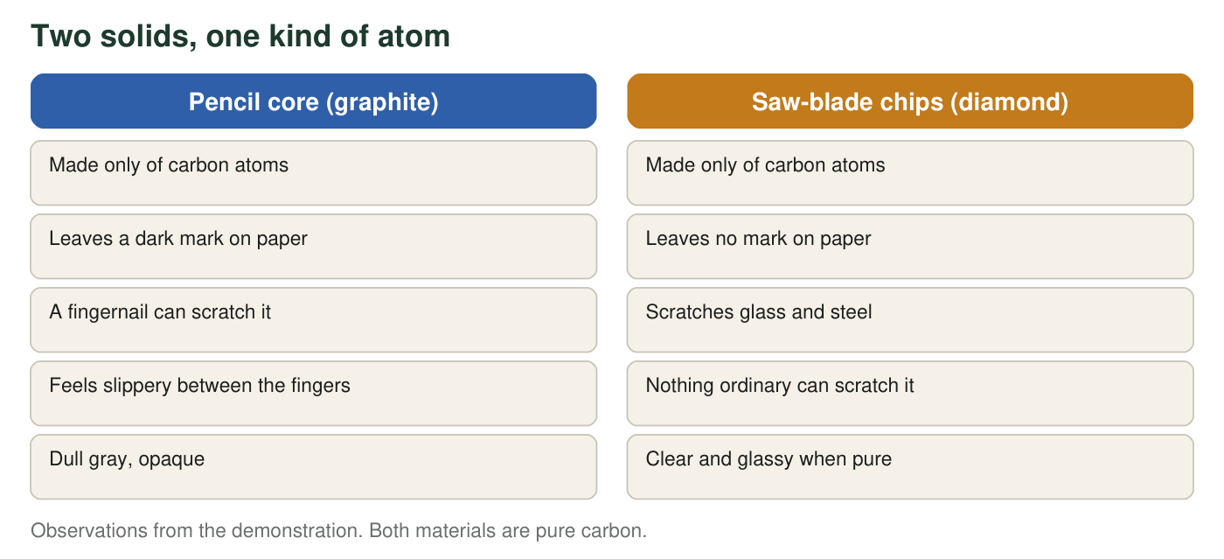
Same atoms in both columns. Everything that differs must come from something other than the kind of atom.
Scratch hardness of some materials (real values, Mohs scale, rounded)
Material | Mohs hardness | What it means
Graphite | 1 to 2 | Softer than a fingernail (2.5)
Copper coin | 3 | Scratches graphite, not glass
Window glass | 5.5 | Scratched by a steel knife
Quartz (sand grains) | 7 | Scratches glass easily
Diamond | 10 | The hardest natural material

On the Mohs scale a material can scratch anything with a lower number.
A few everyday substances and the kinds of atoms in them (real)
Substance | Kinds of atoms | Atoms in one particle
Water | hydrogen, oxygen | 2 hydrogen, 1 oxygen
Hydrogen peroxide (a disinfectant) | hydrogen, oxygen | 2 hydrogen, 2 oxygen
Methane (natural gas) | carbon, hydrogen | 1 carbon, 4 hydrogen
Ethanol (the alcohol in hand sanitizer) | carbon, hydrogen, oxygen | 2 carbon, 6 hydrogen, 1 oxygen
Table sugar (sucrose) | carbon, hydrogen, oxygen | 12 carbon, 22 hydrogen, 11 oxygen
Vitamin C | carbon, hydrogen, oxygen | 6 carbon, 8 hydrogen, 6 oxygen

Fewer than one hundred kinds of atoms occur naturally on Earth, yet chemists have cataloged more than one hundred million different substances.

Part A: Notice and wonder
1. List three things you notice in the description, the figure or the tables. Use only facts that were observed or given, not explanations. Number them 1, 2, 3.
Answer: Any three observed facts, for example: both materials are pure carbon; graphite leaves a mark and diamond does not; a fingernail scratches graphite but nothing ordinary scratches diamond; diamond has Mohs hardness 10 and graphite 1 to 2; water and hydrogen peroxide contain the same two kinds of atoms in different numbers; fewer than one hundred kinds of atoms make more than one hundred million substances.
Reasoning: A notice must be an observation or a given fact, not a cause. 'Diamond is harder because its atoms are locked' is an explanation and belongs in Part C.
Also acceptable: Accept a correct comparison between rows of a table (for example, 'quartz is harder than glass') as a notice.
Full credit must include:
• Three distinct items
• Each is an observation or given fact, not an explanation
• At least one comes from a table or the figure
2. Write two questions you wonder about. At least one must be a question that could be answered with evidence, not just an opinion.
Answer: Two genuine questions, at least one testable. Examples of testable questions: 'Would diamond powder still refuse to mark paper?' 'Do all pure-carbon solids fall into one of these two types?' 'Is there a way to turn graphite into diamond?' Examples of non-testable: 'Why did nature make two kinds?'
Reasoning: The testable question is the one that could be answered by an observation or an experiment. Students often write 'why' questions; one of the two must be answerable with evidence.
Also acceptable: A question about the salt cubes or snow crystals is on topic and acceptable.
Full credit must include:
• Two questions
• At least one could be answered with evidence or an experiment
3. Look at the second table. Which three substances are built from exactly the same three kinds of atoms? Since the kinds of atoms are the same, what is different about them?
Answer: Ethanol, table sugar (sucrose) and vitamin C are all built from carbon, hydrogen and oxygen only. What differs is how many atoms of each kind are in one particle (2 C, 6 H, 1 O for ethanol; 12 C, 22 H, 11 O for sucrose; 6 C, 8 H, 6 O for vitamin C).
Reasoning: Three substances in the table use exactly carbon, hydrogen and oxygen; water and hydrogen peroxide use only hydrogen and oxygen; methane uses only carbon and hydrogen. The key point is that the number of atoms of each kind differs, and students may add that the arrangement differs too.
Also acceptable: A student who also points out that water and hydrogen peroxide form a second same-kinds pair, differing by one oxygen atom, has read the table well; mention this pair in the discussion.
Full credit must include:
• Names ethanol, sucrose and vitamin C
• States that the counts of each kind of atom differ

Part B: What do you think right now?
4. Which statement is closest to what you believe right now about why graphite and diamond are so different? Circle one. (No penalty for a wrong choice.)
Answer: No single correct answer is required for credit; the scientifically accurate option is C (the atoms are the same but connected in different patterns).
Reasoning: This item records prior thinking. Options A, B and D are common initial ideas: that atoms of one element can differ in hardness, that 'more atoms' means harder, or that a hidden second element is responsible.
Also acceptable: Full credit for any circled option with q5 completed.
5. Pick one option in q4 that you did not circle. What observation or fact from this page argues against it?
Answer: Examples: Against A, the demonstration states that both are made only of carbon atoms, so there is no 'harder carbon.' Against B, a pencil core contains far more carbon atoms than a tiny diamond chip, yet the chip is harder, so the number of atoms cannot be the reason. Against D, the description says both are made of nothing but carbon. Against C, a student may say nothing on the page shows how the atoms are connected, which is a fair point: C is the one option the page does not yet give evidence for.
Reasoning: The student must link an observation or given fact to the option they reject.
Also acceptable: Any accurate use of the page's facts earns credit.
Full credit must include:
• Names a rejected option
• Cites a fact from the page that contradicts it

Part C: Your first explanation
6. Write your first explanation of this puzzle: If there are fewer than one hundred kinds of atoms, how can there be more than one hundred million substances, and how can one kind of atom make two solids as different as graphite and diamond? You may use a comparison (letters and words, bricks and buildings, beads and necklaces) if it helps. It is fine if your explanation is incomplete.
Answer: A strong first explanation says something like: a small number of kinds of atoms can make an enormous number of substances because atoms join together in groups, and both the number of each kind of atom and the way they are attached can change, like 26 letters making over a million words. Graphite and diamond must differ in how the carbon atoms are joined to each other, since the atoms themselves are the same; one arrangement must come apart in layers (so it rubs off) and the other must hold together in every direction (so it is hard).
Reasoning: Students have not yet learned the terms molecule, composition, structure or extended structure. Credit the reasoning, not the vocabulary. The two key moves are (1) atoms combine in different numbers and arrangements and (2) same atoms with different connections give different materials.
Also acceptable: An explanation that uses only the letters analogy without connecting it to atoms is a partial answer; an explanation that proposes 'spacing' or 'how tightly packed' instead of 'how connected' is a reasonable first idea and should be credited.
Full credit must include:
• Explains the many-from-few puzzle through combining atoms (counts or arrangements)
• Explains graphite versus diamond through a difference other than the kind of atom
• Uses at least one fact from the page as support
7. Predict: if a diamond chip were ground into a fine powder, would the powder write on paper the way graphite does? Explain your reasoning in one or two sentences.
Answer: No. Grinding breaks the diamond into smaller pieces, but each tiny piece still has its carbon atoms connected the diamond way. The powder would be a pile of very hard grains, which is why diamond powder is used for polishing, not for writing. Graphite writes because its layers slide off onto paper, and diamond has no such layers.
Reasoning: This prediction checks whether students locate the difference inside the material (how atoms are connected) rather than in the size of the piece.
Also acceptable: A student who predicts it would write because 'small pieces rub off' has a sensible but incorrect idea; give partial credit if the reasoning is stated, and revisit after Worksheet 6.
Full credit must include:
• Predicts no mark (or a scratch instead of a mark)
• Reasons that grinding changes size, not how the atoms are connected
8. Under a magnifier, grains of table salt tend to look like tiny cubes, and water droplets that freeze slowly in the air tend to grow six-sided snow crystals. Write one question these facts raise about the invisible particles inside the solids.
Answer: Any question linking the visible shape to an invisible arrangement, for example: 'Are the particles inside salt stacked in a cube pattern that shows up as cube-shaped grains?' 'Do water molecules in ice arrange themselves in a six-sided pattern?' 'Would every crystal's shape tell you something about how its particles are arranged?'
Reasoning: The intended idea is that patterns we can see might come from patterns at the atomic scale. This is the lesson's final section.
Also acceptable: Accept a question about whether the shapes are always the same (they tend to be, but not always), which is a good evidence question.
Full credit must include:
• A question, not a statement
• Connects visible shape to the arrangement of particles

Teacher notes
The demonstration is safe if the teacher handles the saw blade; students do not need to touch it. Both materials really are pure carbon; graphite is soft because its carbon atoms form flat sheets held to one another only by weak attractions, while in diamond every carbon atom is bonded to four neighbors in a rigid network. Keep the explanation for Worksheets 4 and 6; here, collect initial ideas on the board. Common prior ideas to listen for: 'diamond atoms are harder,' 'diamond has more atoms,' 'diamond has a secret ingredient.' The Mohs values are real and rounded; a fingernail is about 2.5 and a steel knife about 5.5. The 'fewer than one hundred' phrasing is deliberate: the textbook says 92 natural elements, but the count depends on whether trace amounts of unstable elements are included, so avoid testing an exact number. The 'more than one hundred million substances' figure refers to the number of distinct substances registered in the Chemical Abstracts Service registry, which passed 100 million in 2015. The extension answer is 4 × 4 × 4 = 64 arrangements; real words include ATE, EAT, TEA, SET, SAT, SEA; the point is that few kinds give many combinations, but not every combination is a real word, just as not every imaginable arrangement of atoms is a stable substance.

