Angela's Tools · Chapter 2: Molecules and Extended Structures · Worksheet 1 of 10

Pencil Core and Saw Blade: Two Solids Made of the Same Atoms
Learning target: I can record observations about materials built from the same kind of atom, draw on what I already know, and write a first explanation of how so few kinds of atoms can make so many different substances.
Phenomenon exploration · about 25 minutes · individual · Standards: MS-PS1-1 (supports)
Name: ____________________________ Date: ____________ Period: ______

Directions
Read the two descriptions and study the figure and the tables. Do not look anything up yet. Part A asks for what you notice and wonder; use only facts that are given. Part B asks what you think right now, and there is no penalty for being wrong. Part C asks for your first explanation. Write in complete sentences. You will return to this page at the end of the chapter to see how your thinking changed.

Two things on Mr. Okafor's desk
Mr. Okafor holds up a pencil with the wood shaved away so that the gray core shows. He drags it across paper: it leaves a dark line, and a little gray dust comes off on his fingers. Then he holds up a tile saw blade. Its edge is dotted with tiny, hard, glittering chips. He scrapes the edge across a piece of glass, and it leaves a scratch. He drags the same edge across the paper, and it leaves no mark at all. Then he says the thing that makes the class go quiet: 'The pencil core is graphite. The chips on the blade are diamond. Both are made of nothing but carbon atoms.'
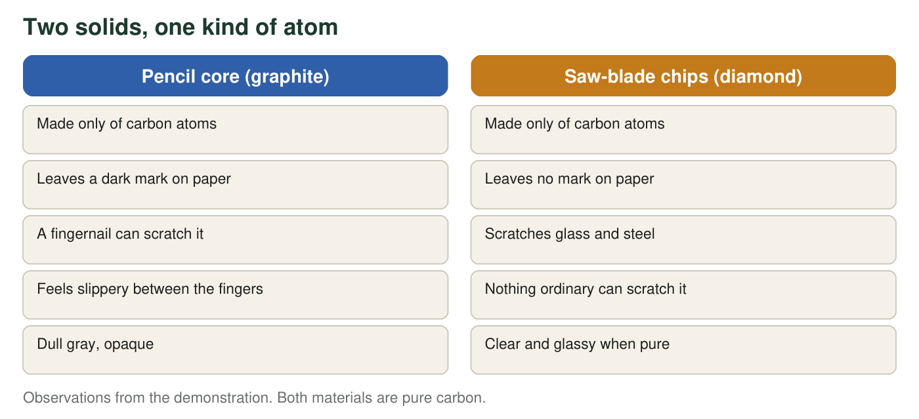
Same atoms in both columns. Everything that differs must come from something other than the kind of atom.
Scratch hardness of some materials (real values, Mohs scale, rounded)
Material | Mohs hardness | What it means
Graphite | 1 to 2 | Softer than a fingernail (2.5)
Copper coin | 3 | Scratches graphite, not glass
Window glass | 5.5 | Scratched by a steel knife
Quartz (sand grains) | 7 | Scratches glass easily
Diamond | 10 | The hardest natural material

On the Mohs scale a material can scratch anything with a lower number.
A few everyday substances and the kinds of atoms in them (real)
Substance | Kinds of atoms | Atoms in one particle
Water | hydrogen, oxygen | 2 hydrogen, 1 oxygen
Hydrogen peroxide (a disinfectant) | hydrogen, oxygen | 2 hydrogen, 2 oxygen
Methane (natural gas) | carbon, hydrogen | 1 carbon, 4 hydrogen
Ethanol (the alcohol in hand sanitizer) | carbon, hydrogen, oxygen | 2 carbon, 6 hydrogen, 1 oxygen
Table sugar (sucrose) | carbon, hydrogen, oxygen | 12 carbon, 22 hydrogen, 11 oxygen
Vitamin C | carbon, hydrogen, oxygen | 6 carbon, 8 hydrogen, 6 oxygen

Fewer than one hundred kinds of atoms occur naturally on Earth, yet chemists have cataloged more than one hundred million different substances.

Part A: Notice and wonder
1. List three things you notice in the description, the figure or the tables. Use only facts that were observed or given, not explanations. Number them 1, 2, 3.
______________________________________________________________________________________
______________________________________________________________________________________
______________________________________________________________________________________
______________________________________________________________________________________
______________________________________________________________________________________
2. Write two questions you wonder about. At least one must be a question that could be answered with evidence, not just an opinion.
______________________________________________________________________________________
______________________________________________________________________________________
______________________________________________________________________________________
______________________________________________________________________________________
______________________________________________________________________________________
3. Look at the second table. Which three substances are built from exactly the same three kinds of atoms? Since the kinds of atoms are the same, what is different about them?
______________________________________________________________________________________
______________________________________________________________________________________
______________________________________________________________________________________

Part B: What do you think right now?
4. Which statement is closest to what you believe right now about why graphite and diamond are so different? Circle one. (No penalty for a wrong choice.)
○ A. Diamond's carbon atoms are harder and heavier than graphite's carbon atoms.
○ B. Diamond has far more carbon atoms than graphite, and more atoms means harder.
○ C. The carbon atoms are the same, but they are connected to each other in different patterns.
○ D. Diamond contains a small amount of a second, harder element that was not mentioned.
5. Pick one option in q4 that you did not circle. What observation or fact from this page argues against it?
______________________________________________________________________________________
______________________________________________________________________________________
______________________________________________________________________________________

Part C: Your first explanation
6. Write your first explanation of this puzzle: If there are fewer than one hundred kinds of atoms, how can there be more than one hundred million substances, and how can one kind of atom make two solids as different as graphite and diamond? You may use a comparison (letters and words, bricks and buildings, beads and necklaces) if it helps. It is fine if your explanation is incomplete.
______________________________________________________________________________________
______________________________________________________________________________________
______________________________________________________________________________________
______________________________________________________________________________________
______________________________________________________________________________________
______________________________________________________________________________________
______________________________________________________________________________________
7. Predict: if a diamond chip were ground into a fine powder, would the powder write on paper the way graphite does? Explain your reasoning in one or two sentences.
______________________________________________________________________________________
______________________________________________________________________________________
______________________________________________________________________________________
8. Under a magnifier, grains of table salt tend to look like tiny cubes, and water droplets that freeze slowly in the air tend to grow six-sided snow crystals. Write one question these facts raise about the invisible particles inside the solids.
______________________________________________________________________________________
______________________________________________________________________________________
______________________________________________________________________________________

Sentence starters for Part C
If you are not sure how to begin q6, try one of these: 'I think the number of substances is so large because atoms can ...' or 'Graphite and diamond might be different because their carbon atoms are ...' Then add one sentence that uses a fact from the figure or a table as support. A guess with a reason is exactly what a first explanation should be.

Test the letters idea
The English alphabet has 26 letters. Using only the four letters A, E, S and T, how many different three-letter arrangements can you write if a letter may repeat (for example, ATE, TEA, EAT, SET, TTT)? Calculate the number instead of listing them all, then list five arrangements that are real English words and five that are not. Write two sentences on what this suggests about atoms: does the number of kinds of atoms limit the number of possible substances, and does every arrangement have to exist?

