Angela's Tools · Chapter 2: Molecules and Extended Structures · Worksheet 2 of 10

Molecule, Structure, Ratio: Words for How Atoms Join (Teacher answer key)
Learning target: I can use the words chemical bond, molecule, composition, structure, extended structure, crystal, polymer and ratio to describe how atoms are joined in a substance, and tell which word fits a new example.
Vocabulary in action · about 30 minutes · individual · Standards: MS-PS1-1 (supports)

Standards connections
MS-PS1-1 (supports): The PE asks students to model the atomic composition of molecules and extended structures. This sheet builds the vocabulary those models must be labeled with, especially the difference between an exact count (molecule) and a constant ratio (extended structure).

Answers with reasoning
chemical bond: The connection that holds two atoms together inside a larger particle or structure.
molecule: A particle built from a definite number of atoms (at least two) joined to one another by chemical bonds, so every particle of the substance has the same count. The atoms can be one element (O₂) or several (H₂O).
model: A stand-in for something too small, too large or too complicated to see directly, built to make the important features easy to notice. Ball-and-stick models use spheres for atoms and sticks for bonds.
chemical formula: Shorthand that lists a substance's elements by symbol. For a molecule the small numbers count atoms in one particle; for an extended structure they give the ratio of the elements.
atomic composition: Which kinds of atoms a substance contains and how many of each (for a molecule) or in what ratio (for an extended structure).
chemical structure: The way the atoms in a substance are connected to one another and arranged in space.
extended structure: A structure built by repeating the same small group of atoms or molecules over and over, so it has no fixed size but keeps a constant ratio of its elements.
crystal: A solid whose atoms or molecules repeat in a regular pattern in all three directions. Salt, quartz, diamond and ice are crystals.
polymer: An extended structure made of many small molecule-based units linked one after another into a long chain, such as polyethylene or PVC.
ratio: A comparison of two amounts, such as 1 silicon atom for every 2 oxygen atoms in quartz, written 1:2.

Part A: Complete the concept map
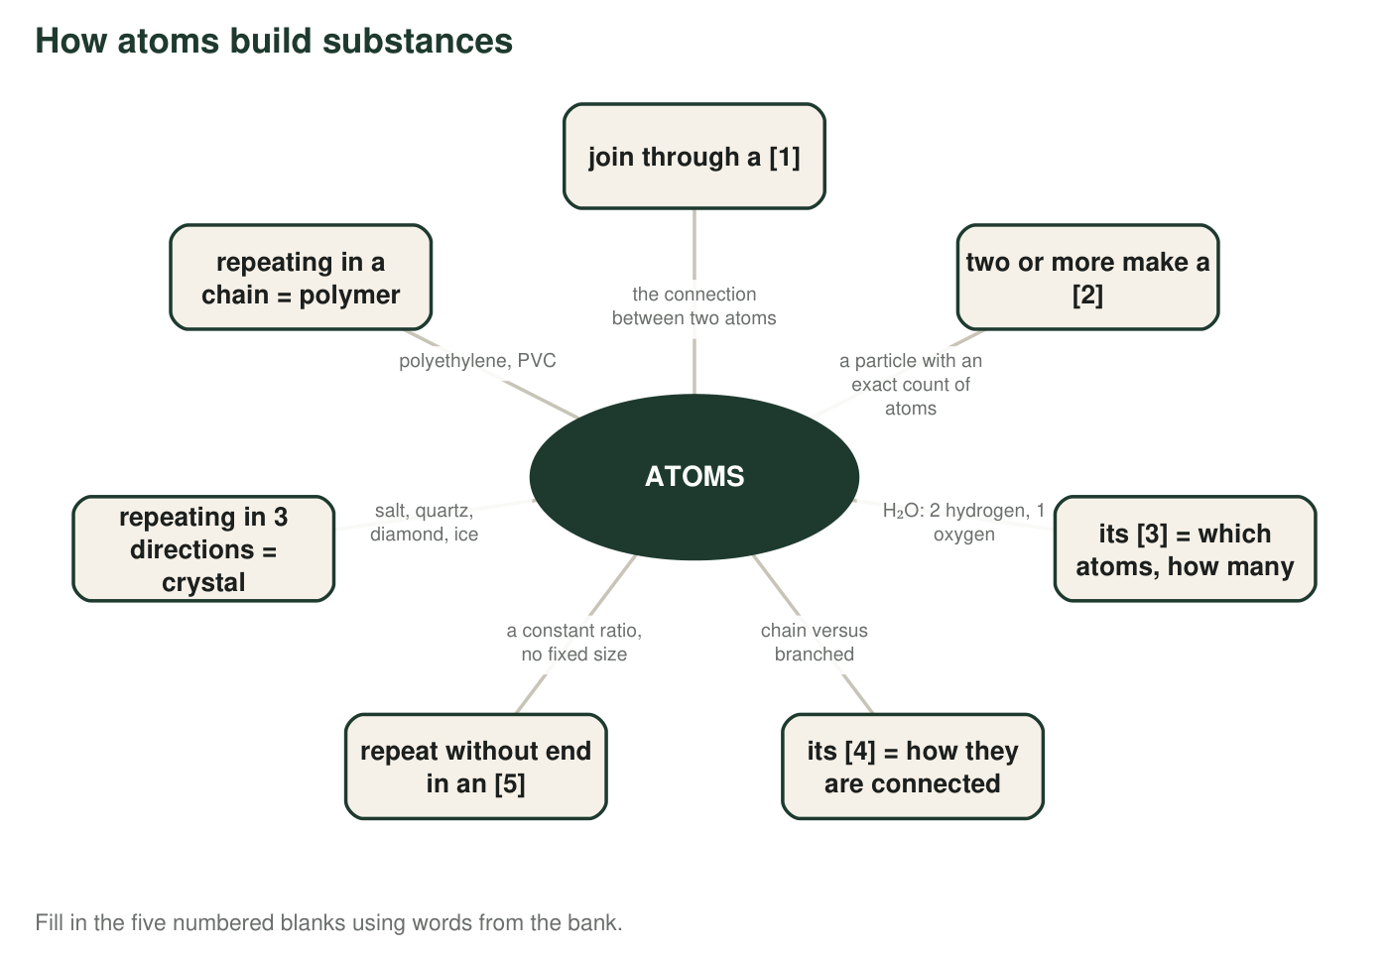
1. Write the five missing words: [1] ______ [2] ______ [3] ______ [4] ______ [5] ______
Answer: [1] chemical bond; [2] molecule; [3] atomic composition (or composition); [4] chemical structure (or structure); [5] extended structure.
Reasoning: The map follows the chapter's logic: bonds join atoms; two or more bonded atoms make a molecule; a molecule is described by its composition and its structure; when subunits repeat without end the result is an extended structure, of which crystals and polymers are the two kinds.
Also acceptable: Accept 'bond' for [1] and 'composition' and 'structure' without the adjectives.
2. Both crystal and polymer hang off box [5]. In one sentence, say what the two words share, and in a second sentence say how they differ.
Answer: Shared: both are extended structures, built from a subunit that repeats, so they have a constant ratio of elements and no fixed size. Different: a crystal's subunit (atoms or molecules) repeats in a regular pattern in all three directions, while a polymer's subunit (a molecule-based unit) repeats along a chain.
Reasoning: The distinction the chapter draws is three-dimensional repetition (crystal) versus a chain (polymer).
Also acceptable: Accept 'crystals can be made of atoms or molecules; polymers are made of molecule units' as the difference.
Full credit must include:
• Names the shared feature: repeating subunit, constant ratio or no fixed size
• Names the difference: pattern in three directions versus a chain

Part B: Which word fits?
For each example, write the one word from the bank that it illustrates best. Think about what the example is really pointing at: a connection, a particle, a count, an arrangement, a repeating pattern or a stand-in.
3. Plastic spheres joined by short sticks, used to show the shape of a caffeine particle: ______
Answer: model
Reasoning: Spheres and sticks standing in for atoms and bonds is a ball-and-stick model.
Also acceptable: None.
4. A particle of ammonia is always exactly one nitrogen atom with three hydrogen atoms attached: ______
Answer: molecule
Reasoning: An exact count of atoms (1 N, 3 H) in one particle is the defining feature of a molecule.
Also acceptable: Accept 'atomic composition' if the student explains that the example states the count; 'molecule' is the better fit because the example describes a particle.
5. Butane and isobutane both contain 4 carbon and 10 hydrogen atoms, but in butane the carbons form a chain and in isobutane one carbon is joined to the other three: ______
Answer: chemical structure
Reasoning: Same counts, different arrangement: the example points at how the atoms are connected.
Also acceptable: Accept 'structure.'
6. A grain of quartz has one silicon atom for every two oxygen atoms whether it is a speck of sand or a fist-sized stone: ______
Answer: extended structure
Reasoning: A constant ratio at any size is the defining feature of an extended structure. 'Ratio' and 'crystal' are related but the sentence stresses 'whether it is a speck or a stone,' which is the no-fixed-size idea.
Also acceptable: Accept 'ratio' or 'crystal' with a one-phrase justification; the teacher should use this item to discuss why the three words overlap.
7. The link that keeps each hydrogen atom attached to the oxygen atom in a water particle: ______
Answer: chemical bond
Reasoning: The connection between two atoms inside a particle is a chemical bond.
Also acceptable: Accept 'bond.'
8. In diamond, carbon atoms repeat in the same pattern up, down, left, right, forward and back: ______
Answer: crystal
Reasoning: A pattern repeating in all three directions is a crystal; diamond is a crystal of one element.
Also acceptable: Accept 'extended structure' with the note that crystal is the more specific word.
9. The PVC in a water pipe is one small unit linked to the next, again and again, in a very long chain: ______
Answer: polymer
Reasoning: A unit linked again and again in a chain is a polymer.
Also acceptable: Accept 'extended structure' with the note that polymer is more specific.
10. Water is H₂O; hydrogen peroxide is H₂O₂. The two differ by one oxygen atom per particle: ______
Answer: atomic composition
Reasoning: The difference between H₂O and H₂O₂ is in which atoms and how many, which is composition.
Also acceptable: Accept 'chemical formula' since the example is written as formulas, with the note that the formulas are showing a difference in composition.

Part C: Use the words
11. A classmate writes 'a molecule of table salt.' Explain what is wrong using the words molecule and extended structure, and tell what the formula NaCl really describes.
Answer: Table salt does not come in molecules. In solid salt, sodium and chlorine alternate in a repeating pattern in every direction, so there is no separate particle with an edge; salt is an extended structure. The formula NaCl gives the ratio, one sodium for every one chlorine, not the contents of a single particle.
Reasoning: This is the chapter's central contrast and the most common error about salt.
Also acceptable: Accept 'a crystal of table salt' as the correction.
Full credit must include:
• Says salt has no molecules
• Calls salt an extended structure (or crystal)
• Explains NaCl as a 1:1 ratio
12. Explain why knowing the composition of a substance is not always enough to identify it. Use the words composition and structure, and give one example from this chapter.
Answer: Two substances can share a composition and still differ in structure, and then they are different substances. Butane and isobutane both have 4 carbon and 10 hydrogen atoms (same composition), but butane's carbons form a chain while isobutane has one carbon joined to the other three (different structure), so they behave differently. Sucrose and maltose are another pair with identical counts but different structures.
Reasoning: Composition says what and how many; structure says how connected. Both are needed to identify a molecule.
Also acceptable: Diamond versus graphite (same element, different structure) is acceptable, though those are extended structures rather than molecules.
Full credit must include:
• States that same composition can go with different structure
• Gives butane/isobutane or sucrose/maltose
• Uses both words correctly
13. Sort these four into molecule, crystal or polymer: oxygen gas, ice, polyester fabric, a salt grain. Then explain your choice for ice using the word repeating.
Answer: Oxygen gas: molecule (O₂). Ice: crystal. Polyester: polymer. Salt grain: crystal. Ice is a crystal because when water freezes, the water molecules settle into a regular repeating pattern in all three directions; the molecules are still H₂O, but their arrangement repeats.
Reasoning: Ice is the case of a crystal built from molecules rather than atoms; the student must see that molecules can be the repeating subunit.
Also acceptable: Accept 'extended structure' for ice or salt if the repeating idea is stated.
Full credit must include:
• All four sorted correctly
• Explains ice as molecules in a repeating pattern
14. The ratio for quartz is 1:2 (silicon to oxygen). State one thing this ratio tells you about a quartz crystal and one thing it does not tell you.
Answer: It tells you that for every silicon atom there are two oxygen atoms, no matter how large or small the crystal is (so a crystal with 500 silicon atoms has 1,000 oxygen atoms). It does not tell you how many atoms the crystal contains in total, or how large the crystal is.
Reasoning: A ratio fixes the proportion, not the amount. Students may also note it does not show how the atoms are arranged, which is also true.
Also acceptable: Accept 'it does not tell you the structure' as the second part.
Full credit must include:
• Correctly states what the 1:2 proportion means
• Names something the ratio does not give: total count, size or arrangement
15. In most ball-and-stick models, oxygen is red and hydrogen is white. Are real oxygen atoms red? Explain what the colors are for, using the word model.
Answer: No. Atoms are far too small to have a color the way a ball does, and the colors in a model are a labeling convention so that anyone can quickly tell which spheres stand for which element. A model shows the important features (which atoms, how they are connected) and uses colors as labels, not as real properties.
Reasoning: The textbook calls the colors a shared convention; the accurate point is that the colors label elements and are not properties of atoms.
Also acceptable: A student who notes that the convention is common but not universal (carbon is drawn gray in some programs and black in others) is correct.
Full credit must include:
• States that real atoms are not red or white
• Explains colors as labels in a model

Teacher notes
Items q6, q8 and q9 overlap on purpose: extended structure is the parent category and crystal and polymer are its two kinds, so accept the more general word with a justification and use the overlap for discussion. Two accuracy points for the teacher: the particles in solid salt are charged (ions), which the lesson leaves out because MS-PS1-1's assessment boundary excludes it, so 'sodium and chlorine' is enough here; and chemists usually treat a single polymer chain as one very large molecule, while the chapter sorts polymers under extended structures because their unit repeats. Both simplifications are acceptable at this level, and students who have heard the word 'ion' can be told it is the more complete picture. Extension answers: polyethylene C:H = 1:2; PVC C:H:Cl = 2:3:1; a ratio can be written because every chain repeats the same unit, so the proportion is constant even when the chain lengths differ.

