Angela's Tools · Chapter 2: Molecules and Extended Structures · Worksheet 2 of 10

Molecule, Structure, Ratio: Words for How Atoms Join
Learning target: I can use the words chemical bond, molecule, composition, structure, extended structure, crystal, polymer and ratio to describe how atoms are joined in a substance, and tell which word fits a new example.
Vocabulary in action · about 30 minutes · individual · Standards: MS-PS1-1 (supports)
Name: ____________________________ Date: ____________ Period: ______

Directions
Read the word bank first. In Part A, complete the concept map by writing the missing words in the numbered blanks. In Part B, decide which one word from the bank best fits each example; a word may be used more than once, and some words are not used. In Part C, use the words in sentences of your own. Spell the terms correctly and write in complete sentences where lines are given.
chemical bond: The connection that holds two atoms together inside a larger particle or structure.
molecule: A particle built from a definite number of atoms (at least two) joined to one another by chemical bonds, so every particle of the substance has the same count. The atoms can be one element (O₂) or several (H₂O).
model: A stand-in for something too small, too large or too complicated to see directly, built to make the important features easy to notice. Ball-and-stick models use spheres for atoms and sticks for bonds.
chemical formula: Shorthand that lists a substance's elements by symbol. For a molecule the small numbers count atoms in one particle; for an extended structure they give the ratio of the elements.
atomic composition: Which kinds of atoms a substance contains and how many of each (for a molecule) or in what ratio (for an extended structure).
chemical structure: The way the atoms in a substance are connected to one another and arranged in space.
extended structure: A structure built by repeating the same small group of atoms or molecules over and over, so it has no fixed size but keeps a constant ratio of its elements.
crystal: A solid whose atoms or molecules repeat in a regular pattern in all three directions. Salt, quartz, diamond and ice are crystals.
polymer: An extended structure made of many small molecule-based units linked one after another into a long chain, such as polyethylene or PVC.
ratio: A comparison of two amounts, such as 1 silicon atom for every 2 oxygen atoms in quartz, written 1:2.

Part A: Complete the concept map
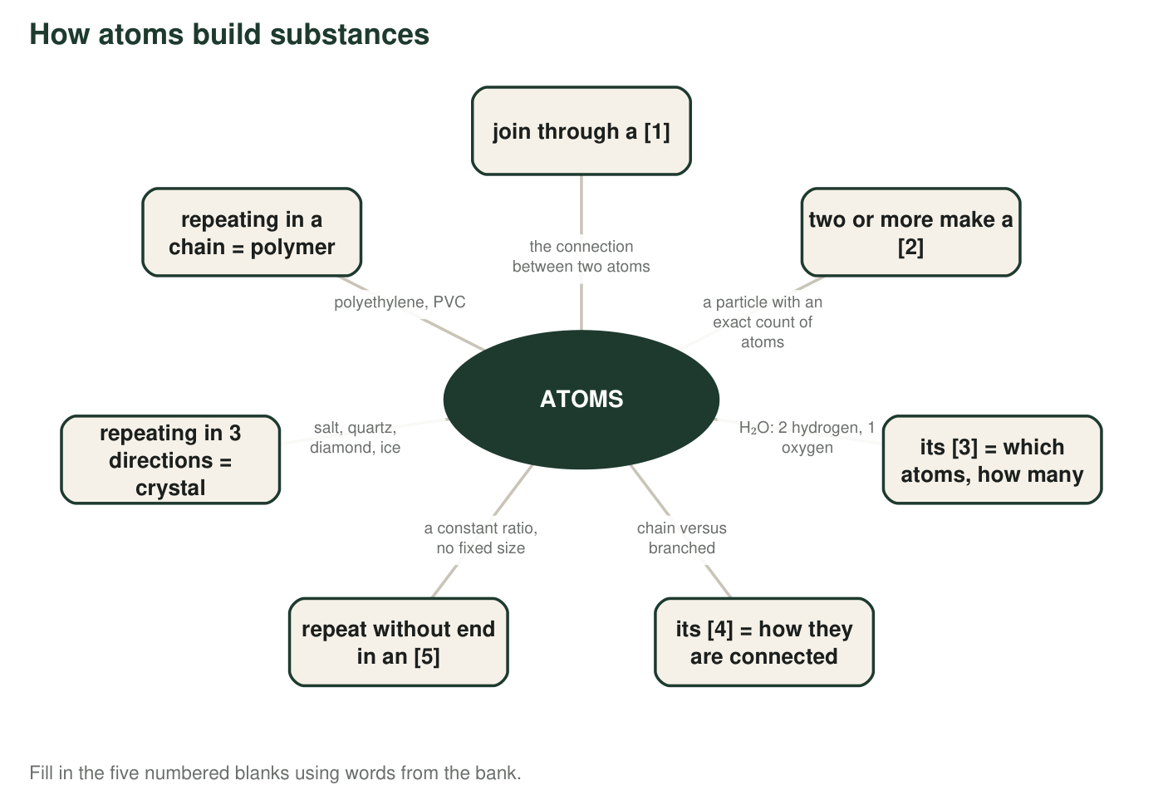
1. Write the five missing words: [1] ______ [2] ______ [3] ______ [4] ______ [5] ______
______________________________________________________________________________________
______________________________________________________________________________________
______________________________________________________________________________________
2. Both crystal and polymer hang off box [5]. In one sentence, say what the two words share, and in a second sentence say how they differ.
______________________________________________________________________________________
______________________________________________________________________________________
______________________________________________________________________________________

Part B: Which word fits?
For each example, write the one word from the bank that it illustrates best. Think about what the example is really pointing at: a connection, a particle, a count, an arrangement, a repeating pattern or a stand-in.
3. Plastic spheres joined by short sticks, used to show the shape of a caffeine particle: ______
______________________________________________________________________________________
______________________________________________________________________________________
______________________________________________________________________________________
4. A particle of ammonia is always exactly one nitrogen atom with three hydrogen atoms attached: ______
______________________________________________________________________________________
______________________________________________________________________________________
______________________________________________________________________________________
5. Butane and isobutane both contain 4 carbon and 10 hydrogen atoms, but in butane the carbons form a chain and in isobutane one carbon is joined to the other three: ______
______________________________________________________________________________________
______________________________________________________________________________________
______________________________________________________________________________________
6. A grain of quartz has one silicon atom for every two oxygen atoms whether it is a speck of sand or a fist-sized stone: ______
______________________________________________________________________________________
______________________________________________________________________________________
______________________________________________________________________________________
7. The link that keeps each hydrogen atom attached to the oxygen atom in a water particle: ______
______________________________________________________________________________________
______________________________________________________________________________________
______________________________________________________________________________________
8. In diamond, carbon atoms repeat in the same pattern up, down, left, right, forward and back: ______
______________________________________________________________________________________
______________________________________________________________________________________
______________________________________________________________________________________
9. The PVC in a water pipe is one small unit linked to the next, again and again, in a very long chain: ______
______________________________________________________________________________________
______________________________________________________________________________________
______________________________________________________________________________________
10. Water is H₂O; hydrogen peroxide is H₂O₂. The two differ by one oxygen atom per particle: ______
______________________________________________________________________________________
______________________________________________________________________________________
______________________________________________________________________________________

Part C: Use the words
11. A classmate writes 'a molecule of table salt.' Explain what is wrong using the words molecule and extended structure, and tell what the formula NaCl really describes.
______________________________________________________________________________________
______________________________________________________________________________________
______________________________________________________________________________________
12. Explain why knowing the composition of a substance is not always enough to identify it. Use the words composition and structure, and give one example from this chapter.
______________________________________________________________________________________
______________________________________________________________________________________
______________________________________________________________________________________
13. Sort these four into molecule, crystal or polymer: oxygen gas, ice, polyester fabric, a salt grain. Then explain your choice for ice using the word repeating.
______________________________________________________________________________________
______________________________________________________________________________________
______________________________________________________________________________________
14. The ratio for quartz is 1:2 (silicon to oxygen). State one thing this ratio tells you about a quartz crystal and one thing it does not tell you.
______________________________________________________________________________________
______________________________________________________________________________________
______________________________________________________________________________________
15. In most ball-and-stick models, oxygen is red and hydrogen is white. Are real oxygen atoms red? Explain what the colors are for, using the word model.
______________________________________________________________________________________
______________________________________________________________________________________
______________________________________________________________________________________

Two questions that sort most examples
When an example could fit two words, ask: (1) Is it about a count (an exact number of atoms in one particle) or a ratio (a proportion that stays the same at any size)? Count points to molecule or composition; ratio points to extended structure, crystal or polymer. (2) Is it about what the atoms are, or how they are connected? What points to composition; how points to structure. Try these two questions on q5 and q6 before answering the rest.

Write the ratio from the structure
In polyethylene, every repeating unit is one carbon atom carrying two hydrogen atoms, bonded to the next carbon in the chain. In polyvinyl chloride (PVC), every repeating pair of carbons carries three hydrogen atoms and one chlorine atom. Write the carbon-to-hydrogen ratio for polyethylene and the carbon-to-hydrogen-to-chlorine ratio for PVC. Then explain, using the words extended structure and ratio, why a chemist can write a ratio for a polymer even though no two polymer chains have exactly the same length.

