Angela's Tools · Chapter 2: Molecules and Extended Structures · Worksheet 4 of 10

Reading Models, Building Models: Molecules and a Salt Slice (Teacher answer key)
Learning target: I can read a model to state a substance's atomic composition, tell a molecule from an extended structure, and draw ball-and-stick models of two molecules that share a composition but differ in structure.
Diagrams and models · about 40 minutes · individual · Standards: MS-PS1-1 (assesses)

Standards connections
MS-PS1-1 (assesses): Part B asks students to develop ball-and-stick models of butane and isobutane that show composition and structure, which is direct evidence toward the PE. Part A has them read the composition of molecules and of a salt slice and a polymer chain from given models. Bonding energy, charges and the complete atom-by-atom description of large structures are not required, in line with the assessment boundary.

Answers with reasoning

Part A: Read the models
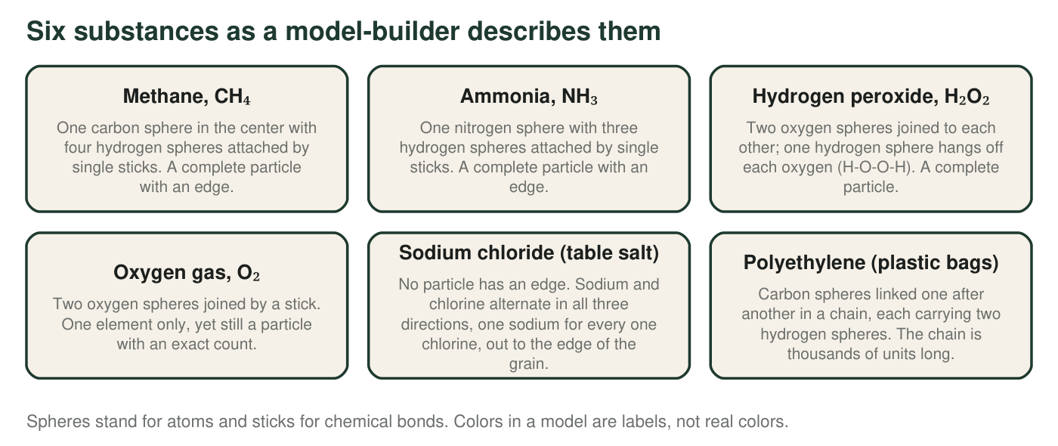
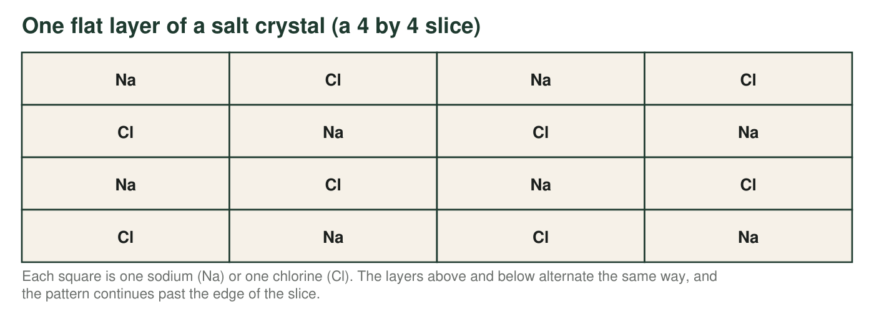
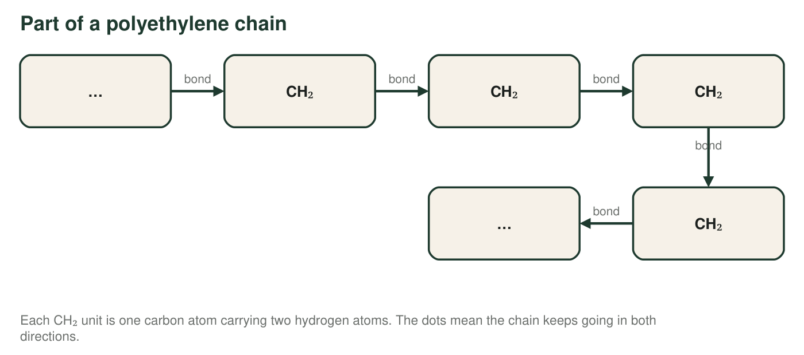
1. Complete the table from the first figure. For the two substances with no particle edge, write the ratio instead of a count and write 'no fixed number' in the total column.
Answer: Methane: carbon, hydrogen; 1 C, 4 H; 5 atoms; molecule. Ammonia: nitrogen, hydrogen; 1 N, 3 H; 4 atoms; molecule. Hydrogen peroxide: hydrogen, oxygen; 2 H, 2 O; 4 atoms; molecule. Oxygen gas: oxygen; 2 O; 2 atoms; molecule. Sodium chloride: sodium, chlorine; ratio 1:1; no fixed number; extended structure. Polyethylene: carbon, hydrogen; ratio 1:2; no fixed number; extended structure.
Reasoning: The four molecules have a particle with an edge and an exact count; the two extended structures have no edge and are described by a ratio. Oxygen gas is the check that a molecule can be a single element.
Also acceptable: Accept 'crystal' for sodium chloride and 'polymer' for polyethylene in the last column, since both are kinds of extended structure.
2. Methane and ammonia both have one central atom with hydrogens attached. Name two ways their composition differs.
Answer: The central atom is a different element (carbon in methane, nitrogen in ammonia), and the number of hydrogens differs (4 in methane, 3 in ammonia), so the totals differ too (5 versus 4 atoms).
Reasoning: Composition means which kinds of atoms and how many; both parts differ here.
Also acceptable: None.
Full credit must include:
• Different central element
• Different number of hydrogens (or different total)
3. Count the sodium and chlorine squares in the 4 by 4 slice and write the ratio. If ten identical alternating layers were stacked to make a block, how many sodium and how many chlorine would it contain? Show your work.
Answer: 8 sodium and 8 chlorine (each row has 2 of each; 4 rows × 2 = 8), ratio 1:1. Ten layers: 10 × 8 = 80 sodium and 10 × 8 = 80 chlorine, still 1:1.
Reasoning: Counting the alternating grid gives equal numbers; stacking identical layers multiplies both counts by the same factor, so the ratio does not change. This models why the formula stays NaCl at any size.
Also acceptable: Accept 80 and 80 with the ratio stated once.
4. Try to draw a circle around 'one NaCl' in the slice so that the sodium inside belongs only to the chlorine inside. Explain why any circle you draw is arbitrary, and what that tells you about what the formula NaCl means.
Answer: Every sodium in the slice touches a chlorine above, below, left and right (and more in the layers above and below), all at the same distance, so there is no reason to pair it with one chlorine rather than another; any circle is a choice, not a fact about the crystal. That means NaCl is a ratio (one sodium for every one chlorine), not a description of a particle.
Reasoning: This is the chapter's key move from count to ratio. The student must connect the arbitrariness of the circle to the meaning of the formula.
Also acceptable: Accept 'there is no molecule of salt' as the conclusion.
Full credit must include:
• Notes that each sodium has several equally close chlorine neighbors
• Concludes that NaCl is a ratio, not a particle
5. A polyethylene chain has 1,500 CH₂ units. How many carbon atoms and how many hydrogen atoms does it contain, and what is the carbon-to-hydrogen ratio? Would the ratio change for a chain of 2,000 units? Show your work.
Answer: 1,500 units × 1 carbon = 1,500 carbon atoms; 1,500 × 2 hydrogen = 3,000 hydrogen atoms. Ratio C:H = 1,500:3,000 = 1:2. A 2,000-unit chain has 2,000 C and 4,000 H, and the ratio is still 1:2, because every unit adds atoms in the same proportion.
Reasoning: Each repeating unit has a fixed composition, so the whole chain keeps the unit's ratio no matter how long it is.
Also acceptable: Accept the ratio written as 1 to 2 or as 'twice as many hydrogens.'
6. Water (H₂O) and hydrogen peroxide (H₂O₂) are compared in the first figure. Which statement is correct?
Answer: B. They contain the same kinds of atoms in different numbers, so they are different substances.
Reasoning: H₂O and H₂O₂ differ in composition (one extra oxygen per particle), which already makes them different substances. A is wrong because the compositions differ; C is wrong because H₂O₂ has only 2 hydrogens, not 4; D is wrong because a change of state does not change the atoms in a particle.
Also acceptable: None.

Part B: Build two models with the same composition
Butane and isobutane each contain exactly 4 carbon atoms and 10 hydrogen atoms. In butane the four carbons are joined in a row. In isobutane one carbon sits in the middle and is joined to each of the other three, which are not joined to one another. Drawing rules: every carbon must have exactly four sticks, and every hydrogen must have exactly one.
Draw ball-and-stick models of butane (left) and isobutane (right). Use a letter inside each sphere (C or H) and add a legend. Add hydrogens until every carbon has four sticks. Label each model with its name and write its atom counts beneath it.
Expected drawing: Butane: four C spheres in a row joined by three sticks; the two end carbons each carry 3 H, the two middle carbons each carry 2 H (3 + 2 + 2 + 3 = 10 H). Isobutane: one central C joined to three other C; the central C carries 1 H, each of the three outer C carries 3 H (1 + 3 × 3 = 10 H). Both labeled with a legend and the counts 4 C, 10 H.
Reasoning: A correct model obeys the four-sticks rule for every carbon and the one-stick rule for every hydrogen, gives 10 hydrogens for both, and places the carbons as described (row versus center with three arms). Bond angles and sphere sizes do not matter at this level.
7. Point to the feature of your two drawings that shows the composition is the same, and the feature that shows the structure is different.
Answer: Same composition: the atom counts written under both models are identical (4 C, 10 H), and the same two kinds of spheres appear. Different structure: in butane the carbon-carbon sticks form a row (each inner carbon joined to two carbons), while in isobutane one carbon is joined to three carbons and the others to only one.
Reasoning: Students must locate composition in the counts and structure in the pattern of connections.
Also acceptable: Accept 'the shape is different' for structure if it is tied to which carbons are connected.
Full credit must include:
• Composition shown by equal counts of C and H
• Structure shown by the different carbon-carbon connection pattern
8. Count the sticks (bonds) in each of your models. Show how you got each number by separating carbon-carbon sticks from carbon-hydrogen sticks, and explain why both models must have the same total.
Answer: Butane: 3 carbon-carbon sticks + 10 carbon-hydrogen sticks = 13 sticks. Isobutane: 3 carbon-carbon sticks + 10 carbon-hydrogen sticks = 13 sticks. Both must be equal because each has 4 carbons needing 4 sticks each (16 stick-ends) and 10 hydrogens needing 1 each (10 stick-ends); every stick has two ends, so (16 + 10) ÷ 2 = 13 sticks in any arrangement that follows the rules.
Reasoning: The stick-ends argument is the deep reason; crediting students who simply count 13 for both and say 'same atoms with the same rules' is acceptable.
Also acceptable: Accept 'same number of atoms and the same rules give the same number of bonds' as the explanation.
9. A classmate draws 'butane' as a ring of four carbons, each joined to two other carbons. Use the four-sticks rule to find how many hydrogens that ring could hold, and explain why the ring cannot be butane.
Answer: In a ring of four carbons, each carbon already uses 2 sticks on its carbon neighbors, leaving room for only 2 hydrogens each: 4 × 2 = 8 hydrogens. A ring of four carbons therefore has the composition C₄H₈, not C₄H₁₀, so it cannot be butane; it is a different substance with a different composition.
Reasoning: Applying the four-sticks rule shows that structure and composition are linked: closing a ring removes two hydrogens. (The ring is cyclobutane, which students need not name.)
Also acceptable: Accept 'it would need to lose two hydrogens' as the key point.
Full credit must include:
• Uses the four-sticks rule to get 8 hydrogens
• Concludes the ring has a different composition and so is not butane

Teacher notes
The first figure deliberately describes models in words so that students work from composition and connectivity rather than from colors. If you project real ball-and-stick images, give the color key each time. Isobutane is branched: one central carbon bonded to three carbons, which are not bonded to each other; avoid the textbook's 'triangle' and 'pyramid' wording, which suggests the outer carbons touch. The four-sticks rule (carbon forms four bonds, hydrogen one, oxygen two, nitrogen three) is a reliable counting tool at this level; it is a consequence of electron sharing that students will meet later, so present it as a rule the models follow. In solid salt the particles are charged ions; the lesson's 'sodium and chlorine' wording is used because MS-PS1-1 keeps the ionic nature of subunits out of assessment. Extension: there are exactly two C₄H₁₀ arrangements and three for C₅H₁₂ (a straight row, a row of four with a branch, and a center carbon with four arms).

