Angela's Tools · Chapter 2: Molecules and Extended Structures · Worksheet 4 of 10

Reading Models, Building Models: Molecules and a Salt Slice
Learning target: I can read a model to state a substance's atomic composition, tell a molecule from an extended structure, and draw ball-and-stick models of two molecules that share a composition but differ in structure.
Diagrams and models · about 40 minutes · individual · Standards: MS-PS1-1 (assesses)
Name: ____________________________ Date: ____________ Period: ______

Directions
Part A gives you three models in words and pictures. Read each one carefully and answer the questions by counting and comparing; do not guess. Part B asks you to build your own models in the drawing box. Follow the two drawing rules in the scaffold, label everything, and write the atom counts beneath each model. A model is correct when another student could rebuild the molecule from your drawing alone.

Part A: Read the models
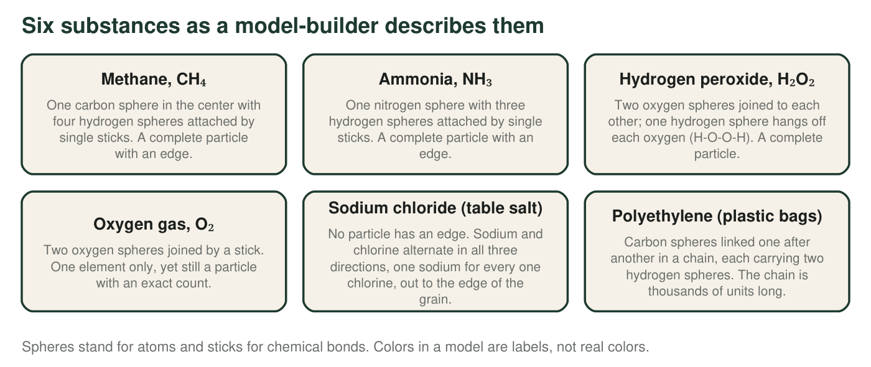
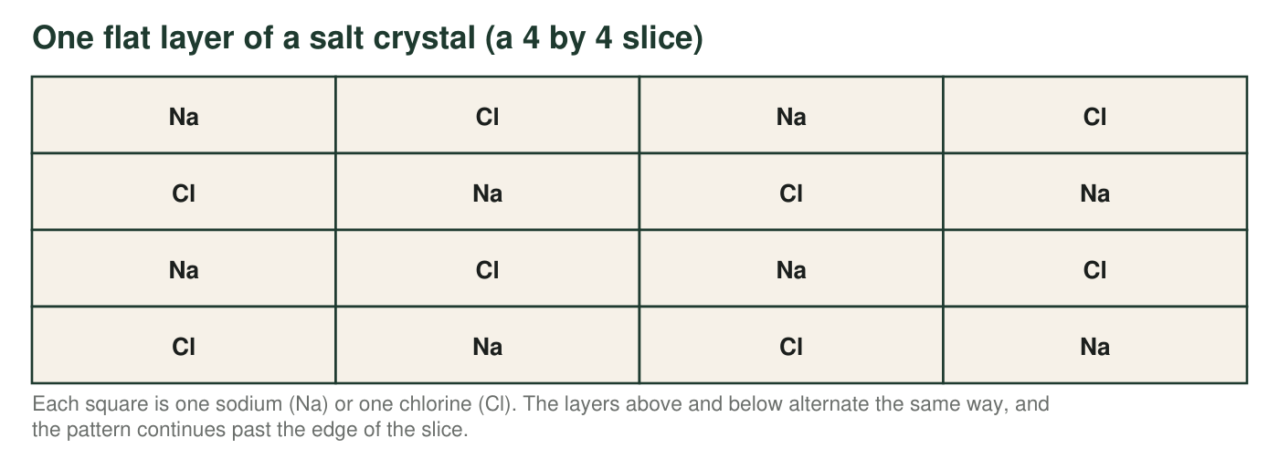
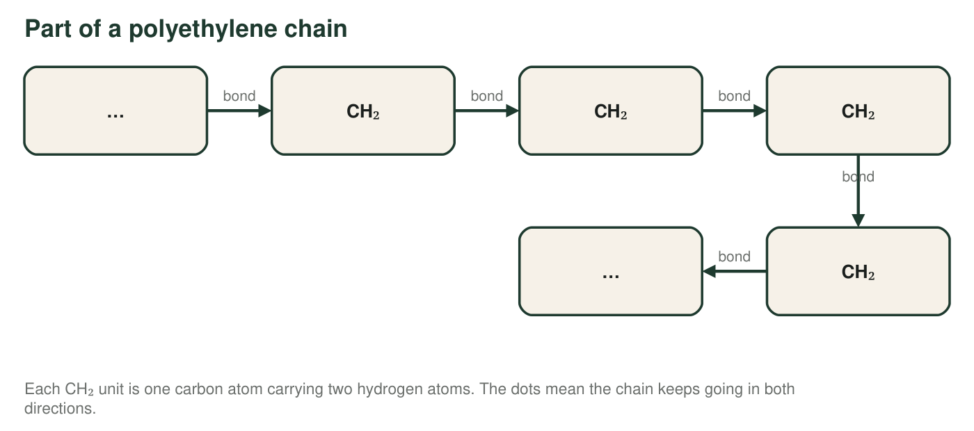
1. Complete the table from the first figure. For the two substances with no particle edge, write the ratio instead of a count and write 'no fixed number' in the total column.
Kinds of atoms | Number of each (or ratio) | Total atoms in one particle | Molecule or extended structure?
Methane
Ammonia
Hydrogen peroxide
Oxygen gas
Sodium chloride
Polyethylene

2. Methane and ammonia both have one central atom with hydrogens attached. Name two ways their composition differs.
______________________________________________________________________________________
______________________________________________________________________________________
______________________________________________________________________________________
3. Count the sodium and chlorine squares in the 4 by 4 slice and write the ratio. If ten identical alternating layers were stacked to make a block, how many sodium and how many chlorine would it contain? Show your work.
______________________________________________________________________________________
______________________________________________________________________________________
______________________________________________________________________________________
4. Try to draw a circle around 'one NaCl' in the slice so that the sodium inside belongs only to the chlorine inside. Explain why any circle you draw is arbitrary, and what that tells you about what the formula NaCl means.
______________________________________________________________________________________
______________________________________________________________________________________
______________________________________________________________________________________
5. A polyethylene chain has 1,500 CH₂ units. How many carbon atoms and how many hydrogen atoms does it contain, and what is the carbon-to-hydrogen ratio? Would the ratio change for a chain of 2,000 units? Show your work.
______________________________________________________________________________________
______________________________________________________________________________________
______________________________________________________________________________________
6. Water (H₂O) and hydrogen peroxide (H₂O₂) are compared in the first figure. Which statement is correct?
○ A. Their compositions are identical; only their structures differ.
○ B. They contain the same kinds of atoms in different numbers, so they are different substances.
○ C. A hydrogen peroxide molecule is two water molecules joined together.
○ D. They are the same substance; hydrogen peroxide is just water in a different state.

Part B: Build two models with the same composition
Butane and isobutane each contain exactly 4 carbon atoms and 10 hydrogen atoms. In butane the four carbons are joined in a row. In isobutane one carbon sits in the middle and is joined to each of the other three, which are not joined to one another. Drawing rules: every carbon must have exactly four sticks, and every hydrogen must have exactly one.
Draw ball-and-stick models of butane (left) and isobutane (right). Use a letter inside each sphere (C or H) and add a legend. Add hydrogens until every carbon has four sticks. Label each model with its name and write its atom counts beneath it.

7. Point to the feature of your two drawings that shows the composition is the same, and the feature that shows the structure is different.
______________________________________________________________________________________
______________________________________________________________________________________
______________________________________________________________________________________
8. Count the sticks (bonds) in each of your models. Show how you got each number by separating carbon-carbon sticks from carbon-hydrogen sticks, and explain why both models must have the same total.
______________________________________________________________________________________
______________________________________________________________________________________
______________________________________________________________________________________
9. A classmate draws 'butane' as a ring of four carbons, each joined to two other carbons. Use the four-sticks rule to find how many hydrogens that ring could hold, and explain why the ring cannot be butane.
______________________________________________________________________________________
______________________________________________________________________________________
______________________________________________________________________________________

Carbons first, hydrogens last
For Part B, draw only the carbon spheres and the carbon-carbon sticks first: a row of four for butane, a center with three arms for isobutane. Then go carbon by carbon. Count the sticks it already has, subtract from four, and add that many hydrogens. An end carbon in the row needs 3 hydrogens; a middle carbon needs 2; the center carbon of isobutane needs only 1. When you finish, count all the hydrogens: the total must be 10 for both models, or a carbon is missing a stick.

A third way to arrange C₄H₁₀?
Try to draw a third molecule with exactly 4 carbons and 10 hydrogens that is not butane and not isobutane, following the four-sticks and one-stick rules with no rings. Keep careful notes on every arrangement you try. You should find that there are only two. Write two or three sentences on why a rule-based model lets you prove something (there are exactly two) that you could never prove by looking, and then look up pentane (C₅H₁₂), which has three arrangements, and sketch them.

