Angela's Tools · Chapter 2: Molecules and Extended Structures · Worksheet 6 of 10

Why Does One Carbon Write and the Other Cut? A CER Case (Teacher answer key)
Learning target: I can use models of two extended structures and test results to argue which feature of atomic-level structure explains a difference that I can see and feel.
Claim, evidence, reasoning · about 40 minutes · individual · Standards: MS-PS1-1 (practice)

Standards connections
MS-PS1-1 (practice): Students read models of diamond and graphite and use them, with test data, to explain why the two pure-carbon solids behave differently. This exercises the crosscutting idea that macroscopic patterns come from atomic-level structure, which the lesson's final section builds toward, without requiring students to draw the models here.

Answers with reasoning

The scenario
Ms. Alvarez's class is given four small samples and asked to explain a puzzle. Two of the samples, a pencil core and a flake of natural graphite, are pure carbon. The third, a chip from an industrial cutting blade, is diamond, also pure carbon. The fourth, labeled only 'Sample Q,' is a soft gray mineral that is not carbon at all. The class runs the same three tests on every sample: drag it across paper and rate the mark, try to scratch it with a fingernail, and try to scratch a glass slide with it. Then they study the structure models that scientists have worked out for diamond and graphite.
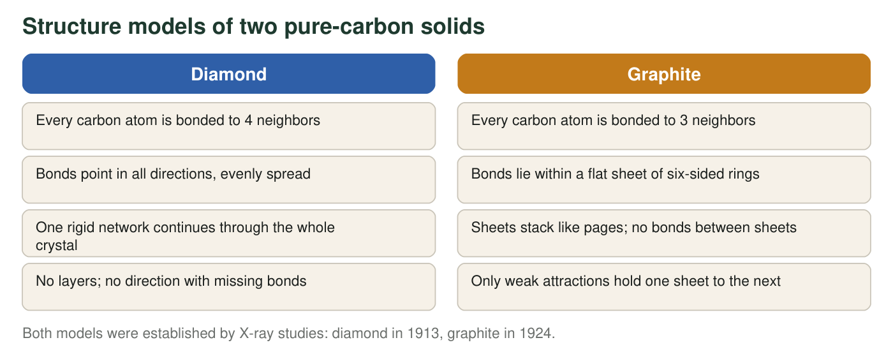
Distances in the two structures (real, rounded)
Structure | Distance between bonded carbon atoms | Distance between sheets | Bonds between sheets
Diamond | 154 pm | no sheets | not applicable
Graphite | 142 pm (within a sheet) | 335 pm | none (weak attractions only)

pm = picometers, one trillionth of a meter.
Class test results on four samples (teaching dataset)
Simulated teaching dataset (not real measurements).
Sample | Mark on paper (0 = none, 5 = very dark) | Scratched by a fingernail? | Scratches glass? | Feel between fingers
Pencil core (graphite) | 5 | yes | no | slippery
Natural graphite flake | 4 | yes | no | slippery
Industrial diamond chip | 0 | no | yes | hard, gritty
Sample Q (gray mineral, not carbon) | 3 | yes | no | slippery

Simulated results for teaching, consistent with the real behavior of these materials.

Warm-up: organize the evidence
1. Using only the test results, sort the four samples into two groups that behave alike. Name the three test results the members of each group share.
Answer: Group 1: pencil core, natural graphite flake and Sample Q; all leave a mark (ratings 5, 4, 3), are scratched by a fingernail, do not scratch glass, and feel slippery. Group 2: the diamond chip alone; mark 0, not scratched by a fingernail, scratches glass, feels hard.
Reasoning: The test results split cleanly three-to-one, and Sample Q lands with graphite despite not being carbon, which sets up q4.
Also acceptable: Accept any three of the four shared results.
Full credit must include:
• Correct grouping (three slippery markers versus diamond)
• Names the shared results for each group
2. Diamond and graphite are both pure carbon, so the kind of atom cannot explain the difference. From the model figure and the distance table, write the one structural difference you think matters most, and give a number from the table that goes with it.
Answer: Graphite has no bonds between its sheets (only weak attractions), while diamond is one network bonded in all directions. The matching number: sheets in graphite are 335 pm apart, more than twice the 142 pm between bonded atoms, which fits 'no bonds between sheets.' (Also acceptable: 3 bonded neighbors in graphite versus 4 in diamond.)
Reasoning: The decisive feature is the absence of bonds in one direction. The neighbor count is a related but less direct clue.
Also acceptable: Accept the 3-versus-4 neighbor difference with the explanation that the fourth bond in diamond is the one that ties the structure together in every direction.
Full credit must include:
• Names the lack of bonds between sheets (or bonds in all directions versus in a plane)
• Attaches a number from the table
3. Write a three-step chain of cause and effect that starts with 'no bonds between the sheets' and ends with 'a dark mark on the paper.'
Answer: No bonds between the sheets, so the sheets are held only by weak attractions. Therefore, dragging the pencil across paper easily pushes sheets off the stack (the friction is stronger than the weak attractions). Therefore, thin stacks of carbon sheets stick to the paper, and because they are opaque gray, they show as a dark mark.
Reasoning: Students must produce a causal chain, not a restatement. The middle step (friction overcomes weak attractions) is the one most often skipped.
Also acceptable: Accept 'the sheets slide apart like a stack of cards' as the middle step.
Full credit must include:
• Three ordered steps
• Includes the sliding or peeling of sheets
• Ends with carbon left on the paper as the mark

Your argument
Claim: Claim: State which feature of atomic-level structure explains why graphite leaves a mark and is soft while diamond leaves no mark and is hard.
Evidence: Evidence: Give at least three specific pieces of evidence from the test results, the model figure and the distance table, with numbers where they exist (mark ratings, number of bonded neighbors, distances). Say what each piece shows.
Reasoning: Reasoning: Explain, step by step, how the structural feature in your claim causes each test result. Use the idea that a pattern you can see comes from a pattern at the atomic scale, and explain why the kind of atom alone cannot be the cause.
Model response: Claim: The difference is caused by how the carbon atoms are bonded: in diamond every atom is bonded to four neighbors in a network that runs in all directions, while in graphite the atoms are bonded only within flat sheets and there are no bonds between sheets. Evidence: (1) In the tests, the two graphite samples rated 5 and 4 for marking and were scratched by a fingernail, while diamond rated 0 and scratched glass. (2) The model shows 4 bonded neighbors per carbon in diamond with bonds in all directions, versus 3 per carbon in graphite with bonds only within a sheet. (3) The distance table shows graphite's sheets 335 pm apart, more than twice the 142 pm bond distance within a sheet, with no bonds between sheets, while diamond has no sheets at all. (4) Both are pure carbon, so the kind of atom is the same in both. Reasoning: A mark forms when pieces of the material come off onto paper. In graphite, only weak attractions hold one sheet to the next, so the friction of paper easily peels sheets away, which gives the dark mark and makes the solid soft enough for a fingernail to scratch. In diamond, moving any atom means breaking strong bonds, and there is no direction in which the bonds are missing, so nothing peels off (mark 0) and the surface is hard enough to scratch glass. Because the atoms are identical in both solids, the only thing that can explain the different behavior is their arrangement; the pattern we feel and see (soft and marking versus hard and clean) is produced by the pattern of bonds we cannot see.
Reasoning: A complete response identifies bonding in all directions versus bonding only within sheets as the cause, supports it with at least three cited pieces of evidence including numbers, and reasons through the mechanism (sheets peel off; the network does not) while ruling out the kind of atom.
• Claim names the structural feature (bonds between sheets absent versus a network in all directions)
• At least three pieces of evidence with numbers from the tests, the model and the table
• Reasoning explains the mechanism for both the mark and the hardness
• Reasoning rules out the kind of atom as the cause
4. Sample Q is not carbon, yet it tested like graphite. Predict what its atomic-level structure is probably like, and name one piece of evidence that would confirm or reject your prediction.
Answer: Sample Q probably has a layered structure: its atoms are bonded within flat sheets, with only weak attractions between sheets, so the sheets slide off and leave a mark and feel slippery, even though the atoms are not carbon. Confirming evidence: an X-ray study showing a repeating layered pattern with a large gap between layers; or a model of its structure from a reference; rejecting evidence would be a structure with bonds in all directions.
Reasoning: The prediction applies the structure-property pattern in reverse (from behavior to structure). Sample Q is molybdenum disulfide, which does have this layered structure.
Also acceptable: Accept 'look at it under a microscope for flaky layers' as weaker but reasonable evidence.
Full credit must include:
• Predicts sheets or layers with weak attraction between them
• Names a piece of evidence that could test the prediction

Scoring rubric
Criterion | 4 Exemplary | 3 Proficient | 2 Developing | 1 Beginning
Claim | Names the specific structural feature (bonds in all directions versus bonds only within sheets, with no bonds between sheets) in one clear statement. | Names a structural difference (layers versus network, or 3 versus 4 neighbors) without saying which bonds are missing. | Says 'the structure is different' with no feature named, or names the kind of atom. | No claim, or a claim unrelated to the evidence.
Evidence | Three or more specific pieces from at least two sources (tests, model, distance table), each with a number or exact observation and a statement of what it shows. | Three pieces, but one lacks a number or is not explained; or all from one source. | One or two pieces, or evidence stated vaguely ('graphite is softer'). | No evidence, or evidence that is not on the sheet.
Reasoning | Explains the mechanism for both the mark and the hardness (sheets peel because only weak attractions hold them; the network resists because every direction is bonded) and rules out the kind of atom. | Explains the mechanism for one result and rules out the kind of atom, or explains both without ruling out the atom. | Restates the evidence or the claim without a cause-and-effect chain. | No reasoning, or reasoning that contradicts the evidence.
Scientific accuracy | No errors; uses bond, sheet, attraction and network correctly; does not claim atoms differ in hardness or that diamond's atoms are closer. | One minor slip in wording that does not change the argument. | One significant error (for example, 'diamond's carbon atoms are harder'). | Several errors or a misconception that drives the argument.

Teacher notes
The structure facts are real: diamond's carbon-carbon distance is about 154 pm with four bonded neighbors per atom; graphite's in-sheet distance is about 142 pm with three bonded neighbors, and its sheets are about 335 pm apart with no bonds between them. The test data are simulated but match real behavior; a natural graphite flake does mark slightly less darkly than a pencil core, which is graphite mixed with clay and pressed. Sample Q is molybdenum disulfide (MoS₂), a layered mineral used as a dry lubricant; students do not need its name until the extension. Two watch-outs: students may argue that diamond is harder because its atoms are 'closer' or 'packed tighter,' which the table contradicts (142 pm is shorter than 154 pm); and some will say diamond has 'stronger atoms.' Redirect both to the bonds-between-sheets row of the evidence grid. The textbook says diamond atoms are bonded 'in a cubic shape'; the accurate statement is that each atom is bonded to four neighbors in a rigid three-dimensional network, and 'cubic' describes the crystal's overall symmetry. Boron nitride in the extension is real: its layered form is white and slippery, which separates slipperiness (from structure) from color (from the kind of atoms).

