Angela's Tools · Chapter 2: Molecules and Extended Structures · Worksheet 6 of 10

Why Does One Carbon Write and the Other Cut? A CER Case
Learning target: I can use models of two extended structures and test results to argue which feature of atomic-level structure explains a difference that I can see and feel.
Claim, evidence, reasoning · about 40 minutes · individual · Standards: MS-PS1-1 (practice)
Name: ____________________________ Date: ____________ Period: ______

Directions
Read the scenario, study the structure models and the two tables, and answer the warm-up questions first; they organize your evidence. Then write your Claim, Evidence and Reasoning in the boxes. A strong response names specific numbers and observations, points to one feature of the atomic-level structure, and explains step by step how that feature produces what you can see.

The scenario
Ms. Alvarez's class is given four small samples and asked to explain a puzzle. Two of the samples, a pencil core and a flake of natural graphite, are pure carbon. The third, a chip from an industrial cutting blade, is diamond, also pure carbon. The fourth, labeled only 'Sample Q,' is a soft gray mineral that is not carbon at all. The class runs the same three tests on every sample: drag it across paper and rate the mark, try to scratch it with a fingernail, and try to scratch a glass slide with it. Then they study the structure models that scientists have worked out for diamond and graphite.
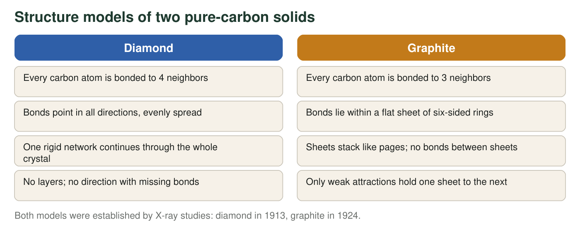
Distances in the two structures (real, rounded)
Structure | Distance between bonded carbon atoms | Distance between sheets | Bonds between sheets
Diamond | 154 pm | no sheets | not applicable
Graphite | 142 pm (within a sheet) | 335 pm | none (weak attractions only)

pm = picometers, one trillionth of a meter.
Class test results on four samples (teaching dataset)
Simulated teaching dataset (not real measurements).
Sample | Mark on paper (0 = none, 5 = very dark) | Scratched by a fingernail? | Scratches glass? | Feel between fingers
Pencil core (graphite) | 5 | yes | no | slippery
Natural graphite flake | 4 | yes | no | slippery
Industrial diamond chip | 0 | no | yes | hard, gritty
Sample Q (gray mineral, not carbon) | 3 | yes | no | slippery

Simulated results for teaching, consistent with the real behavior of these materials.

Warm-up: organize the evidence
1. Using only the test results, sort the four samples into two groups that behave alike. Name the three test results the members of each group share.
______________________________________________________________________________________
______________________________________________________________________________________
______________________________________________________________________________________
2. Diamond and graphite are both pure carbon, so the kind of atom cannot explain the difference. From the model figure and the distance table, write the one structural difference you think matters most, and give a number from the table that goes with it.
______________________________________________________________________________________
______________________________________________________________________________________
______________________________________________________________________________________
3. Write a three-step chain of cause and effect that starts with 'no bonds between the sheets' and ends with 'a dark mark on the paper.'
______________________________________________________________________________________
______________________________________________________________________________________
______________________________________________________________________________________

Your argument
Claim: Claim: State which feature of atomic-level structure explains why graphite leaves a mark and is soft while diamond leaves no mark and is hard.
______________________________________________________________________________________
______________________________________________________________________________________
Evidence: Evidence: Give at least three specific pieces of evidence from the test results, the model figure and the distance table, with numbers where they exist (mark ratings, number of bonded neighbors, distances). Say what each piece shows.
______________________________________________________________________________________
______________________________________________________________________________________
______________________________________________________________________________________
______________________________________________________________________________________
Reasoning: Reasoning: Explain, step by step, how the structural feature in your claim causes each test result. Use the idea that a pattern you can see comes from a pattern at the atomic scale, and explain why the kind of atom alone cannot be the cause.
______________________________________________________________________________________
______________________________________________________________________________________
______________________________________________________________________________________
______________________________________________________________________________________
4. Sample Q is not carbon, yet it tested like graphite. Predict what its atomic-level structure is probably like, and name one piece of evidence that would confirm or reject your prediction.
______________________________________________________________________________________
______________________________________________________________________________________
______________________________________________________________________________________
______________________________________________________________________________________

Evidence grid
On scrap paper, draw a grid with three rows (test results, number of bonded neighbors, distances and bonds between sheets) and two columns (diamond, graphite). Fill every cell with a number or a short phrase from the sheet. Your Evidence section is the grid written out in sentences; your Reasoning section explains why the row about bonds between sheets causes the row about test results. If you are stuck on the claim, finish this sentence: 'The difference comes from whether the carbon atoms are bonded in ______ or only in ______.'

Same structure, different atoms
Sample Q is molybdenum disulfide, a mineral whose sheets are three atoms thick (a layer of molybdenum between two layers of sulfur) and are held together only by weak attractions; it is used as a dry lubricant in machinery. Boron nitride is another layered material, made of boron and nitrogen in six-sided rings like graphite's, and it also feels slippery, but it is white. Write a paragraph arguing which matters more for slipperiness, the kind of atoms or the way they are arranged, using these two materials and graphite as your evidence. Then explain why color is not predicted by the sheet structure.

