Angela's Tools · Chapter 3: Substances and Their Properties · Worksheet 2 of 10

Which Property Is It? Words for Telling Substances Apart (Teacher answer key)
Learning target: I can use the vocabulary of substances and properties to sort descriptions, complete a concept map, and explain which properties identify a substance and which only describe one object.
Vocabulary in action · about 30 minutes · individual · Standards: MS-PS1-2 (practice)

Standards connections
MS-PS1-2 (practice): Analyzing property data later in the unit depends on knowing which properties (density, melting point, boiling point, solubility, flammability) belong to the substance and which (mass, volume, shape) belong to a particular sample. This sheet builds that language.

Answers with reasoning
substance: Matter that has the same makeup all the way through. Every pure sample of a substance, large or small, shares the same set of identifying properties. Water, copper and oxygen gas are substances.
mixture: Two or more substances mingled together without turning into a new substance. The amounts can vary from one sample to the next. Air, wood and the gold alloy in a coin are mixtures.
macroscopic: At the scale of things you can see, hold or measure directly. A glass of water is macroscopic; a single water molecule is not.
property: Any trait of matter that you can observe or measure, such as color, mass, melting point or how it behaves in water.
identifying property: A property that every sample of a substance shares no matter the sample's size or shape, so it can help name the substance. Density, melting point, boiling point, solubility and flammability are examples.
mass: How much matter a sample contains, measured in grams or kilograms. Mass belongs to the particular sample, not to the substance.
volume: How much space a sample takes up, measured in cubic centimeters (cm³) or milliliters (mL). One cm³ is the same as one mL.
density: The mass packed into each unit of volume: density = mass ÷ volume, usually in g/cm³. Every pure sample of a substance has the same density under the same conditions.
melting point: The temperature at which a solid turns into a liquid. A chip and a block of the same pure substance melt at the same temperature, though the block takes longer.
boiling point: The temperature at which a liquid boils into a gas. Reference tables give it at normal sea-level air pressure, because lower air pressure lowers it.
solubility: How much of a substance can spread out into a particular liquid until it vanishes from sight. It is always about a pair: sugar has a high solubility in water, but candle wax has almost none.
flammability: Whether, and how easily, a substance burns. You can only observe it while the substance changes into new substances, so it is a chemical property.
physical property: A property you can measure while the sample stays the same substance, such as density, melting point or solubility.
chemical property: A property you can only observe when the substance changes into different substances, such as flammability.

Part A: Complete the concept map
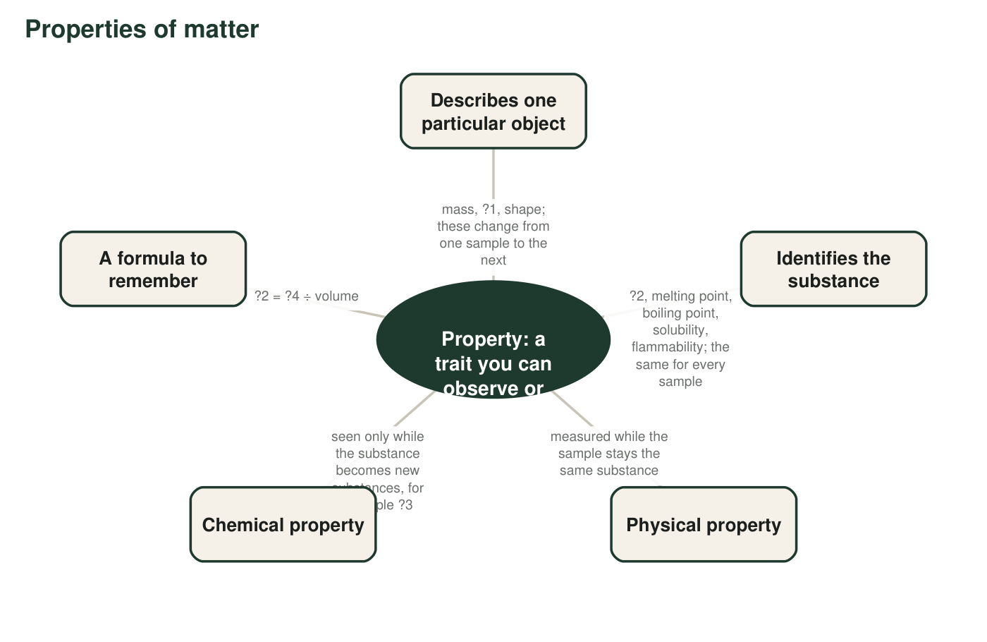
Four labels are missing and marked ?1 to ?4. Use the word bank to fill them in.
1. Write the missing labels: ?1 = ________ ?2 = ________ ?3 = ________ ?4 = ________
Answer: ?1 = volume; ?2 = density; ?3 = flammability; ?4 = mass.
Reasoning: The object branch lists mass, volume and shape. The identifying branch begins with density, which also completes the formula density = mass ÷ volume. The only chemical property in the word bank is flammability.
Also acceptable: Accept 'burning' for ?3 if the student clearly means flammability; ask them to use the term.
2. Melting point appears under 'Identifies the substance' and also counts as a physical property. Explain, using the word bank, why one property can belong to both branches.
Answer: The two branches sort properties by different questions. 'Identifies the substance' asks whether every sample shares the property; melting point does, so it belongs there. 'Physical property' asks whether you can measure it while the substance stays the same; melting a sample does not make a new substance, so it belongs there too. A property can answer yes to both questions.
Reasoning: Students should see that the map has two independent sorting questions (object versus substance; physical versus chemical).
Also acceptable: Accept 'density is also in both' as a supporting example.
Full credit must include:
• States that the branches answer different questions
• Explains why melting point fits each

Part B: Sort the descriptions, then pick the term
Each row below describes something about a sample. Decide whether the description describes this one object (write O) or could help identify the substance (write S). Then name the property with a word from the word bank (for example, mass, shape, density, solubility).
3. Complete the table.
Answer: a. O, length (or size). b. S, melting point. c. O, mass. d. S, density. e. O, shape. f. S, solubility. g. S, flammability. h. O, volume.
Reasoning: Rows b, d, f and g would be true of any sample of that substance; rows a, c, e and h would change if the sample were cut, reshaped or poured into a different jar.
Also acceptable: For row a accept 'length' or 'size' even though neither is in the word bank; the O/S decision is the point. For row h accept 'amount' if the student also writes O.
For each sentence, write the one word-bank term that fits the blank.
4. Oxygen gas is invisible, but a balloon full of it is still a ________ amount of oxygen molecules, large enough to measure.
Answer: macroscopic
Reasoning: A balloon of gas is a measurable, visible-scale amount even if the gas itself is colorless.
Also acceptable: None.
5. Wood is cellulose, lignin and water mingled together, so wood is a ________, not a single substance.
Answer: mixture
Reasoning: Wood is several substances mingled together in amounts that vary from tree to tree.
Also acceptable: None.
6. A camper in a high mountain town finds that water boils at about 92 °C instead of 100 °C. The property that shifted with the lower air pressure is the ________.
Answer: boiling point
Reasoning: Lower air pressure lowers the temperature at which water boils; that is why reference tables state sea-level pressure.
Also acceptable: None.
7. A test that can only be done by letting the sample burn measures a ________ property.
Answer: chemical
Reasoning: Burning changes the substance into new substances, so a property observed by burning is chemical.
Also acceptable: Accept 'flammability' only if the student also indicates it is a chemical property; the blank asks for the kind of property.
8. Permanent-marker ink will not come off with water but wipes away with rubbing alcohol, because ________ always depends on both substances in the pair.
Answer: solubility
Reasoning: The ink's solubility is low in water and high in isopropyl alcohol; the pair matters.
Also acceptable: None.
9. A cube of platinum that is exactly 1 cm on each side has a mass of about 21.5 g. The value 21.5 g/cm³ is platinum's ________.
Answer: density
Reasoning: 21.5 g in 1 cm³ is 21.5 g/cm³, mass per unit volume.
Also acceptable: None.

Part C: Apply the terms
10. A jeweler has two plain rings of exactly the same size and shape. One has nearly twice the mass of the other. Gold has a density of about 19.3 g/cm³ and silver about 10.5 g/cm³. Which ring is gold? Use the terms volume and density in your answer.
Answer: The ring with nearly twice the mass is gold. The two rings have the same volume (same size and shape), so the one with more mass has the higher density, and gold's density (19.3 g/cm³) is nearly twice silver's (10.5 g/cm³): 19.3 ÷ 10.5 ≈ 1.8.
Reasoning: With volume held equal, mass comparison becomes density comparison. The ratio check is a bonus.
Also acceptable: Accept 'about 1.8 times' or 'almost double' for the ratio.
Full credit must include:
• Identifies the heavier ring as gold
• Explains that equal volume makes the mass difference a density difference
11. A student says: 'Mass is a property, so I can use the mass of this bar to identify what metal it is.' Use two word-bank terms to explain what is wrong with this plan.
Answer: Mass is a property of this one object, not an identifying property: a big bar of aluminum can have more mass than a small bar of gold. To identify the metal, divide the mass by the volume to get the density, which is the same for every sample of a substance, and compare it with a reference table.
Reasoning: The two needed terms are mass (object property) and density (identifying property); 'identifying property' and 'volume' also work.
Also acceptable: A student who proposes melting point instead of density as the fix is also correct.
Full credit must include:
• Says mass depends on the amount of sample
• Names density (or another identifying property) as the fix
12. Is the air in this room a substance? Answer using the terms substance and mixture, and name two of the substances in air.
Answer: No. Air is a mixture, not a single substance, because it is several substances mingled together in amounts that can vary: mostly nitrogen gas and oxygen gas, with smaller amounts of argon, carbon dioxide and water vapor. Each of those, separated out, is a substance.
Reasoning: The textbook's own example. Students should name at least two of nitrogen, oxygen, argon, carbon dioxide or water vapor.
Also acceptable: Accept 'neon' as a component.
Full credit must include:
• Classifies air as a mixture
• Names two substances in air
13. A large block of ice and a small ice cube are left on the same counter. Both begin to melt at the same temperature, but the block takes far longer to melt completely. Explain both facts using melting point and mass.
Answer: Melting point is an identifying property of ice (0 °C at normal pressure), so both samples start melting at the same temperature regardless of size. Mass is a property of each object: the block has far more mass, so far more ice has to be melted, which takes more thermal energy and more time.
Reasoning: Separates the temperature at which melting happens (substance property) from how much must melt (object property).
Also acceptable: Accept 'more ice to melt' without the word energy.
Full credit must include:
• Melting point same for both because it belongs to the substance
• Longer time explained by greater mass needing more energy
14. Scientists almost never say a substance is simply 'soluble.' They say 'soluble in water' or 'soluble in alcohol.' Using the definition of solubility, explain why the second substance must be named.
Answer: Solubility measures how much of one substance can spread out into a particular second substance, so it is a property of the pair. The same substance can dissolve well in one liquid and hardly at all in another (marker ink in alcohol versus water; wax in warm oil versus water). Without naming the second substance the statement has no meaning.
Reasoning: This is the accurate framing the textbook implies but never states outright.
Also acceptable: Any correct example earns credit.
Full credit must include:
• States that solubility involves two substances
• Gives or implies an example where the second substance changes the result

Teacher notes
The word bank deliberately adds three terms the textbook uses loosely or not at all: identifying property, physical property and chemical property. The lesson calls flammability a chemical property only in a photo caption, so make that distinction explicit in class. The q6 value (about 92 °C) is realistic for a town around 2,500 m; water boils at about 90 °C in Leadville, Colorado (about 3,100 m), the example used in the extension. Watch for students who write S for 'length' in row a because 'copper wire is always long'; the size test in the scaffold resolves it. The 1.8 ratio in q10 is 19.3 ÷ 10.5 = 1.84.

