Angela's Tools · Chapter 3: Substances and Their Properties · Worksheet 2 of 10

Which Property Is It? Words for Telling Substances Apart
Learning target: I can use the vocabulary of substances and properties to sort descriptions, complete a concept map, and explain which properties identify a substance and which only describe one object.
Vocabulary in action · about 30 minutes · individual · Standards: MS-PS1-2 (practice)
Name: ____________________________ Date: ____________ Period: ______

Directions
Read the word bank first. The definitions are written in student language, but each one is exact, so read slowly. Part A asks you to complete a concept map. Part B asks you to sort descriptions and choose the term that fits. Part C asks you to use the terms to explain new situations. Write in complete sentences wherever a line is provided.
substance: Matter that has the same makeup all the way through. Every pure sample of a substance, large or small, shares the same set of identifying properties. Water, copper and oxygen gas are substances.
mixture: Two or more substances mingled together without turning into a new substance. The amounts can vary from one sample to the next. Air, wood and the gold alloy in a coin are mixtures.
macroscopic: At the scale of things you can see, hold or measure directly. A glass of water is macroscopic; a single water molecule is not.
property: Any trait of matter that you can observe or measure, such as color, mass, melting point or how it behaves in water.
identifying property: A property that every sample of a substance shares no matter the sample's size or shape, so it can help name the substance. Density, melting point, boiling point, solubility and flammability are examples.
mass: How much matter a sample contains, measured in grams or kilograms. Mass belongs to the particular sample, not to the substance.
volume: How much space a sample takes up, measured in cubic centimeters (cm³) or milliliters (mL). One cm³ is the same as one mL.
density: The mass packed into each unit of volume: density = mass ÷ volume, usually in g/cm³. Every pure sample of a substance has the same density under the same conditions.
melting point: The temperature at which a solid turns into a liquid. A chip and a block of the same pure substance melt at the same temperature, though the block takes longer.
boiling point: The temperature at which a liquid boils into a gas. Reference tables give it at normal sea-level air pressure, because lower air pressure lowers it.
solubility: How much of a substance can spread out into a particular liquid until it vanishes from sight. It is always about a pair: sugar has a high solubility in water, but candle wax has almost none.
flammability: Whether, and how easily, a substance burns. You can only observe it while the substance changes into new substances, so it is a chemical property.
physical property: A property you can measure while the sample stays the same substance, such as density, melting point or solubility.
chemical property: A property you can only observe when the substance changes into different substances, such as flammability.

Part A: Complete the concept map
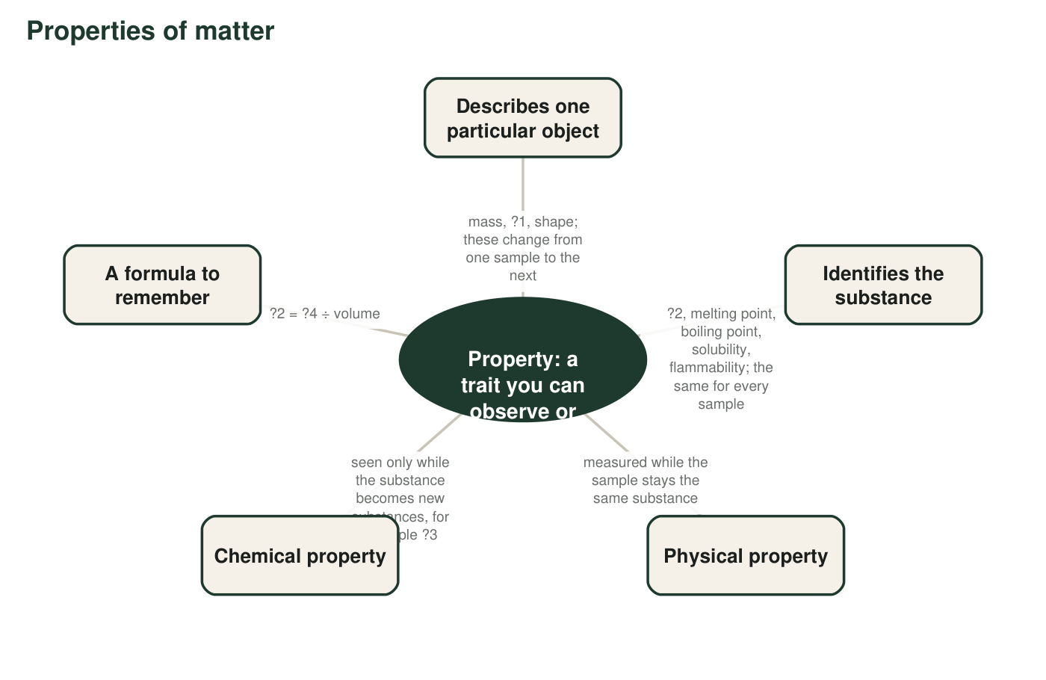
Four labels are missing and marked ?1 to ?4. Use the word bank to fill them in.
1. Write the missing labels: ?1 = ________ ?2 = ________ ?3 = ________ ?4 = ________
______________________________________________________________________________________
______________________________________________________________________________________
______________________________________________________________________________________
2. Melting point appears under 'Identifies the substance' and also counts as a physical property. Explain, using the word bank, why one property can belong to both branches.
______________________________________________________________________________________
______________________________________________________________________________________
______________________________________________________________________________________

Part B: Sort the descriptions, then pick the term
Each row below describes something about a sample. Decide whether the description describes this one object (write O) or could help identify the substance (write S). Then name the property with a word from the word bank (for example, mass, shape, density, solubility).
3. Complete the table.
O or S | Name of the property
a. The copper wire is 40 cm long.
b. Copper melts at about 1085 °C.
c. This block of ice has a mass of 300 g.
d. Ice floats on liquid water because it is less dense.
e. The candle is shaped like a star.
f. Candle wax does not dissolve in water.
g. The ethanol in the burner catches fire easily.
h. The sugar fills the whole 500 mL jar.

For each sentence, write the one word-bank term that fits the blank.
4. Oxygen gas is invisible, but a balloon full of it is still a ________ amount of oxygen molecules, large enough to measure.
______________________________________________________________________________________
______________________________________________________________________________________
______________________________________________________________________________________
5. Wood is cellulose, lignin and water mingled together, so wood is a ________, not a single substance.
______________________________________________________________________________________
______________________________________________________________________________________
______________________________________________________________________________________
6. A camper in a high mountain town finds that water boils at about 92 °C instead of 100 °C. The property that shifted with the lower air pressure is the ________.
______________________________________________________________________________________
______________________________________________________________________________________
______________________________________________________________________________________
7. A test that can only be done by letting the sample burn measures a ________ property.
______________________________________________________________________________________
______________________________________________________________________________________
______________________________________________________________________________________
8. Permanent-marker ink will not come off with water but wipes away with rubbing alcohol, because ________ always depends on both substances in the pair.
______________________________________________________________________________________
______________________________________________________________________________________
______________________________________________________________________________________
9. A cube of platinum that is exactly 1 cm on each side has a mass of about 21.5 g. The value 21.5 g/cm³ is platinum's ________.
______________________________________________________________________________________
______________________________________________________________________________________
______________________________________________________________________________________

Part C: Apply the terms
10. A jeweler has two plain rings of exactly the same size and shape. One has nearly twice the mass of the other. Gold has a density of about 19.3 g/cm³ and silver about 10.5 g/cm³. Which ring is gold? Use the terms volume and density in your answer.
______________________________________________________________________________________
______________________________________________________________________________________
______________________________________________________________________________________
11. A student says: 'Mass is a property, so I can use the mass of this bar to identify what metal it is.' Use two word-bank terms to explain what is wrong with this plan.
______________________________________________________________________________________
______________________________________________________________________________________
______________________________________________________________________________________
12. Is the air in this room a substance? Answer using the terms substance and mixture, and name two of the substances in air.
______________________________________________________________________________________
______________________________________________________________________________________
______________________________________________________________________________________
13. A large block of ice and a small ice cube are left on the same counter. Both begin to melt at the same temperature, but the block takes far longer to melt completely. Explain both facts using melting point and mass.
______________________________________________________________________________________
______________________________________________________________________________________
______________________________________________________________________________________
14. Scientists almost never say a substance is simply 'soluble.' They say 'soluble in water' or 'soluble in alcohol.' Using the definition of solubility, explain why the second substance must be named.
______________________________________________________________________________________
______________________________________________________________________________________
______________________________________________________________________________________

The size test
To decide O or S in Part B, imagine cutting the sample in half. If the description would change (half the mass, half the volume, a new shape), it describes this one object: write O. If the description would stay exactly the same for the half (same melting point, same density, dissolves the same way), it identifies the substance: write S.

Properties that bend
Boiling point is an identifying property, yet it changes with air pressure. Find out roughly how much lower water's boiling point is in Leadville, Colorado (about 3,100 m above sea level) than at sea level, then write a paragraph explaining how a property can still be useful for identifying a substance even though it depends on conditions. Say what a careful scientist writes next to a boiling point in a reference table.

