Angela's Tools · Chapter 3: Substances and Their Properties · Worksheet 4 of 10

Reading the Density Chart and Building an Identification Flowchart (Teacher answer key)
Learning target: I can read a density chart and an identification flowchart, use them to name an unknown metal, and build my own decision model for telling look-alike metals apart.
Diagrams and models · about 35 minutes · individual · Standards: MS-PS1-2 (practice)

Standards connections
MS-PS1-2 (practice): Students interpret density and melting-point values to identify substances and design the order of tests, which is the data-interpretation practice the PE requires. No chemical reaction is involved yet, so this is practice toward the PE, not evidence of it.

Answers with reasoning
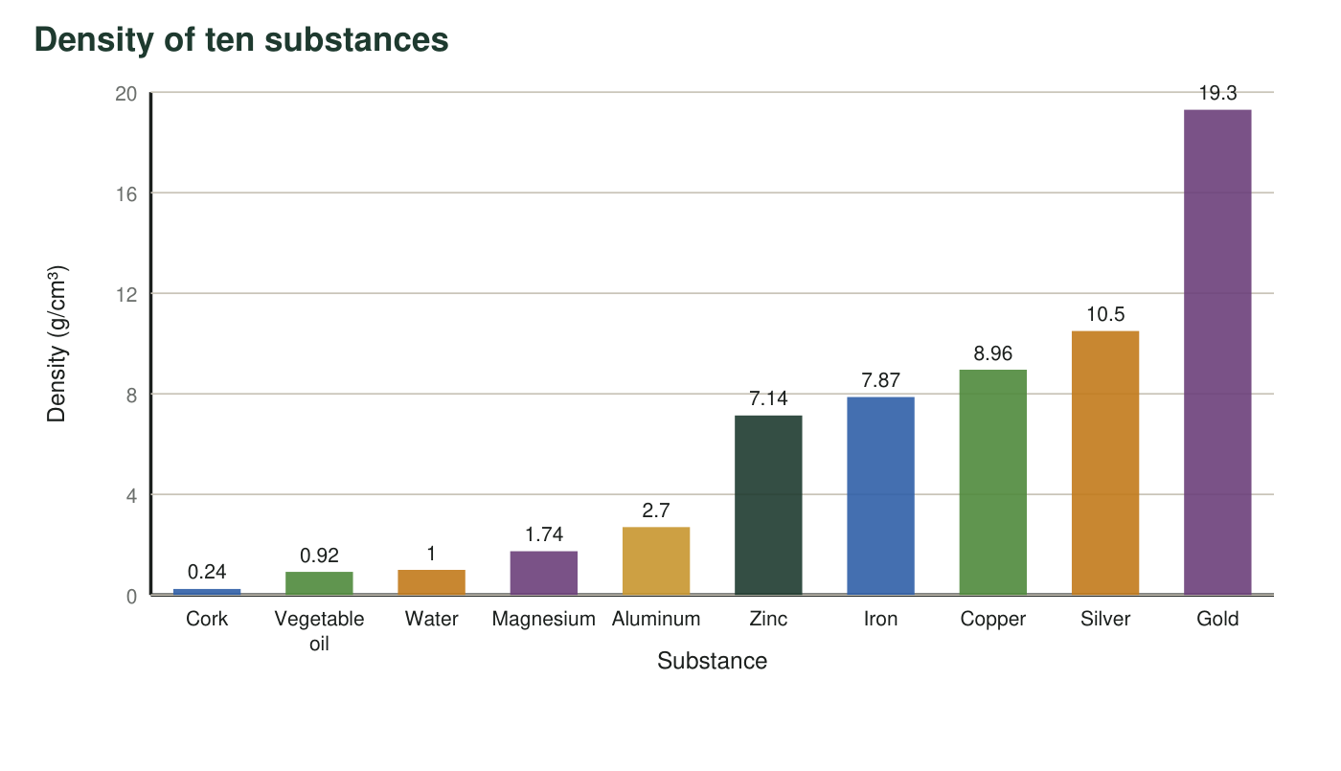
Figure 1. Real rounded densities of ten substances at room temperature. Keep one rule in mind: any substance whose bar is shorter than water's floats on water.
Reference table: eight metals (real rounded values at normal air pressure)
Metal | Color | Density (g/cm³) | Melting point (°C)
Magnesium | silvery gray | 1.74 | 650
Aluminum | silvery gray | 2.7 | 660
Zinc | bluish gray | 7.14 | 420
Iron | gray | 7.87 | 1538
Copper | orange-brown | 8.96 | 1085
Silver | bright silvery | 10.5 | 962
Lead | dull gray | 11.3 | 327
Gold | yellow | 19.3 | 1064

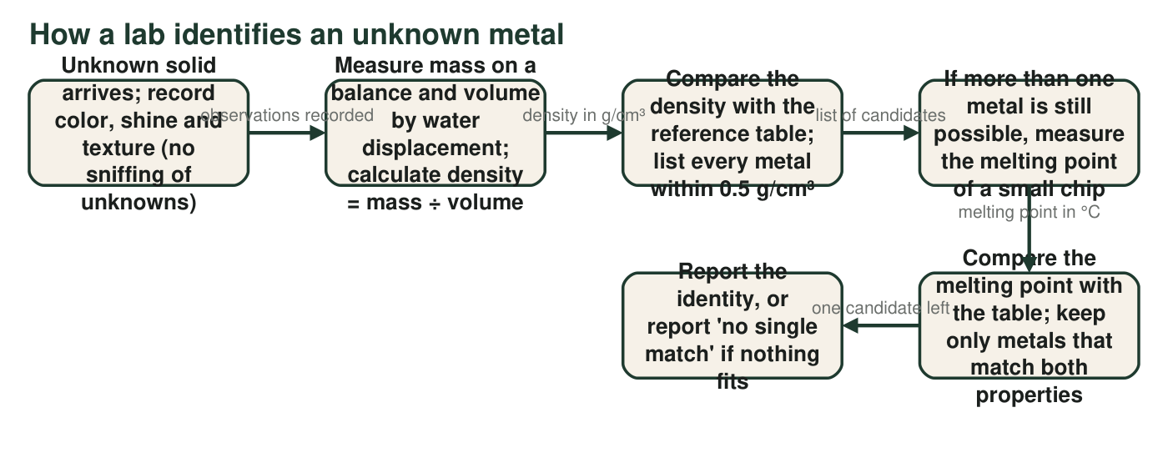
Figure 2. The sequence a materials lab follows for an unknown solid. Each arrow label tells you what result sends you forward.

Part A: Read the diagrams
1. From Figure 1, which substances would float on water? Which single substance in the chart would float on vegetable oil? Explain how you can tell from the bars.
Answer: Cork (0.24) and vegetable oil (0.92) float on water because their bars are shorter than water's (1.00). Only cork would float on vegetable oil, because cork is the only substance with a bar shorter than oil's.
Reasoning: A substance floats on a liquid when its density is lower than the liquid's; the bar heights show this directly.
Also acceptable: None.
Full credit must include:
• Names cork and oil as floaters on water
• Names cork as the only floater on oil
• Explains using bar height or density comparison
2. Imagine a cube of gold and a cube of aluminum, each exactly 1 cm on every side. Using Figure 1, find the mass of each cube and how many times more mass the gold cube has. Show your work.
Answer: A 1 cm cube has a volume of 1 cm³, so mass = density × 1 cm³. Gold cube: 19.3 g. Aluminum cube: 2.70 g. Ratio: 19.3 ÷ 2.70 = 7.1, so the gold cube has about 7 times the mass.
Reasoning: For a 1 cm³ sample the mass in grams equals the density in g/cm³; the ratio of masses equals the ratio of densities.
Also acceptable: Accept 7.1 or 'about 7 times'.
3. Which two metals in the reference table have the closest densities? Give the difference between them. Why would that pair be a problem for a student whose density measurements are only accurate to about 0.5 g/cm³?
Answer: Zinc (7.14) and iron (7.87); difference 7.87 − 7.14 = 0.73 g/cm³. If a measurement can be off by about 0.5 g/cm³, a zinc chip could read anywhere from about 6.6 to 7.6 and an iron chip from about 7.4 to 8.4; the ranges overlap, so a single density reading could not tell them apart.
Reasoning: Students must compare differences; the next-closest pairs are silver-lead (0.8) and magnesium-aluminum (0.96).
Also acceptable: A student who picks silver and lead (0.8) has misread; give partial credit if the error reasoning is sound.
Full credit must include:
• Correct pair
• Difference computed
• Explains the overlap with the measurement error
4. An unknown bluish-gray chip has a mass of 42.8 g and raises the water level in a graduated cylinder from 50.0 mL to 56.0 mL. Follow Figure 2: calculate its density and name every metal in the table within 0.5 g/cm³ of your result.
Answer: Volume = 56.0 mL − 50.0 mL = 6.0 mL = 6.0 cm³. Density = 42.8 g ÷ 6.0 cm³ = 7.13 g/cm³. Within 0.5 g/cm³: zinc (7.14, difference 0.01). Iron (7.87) is 0.74 away, outside the window, and every other metal is farther still. Candidate: zinc, which also matches the bluish-gray color.
Reasoning: Displacement volume is the difference of the two readings. 7.13 is within 0.01 of zinc and 0.74 from iron, so the 0.5 rule leaves one candidate. Note for the teacher: a student who still lists iron 'to be safe' is reasoning sensibly about measurement error; accept it if the arithmetic is right.
Also acceptable: Accept 7.1 g/cm³.
5. In Figure 2, when more than one metal is still possible, the flowchart sends you to measure a different property instead of measuring density again. Why?
Answer: B. Two substances can share nearly the same density, so a more careful density measurement still could not separate them; a second property can.
Reasoning: This is the lesson's central idea: several independent properties narrow the candidates in a way that repeating one property cannot.
Also acceptable: None.
6. A different unknown has a measured density of 10.8 g/cm³. Which metals in the table are within 0.5 g/cm³? Then say what melting point result would point to each one.
Answer: Silver (10.5, difference 0.3) and lead (11.3, difference 0.5) are within 0.5 g/cm³. A melting point near 962 °C points to silver; a melting point near 327 °C points to lead. The two values are so far apart that the melting-point test settles it easily.
Reasoning: Students apply the flowchart's candidate rule and then the second property.
Also acceptable: A student who excludes lead because 0.5 is 'on the edge' should say so explicitly; accept with that explanation.
Full credit must include:
• Both candidates named
• Correct melting point assigned to each
7. Figure 2 says to measure the melting point of a 'small chip,' not the whole sample. Give two reasons this is good practice. One reason must use the idea that melting point is an identifying property.
Answer: (1) Melting point is an identifying property, so a small chip melts at exactly the same temperature as the whole sample; nothing is gained by melting more. (2) A small chip needs much less energy and time to reach its melting point, is safer to handle when hot, and leaves most of the sample unchanged for other tests or for use.
Reasoning: The first reason is the required one; the second may be any practical reason (speed, safety, saving the sample).
Also acceptable: Accept 'so you still have the sample afterward' as the practical reason.
Full credit must include:
• Uses the identifying-property idea
• Gives one practical reason

Part B: Build your own decision model
A hardware store has a bin of unlabeled gray metal chips. The manager knows the chips are aluminum, zinc, iron or silver, one metal per chip. You have a balance, a graduated cylinder of water, and (with a teacher) a way to heat a chip and read its temperature. Design a flowchart that identifies any chip using at most two tests.
Draw your flowchart. Start with a box 'Unknown gray chip.' Your first test must be the density measurement. Draw a branch for each density range that leads to a different answer, and write the actual numbers from the reference table on the branches (for example, 'about 2.7 → aluminum'). Wherever density leaves two metals possible, add the melting-point test with the temperatures that decide between them. Every path must end in a box with one metal's name. Give your model a title.
Expected drawing: A complete model: 'Unknown gray chip' → 'Measure mass and volume; density = mass ÷ volume' → three branches: 'about 2 to 4 g/cm³ → aluminum (2.70)'; 'about 10 to 11 g/cm³ → silver (10.5)'; 'about 6.5 to 8.5 g/cm³ → zinc or iron' → 'Heat a small chip; read the temperature when it melts' → 'melts near 420 °C → zinc' or 'does not melt until about 1538 °C → iron'. Each path ends in one metal; the chart has a title.
Reasoning: Full credit requires density first, numeric ranges on the branches, the melting-point test only on the zinc-iron branch, and every path ending in exactly one metal. Ranges may vary as long as they do not overlap and contain the table values.
8. Which pair of metals in your flowchart needed the second test, and what two melting points separate them? If no pair needed it, explain why one test was enough.
Answer: Zinc and iron needed the second test: zinc melts at about 420 °C and iron at about 1538 °C. Aluminum (2.70) and silver (10.5) are far from every other candidate, so density alone identifies them.
Reasoning: Consistent with the model in the drawing key.
Also acceptable: If the student's chart separated zinc and iron by density alone, accept an explanation that says the two are only 0.73 apart and that this requires very accurate measurement.
Full credit must include:
• Names zinc and iron
• Gives both melting points
9. A chip comes out of your flowchart with a density of 8.5 g/cm³ and a melting point of about 930 °C. No metal in the table matches both. The manager suggests the chip is brass, a mixture of copper and zinc. Explain why a mixture could give results that match no single substance in the table.
Answer: A mixture does not have one fixed makeup, so its properties are not the properties of any single substance. Brass is mostly copper (8.96 g/cm³, 1085 °C) with some zinc (7.14 g/cm³, 420 °C); its density and melting temperature land in between, and they shift with the amount of zinc. The reference table lists pure substances only, so a mixture's results fall between entries and match none of them exactly.
Reasoning: Students connect the lesson's mixtures section to the identification method: a 'no single match' report is a clue that the sample may be a mixture.
Also acceptable: Accept 'brass is partly copper and partly zinc, so its numbers are in between' as the main idea.
Full credit must include:
• Says a mixture's properties are not those of one substance
• Says the values land between the components' values
• Connects to the table listing only pure substances

Teacher notes
All table values are real rounded references (densities in g/cm³ and melting points in °C at normal pressure): magnesium 1.74/650, aluminum 2.70/660, zinc 7.14/420, iron 7.87/1538, copper 8.96/1085, silver 10.5/962, lead 11.3/327, gold 19.3/1064; cork about 0.24 and vegetable oil about 0.92. The brass values in q9 (about 8.5 g/cm³, melting around 900 to 940 °C) are typical for common brass and vary with composition, which is the point. Figure 2 omits the acid 'solubility' tests the textbook describes for metals; a metal that disappears in acid is reacting, not dissolving, so this sheet keeps solubility for W8 where it is used with sugar and salt in water. The flowchart task is paper only; do not have students melt metals. If students ask why color is recorded but never used to decide, point to the three silvery-gray entries in the table.

