Angela's Tools · Chapter 3: Substances and Their Properties · Worksheet 4 of 10

Reading the Density Chart and Building an Identification Flowchart
Learning target: I can read a density chart and an identification flowchart, use them to name an unknown metal, and build my own decision model for telling look-alike metals apart.
Diagrams and models · about 35 minutes · individual · Standards: MS-PS1-2 (practice)
Name: ____________________________ Date: ____________ Period: ______

Directions
Study Figure 1 (the density chart) and the reference table before answering Part A. The table gives real rounded values. Then study Figure 2 (the flowchart a lab uses). Part B asks you to build your own flowchart as a model; use boxes for actions, diamonds or forks for decisions, and write the numbers that decide each branch. Show every calculation.
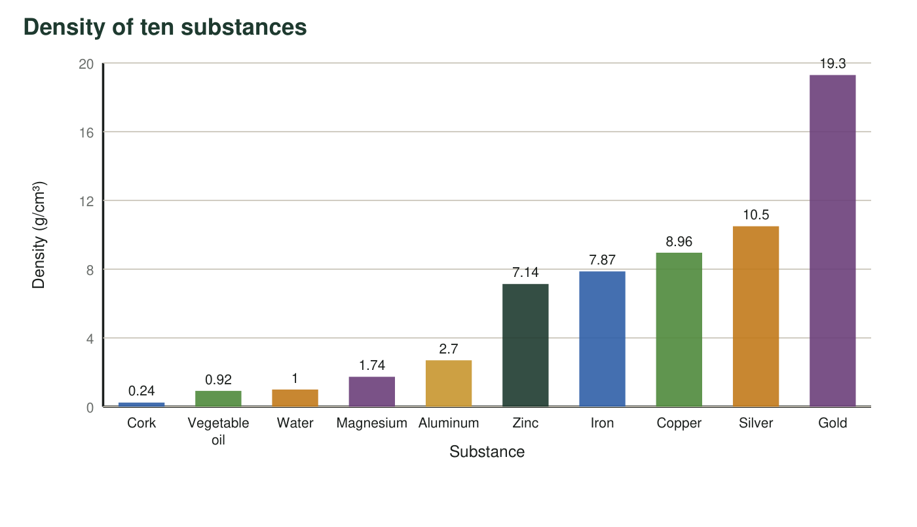
Figure 1. Real rounded densities of ten substances at room temperature. Keep one rule in mind: any substance whose bar is shorter than water's floats on water.
Reference table: eight metals (real rounded values at normal air pressure)
Metal | Color | Density (g/cm³) | Melting point (°C)
Magnesium | silvery gray | 1.74 | 650
Aluminum | silvery gray | 2.7 | 660
Zinc | bluish gray | 7.14 | 420
Iron | gray | 7.87 | 1538
Copper | orange-brown | 8.96 | 1085
Silver | bright silvery | 10.5 | 962
Lead | dull gray | 11.3 | 327
Gold | yellow | 19.3 | 1064

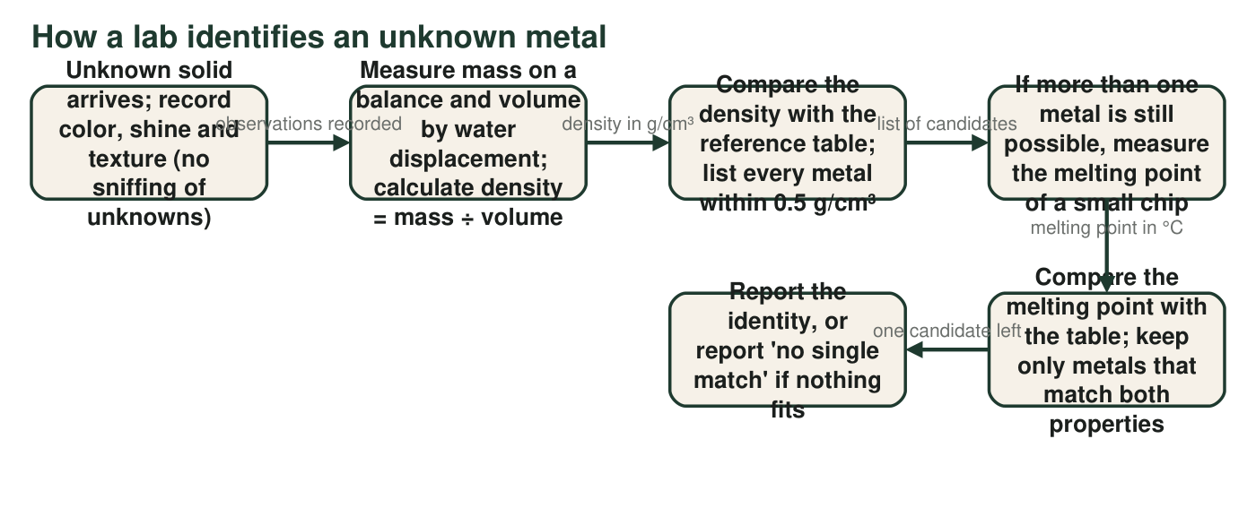
Figure 2. The sequence a materials lab follows for an unknown solid. Each arrow label tells you what result sends you forward.

Part A: Read the diagrams
1. From Figure 1, which substances would float on water? Which single substance in the chart would float on vegetable oil? Explain how you can tell from the bars.
______________________________________________________________________________________
______________________________________________________________________________________
2. Imagine a cube of gold and a cube of aluminum, each exactly 1 cm on every side. Using Figure 1, find the mass of each cube and how many times more mass the gold cube has. Show your work.
______________________________________________________________________________________
______________________________________________________________________________________
______________________________________________________________________________________
3. Which two metals in the reference table have the closest densities? Give the difference between them. Why would that pair be a problem for a student whose density measurements are only accurate to about 0.5 g/cm³?
______________________________________________________________________________________
______________________________________________________________________________________
______________________________________________________________________________________
4. An unknown bluish-gray chip has a mass of 42.8 g and raises the water level in a graduated cylinder from 50.0 mL to 56.0 mL. Follow Figure 2: calculate its density and name every metal in the table within 0.5 g/cm³ of your result.
______________________________________________________________________________________
______________________________________________________________________________________
______________________________________________________________________________________
5. In Figure 2, when more than one metal is still possible, the flowchart sends you to measure a different property instead of measuring density again. Why?
○ A. Measuring density twice is not allowed in a laboratory.
○ B. Two substances can share nearly the same density, so a more careful density measurement still could not separate them; a second property can.
○ C. Melting point is always easier to measure than density.
○ D. The reference table only lists melting points for some metals.
6. A different unknown has a measured density of 10.8 g/cm³. Which metals in the table are within 0.5 g/cm³? Then say what melting point result would point to each one.
______________________________________________________________________________________
______________________________________________________________________________________
______________________________________________________________________________________
7. Figure 2 says to measure the melting point of a 'small chip,' not the whole sample. Give two reasons this is good practice. One reason must use the idea that melting point is an identifying property.
______________________________________________________________________________________
______________________________________________________________________________________
______________________________________________________________________________________

Part B: Build your own decision model
A hardware store has a bin of unlabeled gray metal chips. The manager knows the chips are aluminum, zinc, iron or silver, one metal per chip. You have a balance, a graduated cylinder of water, and (with a teacher) a way to heat a chip and read its temperature. Design a flowchart that identifies any chip using at most two tests.
Draw your flowchart. Start with a box 'Unknown gray chip.' Your first test must be the density measurement. Draw a branch for each density range that leads to a different answer, and write the actual numbers from the reference table on the branches (for example, 'about 2.7 → aluminum'). Wherever density leaves two metals possible, add the melting-point test with the temperatures that decide between them. Every path must end in a box with one metal's name. Give your model a title.

8. Which pair of metals in your flowchart needed the second test, and what two melting points separate them? If no pair needed it, explain why one test was enough.
______________________________________________________________________________________
______________________________________________________________________________________
______________________________________________________________________________________
9. A chip comes out of your flowchart with a density of 8.5 g/cm³ and a melting point of about 930 °C. No metal in the table matches both. The manager suggests the chip is brass, a mixture of copper and zinc. Explain why a mixture could give results that match no single substance in the table.
______________________________________________________________________________________
______________________________________________________________________________________
______________________________________________________________________________________

Branch by gaps, not by exact numbers
When you draw the density branches, look at the gaps in the table. Aluminum (2.7) is far from everything else, so one branch can be 'between 2 and 4 → aluminum.' Zinc (7.14) and iron (7.87) are less than 1 apart, so give them one shared branch, 'between 6.5 and 8.5 → zinc or iron,' and let the melting point (420 °C or 1538 °C) finish the job. Silver (10.5) gets its own branch. Write the ranges on the arrows.

Add a cheaper test
Iron is attracted to a magnet; aluminum, zinc and silver are not. Redesign your flowchart so that it uses a magnet as the first test. Does the new chart need the melting-point test at all? Then write three sentences on the trade-off: a magnet test is fast and safe, but why is being 'attracted to a magnet' a weaker identifying property than density or melting point? (Hint: how many metals in the whole periodic table share it?)

