Angela's Tools · Chapter 4: Capturing the Sun's Energy · Worksheet 2 of 10

Matter Words, Energy Words: The Language of Producers (Teacher answer key)
Learning target: I can sort the vocabulary of photosynthesis into matter, energy and structures or processes, complete a concept map of inputs and outputs, and use the terms correctly in a new ecosystem.
Vocabulary in action · about 30 minutes · individual · Standards: MS-LS1-6 (supports)

Standards connections
MS-LS1-6 (supports): The PE asks students to trace matter and energy through photosynthesis. Keeping 'matter words' and 'energy words' apart, and knowing which terms name inputs, outputs and structures, is the vocabulary that makes that tracing possible.

Answers with reasoning
matter: Anything made of atoms, which means it has mass and takes up space. Air, water, sugar and a leaf are matter; light is not.
producer: An organism that builds its own food from simple substances in its surroundings, usually by capturing light energy. Plants, algae and cyanobacteria are producers.
phytoplankton: Tiny producers, mostly single-celled algae such as diatoms, that drift in the sunlit top layer of oceans and lakes.
photosynthesis: The process in which a producer uses light energy to rearrange carbon dioxide and water into sugar, releasing oxygen. The sugar holds the captured energy as chemical energy.
chloroplast: A small green structure inside the cells of plants and algae where photosynthesis takes place. A single leaf cell can hold dozens.
chlorophyll: The green pigment inside chloroplasts that absorbs light energy. It absorbs red and blue light strongly and green light weakly, so more green light leaves the leaf.
reactant: A substance that goes into a chemical reaction. In a chemical equation, reactants are written before the arrow.
product: A substance that a chemical reaction makes. Products are written after the arrow.
starch: A storage molecule built from many sugar units linked in a chain. Producers pack it into roots, seeds and fruits to use later.
cellulose: Long, tough chains of linked sugar units that form the stiff walls around plant cells. It is the largest single ingredient of wood, and cotton is nearly pure cellulose.
biomass: The total mass of living things, or of material that came from living things. Biomass holds matter and stored chemical energy.
biofuel: A fuel made from biomass, such as plant waste or used cooking oil. Burning it releases the chemical energy that producers stored.

Part A: Three kinds of words
Scientists are careful to keep three kinds of words apart. Some words name matter: substances made of atoms that have mass. Some name energy: not a substance, no atoms, no mass, but it can be transferred and stored. Some name a structure or process: a part of a cell, or something that happens. Put a check in one column for each item.
1. Check one column for each item. Then, below the table, explain in one sentence how you decided whether something was matter.
Answer: Matter: carbon dioxide, water, sugar, oxygen, chlorophyll, starch, cellulose, biomass. Energy: sunlight, chemical energy stored in sugar. Structure or process: chloroplast (structure), photosynthesis (process). Decision sentence: something is matter if it is made of atoms and has mass.
Reasoning: Chlorophyll is a molecule (a pigment), so it is matter even though it is also 'inside a structure'; this is the item most often misplaced. Sunlight is the item most often placed in matter. Biomass is matter by definition.
Also acceptable: Accept chlorophyll in the structure column only if the student explains it as 'part of the chloroplast'; then teach that a pigment is a substance.
2. Chlorophyll and chloroplast land in different columns. Explain why, in one or two sentences, without using the word 'green'.
Answer: Chlorophyll is a substance, a pigment molecule, so it is matter. A chloroplast is a part of a cell, a container that holds chlorophyll and the rest of the machinery, so it is a structure.
Reasoning: The distinction is substance versus cell part. Students may use an analogy such as 'paint versus the paint can'.
Also acceptable: Accept 'chlorophyll is inside the chloroplast' only if paired with the substance-versus-structure idea.
Full credit must include:
• Identifies chlorophyll as a substance or molecule
• Identifies chloroplast as a cell structure or part

Part B: Complete the concept map
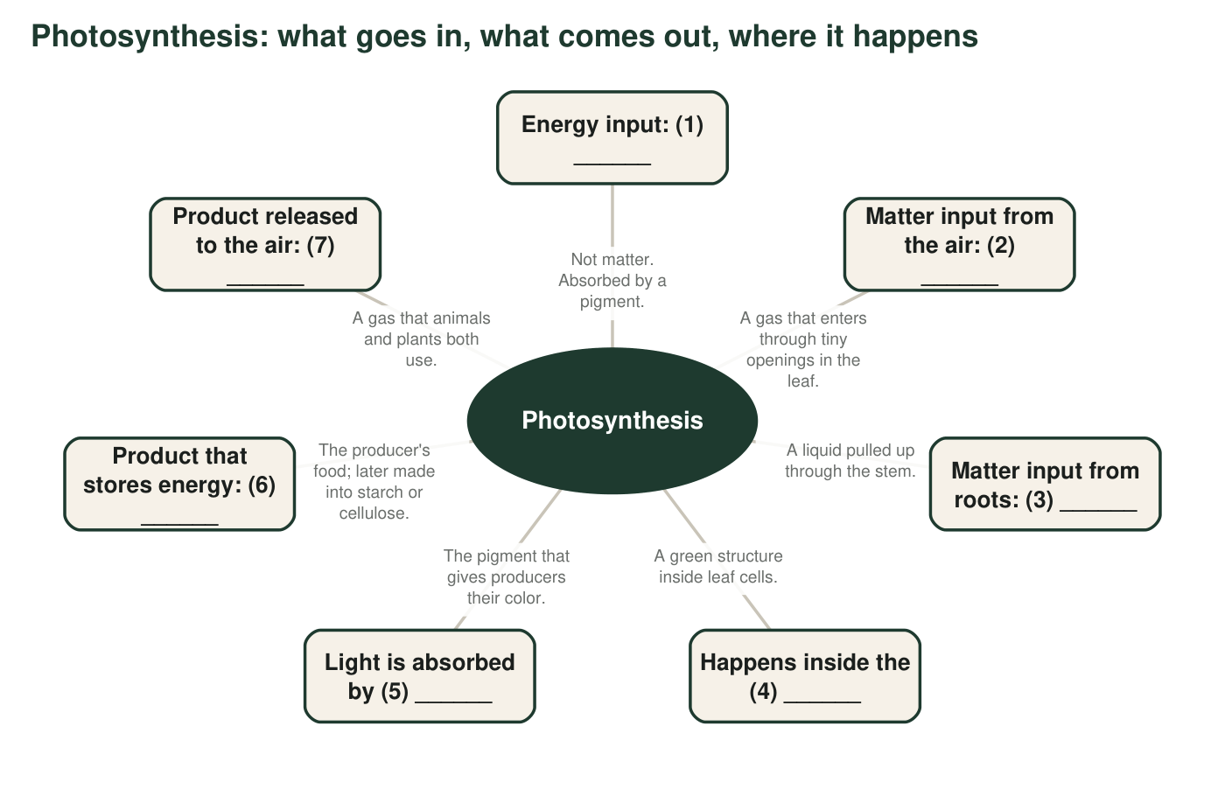
Each spoke has a blank. Fill the blanks in q3 using terms from the word bank or the names of substances.
3. Blanks: (1) ______ (2) ______ (3) ______ (4) ______ (5) ______ (6) ______ (7) ______
Answer: (1) light energy or sunlight; (2) carbon dioxide; (3) water; (4) chloroplast; (5) chlorophyll; (6) sugar (glucose); (7) oxygen.
Reasoning: The map separates the one energy input from the two matter inputs and names the two products and the structure and pigment.
Also acceptable: Accept 'sun' or 'light' for (1) and 'glucose' for (6).
4. Which blanks are reactants and which are products? Which blank is neither, and why?
Answer: Reactants: (2) carbon dioxide and (3) water. Products: (6) sugar and (7) oxygen. Blank (1), light energy, is neither: it is energy, not a substance, so it is not a reactant even though it is needed and is written on the left side of the equation. Blanks (4) and (5) name where and with what, not substances that change.
Reasoning: This checks the matter-versus-energy idea in the context of an equation. The main point is that light energy is written on the reactant side but is not a reactant.
Also acceptable: A student who lists chlorophyll as neither 'because it is not used up' has an accurate extra point.
Full credit must include:
• Names both reactants and both products
• States that light energy is not a reactant because it is not matter

Part C: Which term fits?
5. A diatom drifting in the sunlit surface water of Monterey Bay is a ______ (general term) and belongs to the group called ______.
Answer: producer; phytoplankton
Reasoning: A diatom is a single-celled alga that makes its own food, and drifting single-celled producers are phytoplankton.
Also acceptable: Accept 'algae' for the second blank only with 'phytoplankton' mentioned somewhere.
6. A celery stalk is stiff and stringy because its cell walls are built from ______. A carrot's thick root is sweet because the plant packs sugar and ______ into it as a reserve for later growth.
Answer: cellulose; starch
Reasoning: Cell walls are built from cellulose; roots store sugar and starch.
Also acceptable: None.
7. A truckload of grass cuttings and food scraps is ______. After it is processed into a liquid that can run an engine, it is a ______.
Answer: biomass; biofuel
Reasoning: Material that came from living things is biomass; once turned into a fuel it is a biofuel.
Also acceptable: None.
8. Read this sentence: 'A plant eats sunlight and water to make its food.' Rewrite it so that every word is used the way a scientist would, using at least three terms from the word bank.
Answer: Example: 'A plant is a producer: in its chloroplasts, chlorophyll absorbs light energy, which powers photosynthesis, a reaction that rearranges carbon dioxide and water into sugar and oxygen.' Plants do not 'eat' light; light is energy, not food.
Reasoning: Full credit requires replacing 'eats sunlight' with the idea that light is energy that is absorbed, and naming carbon dioxide as the missing matter input.
Also acceptable: Accept a two-sentence rewrite.
Full credit must include:
• Removes the idea that light is eaten or is food
• Includes carbon dioxide as a matter input
• Uses at least three word-bank terms correctly

Part D: Apply the words to a new place
9. A kelp forest off the California coast is made of giant kelp, a brown alga that grows from the sea floor to the surface. Sea urchins graze on it. Write 4 to 6 sentences explaining how the kelp captures energy and matter and how some of that energy and matter ends up in an urchin. Use at least five terms from the word bank and underline each one.
Answer: Model response: Giant kelp is a producer. Inside its cells, chloroplasts hold chlorophyll, which absorbs light energy from the sun filtering through the water. In photosynthesis, the kelp uses that energy to rearrange carbon dioxide dissolved in seawater and water into sugar, releasing oxygen into the water. The sugar is matter that holds chemical energy; the kelp uses some right away and builds some into the material of its blades, which is biomass. When an urchin grazes on a blade, the kelp's matter and stored energy become part of the urchin.
Reasoning: Look for the chain: light energy absorbed, carbon dioxide and water rearranged, sugar stores energy, biomass eaten by the urchin. Kelp takes carbon dioxide dissolved in seawater, not from the air, which is a good detail but not required.
Also acceptable: Accept 'reactants' and 'products' as two of the five terms if used correctly.
Full credit must include:
• Kelp identified as a producer that captures light energy
• Carbon dioxide and water named as matter inputs
• Sugar or biomass carries matter and energy to the urchin
• At least five terms used correctly and underlined
10. Is every producer a plant? Is every plant a producer? Answer both with an example. (Hint: think about what lives in the open ocean, and about a vine called dodder that has almost no chlorophyll and takes sugar from the plants it wraps around.)
Answer: Not every producer is a plant: phytoplankton such as diatoms, and cyanobacteria, are producers but not plants. Nearly every plant is a producer, but not all: dodder has almost no chlorophyll and takes sugar from the plants it wraps around, so it does not make its own food.
Reasoning: The producer category is defined by what an organism does, not by what group it belongs to. Dodder (Cuscuta) is a real parasitic plant with little or no chlorophyll.
Also acceptable: Accept 'algae' or 'kelp' as the non-plant producer; kelp is an alga, not a plant.
Full credit must include:
• No, with a non-plant producer named
• Mostly yes, with dodder as the exception

Teacher notes
The definitions in the word bank are deliberately more careful than the textbook's: chlorophyll absorbs green light weakly rather than not at all, cellulose is the largest single ingredient of wood rather than 'the bulk of plant bodies', and the energy captured in photosynthesis is described as stored chemical energy in the sugar rather than as energy 'in the bonds' (breaking bonds absorbs energy; energy is released when the sugar reacts with oxygen and new bonds form). Keep q1 open while students work and collect the class count for 'sunlight' and 'chlorophyll'; those two items reveal the matter-versus-energy and substance-versus-structure confusions that W7 revisits. Giant kelp is a brown alga, so it is a producer but not a plant, which makes q9 a quiet rehearsal for q10.

