Angela's Tools · Chapter 4: Capturing the Sun's Energy · Worksheet 2 of 10

Matter Words, Energy Words: The Language of Producers
Learning target: I can sort the vocabulary of photosynthesis into matter, energy and structures or processes, complete a concept map of inputs and outputs, and use the terms correctly in a new ecosystem.
Vocabulary in action · about 30 minutes · individual · Standards: MS-LS1-6 (supports)
Name: ____________________________ Date: ____________ Period: ______

Directions
Read the word bank first. In Part A, sort each item by what kind of thing it is, not by where it appears. In Part B, fill the blanks on the concept map. In Part C, choose the term that fits each sentence; a term may be used more than once or not at all. In Part D, write about a new ecosystem using the words the way a scientist would.
matter: Anything made of atoms, which means it has mass and takes up space. Air, water, sugar and a leaf are matter; light is not.
producer: An organism that builds its own food from simple substances in its surroundings, usually by capturing light energy. Plants, algae and cyanobacteria are producers.
phytoplankton: Tiny producers, mostly single-celled algae such as diatoms, that drift in the sunlit top layer of oceans and lakes.
photosynthesis: The process in which a producer uses light energy to rearrange carbon dioxide and water into sugar, releasing oxygen. The sugar holds the captured energy as chemical energy.
chloroplast: A small green structure inside the cells of plants and algae where photosynthesis takes place. A single leaf cell can hold dozens.
chlorophyll: The green pigment inside chloroplasts that absorbs light energy. It absorbs red and blue light strongly and green light weakly, so more green light leaves the leaf.
reactant: A substance that goes into a chemical reaction. In a chemical equation, reactants are written before the arrow.
product: A substance that a chemical reaction makes. Products are written after the arrow.
starch: A storage molecule built from many sugar units linked in a chain. Producers pack it into roots, seeds and fruits to use later.
cellulose: Long, tough chains of linked sugar units that form the stiff walls around plant cells. It is the largest single ingredient of wood, and cotton is nearly pure cellulose.
biomass: The total mass of living things, or of material that came from living things. Biomass holds matter and stored chemical energy.
biofuel: A fuel made from biomass, such as plant waste or used cooking oil. Burning it releases the chemical energy that producers stored.

Part A: Three kinds of words
Scientists are careful to keep three kinds of words apart. Some words name matter: substances made of atoms that have mass. Some name energy: not a substance, no atoms, no mass, but it can be transferred and stored. Some name a structure or process: a part of a cell, or something that happens. Put a check in one column for each item.
1. Check one column for each item. Then, below the table, explain in one sentence how you decided whether something was matter.
Matter (made of atoms) | Energy (not a substance) | Structure or process
sunlight
carbon dioxide
water
chloroplast
sugar
photosynthesis
oxygen
chemical energy stored in sugar
chlorophyll
starch
cellulose
biomass

2. Chlorophyll and chloroplast land in different columns. Explain why, in one or two sentences, without using the word 'green'.
______________________________________________________________________________________
______________________________________________________________________________________

Part B: Complete the concept map
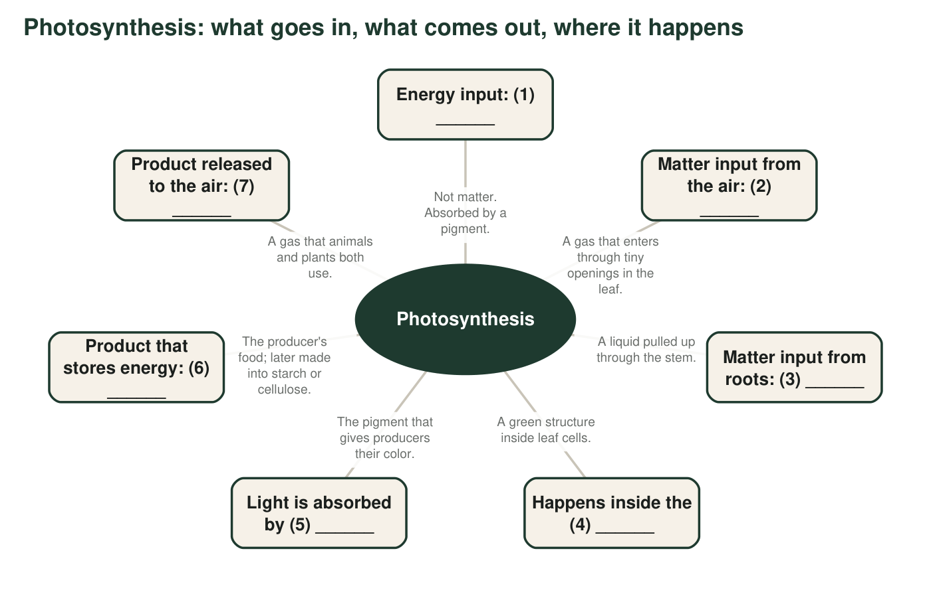
Each spoke has a blank. Fill the blanks in q3 using terms from the word bank or the names of substances.
3. Blanks: (1) ______ (2) ______ (3) ______ (4) ______ (5) ______ (6) ______ (7) ______
______________________________________________________________________________________
______________________________________________________________________________________
______________________________________________________________________________________
4. Which blanks are reactants and which are products? Which blank is neither, and why?
______________________________________________________________________________________
______________________________________________________________________________________

Part C: Which term fits?
5. A diatom drifting in the sunlit surface water of Monterey Bay is a ______ (general term) and belongs to the group called ______.
______________________________________________________________________________________
______________________________________________________________________________________
______________________________________________________________________________________
6. A celery stalk is stiff and stringy because its cell walls are built from ______. A carrot's thick root is sweet because the plant packs sugar and ______ into it as a reserve for later growth.
______________________________________________________________________________________
______________________________________________________________________________________
______________________________________________________________________________________
7. A truckload of grass cuttings and food scraps is ______. After it is processed into a liquid that can run an engine, it is a ______.
______________________________________________________________________________________
______________________________________________________________________________________
______________________________________________________________________________________
8. Read this sentence: 'A plant eats sunlight and water to make its food.' Rewrite it so that every word is used the way a scientist would, using at least three terms from the word bank.
______________________________________________________________________________________
______________________________________________________________________________________
______________________________________________________________________________________

Part D: Apply the words to a new place
9. A kelp forest off the California coast is made of giant kelp, a brown alga that grows from the sea floor to the surface. Sea urchins graze on it. Write 4 to 6 sentences explaining how the kelp captures energy and matter and how some of that energy and matter ends up in an urchin. Use at least five terms from the word bank and underline each one.
______________________________________________________________________________________
______________________________________________________________________________________
______________________________________________________________________________________
______________________________________________________________________________________
______________________________________________________________________________________
______________________________________________________________________________________
______________________________________________________________________________________
10. Is every producer a plant? Is every plant a producer? Answer both with an example. (Hint: think about what lives in the open ocean, and about a vine called dodder that has almost no chlorophyll and takes sugar from the plants it wraps around.)
______________________________________________________________________________________
______________________________________________________________________________________
______________________________________________________________________________________

The atom test
When you are not sure whether a word names matter, ask: 'Could I count the atoms in it?' Carbon dioxide is made of carbon and oxygen atoms, so it is matter. Sunlight has no atoms, so it is energy. A chloroplast is made of atoms, but the word names a part of a cell, not a substance, so it goes in the structure column. Photosynthesis is something that happens, so it is a process.

Write the definitions the other way
Pick four terms from the word bank and write a 'reverse definition' for each: a one-sentence description of a situation in which the term is clearly the wrong word to use, and why. Example for 'producer': 'A mushroom growing on a log is not a producer, because it gets its matter and energy by breaking down the wood rather than capturing light.' Your four examples must be your own.

