Angela's Tools · Chapter 4: Capturing the Sun's Energy · Worksheet 4 of 10

Reading the Leaf: Inputs, Outputs and a Balanced Equation (Teacher answer key)
Learning target: I can read a model of a leaf to tell matter inputs and outputs apart from the energy input, check that atoms are conserved in the photosynthesis equation, and build my own model that traces matter and energy from the sun to a consumer.
Diagrams and models · about 35 minutes · individual · Standards: MS-LS1-6 (practice), MS-LS2-3 (supports)

Standards connections
MS-LS1-6 (practice): Tracing the movement of matter and the flow of energy through a leaf, and counting atoms across the equation, is the core reasoning of this PE. The equation is used only to track atoms and energy, not to describe the biochemical mechanism, which the assessment boundary excludes.
MS-LS2-3 (supports): The drawing extends the leaf model to a consumer, a first step toward modeling matter cycling and energy flow among living and nonliving parts of an ecosystem.

Answers with reasoning
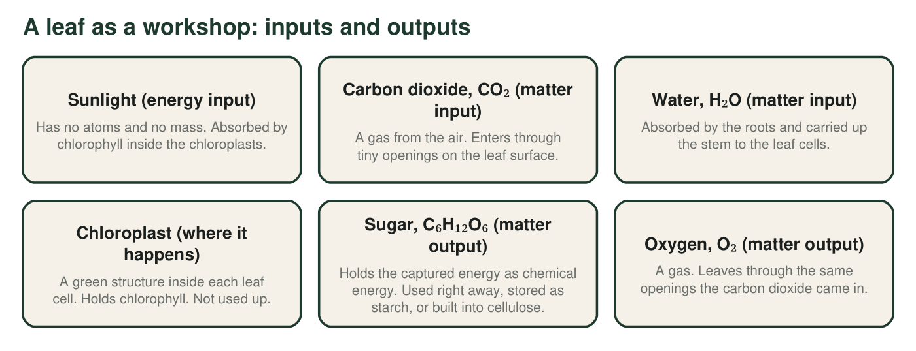
Figure 1. Everything that enters or leaves a leaf during photosynthesis. Three things go in; two things come out. One of the inputs is not matter.
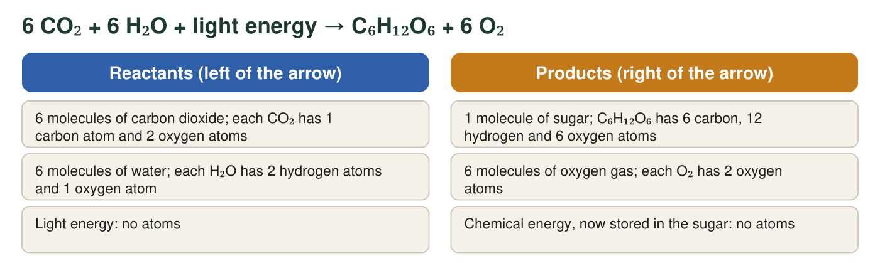
Figure 2. The same reaction written as a chemical equation. Each molecule's atoms are listed so you can count them. Light energy appears on the left because the reaction cannot happen without it, but it is not a molecule.

Part A: Read the model
1. In Figure 1, which inputs are matter and which input is energy? How can you tell from the descriptions?
Answer: Matter inputs: carbon dioxide and water. Energy input: sunlight. The descriptions say sunlight 'has no atoms and no mass,' while the other two are a gas and a liquid made of molecules.
Reasoning: The atoms-and-mass test is the way to tell matter from energy.
Also acceptable: Accept 'light' for sunlight.
Full credit must include:
• Names both matter inputs
• Names sunlight as the energy input
• Uses the no-atoms or no-mass clue
2. Trace the path of one carbon atom. Where is it before photosynthesis, how does it reach the chloroplast, and in which molecule does it end up?
Answer: Before photosynthesis the carbon atom is in a carbon dioxide molecule in the air. It enters the leaf through a tiny opening in the surface and reaches a chloroplast inside a leaf cell. After the reaction it is one of the six carbon atoms in a sugar molecule.
Reasoning: Students should follow a single atom through the three stages: air, leaf opening to chloroplast, sugar.
Also acceptable: Accept 'glucose' for sugar.
Full credit must include:
• Starts in CO₂ in the air
• Enters through a leaf opening to a chloroplast
• Ends in sugar
3. Use Figure 2 to count every atom of each kind on each side of the arrow. Show one multiplication below the table (for example, 6 molecules × 2 oxygen atoms = 12 oxygen atoms).
Answer: Carbon: reactants 6 × 1 = 6; products 6; yes. Hydrogen: reactants 6 × 2 = 12; products 12; yes. Oxygen: reactants (6 × 2) + (6 × 1) = 12 + 6 = 18; products 6 + (6 × 2) = 6 + 12 = 18; yes.
Reasoning: All three rows balance. The oxygen row requires adding two sources on each side and is where most errors occur.
Also acceptable: Accept the multiplications shown in any order.
4. A leaf makes 10 sugar molecules. How many carbon dioxide molecules did it use, and how many oxygen molecules did it release? Show the calculation.
Answer: Carbon dioxide: 10 sugar molecules × 6 CO₂ per sugar = 60 CO₂ molecules. Oxygen: 10 × 6 O₂ per sugar = 60 O₂ molecules.
Reasoning: The equation's ratios scale: one sugar needs six carbon dioxide and releases six oxygen.
Also acceptable: None; both numbers are 60.
5. What happens to the light energy that chlorophyll absorbs?
Answer: C. It ends up stored as chemical energy in the sugar, and is released later when the sugar reacts with oxygen.
Reasoning: Energy is not matter (A is wrong), is not destroyed (B is wrong), and is not released with the oxygen (D is wrong). The release happens when the sugar is used, in the plant's own cells or in an animal that eats it.
Also acceptable: None.
6. A student rewrites the equation as 6 CO₂ + 6 H₂O + light → C₆H₁₂O₆ + 3 O₂, arguing that 'the sugar used up some of the oxygen.' Use your atom count from q3 to explain why this version is impossible.
Answer: The reactant side has 18 oxygen atoms. With 3 O₂ the product side would have 6 (in sugar) + 3 × 2 = 12 oxygen atoms. Six oxygen atoms would have vanished, and atoms are never created or destroyed in a chemical reaction. Only 6 O₂ gives 6 + 12 = 18.
Reasoning: This is conservation of atoms applied to the student's own count. The student's 'used up' idea confuses rearranging atoms with destroying them.
Also acceptable: Accept 'the sugar does not use up oxygen; it just has 6 oxygen atoms in it, and the other 12 must come out as 6 O₂.'
Full credit must include:
• Compares 18 reactant oxygen atoms with 12 product oxygen atoms
• States that atoms cannot disappear
7. Figure 1 says the chloroplast is 'not used up.' Why is it in the diagram at all if it is not a reactant or a product?
Answer: The chloroplast is the place where the reaction happens and holds the chlorophyll that absorbs the light. It is like the workshop, not the materials: without it there is no reaction, but it is still there when the reaction is over.
Reasoning: Students should distinguish the site and the pigment from the substances that change.
Also acceptable: An analogy such as an oven or a kitchen is acceptable.
Full credit must include:
• Chloroplast identified as the site of the reaction or the holder of chlorophyll
• States it is not consumed

Part B: Build your own model
Draw a whole plant (roots, stem, leaves) with the sun above it and one animal that eats the plant beside it. Use solid arrows for matter and dashed arrows for energy. Show: (1) sunlight reaching a leaf; (2) carbon dioxide entering and oxygen leaving the leaf; (3) water moving from the roots to the leaf; (4) sugar moving from the leaf to one storage place such as a root or fruit; (5) matter and energy passing to the animal when it eats. Label every arrow with what it carries. Give your model a title.
Expected drawing: A complete model shows: a dashed arrow from the sun to a leaf labeled 'light energy'; a solid arrow into the leaf labeled 'carbon dioxide' and a solid arrow out labeled 'oxygen'; a solid arrow from roots up the stem to the leaf labeled 'water'; a solid arrow from the leaf to a root or fruit labeled 'sugar (stored as starch)'; and, from the plant to the animal, a solid arrow labeled 'matter (sugar, starch, cellulose)' plus a dashed arrow labeled 'chemical energy'. A title such as 'Matter and energy through a plant.'
Reasoning: The decisive features are the solid-versus-dashed distinction used correctly and the two separate arrows to the animal, which show that eating transfers both matter and energy. A common error is a dashed arrow for sugar or a solid arrow for sunlight.
8. Count the arrows in your model. How many solid (matter) arrows and how many dashed (energy) arrows did you draw? Which arrow was hardest to decide, and why?
Answer: Counts will vary; a model meeting the prompt has at least five solid arrows (CO₂ in, O₂ out, water, sugar to storage, matter to the animal) and at least two dashed arrows (sunlight to leaf, energy to the animal). The hardest arrow is usually the one to the animal, because eating carries both matter and energy, so it needs two arrows.
Reasoning: The purpose is to make students notice that sugar carries both matter and stored energy, which is why one arrow is not enough at the eating step.
Also acceptable: A student who says the sugar arrow was hardest 'because sugar holds energy too' has the key idea.
Full credit must include:
• Gives both counts
• Names a hard arrow with a reason connected to matter versus energy
9. Every model leaves things out. Name one thing that really happens in a plant that your model does not show, and one thing your model might make someone believe that is not true.
Answer: Not shown, for example: the plant also uses some of its sugar for energy day and night and releases carbon dioxide; the water that evaporates from leaves; the minerals from soil; the fact that a single leaf has millions of chloroplasts. Might mislead, for example: arrows can suggest sunlight is a substance that flows in like water, or that the sugar travels only to the root, or that the animal gets energy directly from the sun.
Reasoning: Any accurate omission and any plausible misreading earns credit. This item sets up the model-limits discussion in the chapter.
Also acceptable: Accept 'it does not show the reaction happening inside cells' as the omission.
Full credit must include:
• One real process the model omits
• One possible false impression the model could give

Teacher notes
Figure 2 is the balanced equation 6 CO₂ + 6 H₂O + light energy → C₆H₁₂O₆ + 6 O₂, with 6 carbon, 12 hydrogen and 18 oxygen atoms on each side. The worksheet uses the equation only to count atoms and track energy; do not extend it to where the oxygen atoms in O₂ come from or to the light and dark stages, which are beyond the assessment boundary. Two wording choices are deliberate: energy is 'stored as chemical energy in the sugar' and 'released when the sugar reacts with oxygen,' never 'released when bonds break'; and the chloroplast is a site, not a reactant. The extension gives 6 × 44 + 6 × 18 = 264 + 108 = 372 units on the left and 180 + 6 × 32 = 180 + 192 = 372 units on the right; equal totals show matter is conserved, and the light energy has no mass so it cannot appear in either sum.

