Angela's Tools · Chapter 4: Capturing the Sun's Energy · Worksheet 4 of 10

Reading the Leaf: Inputs, Outputs and a Balanced Equation
Learning target: I can read a model of a leaf to tell matter inputs and outputs apart from the energy input, check that atoms are conserved in the photosynthesis equation, and build my own model that traces matter and energy from the sun to a consumer.
Diagrams and models · about 35 minutes · individual · Standards: MS-LS1-6 (practice), MS-LS2-3 (supports)
Name: ____________________________ Date: ____________ Period: ______

Directions
Study Figure 1 and Figure 2 before you write anything. Figure 1 shows where things enter and leave a leaf. Figure 2 shows the same reaction as a chemical equation, with the molecules counted. Answer Part A from the figures. In Part B, draw your own model; a model is a drawing that explains, so every arrow needs a label.
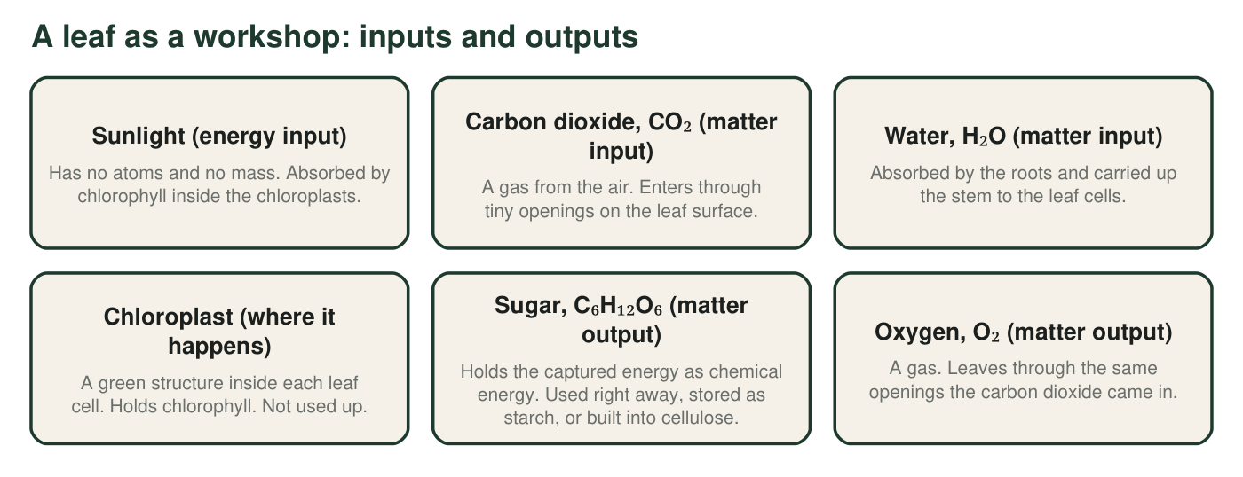
Figure 1. Everything that enters or leaves a leaf during photosynthesis. Three things go in; two things come out. One of the inputs is not matter.
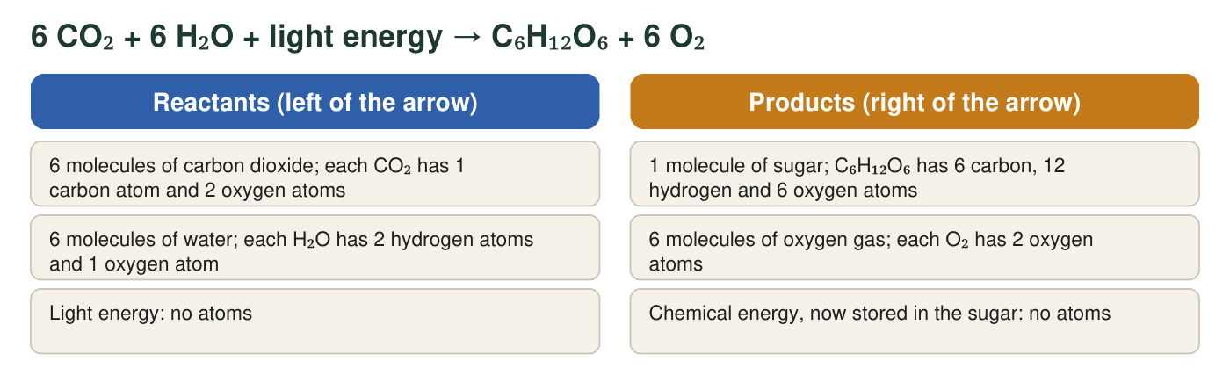
Figure 2. The same reaction written as a chemical equation. Each molecule's atoms are listed so you can count them. Light energy appears on the left because the reaction cannot happen without it, but it is not a molecule.

Part A: Read the model
1. In Figure 1, which inputs are matter and which input is energy? How can you tell from the descriptions?
______________________________________________________________________________________
______________________________________________________________________________________
______________________________________________________________________________________
2. Trace the path of one carbon atom. Where is it before photosynthesis, how does it reach the chloroplast, and in which molecule does it end up?
______________________________________________________________________________________
______________________________________________________________________________________
______________________________________________________________________________________
3. Use Figure 2 to count every atom of each kind on each side of the arrow. Show one multiplication below the table (for example, 6 molecules × 2 oxygen atoms = 12 oxygen atoms).
Atoms on the reactant side | Atoms on the product side | Balanced? (yes/no)
Carbon (C)
Hydrogen (H)
Oxygen (O)

4. A leaf makes 10 sugar molecules. How many carbon dioxide molecules did it use, and how many oxygen molecules did it release? Show the calculation.
______________________________________________________________________________________
______________________________________________________________________________________
______________________________________________________________________________________
5. What happens to the light energy that chlorophyll absorbs?
○ A. It becomes part of the sugar's atoms, adding to the sugar's mass.
○ B. It is used up and disappears once the reaction is over.
○ C. It ends up stored as chemical energy in the sugar, and is released later when the sugar reacts with oxygen.
○ D. It is released right away as the oxygen leaves the leaf.
6. A student rewrites the equation as 6 CO₂ + 6 H₂O + light → C₆H₁₂O₆ + 3 O₂, arguing that 'the sugar used up some of the oxygen.' Use your atom count from q3 to explain why this version is impossible.
______________________________________________________________________________________
______________________________________________________________________________________
______________________________________________________________________________________
7. Figure 1 says the chloroplast is 'not used up.' Why is it in the diagram at all if it is not a reactant or a product?
______________________________________________________________________________________
______________________________________________________________________________________
______________________________________________________________________________________

Part B: Build your own model
Draw a whole plant (roots, stem, leaves) with the sun above it and one animal that eats the plant beside it. Use solid arrows for matter and dashed arrows for energy. Show: (1) sunlight reaching a leaf; (2) carbon dioxide entering and oxygen leaving the leaf; (3) water moving from the roots to the leaf; (4) sugar moving from the leaf to one storage place such as a root or fruit; (5) matter and energy passing to the animal when it eats. Label every arrow with what it carries. Give your model a title.

8. Count the arrows in your model. How many solid (matter) arrows and how many dashed (energy) arrows did you draw? Which arrow was hardest to decide, and why?
______________________________________________________________________________________
______________________________________________________________________________________
______________________________________________________________________________________
9. Every model leaves things out. Name one thing that really happens in a plant that your model does not show, and one thing your model might make someone believe that is not true.
______________________________________________________________________________________
______________________________________________________________________________________
______________________________________________________________________________________

Count by column
For q3, make three columns on scrap paper: C, H, O. Go molecule by molecule. For 6 CO₂ write '6 C' under C and '6 × 2 = 12 O' under O. For 6 H₂O write '6 × 2 = 12 H' under H and '6 O' under O. Then add the O column: 12 + 6 = 18. Do the same for the product side and compare. If the two sides do not match, you have found a counting slip, not a broken law.

Mass in, mass out
The approximate masses of the molecules in Figure 2 are: CO₂ 44 units, H₂O 18 units, C₆H₁₂O₆ 180 units, O₂ 32 units. Compute the total mass on the reactant side (6 × 44 + 6 × 18) and on the product side (180 + 6 × 32). Explain what the comparison shows about matter in photosynthesis, and why the light energy does not appear in either total.

