Angela's Tools · Chapter 5: Using Stored Energy · Worksheet 1 of 10

Warm Seeds in a Dark Flask: Where Did the Energy Come From? (Teacher answer key)
Learning target: I can observe a living system in the dark, record what changes in temperature and gases, and write a first explanation for where the energy and the gases came from.
Phenomenon exploration · about 25 minutes · individual · Standards: MS-LS1-7 (supports), MS-LS1-6 (supports)

Standards connections
MS-LS1-7 (supports): Sprouting seeds in a dark, sealed flask warm up, use oxygen and give off carbon dioxide. Noticing this sets up the question the PE answers: how food is rearranged inside an organism to release energy. No model is built yet; this sheet activates the question.
MS-LS1-6 (supports): The flask is kept dark on purpose, so students must rule out photosynthesis from the last lesson and look for a different process that works without light.

Answers with reasoning

The setup
Mr. Okafor soaked two batches of 100 g of dried bean seeds overnight. He boiled one batch for ten minutes to kill the seeds, then let it cool and rinsed it with a mild antiseptic so mold could not grow. He put each batch into its own insulated vacuum flask (the kind that keeps soup hot) and fitted a stopper carrying a thermometer and a small gas sensor. The stopper had a pinhole vent so that pressure could not build up and a little fresh air could creep in. He placed both flasks inside a closed cabinet with no light. He did not open the cabinet for two days. The figure shows what the instruments read at the start and at the end.
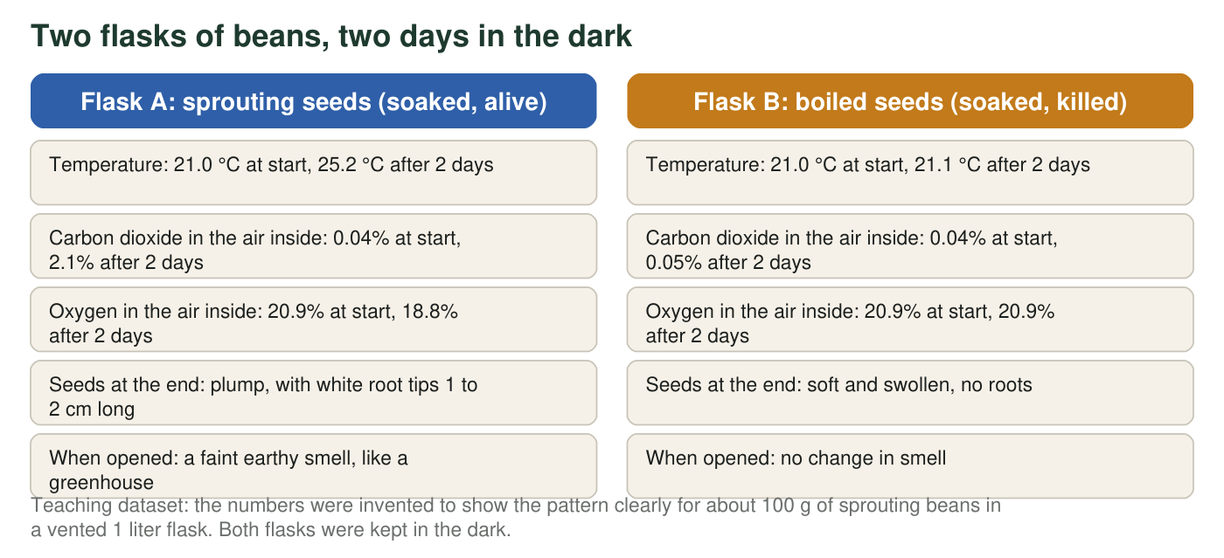

Part A: Notice and wonder
1. List three things that changed in Flask A but did not change (or barely changed) in Flask B. Use the numbers from the figure in each one.
Answer: Any three, with numbers: the temperature rose 4.2 °C in A (21.0 to 25.2) but only 0.1 °C in B; carbon dioxide rose from 0.04% to 2.1% in A but only to 0.05% in B; oxygen fell from 20.9% to 18.8% in A but stayed at 20.9% in B; A's seeds grew 1 to 2 cm root tips while B's grew none; A developed an earthy smell and B did not.
Reasoning: The point is to notice that every change is tied to the seeds being alive; the boiled flask is the comparison.
Also acceptable: Accept the smell and the roots as observations even though they have no number, as long as at least one difference uses the numbers.
Full credit must include:
• Three distinct differences
• Each uses a number or a specific observation from the figure
• Each names both flasks
2. Calculate the temperature change in each flask. Then calculate how many percentage points the carbon dioxide rose in Flask A and how many points the oxygen fell. Show the subtraction for each.
Answer: Flask A: 25.2 °C − 21.0 °C = 4.2 °C warmer. Flask B: 21.1 °C − 21.0 °C = 0.1 °C warmer. Carbon dioxide in A: 2.1% − 0.04% = 2.06 percentage points higher (about 2.1). Oxygen in A: 20.9% − 18.8% = 2.1 percentage points lower.
Reasoning: The carbon dioxide rise and the oxygen drop are almost exactly equal (about 2.1 points each). Students may notice this on their own; it is the first hint that one gas is being traded for the other. Rounding 2.06 to 2.1 is fine.
Also acceptable: Accept 2.1 for the carbon dioxide change if the student rounded 0.04 to 0.
3. Write two questions this setup makes you wonder about. At least one should begin with 'What would happen if...'
Answer: Any two genuine questions, for example: What would happen if the flask had been kept in the light? What would happen if we pumped the oxygen out first? Does the warmth stop when the seeds run out of food? Would the gases change the same way with a mouse or a mushroom in the flask? Does the warming slow down if the flask is kept cold?
Reasoning: Questions should be answerable by observation or experiment. Look for at least one 'what would happen if' question that changes a variable.
Also acceptable: A question about why the seeds smell earthy is acceptable as the second question.
Full credit must include:
• Two questions
• At least one changes a condition of the setup

Part B: What do you already think?
4. The inside of Flask A got warmer, but the cabinet, the flask and the air around it stayed at 21 °C. Which is the most reasonable first guess about where the extra thermal energy came from?
Answer: B. The living seeds released energy that was stored in the food inside them.
Reasoning: The cabinet was dark (rules out A), both flasks were at 21 °C at the start and B stayed there (rules out C), and the gas readings changed too, which a broken thermometer would not explain (rules out D). Students do not need to know the name of the process yet.
Also acceptable: None; a student who picks A should be asked how light could enter a closed cabinet.
5. In the last lesson you learned how producers capture energy. Name that process and explain why it cannot be what is happening in Flask A.
Answer: Photosynthesis. It needs light to capture energy and build sugar from carbon dioxide and water, and it gives off oxygen. The cabinet was dark, and the gas changes are the reverse of photosynthesis (oxygen fell, carbon dioxide rose), so photosynthesis cannot be what is happening.
Reasoning: Both the missing light and the reversed gas pattern are good evidence. Either one earns credit; both is a strong answer.
Also acceptable: Accept 'seeds have no green leaves yet' as an additional supporting reason, but the main reason should be the dark.
Full credit must include:
• Names photosynthesis
• Gives at least one reason: no light, or the gases moved the opposite way
6. One gas went down and one gas went up in Flask A. Name a living thing you already know that makes the same two gas changes, and say how it does it.
Answer: Animals, including people: when we breathe we take in oxygen and breathe out carbon dioxide. A person, a mouse, a fish with gills, or a dog are all good examples. The student should say the animal takes oxygen in and gives carbon dioxide out.
Reasoning: This is the prior-knowledge bridge. The surprise students should carry into the lesson is that seeds, which are plant parts, show the same gas pattern as a breathing animal.
Also acceptable: A student who writes 'a candle burning' is making a strong and scientifically useful comparison; accept it and note that the lesson will connect burning and respiration.
Full credit must include:
• Names an animal or people
• States oxygen in, carbon dioxide out

Part C: Your first explanation
7. Write a first explanation for Flask A that answers all three of these: Where did the thermal energy come from? Where did the extra carbon dioxide come from? Where did the missing oxygen go? Use the phrase 'stored in' at least once. It is fine to be unsure; say what you are unsure about.
Answer: Model response: The seeds are alive and growing roots, so they are doing something that uses energy. The thermal energy came from energy stored in the food inside the seeds (the seed's stored starch and sugar), which the seeds released while they were growing. The carbon dioxide came from the seeds; the food is being broken down and part of it leaves as carbon dioxide gas. The oxygen was taken in by the seeds and used in that breakdown, the way an animal uses the oxygen it breathes. I am not sure how the seeds take in oxygen without lungs, or whether the warmth would stop if the oxygen ran out.
Reasoning: Students have not studied cellular respiration yet, so grade for a coherent first explanation that uses the evidence, not for the correct name. A full-credit answer addresses all three questions and locates the energy source inside the seeds rather than outside the flask.
Also acceptable: A student who writes that the seeds 'burned' their food slowly, or that the seeds 'breathe,' is reasoning well. A student who says the energy came from the water the seeds soaked in has an idea to revisit in W6 and W7.
Full credit must include:
• Energy source placed inside the seeds (stored in food)
• Carbon dioxide explained as coming from the seeds
• Oxygen explained as used or taken in by the seeds
• Uses 'stored in'
• Names something the student is unsure about
8. Mr. Okafor dried both batches of seeds completely at the end and weighed them. Predict which batch had lost more dry mass and explain your prediction in one or two sentences.
Answer: Flask A (the sprouting seeds) lost more dry mass. Some of the seeds' stored food left as carbon dioxide gas (and water), so the solid matter that remained weighed less. The boiled seeds did not use their food, so their dry mass stayed about the same.
Reasoning: This prediction foreshadows conservation of matter: the mass that 'disappeared' from the seeds became gas. Many students predict the opposite because the sprouts are bigger; accept that prediction only with a reason, and use it in discussion.
Also acceptable: A student who predicts Flask A gained mass 'because it grew' has made a reasonable but incorrect prediction; give partial credit for a stated reason and flag it for the lesson.
Full credit must include:
• Picks Flask A
• Connects the lost mass to the gas that was given off
9. Describe one follow-up experiment that would test part of your explanation. Say what you would change, what you would keep the same, and what you would measure.
Answer: Any sensible test, for example: repeat Flask A with the oxygen replaced by nitrogen (change: no oxygen; keep: same seeds, same dark, same flask; measure: temperature and carbon dioxide). Or: repeat Flask A under a lamp (change: light; measure: whether carbon dioxide still rises). Or: put a mouse-sized consumer such as a few mealworms in a flask (change: organism; measure: the same readings) to see if the pattern is the same.
Reasoning: Look for one changed variable, at least one held constant, and a measurement that connects to the explanation in q7.
Also acceptable: Accept an experiment that measures dry mass before and after as the test of q8.
Full credit must include:
• One variable changed
• At least one condition kept the same
• A measurement named

Teacher notes
The figure is a teaching dataset, but the pattern is real: germinating seeds in an insulated flask warm by several degrees over one to two days, consume oxygen and release carbon dioxide, and lose dry mass. If you have vacuum flasks and a simple thermometer, this is a safe demonstration to run alongside the sheet; keep the seeds rinsed to limit mold, and do not seal a glass flask airtight for long periods. Do not name cellular respiration during this sheet. Collect the q7 explanations and return them at the end of the chapter so students can revise them; the ideas to watch for are 'energy came from the water,' 'the seeds are breathing like animals' (useful, but breathing is not the reaction), and 'plants only do photosynthesis.' The near-equal carbon dioxide rise and oxygen drop in q2 is worth pointing out in the debrief.

