Angela's Tools · Chapter 5: Using Stored Energy · Worksheet 1 of 10

Warm Seeds in a Dark Flask: Where Did the Energy Come From?
Learning target: I can observe a living system in the dark, record what changes in temperature and gases, and write a first explanation for where the energy and the gases came from.
Phenomenon exploration · about 25 minutes · individual · Standards: MS-LS1-7 (supports), MS-LS1-6 (supports)
Name: ____________________________ Date: ____________ Period: ______

Directions
Read the setup and study the figure. You have not learned this lesson yet, so there are no wrong ideas in Parts A and B; your job is to notice carefully, use what you already know, and write a first explanation you can test later. Write in complete sentences and use the numbers in the figure when you can.

The setup
Mr. Okafor soaked two batches of 100 g of dried bean seeds overnight. He boiled one batch for ten minutes to kill the seeds, then let it cool and rinsed it with a mild antiseptic so mold could not grow. He put each batch into its own insulated vacuum flask (the kind that keeps soup hot) and fitted a stopper carrying a thermometer and a small gas sensor. The stopper had a pinhole vent so that pressure could not build up and a little fresh air could creep in. He placed both flasks inside a closed cabinet with no light. He did not open the cabinet for two days. The figure shows what the instruments read at the start and at the end.
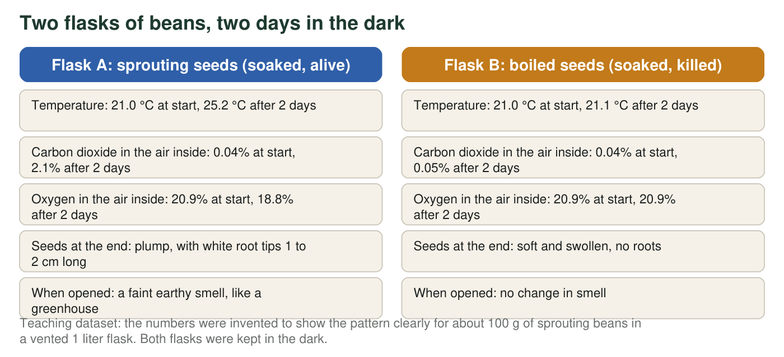

Part A: Notice and wonder
1. List three things that changed in Flask A but did not change (or barely changed) in Flask B. Use the numbers from the figure in each one.
______________________________________________________________________________________
______________________________________________________________________________________
______________________________________________________________________________________
______________________________________________________________________________________
______________________________________________________________________________________
2. Calculate the temperature change in each flask. Then calculate how many percentage points the carbon dioxide rose in Flask A and how many points the oxygen fell. Show the subtraction for each.
______________________________________________________________________________________
______________________________________________________________________________________
______________________________________________________________________________________
3. Write two questions this setup makes you wonder about. At least one should begin with 'What would happen if...'
______________________________________________________________________________________
______________________________________________________________________________________
______________________________________________________________________________________
______________________________________________________________________________________

Part B: What do you already think?
4. The inside of Flask A got warmer, but the cabinet, the flask and the air around it stayed at 21 °C. Which is the most reasonable first guess about where the extra thermal energy came from?
○ A. Light leaking into the cabinet warmed the seeds
○ B. The living seeds released energy that was stored in the food inside them
○ C. Boiling made the seeds in Flask B colder, so Flask A only seemed warmer
○ D. The thermometer in Flask A was broken
5. In the last lesson you learned how producers capture energy. Name that process and explain why it cannot be what is happening in Flask A.
______________________________________________________________________________________
______________________________________________________________________________________
______________________________________________________________________________________
6. One gas went down and one gas went up in Flask A. Name a living thing you already know that makes the same two gas changes, and say how it does it.
______________________________________________________________________________________
______________________________________________________________________________________
______________________________________________________________________________________

Part C: Your first explanation
7. Write a first explanation for Flask A that answers all three of these: Where did the thermal energy come from? Where did the extra carbon dioxide come from? Where did the missing oxygen go? Use the phrase 'stored in' at least once. It is fine to be unsure; say what you are unsure about.
______________________________________________________________________________________
______________________________________________________________________________________
______________________________________________________________________________________
______________________________________________________________________________________
______________________________________________________________________________________
______________________________________________________________________________________
______________________________________________________________________________________
8. Mr. Okafor dried both batches of seeds completely at the end and weighed them. Predict which batch had lost more dry mass and explain your prediction in one or two sentences.
______________________________________________________________________________________
______________________________________________________________________________________
______________________________________________________________________________________
9. Describe one follow-up experiment that would test part of your explanation. Say what you would change, what you would keep the same, and what you would measure.
______________________________________________________________________________________
______________________________________________________________________________________
______________________________________________________________________________________

Sentence frames for a first explanation
If you are not sure how to begin q7, use these frames and fill the blanks: 'The seeds in Flask A are alive, so they must be ____.' 'The thermal energy probably came from ____ that was stored in ____.' 'The carbon dioxide went up because ____.' 'The oxygen went down because ____.' 'I am not sure whether ____.' Compare your frames with a partner before writing your final version.

Design the third flask
Mr. Okafor has one more flask. Design a Flask C that would tell you whether the sprouting seeds need the oxygen in order to warm up. Say what you would put in the flask, what gas you would fill it with (and how), and what readings would support or weaken the idea that the warmth depends on oxygen. Then predict what the root tips would look like after two days in Flask C.

