Angela's Tools · Chapter 5: Using Stored Energy · Worksheet 2 of 10

Reactant or Product? Fuel or Building Block? Working the Words (Teacher answer key)
Learning target: I can use the vocabulary of food, energy and cellular respiration to sort organisms and statements, complete a concept map, and explain new situations.
Vocabulary in action · about 35 minutes · individual · Standards: MS-LS1-7 (practice), MS-LS1-6 (supports)

Standards connections
MS-LS1-7 (practice): Students practice the language they will need to build and explain a model of how food is rearranged in an organism: reactant, product, cellular respiration, and the three families of food molecules and their two fates (fuel or building block).
MS-LS1-6 (supports): Part D asks students to compare the roles of oxygen and carbon dioxide in photosynthesis and in cellular respiration, which connects this lesson's words to the previous one.

Answers with reasoning
producer: An organism that makes its own food. Most producers, such as plants and algae, use light energy to build sugar from carbon dioxide and water.
consumer: An organism that cannot make its own food, so it must take in other organisms, by eating them or by absorbing their molecules, to obtain matter and energy.
chemical energy: Energy held in substances because of how their atoms are joined; a chemical reaction can store it or release it.
cellular respiration: The chemical process in cells in which sugar reacts with oxygen, forming carbon dioxide and water and releasing energy the cell can use.
mitochondria: Small structures inside plant cells, animal cells and many single-celled organisms where most of cellular respiration happens.
reactant: A substance that goes into a chemical reaction and is changed by it.
product: A substance that is formed by a chemical reaction.
carbohydrate: A family of food molecules made of carbon, hydrogen and oxygen. Sugars are simple carbohydrates; starch, glycogen and cellulose are complex carbohydrates built by linking many sugars.
starch: A complex carbohydrate that plants use to store sugar; potatoes, corn and seeds are full of it.
glycogen: A complex carbohydrate that animals build from spare sugar and keep in the liver and muscles as an energy reserve.
fat: An energy-rich food molecule used for long-term energy storage and as part of cell membranes. Fats that are liquid at room temperature are called oils.
protein: A large molecule built from smaller pieces that makes up muscle and many other body structures, moves materials in and out of cells, and helps reactions happen.

Part A: Which term fits?
1. A shelf fungus grows on a fallen log and absorbs the log's matter and energy through thin threads. The fungus is a ________.
Answer: consumer
Reasoning: The fungus cannot make its own food; it absorbs another organism's matter and energy. This case shows that consumers include organisms that absorb rather than eat.
Also acceptable: None.
2. Ten centimeters underground, where no light reaches, a root cell releases energy from sugar. Most of that work happens inside the cell's ________.
Answer: mitochondria (or mitochondrion for one cell structure)
Reasoning: Root cells cannot photosynthesize, yet they need energy; most of cellular respiration takes place in their mitochondria. The lesson's phrase 'most of' is deliberate.
Also acceptable: Accept the singular 'mitochondrion.'
3. In cellular respiration, oxygen is a ________; in photosynthesis, oxygen is a ________.
Answer: reactant; product
Reasoning: Oxygen goes into cellular respiration (reactant) and comes out of photosynthesis (product).
Also acceptable: None.
4. A potato plant stores extra sugar underground as ________, while a runner stores extra sugar in her muscles as ________.
Answer: starch; glycogen
Reasoning: Plants store sugar as starch; animals link spare sugar into glycogen in the liver and muscles.
Also acceptable: None.
5. Before a long migration, a songbird builds up a layer of ________, the food molecule that holds the most energy per gram.
Answer: fat
Reasoning: Fat holds roughly twice the energy per gram of carbohydrate or protein, which is why it is the long-term store for migrating birds and for people.
Also acceptable: None.
6. A growing child's muscles are built from pieces of the ________ in foods such as beans, eggs and fish.
Answer: protein (or proteins)
Reasoning: Food proteins are broken into pieces and rebuilt into the body's own proteins, including muscle.
Also acceptable: None.

Part B: Sort the statements
Think about a typical producer (an oak tree) and a typical consumer (a squirrel). For each statement, put a check in the column that fits: true of producers only, true of consumers only, or true of both.
7. Check one column for each statement.
Answer: Builds sugar from carbon dioxide and water: Producers only. Carries out cellular respiration: Both. Must eat or absorb other organisms: Consumers only. Uses chemical energy stored in sugar: Both. Gets most of its carbon atoms from the air: Producers only. Gets its carbon atoms from food: Consumers only. Releases carbon dioxide: Both. Has mitochondria in its cells: Both.
Reasoning: The two most common errors are marking cellular respiration as consumers only and marking 'releases carbon dioxide' as consumers only; both come from the idea that plants do only photosynthesis. The mitochondria row is limited to the oak tree and the squirrel on purpose; bacteria have none.
Also acceptable: If a student marks 'gets most of its carbon from the air' as Both and argues that the squirrel breathes in air, use it to discuss that the squirrel does not build its body from the carbon dioxide it breathes in.

Part C: Complete the concept map
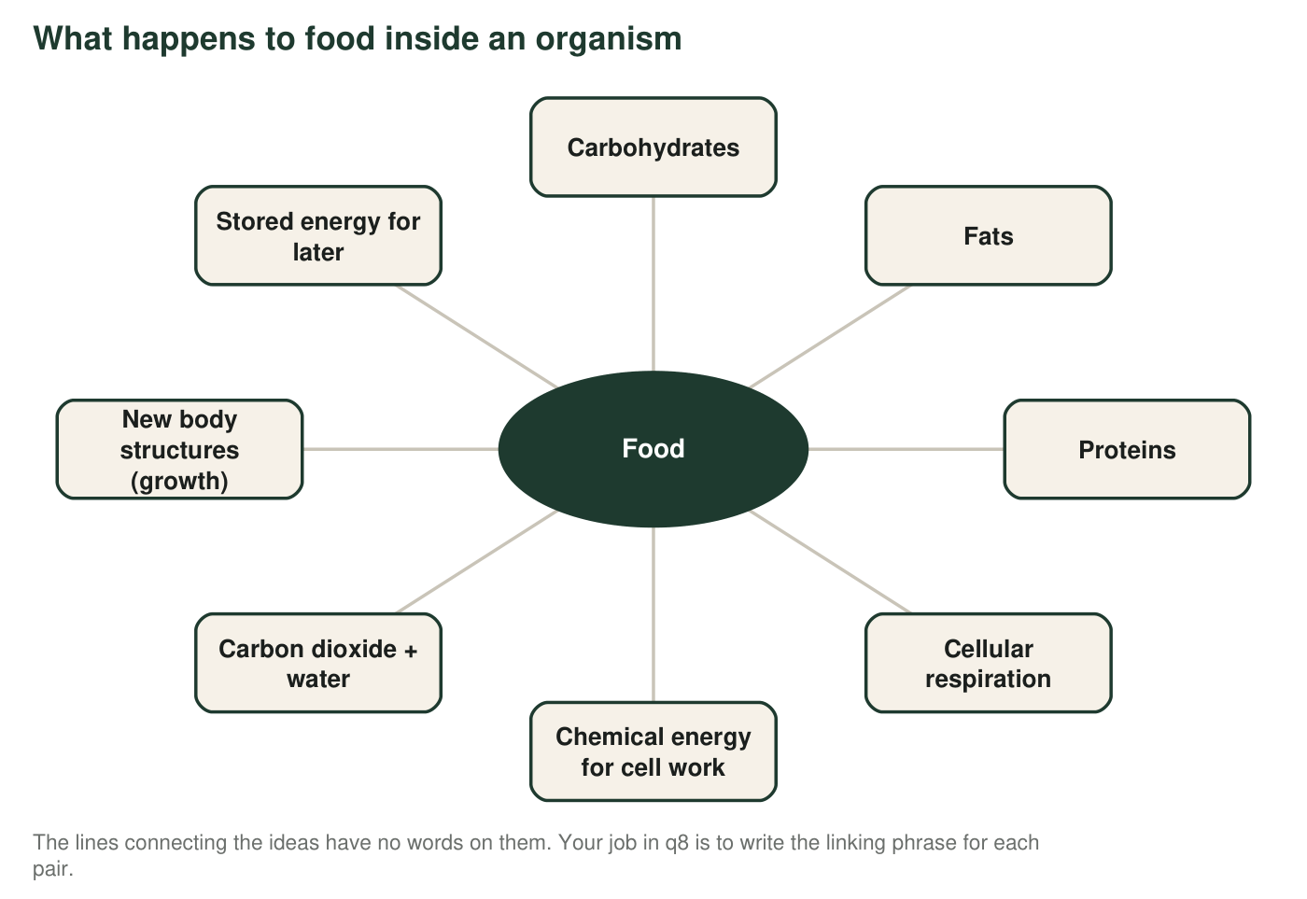
8. Write a short phrase that turns each pair into a true sentence. Example of the form: 'Rain → Puddles' could be 'collects on the ground as.'
Answer: Food → Carbohydrates, Fats, Proteins: 'is made up of' (or 'contains the molecules'). Carbohydrates (sugars) → Cellular respiration: 'are the reactants in' (or 'are broken down by'). Cellular respiration → Chemical energy: 'releases, for the cell to use'. Cellular respiration → Carbon dioxide + water: 'produces' (or 'has the products'). Proteins → New body structures: 'are taken apart and rebuilt into'. Fats → Stored energy: 'hold, for long-term use'. Carbohydrates (sugars) → Stored energy: 'are linked into starch or glycogen as'.
Reasoning: Any phrase that makes a true, specific sentence earns credit. The phrases should show direction: reactants go in, products come out, building molecules are rebuilt, storage molecules hold energy.
Also acceptable: For the sugar-to-storage link, accept 'can be stored as starch or glycogen.'
Full credit must include:
• All seven links filled
• Reactant and product links point the right way
• The protein link mentions building or rebuilding
• The two storage links mention holding energy for later

Part D: Apply the terms to new cases
9. A diatom is a single-celled organism that floats in the ocean and has structures that capture light to build sugar. Is it a producer or a consumer? Does it carry out cellular respiration? Use two words from the word bank in your answer.
Answer: A diatom is a producer because it builds its own sugar using light. It also carries out cellular respiration to release the chemical energy stored in that sugar, in its mitochondria, especially at night or in deep water where light is weak.
Reasoning: This checks the key idea that producers respire too. Uses of 'producer' and 'cellular respiration' (or 'mitochondria' or 'chemical energy') satisfy the two-word requirement.
Also acceptable: A student who adds that diatoms have mitochondria is correct.
Full credit must include:
• Identifies the diatom as a producer with a reason
• States that it also carries out cellular respiration
• Uses two word-bank terms correctly
10. A hiker eats a trail bar made of oats (mostly starch), peanuts (fat and protein) and honey (sugar). Using at least four terms from the word bank, describe which molecules will most likely be used as fuel soon, which could be stored, and which could become part of the hiker's body.
Answer: The honey's sugar (a simple carbohydrate) is the fuel most likely to be used soon as a reactant in cellular respiration. The oats' starch (a complex carbohydrate) will be broken down into sugars during digestion; some fuels the hike and some can be linked into glycogen and stored. The peanuts' fat can be used as fuel over a long hike or stored as body fat, and it also becomes part of cell membranes. The peanuts' protein is broken into pieces and rebuilt into the hiker's own proteins, such as muscle.
Reasoning: Full credit needs the three fates (fuel soon, stored, built into the body) matched to sensible molecules, with four terms used correctly.
Also acceptable: A student who says some sugar is also used to build body molecules is not wrong; sugars can become building blocks, but the main fates listed above are the expected ones.
Full credit must include:
• Sugar identified as quick fuel
• Starch or glycogen used correctly for storage or digestion
• Fat linked to long-term energy or membranes
• Protein linked to building body structures
• At least four word-bank terms
11. Explain why the same substance, oxygen, can be called a product in one process and a reactant in another. Then explain why 'reactant' and 'product' describe a substance's role in a reaction rather than what the substance is.
Answer: Oxygen is formed by photosynthesis, so there it is a product; it is used up by cellular respiration, so there it is a reactant. 'Reactant' and 'product' are not names of substances; they describe what a substance does in a particular reaction. The same molecule can go into one reaction and come out of another, so you have to say which reaction you mean before you can call something a reactant or a product. Carbon dioxide and water work the same way in reverse: products of respiration, reactants of photosynthesis.
Reasoning: The second part is the deeper idea: these are role words, like 'passenger' and 'driver,' not identity words.
Also acceptable: An analogy such as 'the same person can be a student in one class and a tutor in another' earns full credit for the second part if it is explained.
Full credit must include:
• Correctly places oxygen as a product of photosynthesis and a reactant of respiration
• Explains that reactant and product describe a role in a named reaction
• Gives the carbon dioxide or water example, or an analogy, as support

Teacher notes
The word bank definitions deliberately correct several textbook simplifications: a carbohydrate stores energy or builds structure (cellulose is structural), fats are not all oils, most (not all) of cellular respiration happens in mitochondria, and consumers include absorbers such as fungi. Part B is where the 'plants only photosynthesize' idea surfaces; collect the sorts and tally the two cellular-respiration rows before the next lesson. In q8, students sometimes write a single word such as 'makes'; push for a phrase with direction. The extension's cellulose card should say it is built from many sugars, forms plant cell walls, and that the human body can neither make it nor digest it (it passes through as fiber).

