Angela's Tools · Chapter 5: Using Stored Energy · Worksheet 2 of 10

Reactant or Product? Fuel or Building Block? Working the Words
Learning target: I can use the vocabulary of food, energy and cellular respiration to sort organisms and statements, complete a concept map, and explain new situations.
Vocabulary in action · about 35 minutes · individual · Standards: MS-LS1-7 (practice), MS-LS1-6 (supports)
Name: ____________________________ Date: ____________ Period: ______

Directions
Read the word bank first; the definitions are written in plain language and are scientifically accurate. Then work through the four parts in order. Part A asks which term fits a situation. Part B asks you to sort statements. Part C asks you to write the linking words for a concept map. Part D asks you to apply the terms to organisms you have not read about. Write whole words, not abbreviations, and check that each term you choose fits the sentence grammatically.
producer: An organism that makes its own food. Most producers, such as plants and algae, use light energy to build sugar from carbon dioxide and water.
consumer: An organism that cannot make its own food, so it must take in other organisms, by eating them or by absorbing their molecules, to obtain matter and energy.
chemical energy: Energy held in substances because of how their atoms are joined; a chemical reaction can store it or release it.
cellular respiration: The chemical process in cells in which sugar reacts with oxygen, forming carbon dioxide and water and releasing energy the cell can use.
mitochondria: Small structures inside plant cells, animal cells and many single-celled organisms where most of cellular respiration happens.
reactant: A substance that goes into a chemical reaction and is changed by it.
product: A substance that is formed by a chemical reaction.
carbohydrate: A family of food molecules made of carbon, hydrogen and oxygen. Sugars are simple carbohydrates; starch, glycogen and cellulose are complex carbohydrates built by linking many sugars.
starch: A complex carbohydrate that plants use to store sugar; potatoes, corn and seeds are full of it.
glycogen: A complex carbohydrate that animals build from spare sugar and keep in the liver and muscles as an energy reserve.
fat: An energy-rich food molecule used for long-term energy storage and as part of cell membranes. Fats that are liquid at room temperature are called oils.
protein: A large molecule built from smaller pieces that makes up muscle and many other body structures, moves materials in and out of cells, and helps reactions happen.

Part A: Which term fits?
1. A shelf fungus grows on a fallen log and absorbs the log's matter and energy through thin threads. The fungus is a ________.
______________________________________________________________________________________
______________________________________________________________________________________
______________________________________________________________________________________
2. Ten centimeters underground, where no light reaches, a root cell releases energy from sugar. Most of that work happens inside the cell's ________.
______________________________________________________________________________________
______________________________________________________________________________________
______________________________________________________________________________________
3. In cellular respiration, oxygen is a ________; in photosynthesis, oxygen is a ________.
______________________________________________________________________________________
______________________________________________________________________________________
______________________________________________________________________________________
4. A potato plant stores extra sugar underground as ________, while a runner stores extra sugar in her muscles as ________.
______________________________________________________________________________________
______________________________________________________________________________________
______________________________________________________________________________________
5. Before a long migration, a songbird builds up a layer of ________, the food molecule that holds the most energy per gram.
______________________________________________________________________________________
______________________________________________________________________________________
______________________________________________________________________________________
6. A growing child's muscles are built from pieces of the ________ in foods such as beans, eggs and fish.
______________________________________________________________________________________
______________________________________________________________________________________
______________________________________________________________________________________

Part B: Sort the statements
Think about a typical producer (an oak tree) and a typical consumer (a squirrel). For each statement, put a check in the column that fits: true of producers only, true of consumers only, or true of both.
7. Check one column for each statement.
Producers only | Consumers only | Both
Builds sugar from carbon dioxide and water
Carries out cellular respiration in its cells
Must eat or absorb other organisms to get food
Uses chemical energy stored in sugar to power its cells
Gets most of the carbon atoms for its body from the air
Gets the carbon atoms for its body from food
Releases carbon dioxide
Has mitochondria in its cells

Part C: Complete the concept map
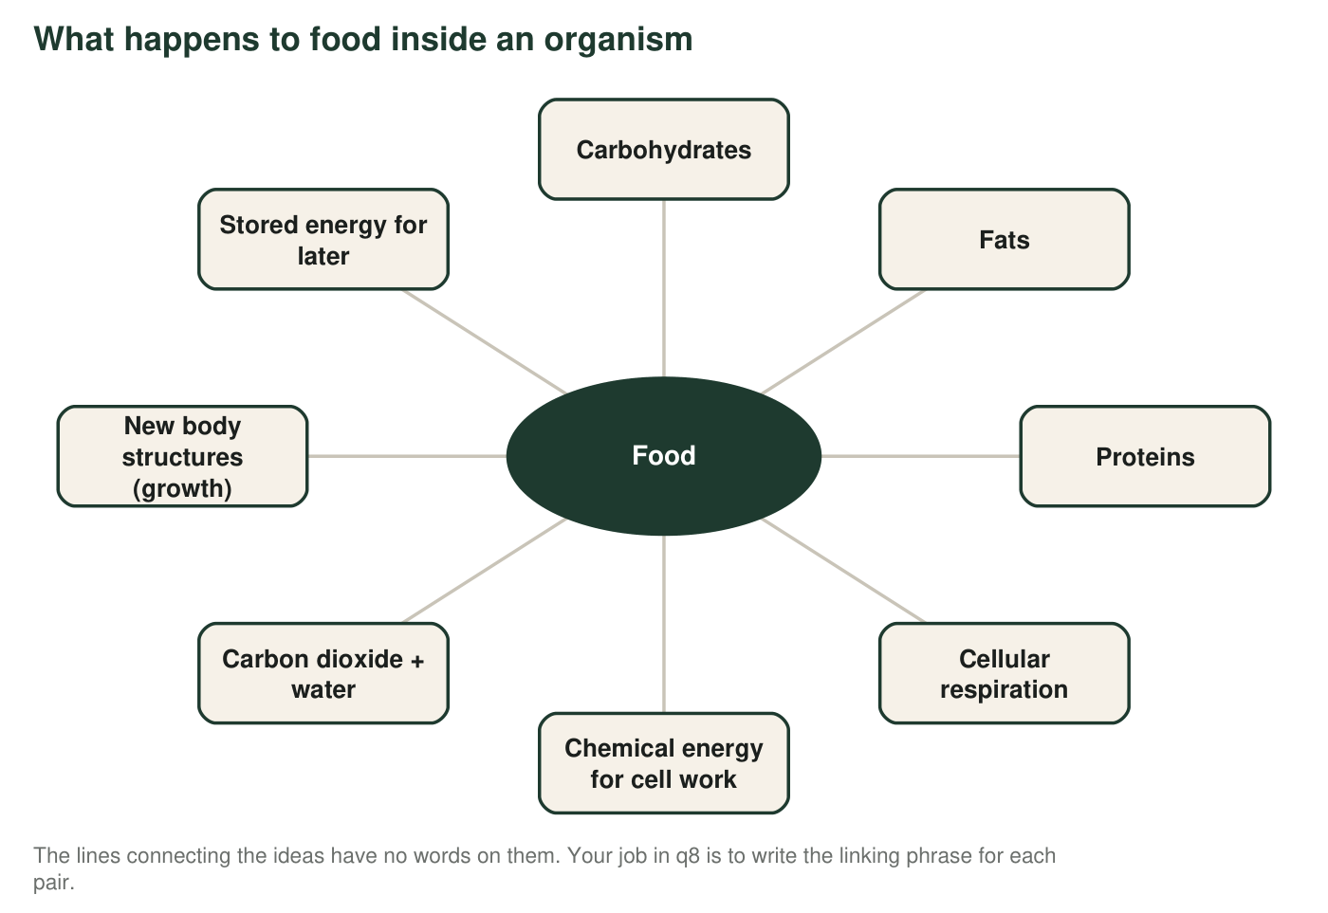
8. Write a short phrase that turns each pair into a true sentence. Example of the form: 'Rain → Puddles' could be 'collects on the ground as.'
Linking phrase (2 to 6 words)
Food → Carbohydrates, Fats, Proteins
Carbohydrates (sugars) → Cellular respiration
Cellular respiration → Chemical energy for cell work
Cellular respiration → Carbon dioxide + water
Proteins → New body structures (growth)
Fats → Stored energy for later
Carbohydrates (sugars) → Stored energy for later

Part D: Apply the terms to new cases
9. A diatom is a single-celled organism that floats in the ocean and has structures that capture light to build sugar. Is it a producer or a consumer? Does it carry out cellular respiration? Use two words from the word bank in your answer.
______________________________________________________________________________________
______________________________________________________________________________________
______________________________________________________________________________________
10. A hiker eats a trail bar made of oats (mostly starch), peanuts (fat and protein) and honey (sugar). Using at least four terms from the word bank, describe which molecules will most likely be used as fuel soon, which could be stored, and which could become part of the hiker's body.
______________________________________________________________________________________
______________________________________________________________________________________
______________________________________________________________________________________
______________________________________________________________________________________
11. Explain why the same substance, oxygen, can be called a product in one process and a reactant in another. Then explain why 'reactant' and 'product' describe a substance's role in a reaction rather than what the substance is.
______________________________________________________________________________________
______________________________________________________________________________________
______________________________________________________________________________________
______________________________________________________________________________________
______________________________________________________________________________________

Two questions that sort almost everything
When you are unsure which term fits, ask: (1) Is this about where the organism gets its food (producer or consumer), or about what cells do with food (cellular respiration, reactant, product)? (2) Is this molecule being used as fuel right now, stored for later, or built into the body? Carbohydrates and fats are the usual fuel and storage molecules; proteins are the usual building molecules. Mark each question with F (fuel), S (stored) or B (building) before you answer.

Write the missing card
The word bank has no entry for 'cellulose' even though it is a complex carbohydrate. Write a word-bank card for cellulose in the same style: a plain-language definition that says what it is built from, what plants use it for, and whether your body can make it or break it down. Then explain why a carbohydrate can be a building block rather than a fuel, and name one everyday object made mostly of cellulose.

