Angela's Tools · Chapter 5: Using Stored Energy · Worksheet 4 of 10

From Acorn to Muscle Cell: Reading and Building a Model of Food's Path (Teacher answer key)
Learning target: I can read a model that traces food from a meal to a cell, count the atoms going in and out of cellular respiration, and build my own model showing how food is rearranged to release energy or to build an organism.
Diagrams and models · about 40 minutes · individual · Standards: MS-LS1-7 (assesses), MS-PS1-5 (practice)

Standards connections
MS-LS1-7 (assesses): Part B asks students to develop their own model of how a root cell rearranges sugar into carbon dioxide and water (releasing energy) and into new cell-wall material (growth). The model stays at the level of inputs, outputs and atom conservation; it does not include the steps of the reaction, which the assessment boundary excludes.
MS-PS1-5 (practice): Counting the carbon, hydrogen and oxygen atoms on both sides of the overall cellular respiration summary practices the idea that atoms are conserved in a chemical reaction, which students will study in depth in the chemistry chapters.

Answers with reasoning

Part A: Read the model
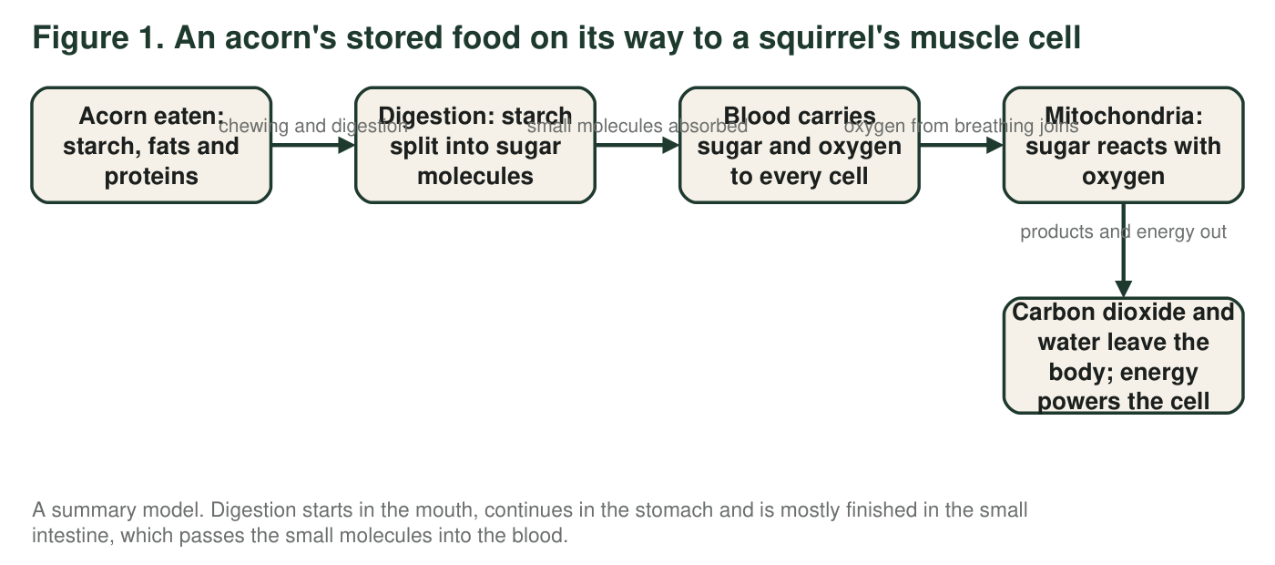
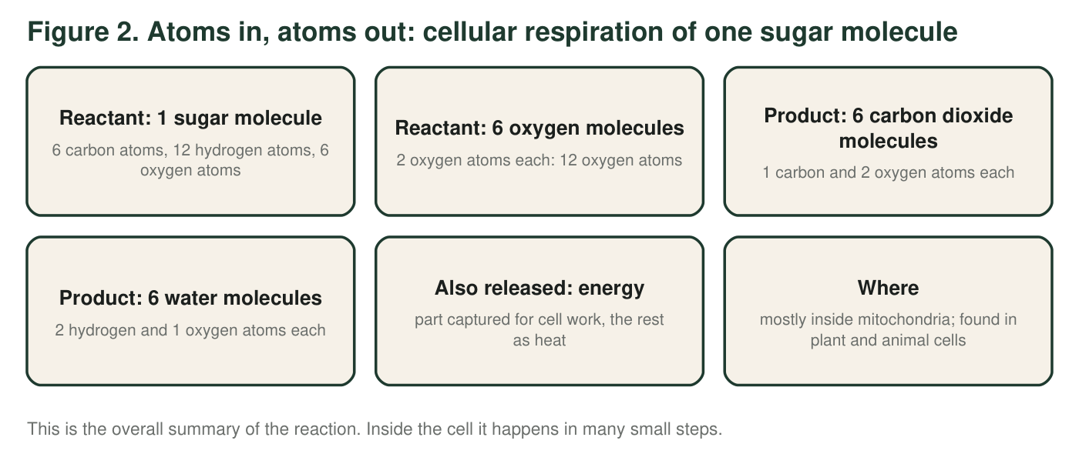
1. In Figure 1, at which two steps are molecules actually taken apart or rearranged into new molecules? What happens to molecules at the other steps?
Answer: Molecules are taken apart or rearranged at the digestion step (starch is split into sugar molecules) and at the mitochondria step (sugar and oxygen are rearranged into carbon dioxide and water). At the other steps the molecules are only moved: chewing makes smaller pieces of food but the molecules are the same, the blood transports sugar and oxygen, and the products are carried out of the body.
Reasoning: This distinction between moving molecules and changing them is the heart of the PE: rearrangement happens through chemical reactions, and transport is not a reaction.
Also acceptable: Accept 'chewing' as not changing molecules; it is a physical change.
Full credit must include:
• Names digestion and the mitochondria step
• Says the other steps move molecules without changing them
2. Use Figure 2 to count the atoms of each kind on the reactant side and on the product side. Show one multiplication below the table (for example, how you got the oxygen atoms in 6 carbon dioxide molecules).
Answer: Reactants: carbon 6 (all from the sugar); hydrogen 12 (from the sugar); oxygen 6 + 12 = 18 (6 in the sugar plus 6 × 2 = 12 in the oxygen molecules). Products: carbon 6 × 1 = 6 (in the carbon dioxide); hydrogen 6 × 2 = 12 (in the water); oxygen 6 × 2 + 6 × 1 = 12 + 6 = 18. Every row matches: 6 carbon, 12 hydrogen and 18 oxygen on both sides.
Reasoning: The multiplication students most often miss is the 12 oxygen atoms in six oxygen molecules; the next is adding the sugar's own 6 oxygen atoms to get 18.
Also acceptable: Accept any correct multiplication shown below the table.
3. Where do the six carbon atoms of the sugar molecule end up, and how do they leave the squirrel's body?
Answer: Each of the six carbon atoms ends up in a carbon dioxide molecule. The carbon dioxide is carried by the blood to the lungs and leaves the body when the squirrel breathes out.
Reasoning: Students should trace the atoms, not just name the product; the breathing-out step closes the loop back to the air.
Also acceptable: Accept 'exhaled.'
Full credit must include:
• Carbon ends up in carbon dioxide
• Leaves through breathing out (via the blood and lungs)
4. Figure 2 lists energy as something released but gives it no atom count. Explain why energy cannot be counted in atoms, and what the model says happens to it.
Answer: Energy is not a substance; it is not made of atoms, so it cannot be counted the way matter can. The model says the energy is released by the reaction, part of it is captured by the cell for its work and the rest leaves as heat.
Reasoning: Keeping matter and energy separate is a crosscutting idea students need for the misconception sheet (W7) and the mastery check.
Also acceptable: A student who adds that the energy was stored in the sugar and oxygen before the reaction is correct.
Full credit must include:
• States that energy is not matter and has no atoms
• States the two fates: captured for cell work and released as heat
5. A student wants to add an arrow to Figure 1 from 'oxygen from breathing' straight to 'new muscle protein.' Explain why that arrow would be wrong, and say where the matter for new muscle protein actually comes from.
Answer: Oxygen is a reactant in cellular respiration; it ends up in carbon dioxide and water, not in protein. The matter for new muscle protein comes from the proteins in the squirrel's food, which are digested into small pieces and rebuilt into the squirrel's own proteins.
Reasoning: This targets the idea that consumers build their bodies from food, not from the air they breathe.
Also acceptable: Accept 'from the acorn's proteins' as the source.
Full credit must include:
• Says oxygen goes to carbon dioxide and water, not to protein
• Says muscle protein is built from food protein pieces
6. Figure 1 follows only the acorn's starch. Which arrow would you add to show what happens to most of the acorn's proteins?
Answer: B. Proteins → digestion into small pieces → rebuilt into the squirrel's own proteins.
Reasoning: Most food protein is used as building material. Option A is the fate of sugar (and proteins can be used for energy too, but that is not their main use); glycogen is made from sugar, not protein; protein does not leave as a gas.
Also acceptable: None.

Part B: Build your own model
A bean seed sprouted in a dark cupboard. Its root tip is now 3 cm below the surface of damp soil, where there is no light. The root cells are growing fast. They get sugar from the starch the seed stored and oxygen from the air pockets between the soil grains.
Draw a model of ONE root cell and its surroundings that shows two different fates for the sugar molecules that reach it. Fate 1: sugar reacts with oxygen in the mitochondria, producing carbon dioxide and water and releasing energy. Fate 2: some sugar molecules are linked together to build cellulose for the new cell wall as the cell grows. Requirements: a title; the cell drawn as a box with at least one mitochondrion inside; labeled arrows for everything that enters and everything that leaves; the word 'energy' placed where it is released and an arrow showing what it is used for; and a note that says where the sugar came from and where the oxygen came from.
Expected drawing: A titled diagram of one root cell (box) containing at least one mitochondrion. Inputs: an arrow labeled 'sugar, from the seed's stored starch' and an arrow labeled 'oxygen, from air pockets in the soil' entering the cell. Fate 1: sugar and oxygen arrows meet at the mitochondrion; arrows leave labeled 'carbon dioxide' and 'water' and exit the cell; the word 'energy' sits beside the mitochondrion with an arrow to 'cell work and growth.' Fate 2: an arrow from sugar to 'cellulose in the new cell wall,' drawn at the edge of the cell, labeled 'sugars linked together.' No light or chloroplast is drawn, since the root is in the dark.
Reasoning: Full credit needs both fates, every input and output labeled, energy shown as released and used, and the sources of sugar and oxygen stated. The cellulose arrow is the growth half of the PE; a model with only the respiration half is incomplete.
7. Describe the two fates of sugar in your model in one sentence each. Which fate adds matter to the plant, and which fate releases matter from the plant?
Answer: Fate 1: sugar reacts with oxygen in the mitochondria to form carbon dioxide and water and release energy. Fate 2: sugar molecules are linked together into cellulose for the growing cell wall. Fate 2 adds matter to the plant (the cell wall gets bigger); Fate 1 releases matter from the plant (carbon dioxide and water leave).
Reasoning: This makes explicit that the same food molecule can be a fuel or a building block, and that growth means keeping atoms while respiration means releasing them.
Also acceptable: None.
Full credit must include:
• Both fates described
• Growth fate identified as adding matter
• Respiration fate identified as releasing matter
8. Explain how your model shows that atoms are conserved. Point to a specific arrow or label.
Answer: Every atom that enters the cell on an input arrow leaves on an output arrow or stays in a labeled structure: the carbon in the sugar leaves as carbon dioxide or stays in the cellulose; the oxygen that enters leaves in the carbon dioxide and water. Nothing appears or vanishes; the arrows account for all the matter. A student might point to the carbon dioxide arrow and say 'this is where the sugar's carbon goes.'
Reasoning: Look for a specific arrow or label being cited, not a general statement.
Also acceptable: Accept an answer that writes atom counts beside the arrows.
Full credit must include:
• Cites a specific arrow or label
• Explains that the atoms in the inputs are accounted for in the outputs or in the new cell material
9. Compare your root-cell model with Figure 1. Name two things that are the same for the root cell and the squirrel's muscle cell, and two things that are different (think about where the sugar came from and how the oxygen arrived).
Answer: Same: both cells carry out cellular respiration in mitochondria with sugar and oxygen as reactants; both produce carbon dioxide and water and release energy for the cell's work; in both, atoms are conserved. Different: the root cell's sugar came from starch the plant itself made and stored in the seed, while the squirrel's sugar came from food it ate (the acorn); the root cell gets oxygen directly from air pockets in the soil, while the squirrel's muscle cell gets oxygen delivered by blood after breathing. Another difference: the root cell builds cellulose for a cell wall, which animal cells do not make.
Reasoning: Two similarities and two differences, with the differences about the source of sugar and the delivery of oxygen, earn full credit.
Also acceptable: Accept 'the root is in the dark, so no photosynthesis is happening' as a point of comparison if it is paired with the fact that a muscle cell never photosynthesizes.
Full credit must include:
• Two correct similarities
• Difference in the source of sugar (made by the plant versus eaten)
• Difference in how oxygen arrives (soil air directly versus breathing and blood)

Teacher notes
Figure 2 uses the overall summary of cellular respiration (one sugar molecule and six oxygen molecules give six carbon dioxide and six water molecules). It is presented as an atom-counting model, which the lesson itself provides, and not as a description of the reaction's steps; stay at this level to respect the MS-LS1-7 assessment boundary. The caption of Figure 1 corrects the textbook's statement that digestion happens in the stomach: it is mostly completed in the small intestine. The Part B scenario is chosen so that the organism is a producer with no light, which forces the model to show that plants respire and take in oxygen from their surroundings (the textbook says producers already have the oxygen they need from photosynthesis, which is false for roots and seeds). Common drawing errors: a chloroplast or sunlight in the root cell; oxygen arrows pointing out of the cell; energy drawn as an input; and no growth path. Save these drawings; the W9 model uses the same conventions.

