Angela's Tools · Chapter 5: Using Stored Energy · Worksheet 4 of 10

From Acorn to Muscle Cell: Reading and Building a Model of Food's Path
Learning target: I can read a model that traces food from a meal to a cell, count the atoms going in and out of cellular respiration, and build my own model showing how food is rearranged to release energy or to build an organism.
Diagrams and models · about 40 minutes · individual · Standards: MS-LS1-7 (assesses), MS-PS1-5 (practice)
Name: ____________________________ Date: ____________ Period: ______

Directions
Part A has two figures. Figure 1 follows the sugar in an acorn through a squirrel's body. Figure 2 shows the atoms that go into and come out of cellular respiration for one sugar molecule. Read both figures before answering any question, and answer the Part A questions in order. In Part B you will build your own model for a different organism in the drawing box; label every arrow and every molecule, and give your model a title.

Part A: Read the model
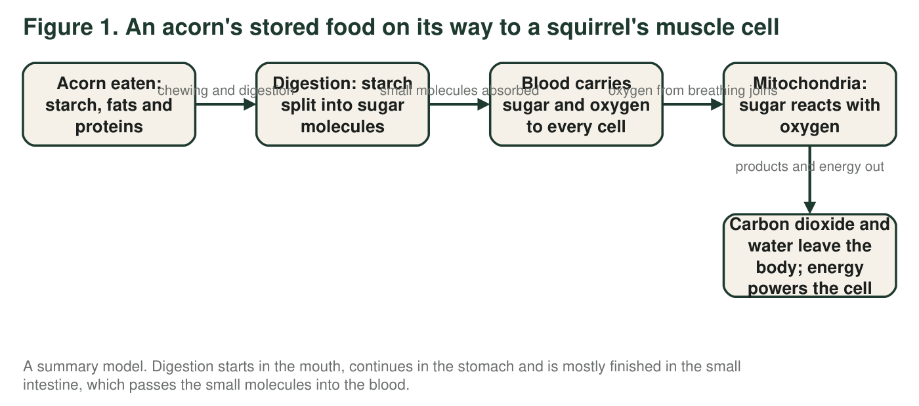
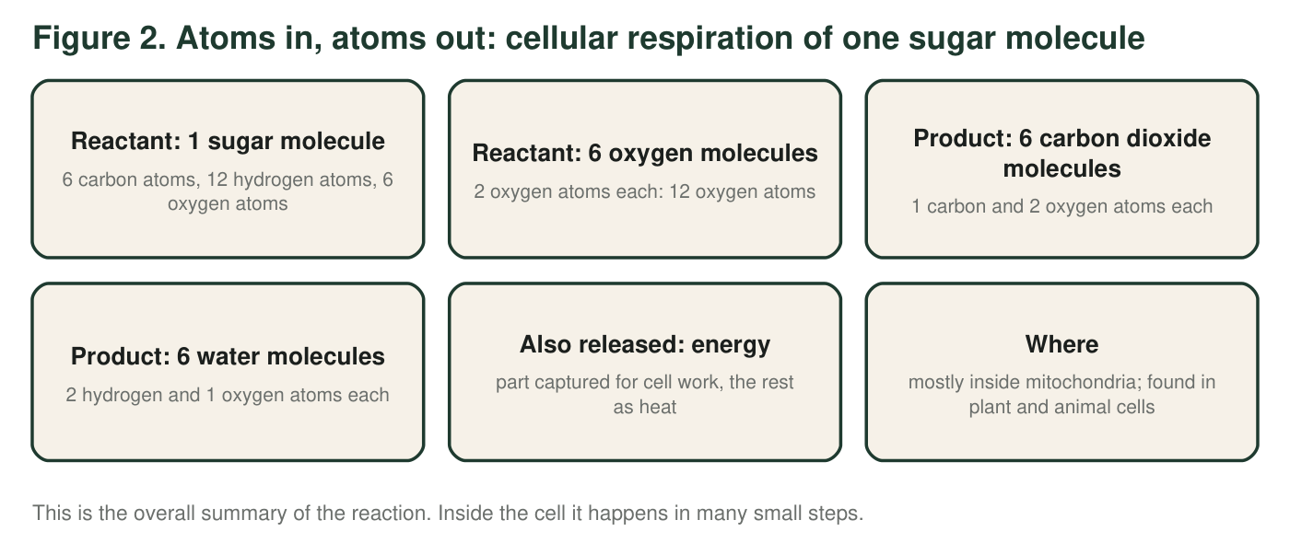
1. In Figure 1, at which two steps are molecules actually taken apart or rearranged into new molecules? What happens to molecules at the other steps?
______________________________________________________________________________________
______________________________________________________________________________________
______________________________________________________________________________________
2. Use Figure 2 to count the atoms of each kind on the reactant side and on the product side. Show one multiplication below the table (for example, how you got the oxygen atoms in 6 carbon dioxide molecules).
Carbon atoms | Hydrogen atoms | Oxygen atoms
Reactants (1 sugar + 6 oxygen)
Products (6 carbon dioxide + 6 water)

3. Where do the six carbon atoms of the sugar molecule end up, and how do they leave the squirrel's body?
______________________________________________________________________________________
______________________________________________________________________________________
______________________________________________________________________________________
4. Figure 2 lists energy as something released but gives it no atom count. Explain why energy cannot be counted in atoms, and what the model says happens to it.
______________________________________________________________________________________
______________________________________________________________________________________
______________________________________________________________________________________
5. A student wants to add an arrow to Figure 1 from 'oxygen from breathing' straight to 'new muscle protein.' Explain why that arrow would be wrong, and say where the matter for new muscle protein actually comes from.
______________________________________________________________________________________
______________________________________________________________________________________
______________________________________________________________________________________
6. Figure 1 follows only the acorn's starch. Which arrow would you add to show what happens to most of the acorn's proteins?
○ A. Proteins → mitochondria → carbon dioxide, water and energy, exactly like sugar
○ B. Proteins → digestion into small pieces → rebuilt into the squirrel's own proteins
○ C. Proteins → stored unchanged in the squirrel's liver as glycogen
○ D. Proteins → breathed out as a gas

Part B: Build your own model
A bean seed sprouted in a dark cupboard. Its root tip is now 3 cm below the surface of damp soil, where there is no light. The root cells are growing fast. They get sugar from the starch the seed stored and oxygen from the air pockets between the soil grains.
Draw a model of ONE root cell and its surroundings that shows two different fates for the sugar molecules that reach it. Fate 1: sugar reacts with oxygen in the mitochondria, producing carbon dioxide and water and releasing energy. Fate 2: some sugar molecules are linked together to build cellulose for the new cell wall as the cell grows. Requirements: a title; the cell drawn as a box with at least one mitochondrion inside; labeled arrows for everything that enters and everything that leaves; the word 'energy' placed where it is released and an arrow showing what it is used for; and a note that says where the sugar came from and where the oxygen came from.

7. Describe the two fates of sugar in your model in one sentence each. Which fate adds matter to the plant, and which fate releases matter from the plant?
______________________________________________________________________________________
______________________________________________________________________________________
______________________________________________________________________________________
8. Explain how your model shows that atoms are conserved. Point to a specific arrow or label.
______________________________________________________________________________________
______________________________________________________________________________________
______________________________________________________________________________________
9. Compare your root-cell model with Figure 1. Name two things that are the same for the root cell and the squirrel's muscle cell, and two things that are different (think about where the sugar came from and how the oxygen arrived).
______________________________________________________________________________________
______________________________________________________________________________________
______________________________________________________________________________________
______________________________________________________________________________________
______________________________________________________________________________________

Build the model in layers
Draw in this order so nothing is forgotten. Layer 1: the cell as a box, with one oval inside labeled 'mitochondrion.' Layer 2: two arrows coming into the cell, labeled 'sugar (from the seed's starch)' and 'oxygen (from soil air pockets).' Layer 3: two arrows leaving the mitochondrion and the cell, labeled 'carbon dioxide' and 'water,' plus the word 'energy' with an arrow to 'growth and cell work.' Layer 4: a second path for sugar inside the cell: an arrow from sugar to 'cellulose in the new cell wall.' Layer 5: the title. Check that every arrow has a label.

Daylight version
Redraw your model for a leaf cell of the same bean plant two weeks later, at noon, in bright light. Now the cell carries out both photosynthesis and cellular respiration at the same time. Show both processes in one cell, with arrows for every input and output, and explain in two sentences why the leaf cell, unlike the root cell, might not need to take in oxygen from the air during the day, but still needs it at night.

