Angela's Tools · Chapter 6: Food Webs and Trophic Pyramids · Worksheet 2 of 10

Thirteen Words, One Ecosystem: Using the Language of Food Webs (Teacher answer key)
Learning target: I can tell apart the terms that name organisms, models, interactions and measurements in a food web, and use each one correctly in a new situation.
Vocabulary in action · about 30 minutes · individual · Standards: MS-LS2-3 (supports)

Standards connections
MS-LS2-3 (supports): Students need a precise working vocabulary before they can build or read a model of matter cycling and energy flow. Sorting the terms by what kind of thing each names (an organism, a model, an interaction, a quantity) prepares them for the modeling tasks in W4 and W8.

Answers with reasoning
producer: An organism that builds its own food from carbon dioxide and water using energy from sunlight. Plants, algae and phytoplankton are producers.
consumer: An organism that gets its matter and energy by eating other organisms or what they leave behind.
decomposer: A consumer, such as a bacterium or a fungus, that feeds on wastes and dead remains and releases simple materials that producers can take in again.
top predator: An animal at the end of a food chain that no other organism in that particular model eats.
phytoplankton: Tiny producers that drift in lakes and oceans and make food by photosynthesis.
zooplankton: Tiny consumers that drift in water, many of them small animals, that feed on phytoplankton or on each other.
food web: A diagram model of the feeding links in an ecosystem. Each arrow runs from a food to the organism that eats it.
food chain: One single path through a food web, starting at a producer and following the arrows to a top predator.
trophic level: A feeding step in a food chain. Producers are the first level, the organisms that eat them are the second, and so on.
trophic pyramid: A model that stacks the trophic levels of a food chain and shows how much energy passes to each level, widest at the producer base.
biomass: The total mass of living material in a group of organisms, such as all the producers in a pond.
direct effect: A change in one population caused by a population that eats it or is eaten by it, with nothing in between.
indirect effect: A change in one population caused by another population acting through a third population in between.

Part A: What kind of thing does each word name?
1. Sort all thirteen words from the word bank into the four rows. Every word goes in exactly one row.
Answer: Organism (feeding role): producer, consumer, decomposer, top predator, phytoplankton, zooplankton. Model or diagram: food web, food chain, trophic pyramid. Interaction: direct effect, indirect effect. Quantity: biomass, trophic level.
Reasoning: Trophic level is the one students most often misplace; it is a position number in a chain (first, second, third), so it belongs with quantities you could count. Food chain is a path in a model, so it is a model. Accept trophic level placed with models if the student explains it as a labeled step in a pyramid.
Also acceptable: Trophic level may be placed in the model row with an explanation.
Full credit must include:
• All six organism terms together
• Food web, food chain and trophic pyramid as models
• Both effects as interactions
• Biomass as a quantity

Part B: Which term fits?
Write the one word from the bank that best fits each situation.
2. A biologist dries all the grasshoppers collected from a plot, weighs them together, and reports 3.2 kilograms.
Answer: biomass
Reasoning: The total dried mass of a group of organisms is biomass.
Also acceptable: None.
3. Orange threads of a fungus spread through a fallen log and slowly turn the wood to crumbs.
Answer: decomposer
Reasoning: A fungus feeding on a dead log is the classic decomposer.
Also acceptable: Accept 'consumer' only with a note that decomposer is more precise.
4. On a poster of a kelp forest, arrows run from kelp to sea urchins, from urchins to sea otters, from kelp to snails, and from snails to fish.
Answer: food web
Reasoning: Several linked arrows with branching paths make a web, not a single chain.
Also acceptable: None.
5. When sea otters return to a bay, the number of sea urchins, which otters eat, goes down.
Answer: direct effect
Reasoning: Otters eat urchins, so the change in urchins has no population in between.
Also acceptable: None.
6. When sea otters return to a bay, the kelp, which otters do not eat, grows back thicker.
Answer: indirect effect
Reasoning: Otters do not eat kelp; the effect reaches kelp through the urchin population.
Also acceptable: None.
7. A drawing shows four stacked boxes labeled 20,000, 2,000, 200 and 20 energy units, with the biggest box at the bottom.
Answer: trophic pyramid
Reasoning: Stacked boxes showing energy at each level, largest at the base, is a trophic pyramid.
Also acceptable: None.
8. A drop of lake water under a microscope holds tiny drifting animals that are feeding on green cells even smaller than they are. Name the eaters.
Answer: zooplankton
Reasoning: Tiny drifting animals eating green cells (phytoplankton) are zooplankton. The question asks for the eaters.
Also acceptable: If a student writes 'phytoplankton', they have named the food, not the eaters; no credit, but use it to reteach.

Part C: Complete the concept map
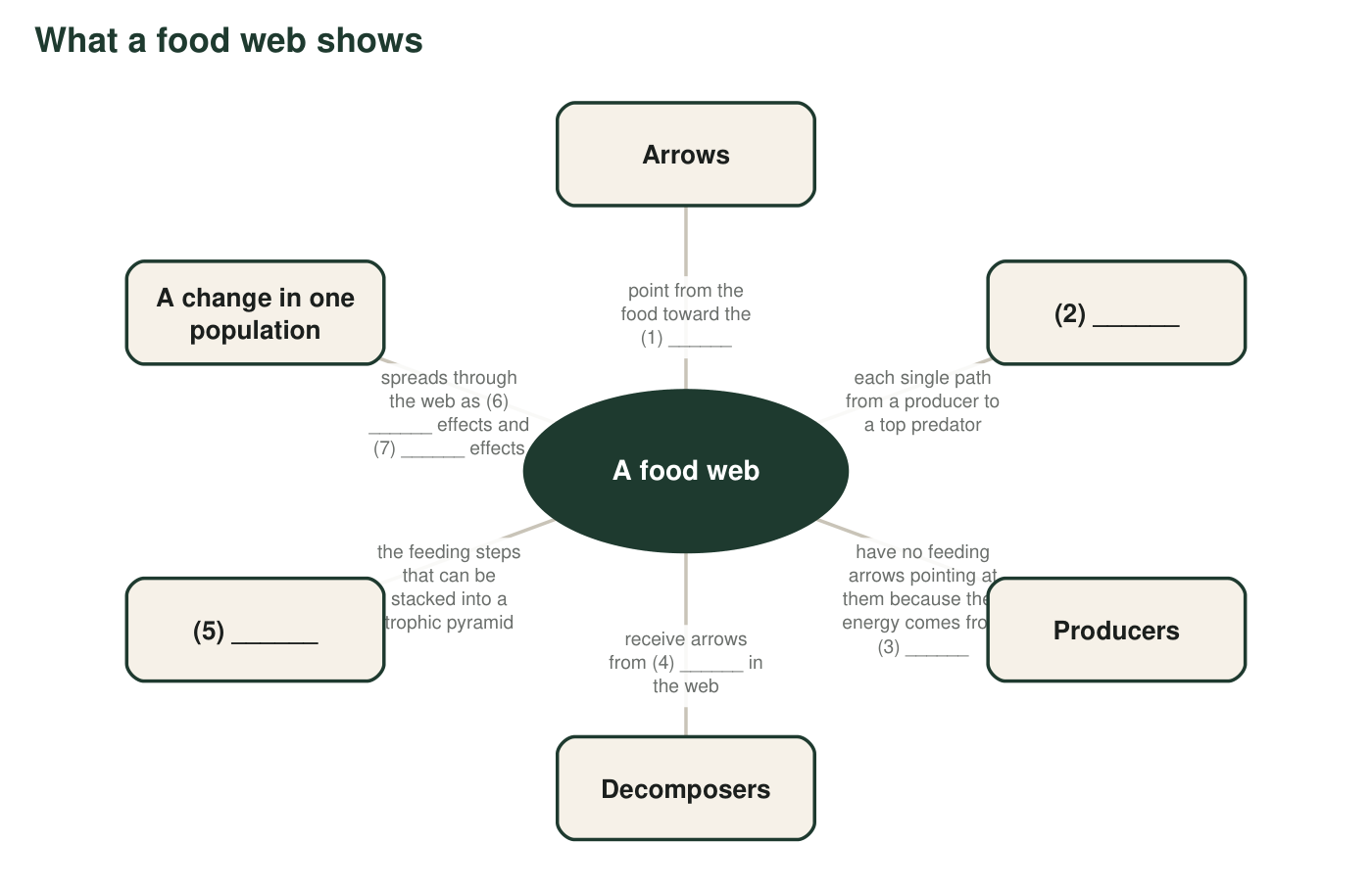
A concept map about food webs with seven blanks. Each blank is a word or phrase from the word bank or from your earlier lessons.
9. Fill each numbered blank in the concept map.
Answer: 1: eater (consumer or predator). 2: food chain. 3: sunlight (or the sun). 4: every organism (all organisms). 5: trophic levels. 6: direct. 7: indirect (6 and 7 may be in either order).
Reasoning: Each blank is anchored by the surrounding text; blank 4 tests the idea that decomposers feed on wastes and remains from every part of the web.
Also acceptable: Blank 1: accept 'consumer' or 'the organism that eats it'. Blank 3: accept 'photosynthesis using sunlight'.
Full credit must include:
• Blanks 1-5 correct
• Blanks 6 and 7 are direct and indirect in either order

Part D: Relationships between words
10. Only one of these pairs can describe the same organism at the same time: producer and consumer, consumer and decomposer, producer and top predator. Which pair is it, and why can the other two pairs never describe one organism?
Answer: Consumer and decomposer: every decomposer is also a consumer (it feeds on other organisms' remains), so a mushroom is both at once. Producer and consumer cannot be the same organism in this chapter's sense because a producer makes its own food from carbon dioxide and water while a consumer gets food by eating. A producer can never be a top predator because a top predator must eat other organisms and sit at the end of a chain, while a producer sits at the start.
Reasoning: This checks the nested relationship (decomposer inside consumer) against the mutually exclusive pairs.
Also acceptable: A student who notes that a few unusual organisms (such as a Venus flytrap) both photosynthesize and digest animals is making a fair point; the chapter's model treats roles as separate.
Full credit must include:
• Chooses consumer and decomposer
• Explains that a decomposer is a type of consumer
• Gives a reason for each of the other two pairs
11. Explain how trophic level and trophic pyramid are related. Which one is a part of the other?
Answer: A trophic level is one feeding step (producers, first-stage consumers, and so on). A trophic pyramid is the model that stacks those levels on top of each other and shows how much energy each one receives. The level is a part of the pyramid.
Reasoning: Part-whole relationship: levels are the layers; the pyramid is the whole stack.
Also acceptable: Accept 'a pyramid is a stack of trophic levels'.
Full credit must include:
• Defines trophic level as a feeding step
• States that the pyramid is made of stacked levels
• Says the level is the part
12. A classmate says, 'A food chain and a food web are just two names for the same drawing.' Use a pond example to explain why that is wrong.
Answer: A food chain is one path only: for example, algae to water fleas to bluegill to heron. A food web joins many chains together because most pond animals eat more than one food and are eaten by more than one predator: the bluegill also eats mayfly larvae, and the bass also eats bluegill. The web is the whole set of arrows; the chain is a single route through it.
Reasoning: The example must show branching (an organism with more than one food or more than one predator) to make the difference concrete.
Also acceptable: Any pond organisms are acceptable as long as the branching idea is shown.
Full credit must include:
• States that a chain is one path and a web is many linked paths
• Uses a pond example with at least one branch
13. Write a short paragraph (4 to 6 sentences) about a desert ecosystem with creosote bushes, kangaroo rats, beetles, kit foxes, golden eagles and soil bacteria. Use at least six words from the word bank correctly. Underline each one.
Answer: Model paragraph: In a desert food web, creosote bushes are the producers; they build their biomass from carbon dioxide and water using sunlight. Kangaroo rats and beetles are consumers that eat seeds and leaves, and kit foxes eat the rats. The golden eagle is a top predator in this model because nothing shown eats it. Soil bacteria are decomposers that feed on droppings and dead remains from every trophic level. If a disease reduced the kit foxes, the kangaroo rats would increase as a direct effect, and the creosote seeds they eat would decrease as an indirect effect.
Reasoning: Grade on correct use, not on matching the model. Each underlined term must be used in a way consistent with the word bank.
Also acceptable: Students may invent different feeding links (for example, eagles eating foxes or rats) as long as the terms fit the links they describe.
Full credit must include:
• At least six word-bank terms underlined
• Each term used correctly
• Organisms placed in sensible feeding roles
• 4 to 6 sentences

Teacher notes
The word bank definitions are deliberately more careful than the textbook's: zooplankton are described as mostly small animals (the book calls them single-celled, which is incorrect for most of them), and top predator is defined relative to the model, since adding organisms can change who is at the top. The sea otter items in Part B preview the reading in W3. In q1, expect debate about trophic level; use it to discuss that a level is a position that can be numbered, which is why it sits with quantities. The extension introduces detritivore because the textbook calls earthworms and dung beetles decomposers; both usages appear in school materials, and students should know the distinction exists without being tested on it.

