Angela's Tools · Chapter 6: Food Webs and Trophic Pyramids · Worksheet 2 of 10

Thirteen Words, One Ecosystem: Using the Language of Food Webs
Learning target: I can tell apart the terms that name organisms, models, interactions and measurements in a food web, and use each one correctly in a new situation.
Vocabulary in action · about 30 minutes · individual · Standards: MS-LS2-3 (supports)
Name: ____________________________ Date: ____________ Period: ______

Directions
Read the word bank first; every definition is written in plain language. Then work through Parts A to D in order. Part A asks what kind of thing each word names. Part B gives you short situations and asks which single term fits best. Part C has you complete a concept map. Part D asks you to use the words in your own sentences. You may use the word bank for every part.
producer: An organism that builds its own food from carbon dioxide and water using energy from sunlight. Plants, algae and phytoplankton are producers.
consumer: An organism that gets its matter and energy by eating other organisms or what they leave behind.
decomposer: A consumer, such as a bacterium or a fungus, that feeds on wastes and dead remains and releases simple materials that producers can take in again.
top predator: An animal at the end of a food chain that no other organism in that particular model eats.
phytoplankton: Tiny producers that drift in lakes and oceans and make food by photosynthesis.
zooplankton: Tiny consumers that drift in water, many of them small animals, that feed on phytoplankton or on each other.
food web: A diagram model of the feeding links in an ecosystem. Each arrow runs from a food to the organism that eats it.
food chain: One single path through a food web, starting at a producer and following the arrows to a top predator.
trophic level: A feeding step in a food chain. Producers are the first level, the organisms that eat them are the second, and so on.
trophic pyramid: A model that stacks the trophic levels of a food chain and shows how much energy passes to each level, widest at the producer base.
biomass: The total mass of living material in a group of organisms, such as all the producers in a pond.
direct effect: A change in one population caused by a population that eats it or is eaten by it, with nothing in between.
indirect effect: A change in one population caused by another population acting through a third population in between.

Part A: What kind of thing does each word name?
1. Sort all thirteen words from the word bank into the four rows. Every word goes in exactly one row.
Terms that belong here
A kind of organism (a role in feeding)
A model or diagram scientists draw
An interaction between populations
A quantity you could measure or count

Part B: Which term fits?
Write the one word from the bank that best fits each situation.
2. A biologist dries all the grasshoppers collected from a plot, weighs them together, and reports 3.2 kilograms.
______________________________________________________________________________________
______________________________________________________________________________________
______________________________________________________________________________________
3. Orange threads of a fungus spread through a fallen log and slowly turn the wood to crumbs.
______________________________________________________________________________________
______________________________________________________________________________________
______________________________________________________________________________________
4. On a poster of a kelp forest, arrows run from kelp to sea urchins, from urchins to sea otters, from kelp to snails, and from snails to fish.
______________________________________________________________________________________
______________________________________________________________________________________
______________________________________________________________________________________
5. When sea otters return to a bay, the number of sea urchins, which otters eat, goes down.
______________________________________________________________________________________
______________________________________________________________________________________
______________________________________________________________________________________
6. When sea otters return to a bay, the kelp, which otters do not eat, grows back thicker.
______________________________________________________________________________________
______________________________________________________________________________________
______________________________________________________________________________________
7. A drawing shows four stacked boxes labeled 20,000, 2,000, 200 and 20 energy units, with the biggest box at the bottom.
______________________________________________________________________________________
______________________________________________________________________________________
______________________________________________________________________________________
8. A drop of lake water under a microscope holds tiny drifting animals that are feeding on green cells even smaller than they are. Name the eaters.
______________________________________________________________________________________
______________________________________________________________________________________
______________________________________________________________________________________

Part C: Complete the concept map
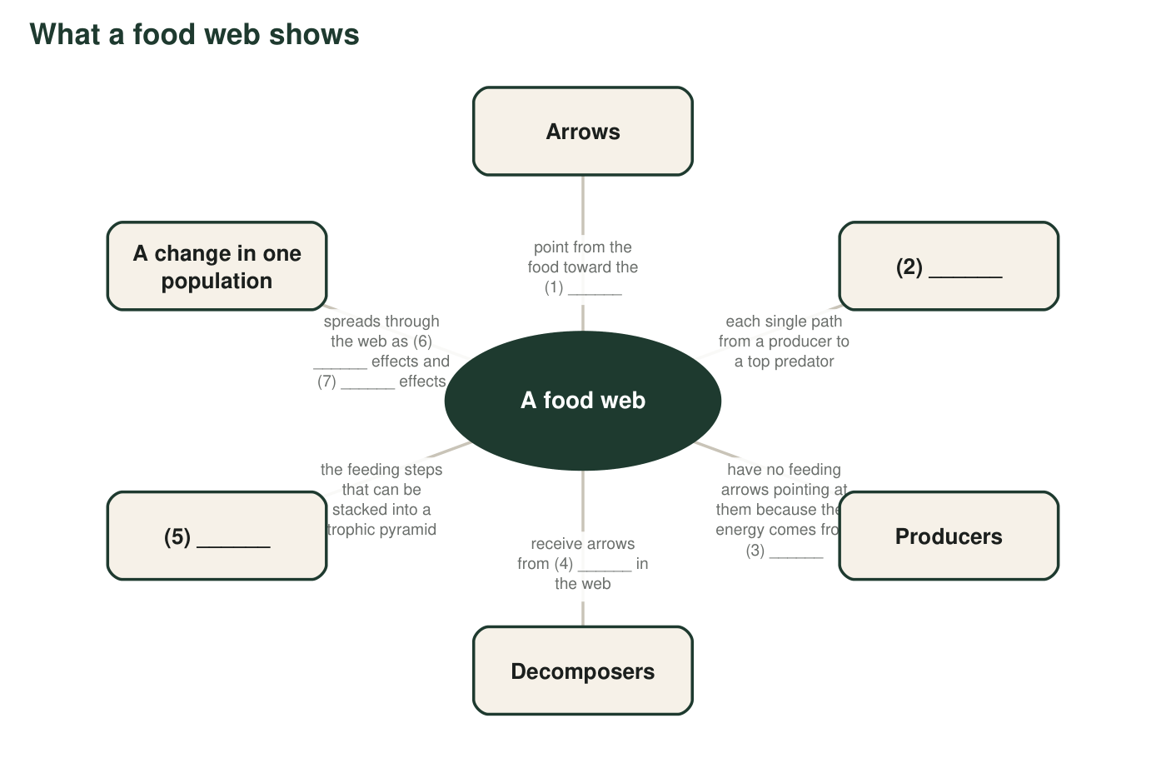
A concept map about food webs with seven blanks. Each blank is a word or phrase from the word bank or from your earlier lessons.
9. Fill each numbered blank in the concept map.
Word or phrase that fills the blank
Blank 1
Blank 2
Blank 3
Blank 4
Blank 5
Blank 6
Blank 7

Part D: Relationships between words
10. Only one of these pairs can describe the same organism at the same time: producer and consumer, consumer and decomposer, producer and top predator. Which pair is it, and why can the other two pairs never describe one organism?
______________________________________________________________________________________
______________________________________________________________________________________
______________________________________________________________________________________
11. Explain how trophic level and trophic pyramid are related. Which one is a part of the other?
______________________________________________________________________________________
______________________________________________________________________________________
______________________________________________________________________________________
12. A classmate says, 'A food chain and a food web are just two names for the same drawing.' Use a pond example to explain why that is wrong.
______________________________________________________________________________________
______________________________________________________________________________________
______________________________________________________________________________________
13. Write a short paragraph (4 to 6 sentences) about a desert ecosystem with creosote bushes, kangaroo rats, beetles, kit foxes, golden eagles and soil bacteria. Use at least six words from the word bank correctly. Underline each one.
______________________________________________________________________________________
______________________________________________________________________________________
______________________________________________________________________________________
______________________________________________________________________________________
______________________________________________________________________________________
______________________________________________________________________________________

Ask 'what kind of thing is it?'
If a term confuses you, ask what you could point to. Can you point to a living thing (an organism)? Can you point to a drawing on paper (a model)? Is it something that happens between two groups of organisms (an interaction)? Is it a number with a unit (a quantity)? For Part B, cross out any word that names the wrong kind of thing before you choose.

The word the textbook does not use
Many scientists use the word detritivore for animals such as earthworms, dung beetles and crayfish that eat dead material, and keep decomposer for bacteria and fungi that break material down outside their bodies. Write your own definition of detritivore in the style of the word bank, place it in one of the four rows from Part A, and explain in two sentences what an earthworm and a mushroom have in common and how they differ in the way they feed.

