Angela's Tools · Chapter 6: Food Webs and Trophic Pyramids · Worksheet 4 of 10

Draw the Pond: Building a Food Web and Tracing Matter and Energy (Teacher answer key)
Learning target: I can build a food web from feeding facts, read it to find chains and direct and indirect effects, and model how matter cycles between living and nonliving parts while energy flows through and leaves as heat.
Diagrams and models · about 45 minutes · individual · Standards: MS-LS2-3 (assesses)

Standards connections
MS-LS2-3 (assesses): Students construct a model of a pond that shows where matter goes (including the air, water and mud) and where energy goes, and they define what is inside and outside the system. That is the PE's own task. The sheet stays within the assessment boundary: no chemical reactions are written.

Answers with reasoning

Figure 1: Who eats whom in Willow Pond
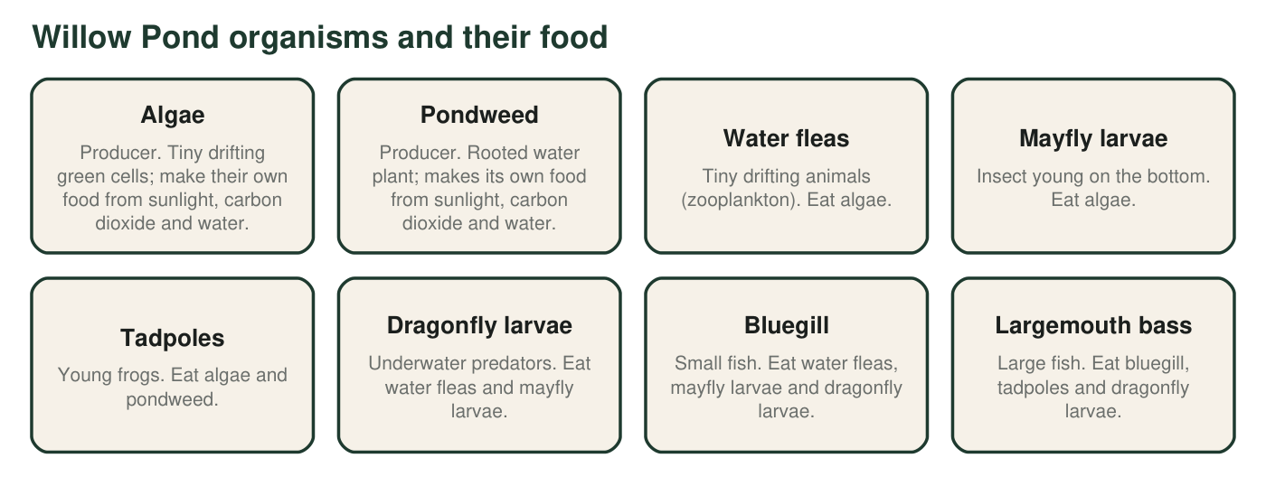
Feeding facts for ten groups of organisms in a small farm pond. The feeding links are typical for California farm ponds and are simplified for this model.
Draw the Willow Pond food web. Put the two producers at the bottom, the heron at the top, and the decomposers off to one side. Draw a solid arrow from each food to its eater (you should have 14 solid arrows). Draw a dashed arrow from every organism to the decomposers. Add a small sun and one arrow from the sun to each producer.
Expected drawing: Fourteen solid arrows: algae to water fleas, algae to mayfly larvae, algae to tadpoles, pondweed to tadpoles, water fleas to dragonfly larvae, mayfly larvae to dragonfly larvae, water fleas to bluegill, mayfly larvae to bluegill, dragonfly larvae to bluegill, bluegill to bass, tadpoles to bass, dragonfly larvae to bass, bass to heron, bluegill to heron. Dashed arrows from all nine other groups to the decomposers. A sun with arrows to algae and to pondweed. Producers at the bottom, heron at the top.
Reasoning: Every solid arrow corresponds to one food listed in Figure 1. The most common errors are arrows drawn backward (from eater to food) and a missing pondweed-to-tadpole arrow.

Part A: Read your web
1. Which organisms have no solid arrows pointing at them? Explain what that tells you about where they get their matter and energy.
Answer: Algae and pondweed. No solid arrows point at them because they are producers: they do not get matter and energy by eating other organisms. They build their matter from carbon dioxide and water and get energy from sunlight.
Reasoning: Producers are identified by the absence of incoming feeding arrows.
Also acceptable: Accept 'they get energy from the sun, not from eating.'
Full credit must include:
• Names both producers
• Explains that producers make their own food from carbon dioxide, water and sunlight
2. Not counting the dashed arrows, which organism has the most solid arrows leaving it? How many? What does a large number of leaving arrows mean for that organism?
Answer: Algae, with 3 arrows leaving (to water fleas, mayfly larvae and tadpoles). Many leaving arrows mean the organism is food for many different populations, so many consumers depend on it and a change in it would spread widely.
Reasoning: Count from Figure 1: algae are eaten by three groups; every other organism has 2 or fewer.
Also acceptable: If a student counts dashed arrows, every organism has one more; the answer is still algae.
Full credit must include:
• Names algae
• Gives 3
• Interprets leaving arrows as being prey or food for many
3. Write one food chain from algae to the heron that has exactly 3 arrows, and one that has 5 arrows. Use arrows between the names.
Answer: 3 arrows: algae → water fleas → bluegill → heron (or algae → tadpoles → bass → heron, or algae → mayfly larvae → bluegill → heron). 5 arrows: algae → water fleas → dragonfly larvae → bluegill → bass → heron (or the same with mayfly larvae in place of water fleas).
Reasoning: The shortest chains have three arrows; the longest possible chain passes through dragonfly larvae, bluegill and bass and has five arrows.
Also acceptable: Any chain that follows the listed feeding facts earns credit.
Full credit must include:
• A valid 3-arrow chain that follows Figure 1
• A valid 5-arrow chain that follows Figure 1
• Arrows point toward the eater
4. Why does the heron count as a top predator in this model? Name one organism not shown that could change that, and explain how adding it would change the web.
Answer: The heron is a top predator here because no organism in this model eats it; no solid arrow leaves it. A coyote, bobcat or large hawk that preys on herons (or on their chicks) would add an arrow leaving the heron, and the new animal would become the top of the web.
Reasoning: Top predator is defined relative to the organisms the model includes, which the chapter's accuracy notes stress.
Also acceptable: Accept an egg predator (raccoon) with the explanation that it eats heron young.
Full credit must include:
• Explains top predator as 'no arrow leaves it' in this model
• Names a plausible predator or scavenger of herons
• States that the new organism would take the top position
5. Why are there no arrows from the decomposers back to the algae or the pondweed, even though producers depend on what decomposers release?
Answer: Producers do not eat decomposers, so there is no feeding arrow. Decomposers release carbon dioxide and nutrients into the water and mud, and the producers take those materials in from the nonliving surroundings. That path appears in Figure 2 through the water, air and mud box, not as a feeding arrow.
Reasoning: Arrows in a food web mean 'is eaten by'; the decomposer-to-producer link runs through the environment.
Also acceptable: Accept 'the nutrients go into the water first, then the plants take them in.'
Full credit must include:
• States that producers do not eat decomposers
• Explains that the link passes through the water, air or mud

Part B: A change in the web
Suppose a pesticide washes into Willow Pond and kills almost all the dragonfly larvae, but harms nothing else directly.
6. Name two populations that would change as a direct effect of losing the dragonfly larvae, and say whether each would go up or down. Use the arrows to justify each answer.
Answer: Water fleas and mayfly larvae would go up (direct effect: their predator is gone, so fewer of them are eaten). Bluegill and bass would be affected directly too, because they lose one of their foods; they might go down a little, though both have other foods.
Reasoning: A direct effect involves a population that the dragonfly larvae eat or that eats them. Both prey and predators of the larvae count.
Also acceptable: Any two of water fleas (up), mayfly larvae (up), bluegill (down or little change), bass (down or little change) with justification.
Full credit must include:
• Two populations that share an arrow with dragonfly larvae
• Correct direction for each
• Uses the arrows to justify
7. Name one population that would change as an indirect effect. Trace the path through the web that connects it to the dragonfly larvae, naming the population in between.
Answer: Algae would go down as an indirect effect: dragonfly larvae gone → more water fleas and mayfly larvae survive → they eat more algae. The population in between is the water fleas (or the mayfly larvae).
Reasoning: Dragonfly larvae do not eat algae; the effect reaches algae through their prey.
Also acceptable: Accept the heron (a slight decrease, reached through bluegill and bass) or tadpoles (a decrease, because bass that lose dragonfly larvae may eat more tadpoles), as long as the path through a middle population is traced.
Full credit must include:
• Names a population that does not share an arrow with dragonfly larvae
• Traces the path and names the population in between
• Correct direction

Part C: Matter and energy in the same pond
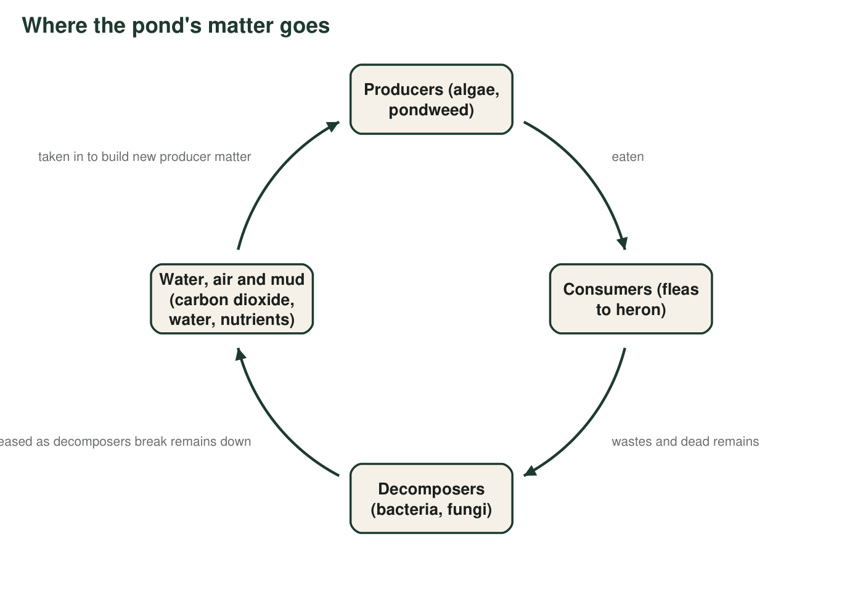
Figure 2. The cycle of matter in Willow Pond. Arrows show where matter goes. The nonliving parts of the pond (water, air above it, and mud) are part of the cycle.
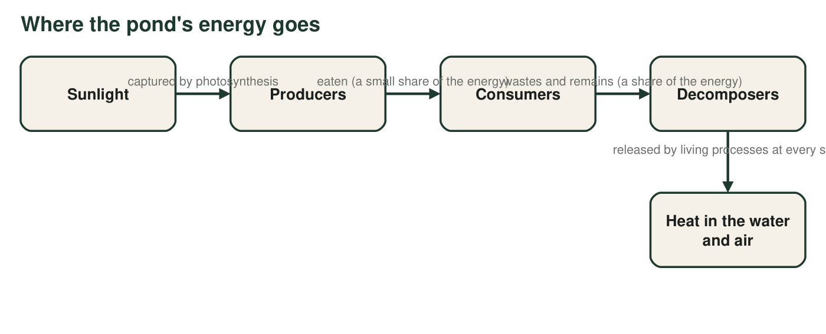
Figure 3. The path of energy through Willow Pond. Energy enters as sunlight and leaves as heat at every living step; none of it returns to the start.
8. Figure 2 is drawn as a loop and Figure 3 is drawn as a line. Explain what that difference in shape says about matter and energy in the pond.
Answer: The loop shows that matter is reused: the atoms in a dead fish become nutrients in the mud, then part of a pondweed, then part of a tadpole, and so on without being used up. The line shows that energy passes through once: it enters as sunlight and leaves as heat at each step, and heat in the water cannot be captured again by producers, so the pond needs a constant new supply.
Reasoning: The shapes encode the key contrast: matter cycles, energy flows one way.
Also acceptable: Accept 'matter cycles, energy flows' with a short explanation of each.
Full credit must include:
• Matter is reused or recycled (loop)
• Energy flows one way and leaves as heat (line)
• States that heat cannot be reused by producers
9. Figure 2 has a nonliving box in it. Name the three things that box supplies to producers, and name one way matter gets into that box from living things other than through decomposers.
Answer: The box supplies carbon dioxide, water and nutrients (such as nitrogen-containing materials). Matter also enters the box when any living organism breathes out carbon dioxide during cellular respiration, or when consumers release wastes directly into the water.
Reasoning: This checks that students see nonliving parts as part of the system and know that respiration by all organisms, not only decomposers, returns carbon dioxide.
Also acceptable: Accept 'fish breathe out carbon dioxide into the water.'
Full credit must include:
• Names carbon dioxide, water and nutrients
• Names respiration (breathing out carbon dioxide) or direct waste release as another input to the nonliving box
10. Figure 3 shows heat leaving at every step but shows energy entering only once. Explain why the pond needs sunlight every day but does not need a daily delivery of new carbon atoms.
Answer: Energy leaves the pond as heat at every step and cannot be collected again by the producers, so the only way to keep the web running is a fresh supply of sunlight every day. Carbon atoms are not used up: the carbon dioxide released by respiration and decomposition stays in the water and air, where producers take it in again, so the same atoms cycle around the pond year after year.
Reasoning: The contrast between a one-way energy flow and a closed matter loop is the chapter's central idea.
Also acceptable: A student who adds that a little matter does enter and leave (rain, leaves blowing in) is reasoning well; the point is that the pond does not depend on it.
Full credit must include:
• Energy leaves as heat and cannot be recaptured
• Carbon atoms are recycled through carbon dioxide
• Connects each to the daily need or lack of it
11. Your food web, Figure 2 and Figure 3 all describe the same pond. Write one sentence that states the boundary of the system (what is inside and what is outside), and name one thing that crosses the boundary in each direction.
Answer: Example: The system is the pond with its water, mud, the air just above the surface and all the organisms living in it; the farm fields, the stream that feeds the pond and the sky are outside. Crossing in: sunlight, rain, leaves blown in. Crossing out: heat, carbon dioxide drifting into the air above, a heron that flies away after eating.
Reasoning: The PE's clarification emphasizes defining the system boundary. Any reasonable boundary earns credit if the student names an input and an output that cross it.
Also acceptable: A student who treats the heron as outside the system (it flies in to feed) has drawn a defensible boundary; then the heron's visits are the crossing.
Full credit must include:
• States a clear boundary
• Names one thing crossing in
• Names one thing crossing out

Teacher notes
The feeding facts are simplified but realistic for a California farm pond: water fleas (Daphnia) and mayfly larvae graze algae, dragonfly larvae take small invertebrates, bluegill eat invertebrates, bass eat bluegill and tadpoles, and great blue herons take fish. The 14-arrow count is the key check for the drawing; students who draw arrows backward usually also misread q2. For q7, several indirect answers are valid as long as the path is traced through a middle population. Figure 2 includes the nonliving parts on purpose: the PE asks for cycling among living and nonliving components, and q9 and q11 target that. Keep the discussion at the level of 'carbon dioxide and nutrients are released and taken in'; the assessment boundary excludes chemical equations.

