Angela's Tools · Chapter 6: Food Webs and Trophic Pyramids · Worksheet 4 of 10

Draw the Pond: Building a Food Web and Tracing Matter and Energy
Learning target: I can build a food web from feeding facts, read it to find chains and direct and indirect effects, and model how matter cycles between living and nonliving parts while energy flows through and leaves as heat.
Diagrams and models · about 45 minutes · individual · Standards: MS-LS2-3 (assesses)
Name: ____________________________ Date: ____________ Period: ______

Directions
Figure 1 lists the organisms of a small farm pond and what each one eats. You will turn that list into a food web in the drawing box: write each organism's name, then draw one arrow from every food to the organism that eats it. Arrows point toward the eater. Use a different color or a dashed line for the arrows to the decomposers. Then use Figures 2 and 3 to answer the questions about matter and energy. Work in pencil first; you will revise.

Figure 1: Who eats whom in Willow Pond
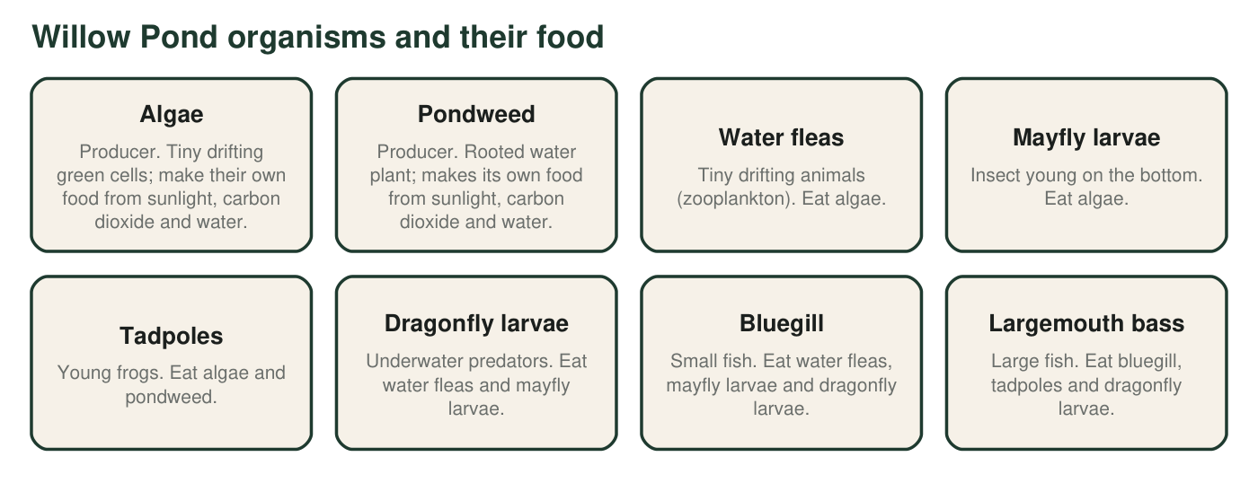
Feeding facts for ten groups of organisms in a small farm pond. The feeding links are typical for California farm ponds and are simplified for this model.
Draw the Willow Pond food web. Put the two producers at the bottom, the heron at the top, and the decomposers off to one side. Draw a solid arrow from each food to its eater (you should have 14 solid arrows). Draw a dashed arrow from every organism to the decomposers. Add a small sun and one arrow from the sun to each producer.

Part A: Read your web
1. Which organisms have no solid arrows pointing at them? Explain what that tells you about where they get their matter and energy.
______________________________________________________________________________________
______________________________________________________________________________________
2. Not counting the dashed arrows, which organism has the most solid arrows leaving it? How many? What does a large number of leaving arrows mean for that organism?
______________________________________________________________________________________
______________________________________________________________________________________
3. Write one food chain from algae to the heron that has exactly 3 arrows, and one that has 5 arrows. Use arrows between the names.
______________________________________________________________________________________
______________________________________________________________________________________
______________________________________________________________________________________
4. Why does the heron count as a top predator in this model? Name one organism not shown that could change that, and explain how adding it would change the web.
______________________________________________________________________________________
______________________________________________________________________________________
______________________________________________________________________________________
5. Why are there no arrows from the decomposers back to the algae or the pondweed, even though producers depend on what decomposers release?
______________________________________________________________________________________
______________________________________________________________________________________

Part B: A change in the web
Suppose a pesticide washes into Willow Pond and kills almost all the dragonfly larvae, but harms nothing else directly.
6. Name two populations that would change as a direct effect of losing the dragonfly larvae, and say whether each would go up or down. Use the arrows to justify each answer.
______________________________________________________________________________________
______________________________________________________________________________________
______________________________________________________________________________________
______________________________________________________________________________________
7. Name one population that would change as an indirect effect. Trace the path through the web that connects it to the dragonfly larvae, naming the population in between.
______________________________________________________________________________________
______________________________________________________________________________________
______________________________________________________________________________________
______________________________________________________________________________________

Part C: Matter and energy in the same pond
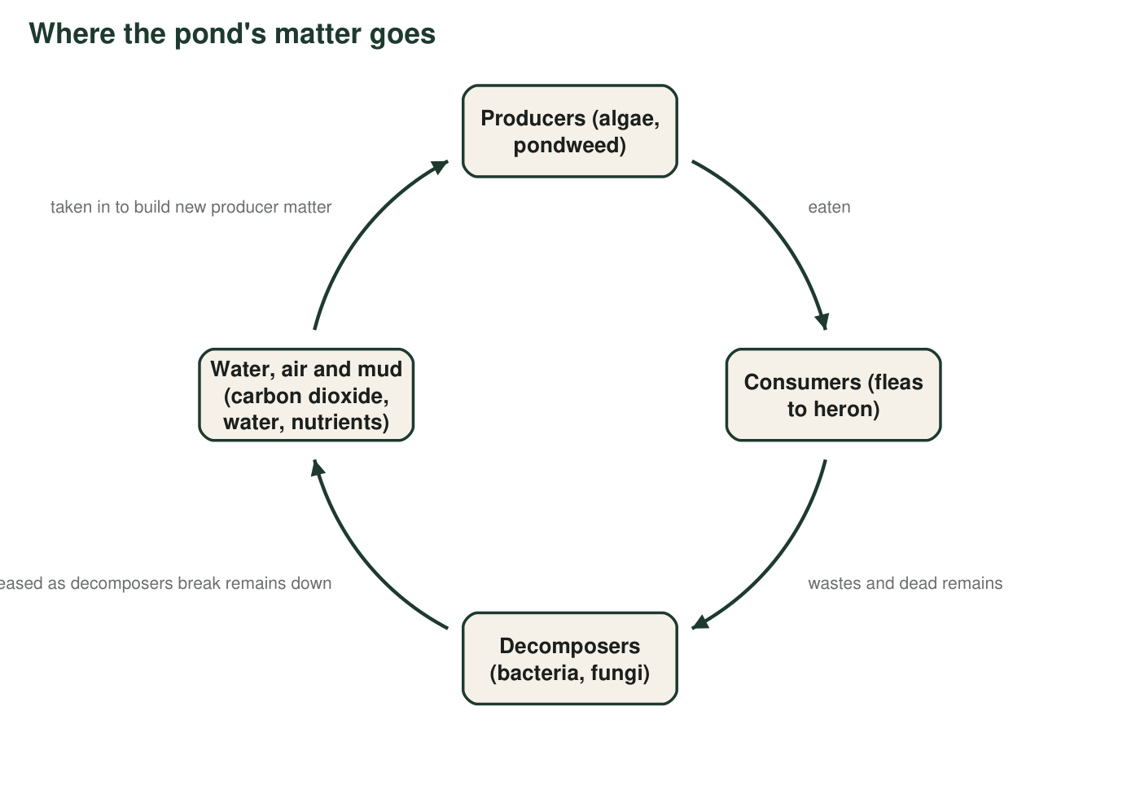
Figure 2. The cycle of matter in Willow Pond. Arrows show where matter goes. The nonliving parts of the pond (water, air above it, and mud) are part of the cycle.
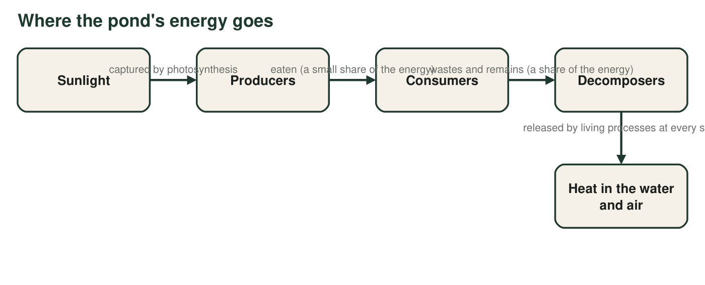
Figure 3. The path of energy through Willow Pond. Energy enters as sunlight and leaves as heat at every living step; none of it returns to the start.
8. Figure 2 is drawn as a loop and Figure 3 is drawn as a line. Explain what that difference in shape says about matter and energy in the pond.
______________________________________________________________________________________
______________________________________________________________________________________
______________________________________________________________________________________
9. Figure 2 has a nonliving box in it. Name the three things that box supplies to producers, and name one way matter gets into that box from living things other than through decomposers.
______________________________________________________________________________________
______________________________________________________________________________________
______________________________________________________________________________________
10. Figure 3 shows heat leaving at every step but shows energy entering only once. Explain why the pond needs sunlight every day but does not need a daily delivery of new carbon atoms.
______________________________________________________________________________________
______________________________________________________________________________________
______________________________________________________________________________________
11. Your food web, Figure 2 and Figure 3 all describe the same pond. Write one sentence that states the boundary of the system (what is inside and what is outside), and name one thing that crosses the boundary in each direction.
______________________________________________________________________________________
______________________________________________________________________________________
______________________________________________________________________________________

Build the web one organism at a time
Start by writing the ten names in the box in three rows: producers at the bottom, small eaters in the middle, fish and heron at the top. Then take Figure 1 one line at a time. For 'Water fleas: eat algae,' draw one arrow starting at algae and ending at water fleas. When a line names two or three foods, draw two or three arrows. Check your count at the end: 3 arrows leave algae, 1 leaves pondweed, 2 leave water fleas, 2 leave mayfly larvae, 1 leaves tadpoles, 2 leave dragonfly larvae, 2 leave bluegill, 1 leaves bass. That is 14.

Add two organisms, predict the ripple
Add a crayfish (eats dead material on the bottom, pondweed and snails) and a raccoon (eats crayfish, bluegill and frogs) to your web. Then write a short paragraph predicting the direct and indirect effects on the rest of the pond if raccoons became common, and explain whether the heron is still a top predator in your new model. Finally, describe one way matter in a dead raccoon on the bank could end up in a pondweed leaf next spring.

