Angela's Tools · Chapter 7: Global Cycles of Matter · Worksheet 1 of 10

Two Ponds, One Rainstorm: Why Did Only One Turn Green? (Teacher answer key)
Learning target: I can observe a change in a pond, record what I notice and wonder, and write a first explanation that follows matter from a field into living things.
Phenomenon exploration · about 25 minutes · pairs · Standards: MS-LS2-3 (practice), MS-LS2-4 (supports)

Standards connections
MS-LS2-3 (practice): Students build a first, rough model of matter moving from a fertilizer bag through water into the bodies of algae. It starts the practice of modeling matter cycling between nonliving and living parts of an ecosystem; it is not yet evidence toward the PE.
MS-LS2-4 (supports): The dead fish at the end of the story hint that a change to a nonliving part of the pond (added nitrate) changed a population. That idea is background here and is developed in Worksheets 5 and 8.

Answers with reasoning

The story
The Arroyo family runs a small farm east of Modesto. They have two ponds. Upper Pond sits on a hill above the fields and is fed by a spring. Lower Pond sits at the bottom of the hill, just below a six-hectare cornfield. On April 20, the family spread nitrate fertilizer on the cornfield. On May 3, a storm dropped more rain in three days than the farm had seen in the whole previous month, and brown water ran off the field into Lower Pond. By May 24, Lower Pond was covered in a bright green scum that smelled like rotting grass. Upper Pond, 200 meters away, stayed clear the whole time. On May 30, before sunrise, the family found fourteen dead bluegill floating in Lower Pond. The water tests they paid for are shown in the figure.
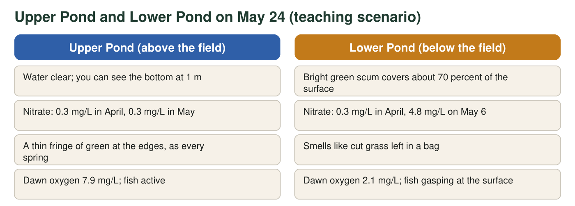
Both ponds are about 40 m across and 2 m deep and had the same storm, temperature and sunlight. The numbers are a teaching scenario built to be realistic; they were not measured at a real farm. Fish usually need dawn oxygen above about 5 mg/L.
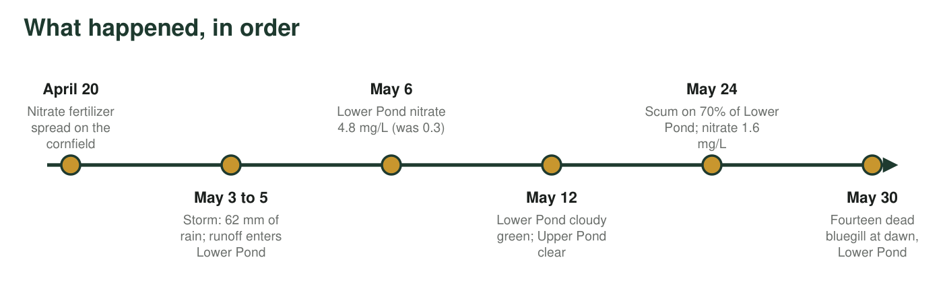

Part A: Notice and wonder (alone)
1. Write at least four things you notice in the story, the figure or the timeline. A notice is something you can point to, not a guess about why. Include at least one number.
Answer: Any four accurate observations, for example: Lower Pond is below the fertilized field and Upper Pond is above it; nitrate in Lower Pond rose from 0.3 to 4.8 mg/L after the storm; the storm dropped 62 mm of rain; the green scum covered about 70 percent of Lower Pond by May 24; nitrate fell to 1.6 mg/L by May 24 as the scum grew; dawn oxygen was 2.1 mg/L in Lower Pond and 7.9 mg/L in Upper Pond; fourteen bluegill died at dawn; both ponds are the same size and had the same weather.
Reasoning: Notices must be observable facts from the text, figure or timeline, not explanations. At least one must include a number.
Also acceptable: A student who writes 'the pond smelled like cut grass' or 'the scum is green' is observing correctly, even though these are not numeric.
Full credit must include:
• Four or more observations
• At least one includes a number
• No explanations disguised as observations
2. Write at least three things you wonder. Write each one as a question that could be answered by measuring or testing something.
Answer: Examples: Would the pond have turned green if the fertilizer had been spread after the storm instead of before it? How much of the fertilizer ended up in the pond? Why did nitrate fall from 4.8 to 1.6 mg/L while the scum grew? Why is oxygen lowest at dawn? Would Upper Pond turn green if fertilizer were added to it on purpose? How long will the scum last?
Reasoning: Each wonder must be phrased as a question that a measurement or test could answer. Vague wonders ('why ponds?') do not meet the bar.
Also acceptable: Accept questions about the fish, the smell, or the timing as long as they are testable.
Full credit must include:
• Three or more questions
• Each could be answered by measuring or testing

Part B: What you already know (with a partner)
3. The green scum is made of billions of tiny algae, which are producers like plants. List everything you think a producer needs in order to grow and build more of itself.
Answer: Sunlight, water, carbon dioxide (dissolved in the water or from the air), and nutrients dissolved in the water such as nitrogen-containing substances (nitrate, ammonium) and phosphorus. Warmth also helps.
Reasoning: This probes prior knowledge. Many students will list only sunlight and water; the chapter adds carbon dioxide and nitrogen compounds as the matter producers are built from.
Also acceptable: Accept 'fertilizer' or 'nutrients' for the nitrogen compounds. A student who lists 'soil' should be asked later what in soil a plant actually takes in.
Full credit must include:
• Lists light and water
• Lists at least one source of matter: carbon dioxide or dissolved nutrients
4. By May 24 Lower Pond held several kilograms of new algae that were not there in April. Where did the matter that makes up those algae most likely come from?
Answer: B. Substances dissolved in the water, including the fertilizer that washed in, plus carbon dioxide, were built into the algae.
Reasoning: Algae are producers: they build their bodies from carbon dioxide, water and dissolved nutrients using light energy. Sunlight is energy, not matter (A). The fish died after the scum formed, so they cannot be its source (C). Algae do not eat mud (D).
Also acceptable: None. Discuss option A in the debrief: energy from sunlight powers the building, but it is not what the algae are made of.
5. Nitrate in Lower Pond rose from 0.3 mg/L to 4.8 mg/L after the storm. By how many mg/L did it rise, and how many times greater is the May 6 value than the April value? Show your work.
Answer: Rise: 4.8 mg/L − 0.3 mg/L = 4.5 mg/L. Ratio: 4.8 ÷ 0.3 = 16, so the May 6 value is 16 times the April value.
Reasoning: Simple subtraction and division; the point is to notice that this is a large change, not a small drift.
Also acceptable: Accept 'about 16 times' or 'sixteen-fold'.

Part C: Your first explanation
6. Write your first explanation of why Lower Pond turned green. Describe the path matter took as a chain of at least four steps, starting with the fertilizer bag and ending with the green scum. Use the word because at least twice.
Answer: A strong first explanation: (1) The fertilizer contained nitrate, which dissolves easily in water. (2) The storm washed water across the field and carried dissolved nitrate downhill into Lower Pond because the pond sits below the field. (3) Algae in the pond took in the nitrate, along with carbon dioxide and water, and used it to build more algae because nitrogen is needed to make proteins and other parts of their cells. (4) With far more nitrate than usual, the algae multiplied until their bodies covered most of the surface as green scum, which is why nitrate fell as the scum grew.
Reasoning: This is a pre-assessment. Credit any chain that starts at the fertilizer, passes through water, and ends with algae built from the dissolved matter. Do not penalize missing vocabulary; note misconceptions (sunlight becomes algae, fertilizer 'feeds' algae the way food feeds animals) for Worksheet 7.
Also acceptable: A student who says the fertilizer 'fed' the algae is partly right; push later toward 'was built into'.
Full credit must include:
• At least four ordered steps
• Starts with the fertilizer and ends with the scum
• Uses 'because' at least twice to give reasons
• Matter is described as moving, not appearing
7. Upper Pond had the same storm, sunlight and temperature but stayed clear. What does that comparison let you rule out, and what does it point to?
Answer: It rules out the storm, sunlight, temperature and pond size as the cause by themselves, since Upper Pond had all of those and stayed clear. It points to the one difference: Lower Pond received runoff from the fertilized field and its nitrate jumped, while Upper Pond's nitrate did not change.
Reasoning: This is the logic of a controlled comparison. The two ponds act as a natural control and treatment.
Also acceptable: Accept 'the position below the field' as the difference if the student connects it to runoff.
Full credit must include:
• Names at least one shared factor that is ruled out
• Identifies the fertilizer runoff or nitrate rise as the key difference
8. Draw a first model of the farm: the field, the hill, Lower Pond and the air above it. Add arrows that show where you think matter moved, and label each arrow with what moved (for example, 'nitrate in runoff'). Circle the living things.
Answer: A sketch showing the field uphill, Lower Pond downhill and the air above. Arrows: 'nitrate in rainwater' from field to pond; 'nitrate taken in' from water to algae; 'carbon dioxide' from air or water to algae; optionally 'dead algae' sinking to the bottom and 'oxygen used' by bacteria. Algae, fish and bacteria circled as living things.
Reasoning: This is the student's initial model and will be revisited in Worksheet 4 and the mastery check. Look for arrows that carry matter into the algae rather than arrows that just point at the pond.
Also acceptable: Any reasonable layout. An arrow from the sun labeled 'energy' is a good addition if it is not labeled as matter.
Full credit must include:
• Field, pond and air drawn
• At least two labeled arrows showing matter moving
• Living things circled
9. The fish died at dawn, not in the afternoon. Write one question this raises for you and one measurement you would take to answer it.
Answer: Example question: 'Does the oxygen in Lower Pond drop during the night?' Measurement: dissolved oxygen in both ponds every few hours for a full day and night. Other acceptable pairs: 'Are the algae using oxygen at night?' measured by oxygen in a covered jar of pond water; 'Are bacteria breaking down dead algae?' measured by counting sinking dead algae and oxygen near the bottom.
Reasoning: The question should link the timing (dawn) to something measurable. The answer is previewed in the extension: producers and decomposers use oxygen all night while no new oxygen is made.
Also acceptable: Accept temperature or light measurements if the student explains how they would test the dawn timing.
Full credit must include:
• A specific question tied to the dawn timing
• A matching measurement

Teacher notes
This is an activation sheet; collect it and return it at the end of the chapter so students can revise q6 and q8. The scenario is invented but realistic: nitrate is highly soluble and is not held by soil particles, so a storm shortly after application moves a large share of it into surface water; algal blooms follow within one to three weeks in warm weather; dawn is the oxygen minimum because algae and decomposers use oxygen all night while photosynthesis has stopped. Expect q4 answers of A (sunlight becomes algae) from several students; that misconception is targeted in Worksheet 7. Keep the debrief short: the point is to surface ideas, not to teach the cycles yet. The phenomenon returns in Worksheet 5 (data), Worksheet 8 (evidence jigsaw) and Lab 3.

