Angela's Tools · Chapter 7: Global Cycles of Matter · Worksheet 1 of 10

Two Ponds, One Rainstorm: Why Did Only One Turn Green?
Learning target: I can observe a change in a pond, record what I notice and wonder, and write a first explanation that follows matter from a field into living things.
Phenomenon exploration · about 25 minutes · pairs · Standards: MS-LS2-3 (practice), MS-LS2-4 (supports)
Name: ____________________________ Date: ____________ Period: ______

Directions
Read the story of the two ponds and study the figure and the timeline. Do Part A alone before talking to anyone. In Part B and Part C, work with a partner but write your own answers. There are no wrong answers in Part A and Part C; the goal is to write down what you think now so you can compare it with what you think at the end of the chapter.

The story
The Arroyo family runs a small farm east of Modesto. They have two ponds. Upper Pond sits on a hill above the fields and is fed by a spring. Lower Pond sits at the bottom of the hill, just below a six-hectare cornfield. On April 20, the family spread nitrate fertilizer on the cornfield. On May 3, a storm dropped more rain in three days than the farm had seen in the whole previous month, and brown water ran off the field into Lower Pond. By May 24, Lower Pond was covered in a bright green scum that smelled like rotting grass. Upper Pond, 200 meters away, stayed clear the whole time. On May 30, before sunrise, the family found fourteen dead bluegill floating in Lower Pond. The water tests they paid for are shown in the figure.
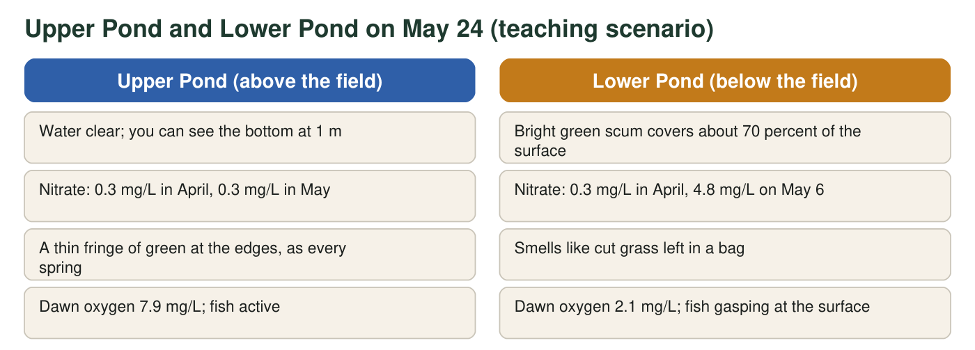
Both ponds are about 40 m across and 2 m deep and had the same storm, temperature and sunlight. The numbers are a teaching scenario built to be realistic; they were not measured at a real farm. Fish usually need dawn oxygen above about 5 mg/L.
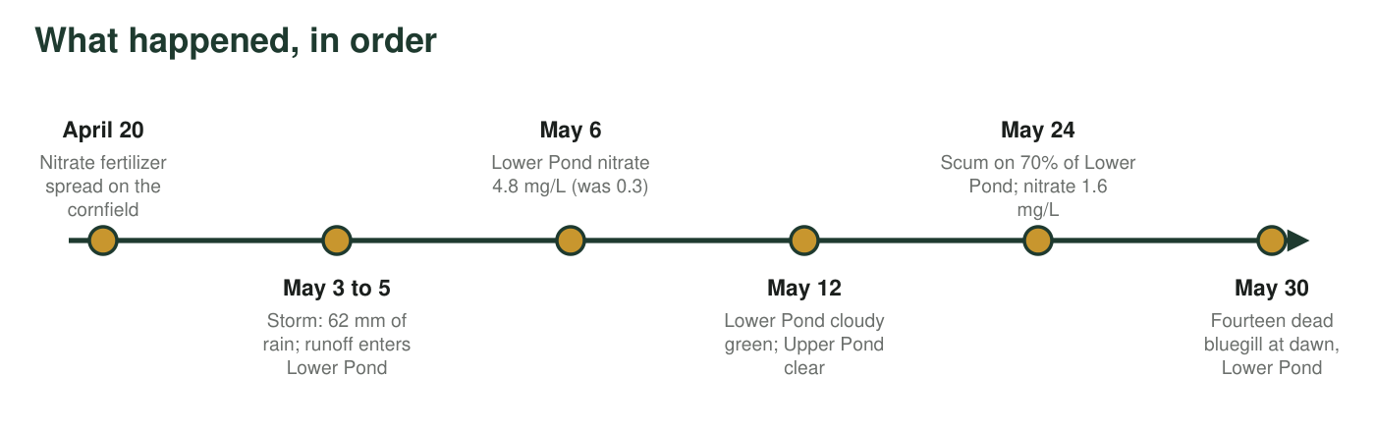

Part A: Notice and wonder (alone)
1. Write at least four things you notice in the story, the figure or the timeline. A notice is something you can point to, not a guess about why. Include at least one number.
______________________________________________________________________________________
______________________________________________________________________________________
______________________________________________________________________________________
______________________________________________________________________________________
______________________________________________________________________________________
______________________________________________________________________________________
2. Write at least three things you wonder. Write each one as a question that could be answered by measuring or testing something.
______________________________________________________________________________________
______________________________________________________________________________________
______________________________________________________________________________________
______________________________________________________________________________________
______________________________________________________________________________________

Part B: What you already know (with a partner)
3. The green scum is made of billions of tiny algae, which are producers like plants. List everything you think a producer needs in order to grow and build more of itself.
______________________________________________________________________________________
______________________________________________________________________________________
______________________________________________________________________________________
4. By May 24 Lower Pond held several kilograms of new algae that were not there in April. Where did the matter that makes up those algae most likely come from?
○ A. Sunlight was turned directly into algae.
○ B. Substances dissolved in the water, including the fertilizer that washed in, plus carbon dioxide, were built into the algae.
○ C. The dead fish were eaten by the algae.
○ D. The algae ate the mud at the bottom of the pond.
5. Nitrate in Lower Pond rose from 0.3 mg/L to 4.8 mg/L after the storm. By how many mg/L did it rise, and how many times greater is the May 6 value than the April value? Show your work.
______________________________________________________________________________________
______________________________________________________________________________________
______________________________________________________________________________________

Part C: Your first explanation
6. Write your first explanation of why Lower Pond turned green. Describe the path matter took as a chain of at least four steps, starting with the fertilizer bag and ending with the green scum. Use the word because at least twice.
______________________________________________________________________________________
______________________________________________________________________________________
______________________________________________________________________________________
______________________________________________________________________________________
______________________________________________________________________________________
______________________________________________________________________________________
______________________________________________________________________________________
7. Upper Pond had the same storm, sunlight and temperature but stayed clear. What does that comparison let you rule out, and what does it point to?
______________________________________________________________________________________
______________________________________________________________________________________
______________________________________________________________________________________
8. Draw a first model of the farm: the field, the hill, Lower Pond and the air above it. Add arrows that show where you think matter moved, and label each arrow with what moved (for example, 'nitrate in runoff'). Circle the living things.

9. The fish died at dawn, not in the afternoon. Write one question this raises for you and one measurement you would take to answer it.
______________________________________________________________________________________
______________________________________________________________________________________
______________________________________________________________________________________

Sentence frames for Part C
If you are not sure how to begin q6, use these frames: 'First, the fertilizer ______ because ______.' 'Then the rain ______, carrying ______ into ______.' 'In the pond, the algae ______ because ______.' 'As a result, by May 24 ______.' For q7, start with 'The only difference between the ponds was ______, so ______.'

The dawn clue
Algae make their own food in sunlight, but like every living thing they also use oxygen around the clock to release energy from that food. So do the bacteria that feed on dead algae. Using that idea, predict how the oxygen in Lower Pond changes from noon to dawn, sketch a line graph of oxygen versus time of day for both ponds, and explain in three sentences why the fish died before sunrise rather than at midday.

