Angela's Tools · Chapter 7: Global Cycles of Matter · Worksheet 2 of 10

Reservoirs, Routes and Rules: Sorting the Language of Cycles (Teacher answer key)
Learning target: I can tell the difference between a reservoir and a process in a cycle of matter, and use the chapter's terms to describe how matter moves and why its total never changes.
Vocabulary in action · about 30 minutes · individual · Standards: MS-LS2-3 (practice), MS-ESS2-4 (supports)

Standards connections
MS-LS2-3 (practice): Every arrow in a matter-cycle model is a process and every box is a reservoir. Sorting the terms this way builds the vocabulary students need to construct and explain their own cycling-of-matter models later in the chapter.
MS-ESS2-4 (supports): Water-cycle terms (evaporation, condensation, precipitation) appear in the sort. MS-ESS2-4 is a Grade 6 PE in the California integrated sequence; here the water cycle is background that students met last year, not a target of this chapter.

Answers with reasoning
reservoir: A place where matter is stored for a while in a cycle: the air, the ocean, soil, ice, living bodies, or buried fossil fuels.
closed system: A system that matter does not enter or leave. Energy can still flow in and out. Earth is very nearly closed for matter but wide open for energy.
law of conservation of matter: In ordinary physical and chemical changes, atoms are not created or destroyed. Seal a system so nothing gets in or out, and its total mass holds steady however its contents change form.
water cycle: A model of how water moves among air, land, oceans, ice and living things, changing between solid, liquid and gas along the way.
carbon cycle: A model of how carbon atoms move among air, water, soil, rock and living things as parts of different molecules.
nitrogen cycle: A model of how nitrogen atoms move between nitrogen gas in the air, nitrogen compounds in soil and water, and the proteins of living things.
photosynthesis: The process in which producers use light energy to build sugar from carbon dioxide and water. It moves carbon from the nonliving world into living things.
cellular respiration: The process in the cells of plants, animals and decomposers that breaks down sugar with oxygen to release energy, giving off carbon dioxide and water.
decomposer: An organism, such as a fungus or a bacterium, that feeds on wastes and dead remains and returns their matter to soil, water and air.
combustion: Burning: a fast reaction between a fuel and oxygen that releases energy and sends the fuel's carbon into the air as carbon dioxide.
nitrogen fixation: Turning nitrogen gas from the air into nitrogen compounds that living things can use. Certain bacteria do most of it; lightning and fertilizer factories do some.
nitrifying bacteria: Soil bacteria that change ammonium into nitrate, a form of nitrogen that plant roots absorb easily.
denitrifying bacteria: Bacteria that change nitrate back into nitrogen gas, which returns to the air. They thrive in wet soil with little oxygen.
fossil fuel: Coal, oil or natural gas: a fuel formed from the remains of ancient organisms buried under sediment and rock, with heat and pressure, over millions of years.
reforestation: Growing a forest again where one was cut down. As the trees grow, photosynthesis pulls carbon dioxide out of the air and stores the carbon as wood.

Part A: Reservoir or process?
1. For each item, write whether it is a reservoir (a place matter is stored) or a process (a route that moves matter), and name every cycle it belongs to. Some items belong to more than one cycle.
Answer: The ocean: reservoir; water and carbon (dissolved carbon dioxide; nitrogen is also acceptable). Evaporation: process; water. Nitrogen gas in the air: reservoir; nitrogen. Nitrogen fixation: process; nitrogen. The proteins in a peanut plant: reservoir; nitrogen and carbon. Cellular respiration: process; carbon and water (it releases both carbon dioxide and water). A coal seam: reservoir; carbon. Combustion: process; carbon (also releases water vapor). Ammonium in soil: reservoir; nitrogen. Photosynthesis: process; carbon and water (it takes in both).
Reasoning: Reservoirs are nouns naming a place or body that holds matter; processes are the routes between them. The second column rewards students who see that one process can serve two cycles.
Also acceptable: Accept 'carbon' alone for cellular respiration, photosynthesis and combustion; accept 'all three' for the ocean.
Full credit must include:
• All ten classified correctly as reservoir or process
• At least the primary cycle named for each
• Credit for naming second cycles where accurate

Part B: Complete the concept map
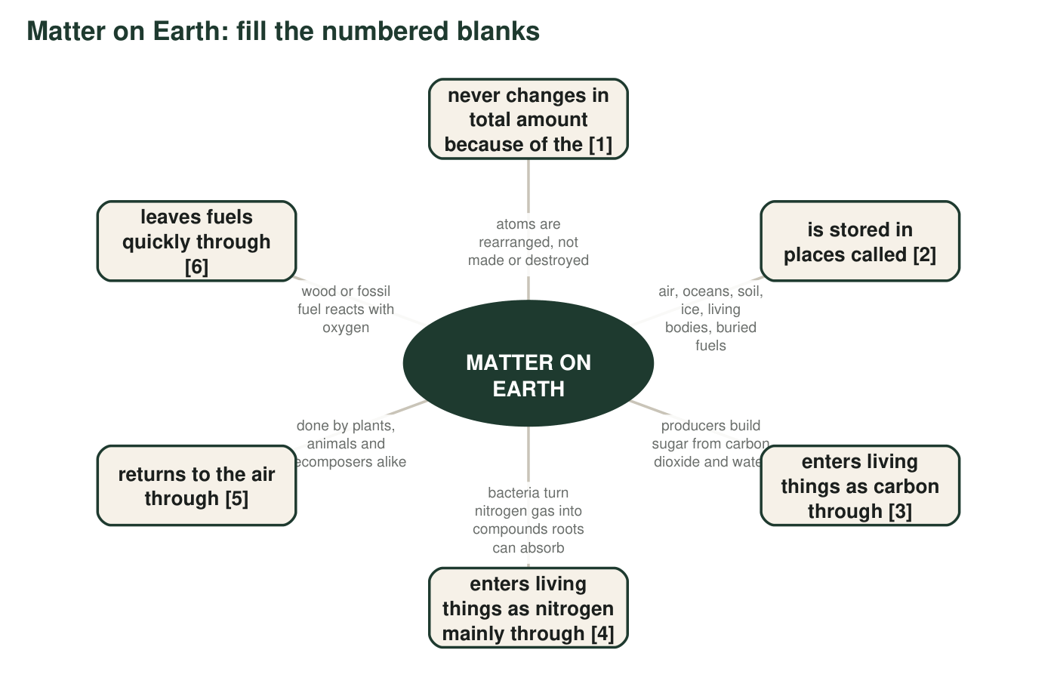
2. Write the term that belongs in each blank: [1] ______ [2] ______ [3] ______ [4] ______ [5] ______ [6] ______
Answer: [1] law of conservation of matter; [2] reservoirs; [3] photosynthesis; [4] nitrogen fixation; [5] cellular respiration; [6] combustion.
Reasoning: Each description beside the blank gives the clue: 'atoms are rearranged, not made or destroyed' identifies the law; 'bacteria turn nitrogen gas into compounds' identifies fixation; 'fuel reacts with oxygen' identifies combustion.
Also acceptable: Accept 'conservation of matter' for [1] and 'reservoir' (singular) for [2].

Part C: Which term fits?
Each situation below is an example of one term from the list. Write the term that fits best and, in a few words, say what gave it away.
3. A compost pile is warm in the middle and shrinks week by week, even though nobody removes anything from it.
Answer: Decomposer (or decomposition, with cellular respiration as the reason for warmth and shrinking). Clue: the pile shrinks with nothing removed, so matter is leaving as gas; warmth shows energy being released.
Reasoning: Decomposers break down the plant material and release carbon dioxide and water vapor through cellular respiration, which is why mass leaves and heat appears.
Also acceptable: Accept 'cellular respiration' if the student explains that decomposers are doing it.
4. After a thunderstorm, rainwater carries small amounts of nitrate into the soil that were not there before.
Answer: Nitrogen fixation (by lightning). Clue: new nitrate appears after a thunderstorm; lightning makes nitrogen gas react with oxygen, and the products dissolve in rain as nitrate.
Reasoning: This is the lightning route of fixation. Note the accurate product: nitrate, not ammonia.
Also acceptable: Accept 'nitrogen cycle' only with the lightning explanation.
5. A candle burns down to a stub, and a sensor above it shows carbon dioxide rising in the air.
Answer: Combustion. Clue: a fuel (wax) reacts with oxygen, the fuel disappears, and carbon dioxide rises.
Reasoning: The wax's carbon leaves as carbon dioxide; the stub is lighter, but the matter is now in the air.
Also acceptable: None.
6. Small lumps on the roots of a clover plant hold bacteria that take nitrogen gas from the air in the soil and make it usable.
Answer: Nitrogen fixation (nitrogen-fixing bacteria in root nodules). Clue: bacteria in root lumps turning nitrogen gas into a usable form.
Reasoning: Clover is a legume; its nodules house nitrogen-fixing bacteria that make ammonium from nitrogen gas.
Also acceptable: Accept 'nitrogen-fixing bacteria'.
7. A flooded, oxygen-poor field loses nitrogen to the air as a gas, so the farmer has to add more the next year.
Answer: Denitrifying bacteria (denitrification). Clue: wet, oxygen-poor soil; nitrogen leaves as a gas.
Reasoning: Denitrifiers convert nitrate to nitrogen gas, especially where oxygen is scarce, so flooded fields lose fixed nitrogen.
Also acceptable: Accept 'denitrification'.
8. A black rock that burns was once a swamp forest buried under sediment for about 300 million years.
Answer: Fossil fuel (coal). Clue: ancient buried organisms, millions of years, a rock that burns.
Reasoning: Coal formed from swamp forests buried under sediment with heat and pressure over very long times; its carbon has been out of the fast cycle until it is burned.
Also acceptable: Accept 'coal'.

Part D: How the terms relate
9. Photosynthesis and cellular respiration move carbon in opposite directions. Explain what each one does to carbon, using the words living and nonliving.
Answer: Photosynthesis moves carbon from the nonliving world (carbon dioxide in air or water) into living things by building it into sugar. Cellular respiration moves carbon from living things back to the nonliving world by breaking sugar down and releasing carbon dioxide.
Reasoning: The two processes are the main entry and exit of carbon for living things. Students should not be asked for chemical equations (MS-LS2-3 assessment boundary).
Also acceptable: Accept 'takes in carbon dioxide' and 'gives off carbon dioxide' as the descriptions.
Full credit must include:
• Photosynthesis described as nonliving to living
• Cellular respiration described as living to nonliving
10. Earth is called a closed system, yet sunlight arrives every day. Explain why that is not a contradiction.
Answer: Closed system refers to matter, not energy. Almost no atoms enter or leave Earth, so matter is conserved and must be reused. Energy is different: sunlight enters every day and heat leaves to space every night. Earth is closed for matter and open for energy.
Reasoning: This corrects a common reading of the textbook, which never states that Earth is open to energy. The distinction matters because energy flows through ecosystems while matter cycles.
Also acceptable: Accept 'closed to matter, open to energy' with a one-sentence explanation.
Full credit must include:
• States that 'closed' refers to matter
• States that energy enters (sunlight) and leaves (heat)
11. A classmate says: 'A fossil fuel is a reservoir, and combustion is the route out of it.' Do you agree? Explain, and name the reservoir the carbon goes to next.
Answer: Agree. A coal seam or oil deposit stores carbon for millions of years, so it is a reservoir. Combustion is the process that moves that carbon out, as carbon dioxide, into the next reservoir: the air (the atmosphere). From there it may dissolve in the ocean or be taken up by producers.
Reasoning: The question checks that students can chain reservoir, process, reservoir. The next reservoir is the atmosphere.
Also acceptable: Accept 'the air' or 'the atmosphere'; a student who adds the ocean as a later stop is correct.
Full credit must include:
• Agrees with a reason
• Names the atmosphere (air) as the next reservoir
12. Write one or two sentences that correctly use all three of these terms: reforestation, reservoir, photosynthesis.
Answer: Example: 'Reforestation adds trees that use photosynthesis to pull carbon dioxide out of the air, so the growing forest becomes a reservoir that stores carbon as wood.'
Reasoning: All three terms must be used correctly and connected: reforestation is the action, photosynthesis is the process, the forest is the reservoir.
Also acceptable: Any accurate sentence pair; the forest, the trees, or 'wood' may be named as the reservoir.
Full credit must include:
• All three terms used
• Each term used with its correct meaning
• The sentences connect the terms causally

Part E: Apply the terms to a new place
13. A sealed glass jar holds pond water, a water plant, a snail, and mud with bacteria. It sits by a window. Nothing goes in or out except light and heat. In three to five sentences, describe how carbon moves inside the jar over one day and night. Use at least four terms from the list and underline them.
Answer: Example: 'During the day the water plant carries out photosynthesis, taking carbon dioxide dissolved in the water and building it into sugar, so carbon moves from a nonliving reservoir into a living one. The snail eats the plant and builds some of that carbon into its body. Day and night, the plant, the snail and the decomposers in the mud carry out cellular respiration, releasing carbon dioxide back into the water. The jar is a closed system for matter, so by the law of conservation of matter the total amount of carbon inside never changes; it just moves between the water, the plant, the snail and the mud.'
Reasoning: Full credit needs at least four terms used correctly, a day-night contrast (photosynthesis only in light; respiration always), and the idea that carbon moves between reservoirs without being lost.
Also acceptable: A student who adds that the mud's decomposers return carbon from dead leaves is giving a stronger answer. Energy (light in, heat out) may be mentioned but must not be called matter.
Full credit must include:
• At least four list terms, underlined and used correctly
• Photosynthesis limited to the light; cellular respiration continuous
• Carbon described as moving between reservoirs
• Conservation of matter stated or clearly implied

Teacher notes
The definitions above are written to be accurate where the textbook simplifies: lightning fixation yields nitrate, not ammonia; decomposers release ammonium and nitrifiers make nitrate; animals obtain nitrogen as amino acids from protein, not as nitrate; Earth is closed for matter but open for energy. Part A is the heart of the sheet: the reservoir-versus-process distinction is what makes cycle diagrams readable, and students who master it find Worksheet 4 much easier. Common slips: calling cellular respiration 'breathing' (breathing moves gases in and out of lungs; respiration happens in cells) and classifying 'the proteins in a peanut plant' as a process because proteins are 'made'. The extension's travel diary is a good formative check on whether students understand that the three cycles are one interconnected set of reservoirs.

