Angela's Tools · Chapter 7: Global Cycles of Matter · Worksheet 2 of 10

Reservoirs, Routes and Rules: Sorting the Language of Cycles
Learning target: I can tell the difference between a reservoir and a process in a cycle of matter, and use the chapter's terms to describe how matter moves and why its total never changes.
Vocabulary in action · about 30 minutes · individual · Standards: MS-LS2-3 (practice), MS-ESS2-4 (supports)
Name: ____________________________ Date: ____________ Period: ______

Directions
Read the term list first. Every term is either a place where matter is stored (a reservoir) or a process that moves matter between places, or a rule about the whole system. Work through Parts A to E in order. Write complete sentences wherever a question asks you to explain. You may use a term more than once.
reservoir: A place where matter is stored for a while in a cycle: the air, the ocean, soil, ice, living bodies, or buried fossil fuels.
closed system: A system that matter does not enter or leave. Energy can still flow in and out. Earth is very nearly closed for matter but wide open for energy.
law of conservation of matter: In ordinary physical and chemical changes, atoms are not created or destroyed. Seal a system so nothing gets in or out, and its total mass holds steady however its contents change form.
water cycle: A model of how water moves among air, land, oceans, ice and living things, changing between solid, liquid and gas along the way.
carbon cycle: A model of how carbon atoms move among air, water, soil, rock and living things as parts of different molecules.
nitrogen cycle: A model of how nitrogen atoms move between nitrogen gas in the air, nitrogen compounds in soil and water, and the proteins of living things.
photosynthesis: The process in which producers use light energy to build sugar from carbon dioxide and water. It moves carbon from the nonliving world into living things.
cellular respiration: The process in the cells of plants, animals and decomposers that breaks down sugar with oxygen to release energy, giving off carbon dioxide and water.
decomposer: An organism, such as a fungus or a bacterium, that feeds on wastes and dead remains and returns their matter to soil, water and air.
combustion: Burning: a fast reaction between a fuel and oxygen that releases energy and sends the fuel's carbon into the air as carbon dioxide.
nitrogen fixation: Turning nitrogen gas from the air into nitrogen compounds that living things can use. Certain bacteria do most of it; lightning and fertilizer factories do some.
nitrifying bacteria: Soil bacteria that change ammonium into nitrate, a form of nitrogen that plant roots absorb easily.
denitrifying bacteria: Bacteria that change nitrate back into nitrogen gas, which returns to the air. They thrive in wet soil with little oxygen.
fossil fuel: Coal, oil or natural gas: a fuel formed from the remains of ancient organisms buried under sediment and rock, with heat and pressure, over millions of years.
reforestation: Growing a forest again where one was cut down. As the trees grow, photosynthesis pulls carbon dioxide out of the air and stores the carbon as wood.

Part A: Reservoir or process?
1. For each item, write whether it is a reservoir (a place matter is stored) or a process (a route that moves matter), and name every cycle it belongs to. Some items belong to more than one cycle.
Reservoir (storage) or process (route)? | Which cycle(s)? water, carbon, nitrogen
The ocean
Evaporation
Nitrogen gas in the air
Nitrogen fixation
The proteins in a peanut plant
Cellular respiration
A coal seam underground
Combustion
Ammonium in soil
Photosynthesis

Part B: Complete the concept map
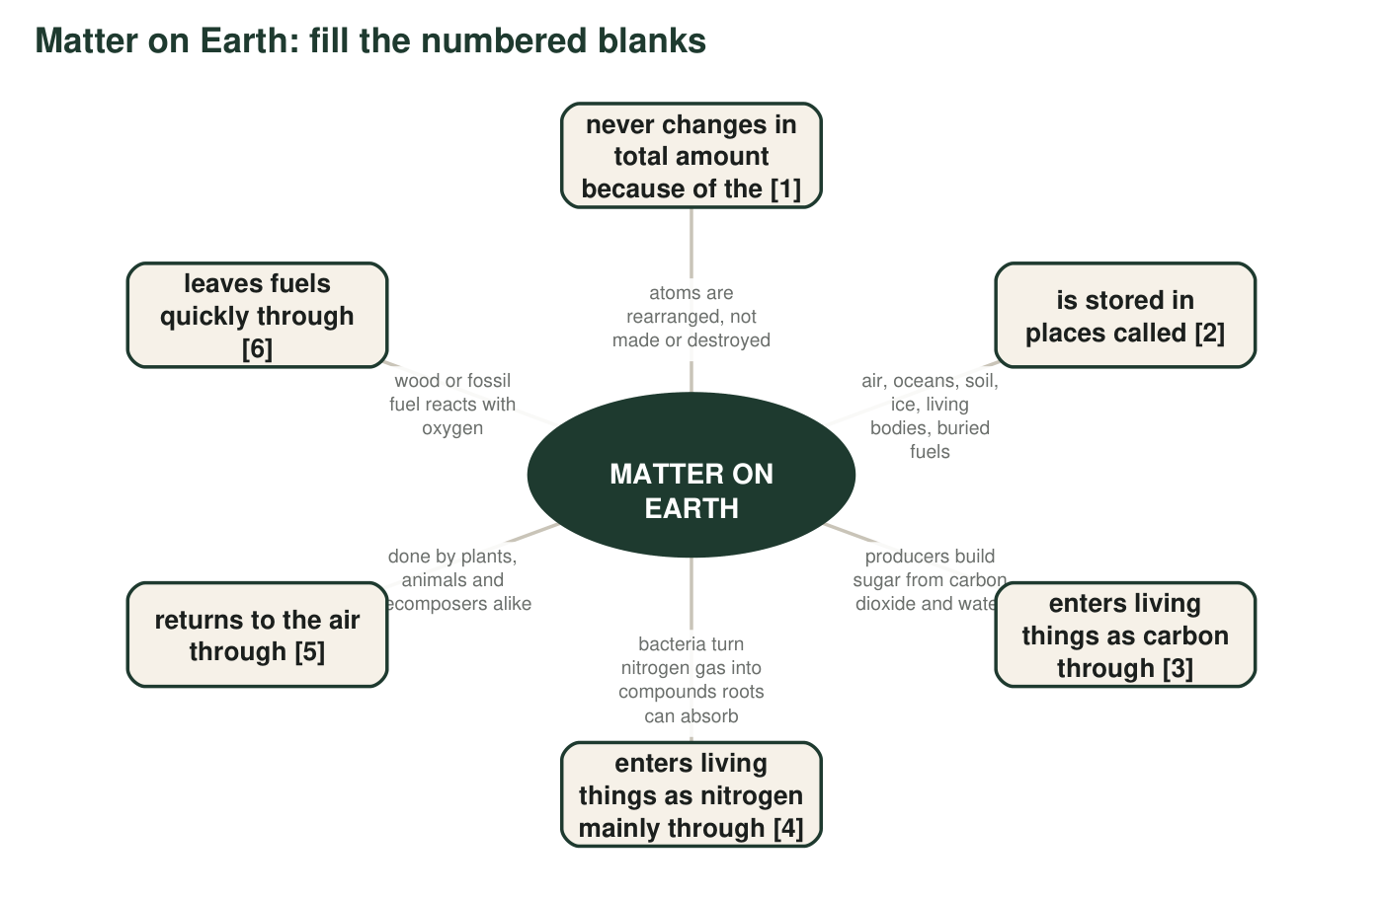
2. Write the term that belongs in each blank: [1] ______ [2] ______ [3] ______ [4] ______ [5] ______ [6] ______
______________________________________________________________________________________
______________________________________________________________________________________
______________________________________________________________________________________

Part C: Which term fits?
Each situation below is an example of one term from the list. Write the term that fits best and, in a few words, say what gave it away.
3. A compost pile is warm in the middle and shrinks week by week, even though nobody removes anything from it.
______________________________________________________________________________________
______________________________________________________________________________________
4. After a thunderstorm, rainwater carries small amounts of nitrate into the soil that were not there before.
______________________________________________________________________________________
______________________________________________________________________________________
5. A candle burns down to a stub, and a sensor above it shows carbon dioxide rising in the air.
______________________________________________________________________________________
______________________________________________________________________________________
6. Small lumps on the roots of a clover plant hold bacteria that take nitrogen gas from the air in the soil and make it usable.
______________________________________________________________________________________
______________________________________________________________________________________
7. A flooded, oxygen-poor field loses nitrogen to the air as a gas, so the farmer has to add more the next year.
______________________________________________________________________________________
______________________________________________________________________________________
8. A black rock that burns was once a swamp forest buried under sediment for about 300 million years.
______________________________________________________________________________________
______________________________________________________________________________________

Part D: How the terms relate
9. Photosynthesis and cellular respiration move carbon in opposite directions. Explain what each one does to carbon, using the words living and nonliving.
______________________________________________________________________________________
______________________________________________________________________________________
______________________________________________________________________________________
10. Earth is called a closed system, yet sunlight arrives every day. Explain why that is not a contradiction.
______________________________________________________________________________________
______________________________________________________________________________________
______________________________________________________________________________________
11. A classmate says: 'A fossil fuel is a reservoir, and combustion is the route out of it.' Do you agree? Explain, and name the reservoir the carbon goes to next.
______________________________________________________________________________________
______________________________________________________________________________________
______________________________________________________________________________________
12. Write one or two sentences that correctly use all three of these terms: reforestation, reservoir, photosynthesis.
______________________________________________________________________________________
______________________________________________________________________________________
______________________________________________________________________________________

Part E: Apply the terms to a new place
13. A sealed glass jar holds pond water, a water plant, a snail, and mud with bacteria. It sits by a window. Nothing goes in or out except light and heat. In three to five sentences, describe how carbon moves inside the jar over one day and night. Use at least four terms from the list and underline them.
______________________________________________________________________________________
______________________________________________________________________________________
______________________________________________________________________________________
______________________________________________________________________________________
______________________________________________________________________________________
______________________________________________________________________________________

The box-and-arrow test
If you cannot decide whether something is a reservoir or a process, imagine drawing it on a cycle diagram. If it would be a box that matter sits in (the air, a tree, the ocean), it is a reservoir. If it would be an arrow that carries matter from one box to another (evaporation, feeding, burning), it is a process. Every process term in this list ends in a verb-like idea: fixing, burning, breaking down, building.

One atom, three cycles
Oxygen atoms are part of water (H₂O), carbon dioxide (CO₂), nitrate (NO₃⁻) and sugar. Choose one oxygen atom and write a short 'travel diary' of at least six stops in which it passes through the water cycle, the carbon cycle and the nitrogen cycle, naming the process at each step. Then explain why a single atom can belong to all three cycles while the diagrams in the book show each cycle separately.

