Angela's Tools · Chapter 7: Global Cycles of Matter · Worksheet 4 of 10

Reading the Carbon Loop, Drawing the Nitrogen Loop (Teacher answer key)
Learning target: I can read a cycle diagram as reservoirs connected by processes, explain what each arrow means for a single atom, and build my own labeled model of a nutrient cycling through a field.
Diagrams and models · about 40 minutes · individual · Standards: MS-LS2-3 (assesses), MS-LS1-6 (supports)

Standards connections
MS-LS2-3 (assesses): The drawing task asks students to construct a model of nitrogen cycling in a peanut field with reservoirs, labeled process arrows and a drawn system boundary. A complete drawing is direct evidence toward the PE. No chemical equations are required, which respects the assessment boundary.
MS-LS1-6 (supports): Reading the photosynthesis arrow in the carbon loop reinforces that producers bring carbon from the nonliving world into living things. The task does not ask for the explanation of photosynthesis's role that the PE itself requires.

Answers with reasoning

Part A: Read a model of carbon in a pond
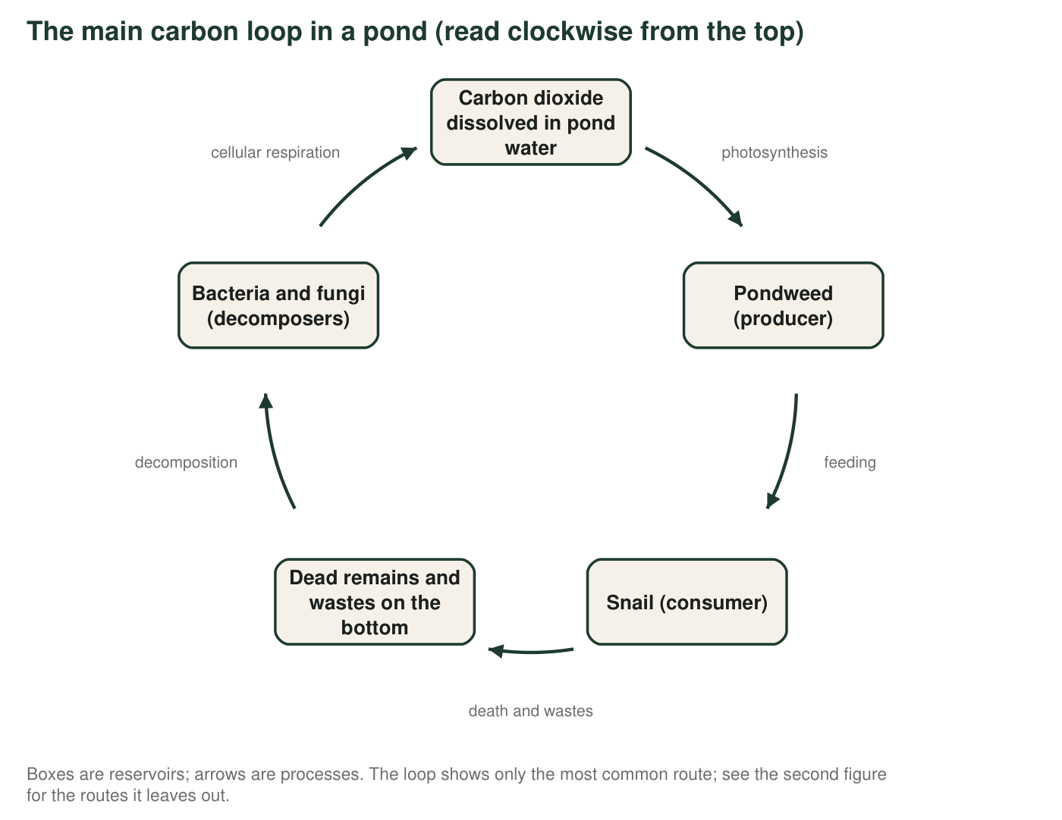
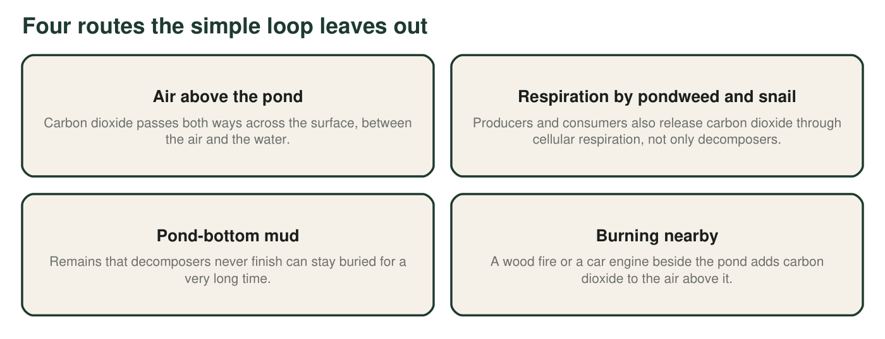
1. Which arrow in the loop moves carbon from a nonliving reservoir into a living one? Name the process and the two reservoirs it connects.
Answer: Photosynthesis. It connects carbon dioxide dissolved in the pond water (nonliving) to the pondweed (living).
Reasoning: In this loop only one arrow enters a living reservoir from a nonliving one; feeding moves carbon between living things.
Also acceptable: None.
2. Which arrow or arrows return carbon from living things to a nonliving reservoir? Use both figures, and name every organism that carries out this process.
Answer: Cellular respiration. In the loop it is drawn from the decomposers back to dissolved carbon dioxide, but the second figure says the pondweed (producer) and the snail (consumer) also release carbon dioxide by cellular respiration. So all three groups return carbon: producers, consumers and decomposers.
Reasoning: The point is that respiration is not a decomposer-only process; every living thing in the pond does it.
Also acceptable: Accept 'everything alive in the pond'. A student who adds that burning nearby also sends carbon to the air is noting a nonliving-to-nonliving route, which is fine as an extra.
Full credit must include:
• Names cellular respiration
• Names decomposers, pondweed and snail (all three groups)
3. When a carbon atom is 'in the snail,' it is part of a molecule. Name two different kinds of carbon-containing material in a snail's body that the atom could be part of, and say what each is for.
Answer: Any two of: protein (building muscle and other body parts), fat (energy storage), sugar such as glucose (fuel for cellular respiration), DNA (instructions for the cell), or the shell, which is made of calcium carbonate and contains carbon atoms (protection).
Reasoning: Students should see that 'in the snail' means built into several different molecules with different jobs. The shell is a nice catch: carbon is not only in soft tissue.
Also acceptable: Accept 'carbohydrates' for sugar and 'its body' for protein only if a purpose is given.
Full credit must include:
• Two distinct carbon-containing materials named
• A purpose given for each
4. Suppose every decomposer in the pond died and none returned. According to the model, what would happen over the following year?
Answer: B. Dead remains and wastes would pile up on the bottom, and less carbon dioxide would be returned to the water for the pondweed.
Reasoning: Decomposers are the main route from remains back to dissolved carbon dioxide. Without them the remains reservoir grows and the recycling slows. Carbon is never destroyed (A). Snails are consumers, not decomposers (C). Photosynthesis needs carbon dioxide, which would decline slowly, not stop at once (D).
Also acceptable: None.
5. Now imagine the whole pond is sealed inside a giant glass dome that lets light and heat through. Is the dome a closed system for matter? For energy? Explain each answer in one sentence.
Answer: Matter: yes, the dome is a closed system for matter, because no carbon (or water or nitrogen) can enter or leave through the glass. Energy: no, it is open for energy, because light enters through the glass and heat leaves through it.
Reasoning: This is the model of Earth in miniature: closed for matter, open for energy. Both halves are needed for full credit.
Also acceptable: Accept 'nearly closed' for matter if the student notes that a real dome might leak.
Full credit must include:
• Closed for matter, with the reason that nothing crosses the glass
• Open for energy, with light in and heat out
6. Describe two different paths a single carbon atom could take, each starting as carbon dioxide dissolved in the water and ending as carbon dioxide again. Use both figures. Each path must name every reservoir and process in order, and the two paths must differ in at least two stops.
Answer: Path 1: dissolved carbon dioxide → (photosynthesis) → pondweed → (feeding) → snail → (cellular respiration by the snail) → dissolved carbon dioxide. Path 2: dissolved carbon dioxide → (photosynthesis) → pondweed → (death) → dead remains on the bottom → (decomposition: decomposers feed on the remains) → decomposers → (cellular respiration by decomposers) → dissolved carbon dioxide. Other valid paths: dissolved carbon dioxide → (passes across the surface) → air → (burning nearby adds more; or carbon dioxide dissolves again) → water; or pondweed → (cellular respiration by the pondweed) → dissolved carbon dioxide directly.
Reasoning: The two paths must differ in at least two stops and must name every reservoir and process. The exercise shows that a cycle diagram is a map of possible routes, not a single track.
Also acceptable: A path that leaves the pond for the air and returns is acceptable. A path that goes to the mud and stays there does not end at carbon dioxide and should be revised.
Full credit must include:
• Two complete paths, each starting and ending at dissolved carbon dioxide
• Every reservoir and process named in order
• Paths differ in at least two stops
7. The first figure is a model, not a photograph. Name one thing it shows well and one real feature of a pond it leaves out or simplifies. Use the second figure to help.
Answer: Shows well: the order in which carbon passes from nonliving to producer to consumer to remains to decomposers and back, and the fact that it is a loop. Leaves out or simplifies: that producers and consumers also respire; that carbon dioxide moves between the pond and the air; that some remains stay buried in the mud for a very long time; that there are many kinds of producers, consumers and decomposers, not one of each; that the water also holds other carbon-containing substances.
Reasoning: Students should recognize that a model is a simplification that keeps the mechanism and drops detail.
Also acceptable: Accept 'it does not show how long carbon stays in each box' as a limitation.
Full credit must include:
• One strength tied to what the diagram shows
• One accurate limitation

Part B: Build a model of nitrogen in a peanut field
A peanut field has air above it, soil below it, peanut plants with nitrogen-fixing bacteria in their root nodules, people who eat the peanuts, and decomposers in the soil. Build a model of how nitrogen moves through this field. Your model must include all of the following: nitrogen gas in the air; nitrogen-fixing bacteria in root nodules; ammonium in soil; nitrate in soil; nitrifying bacteria; proteins in the peanut plant; a consumer (a person or an animal); decomposers; denitrifying bacteria; and a dashed line showing the boundary of your system. Every arrow must carry a label naming the process.
Draw your nitrogen model here. Boxes = reservoirs (write what form the nitrogen is in). Arrows = processes (write the process and, where it applies, the organism that does it). Draw a dashed line around the system you are modeling and label at least one arrow that crosses it.
Expected drawing: A complete model has: nitrogen gas in the air → (nitrogen fixation by nitrogen-fixing bacteria in root nodules) → ammonium in soil (or directly into the plant via the nodules) → (nitrifying bacteria) → nitrate in soil; ammonium and nitrate → (absorbed by roots) → proteins in the peanut plant; peanut plant → (eating and digestion) → consumer proteins; plant and consumer → (death and wastes) → remains; remains → (decomposers) → ammonium in soil; nitrate in soil → (denitrifying bacteria) → nitrogen gas in the air. A dashed boundary encloses the field, soil and air above it; at least one labeled arrow crosses it (for example, nitrogen gas exchanged with the wider atmosphere, or peanuts harvested and carried away). Optional extras: lightning fixation producing nitrate; fertilizer arriving from outside.
Reasoning: Score the presence of all ten required parts, correct direction of every arrow, accurate process labels (nitrifying bacteria make nitrate from ammonium; decomposers release ammonium, not nitrate; denitrifiers return nitrogen gas), and a drawn boundary with a crossing arrow. Direction errors to watch: an arrow from nitrate to ammonium labeled 'nitrifying', or plants taking nitrogen gas from the air directly.
8. Count the arrows in your model that depend on bacteria. List them, and explain what would happen to the peanut plants if the nitrogen-fixing bacteria alone disappeared.
Answer: Three arrows depend on bacteria: nitrogen fixation (nitrogen-fixing bacteria), ammonium to nitrate (nitrifying bacteria), and nitrate to nitrogen gas (denitrifying bacteria). Decomposition is also done partly by bacteria, so four is acceptable. If the nitrogen-fixing bacteria alone disappeared, no new nitrogen would enter the field from the air; the plants would depend on the ammonium and nitrate already in the soil and on recycling by decomposers, and as denitrifiers kept returning nitrogen to the air, the soil supply would shrink and growth would decline unless the farmer added fertilizer.
Reasoning: The answer should show that bacteria run the entry and exit of the cycle and that losing fixation turns the field into a leaking bucket.
Also acceptable: Accept 'the plants would run short of nitrogen over time' with a reason.
Full credit must include:
• Lists the bacterial arrows (at least three)
• Explains that fixation is the only natural entry route and that supply would decline
9. The farmer decides to spread nitrate fertilizer made in a factory. Add this to your model with a new arrow. Does the arrow start inside or outside your system boundary? What does that tell you about where the extra nitrogen came from?
Answer: The fertilizer arrow starts outside the boundary and ends at the nitrate (or ammonium) in the soil. It starts outside because the nitrogen in the fertilizer was fixed in a factory far away, not in the field. The field is no longer a closed system for nitrogen: matter is being added from outside, which is why the amount of nitrogen in the field can increase.
Reasoning: This connects system boundaries (MS-LS2-3 clarification) to conservation: the total inside can rise only if something crosses the boundary.
Also acceptable: A student who draws the factory outside the dashed line and labels the arrow 'fertilizer spread by farmer' has it right.
Full credit must include:
• Arrow crosses the boundary from outside
• Explains that the nitrogen was fixed elsewhere
10. A nitrogen atom in a peanut plant's protein could end up back in the air in two different ways. Trace both using your model.
Answer: Way 1: plant protein → (death) → remains → (decomposers) → ammonium → (nitrifying bacteria) → nitrate → (denitrifying bacteria) → nitrogen gas in the air. Way 2: plant protein → (eaten) → consumer protein → (wastes or death) → remains → (decomposers) → ammonium → (nitrifying bacteria) → nitrate → (denitrifying bacteria) → nitrogen gas.
Reasoning: Both routes end with denitrification; they differ in whether the atom passes through a consumer first. Students may also note the atom could loop through the plant several times before leaving.
Also acceptable: Accept a route that passes through the consumer's wastes rather than death.
Full credit must include:
• Two routes traced in order
• Both end with denitrifying bacteria releasing nitrogen gas
• Routes differ (consumer or no consumer)

Teacher notes
Part A's cycle figure intentionally shows only the main loop so that students practice spotting what a model leaves out; the labeled figure supplies the missing routes. In the drawing, the most common errors are (1) an arrow from the air directly into the plant labeled 'absorbs nitrogen' (plants cannot use nitrogen gas), (2) decomposers releasing 'nitrates' (they release ammonium; nitrifiers make nitrate), and (3) no boundary drawn. Have students use the three-pass scaffold if they stall. Accurate details worth saying aloud: in moist soil ammonia is mostly present as ammonium; roots absorb both ammonium and nitrate; the 'cellular respiration' arrow in the carbon loop is shorthand for a process that happens in every living cell, not breathing. The extension pairs well with Worksheet 2's travel diary.

