Angela's Tools · Chapter 7: Global Cycles of Matter · Worksheet 4 of 10

Reading the Carbon Loop, Drawing the Nitrogen Loop
Learning target: I can read a cycle diagram as reservoirs connected by processes, explain what each arrow means for a single atom, and build my own labeled model of a nutrient cycling through a field.
Diagrams and models · about 40 minutes · individual · Standards: MS-LS2-3 (assesses), MS-LS1-6 (supports)
Name: ____________________________ Date: ____________ Period: ______

Directions
Part A gives you a finished carbon-cycle model of a pond. Read it the way a scientist does: every box is a reservoir where carbon is stored, and every arrow is a process that moves carbon from one reservoir to the next. Answer the questions about it. In Part B you will build your own model of the nitrogen cycle in a peanut field, then answer questions about your own drawing. Use a pencil so you can revise.

Part A: Read a model of carbon in a pond
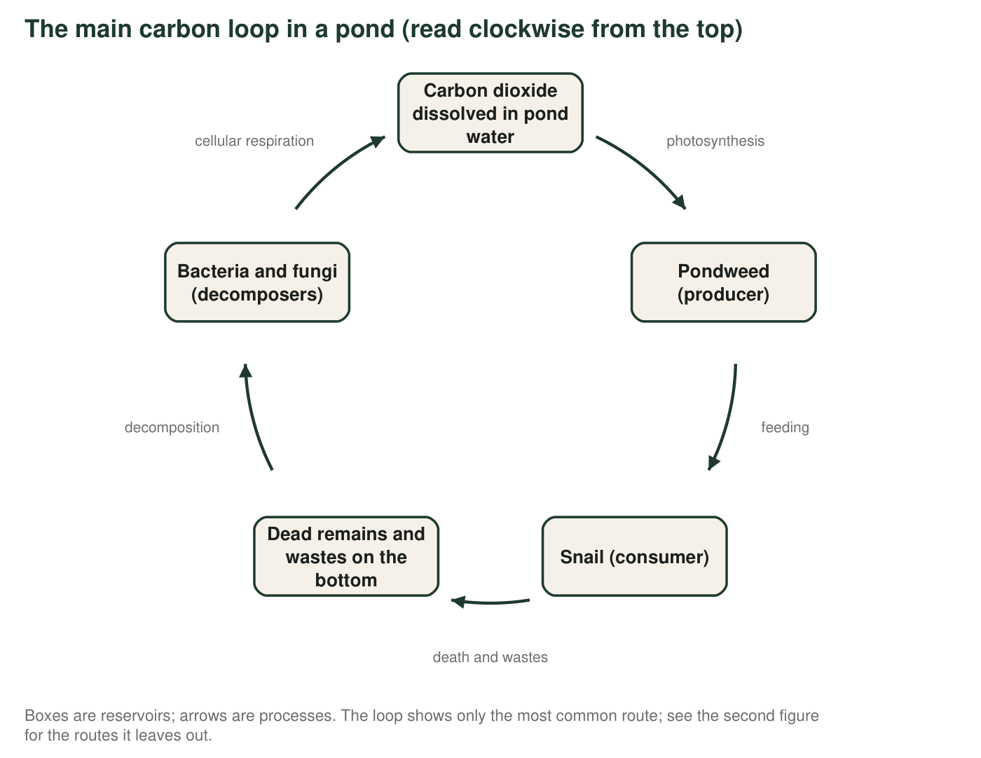
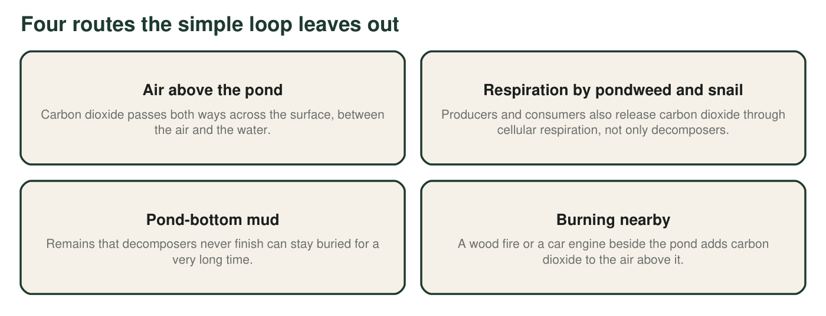
1. Which arrow in the loop moves carbon from a nonliving reservoir into a living one? Name the process and the two reservoirs it connects.
______________________________________________________________________________________
______________________________________________________________________________________
2. Which arrow or arrows return carbon from living things to a nonliving reservoir? Use both figures, and name every organism that carries out this process.
______________________________________________________________________________________
______________________________________________________________________________________
______________________________________________________________________________________
3. When a carbon atom is 'in the snail,' it is part of a molecule. Name two different kinds of carbon-containing material in a snail's body that the atom could be part of, and say what each is for.
______________________________________________________________________________________
______________________________________________________________________________________
______________________________________________________________________________________
4. Suppose every decomposer in the pond died and none returned. According to the model, what would happen over the following year?
○ A. Carbon would be destroyed, so the pond would slowly run out of carbon.
○ B. Dead remains and wastes would pile up on the bottom, and less carbon dioxide would be returned to the water for the pondweed.
○ C. The snails would take over the decomposers' job and the loop would continue unchanged.
○ D. Photosynthesis would stop immediately because it depends on decomposers.
5. Now imagine the whole pond is sealed inside a giant glass dome that lets light and heat through. Is the dome a closed system for matter? For energy? Explain each answer in one sentence.
______________________________________________________________________________________
______________________________________________________________________________________
______________________________________________________________________________________
6. Describe two different paths a single carbon atom could take, each starting as carbon dioxide dissolved in the water and ending as carbon dioxide again. Use both figures. Each path must name every reservoir and process in order, and the two paths must differ in at least two stops.
______________________________________________________________________________________
______________________________________________________________________________________
______________________________________________________________________________________
______________________________________________________________________________________
______________________________________________________________________________________
7. The first figure is a model, not a photograph. Name one thing it shows well and one real feature of a pond it leaves out or simplifies. Use the second figure to help.
______________________________________________________________________________________
______________________________________________________________________________________
______________________________________________________________________________________

Part B: Build a model of nitrogen in a peanut field
A peanut field has air above it, soil below it, peanut plants with nitrogen-fixing bacteria in their root nodules, people who eat the peanuts, and decomposers in the soil. Build a model of how nitrogen moves through this field. Your model must include all of the following: nitrogen gas in the air; nitrogen-fixing bacteria in root nodules; ammonium in soil; nitrate in soil; nitrifying bacteria; proteins in the peanut plant; a consumer (a person or an animal); decomposers; denitrifying bacteria; and a dashed line showing the boundary of your system. Every arrow must carry a label naming the process.
Draw your nitrogen model here. Boxes = reservoirs (write what form the nitrogen is in). Arrows = processes (write the process and, where it applies, the organism that does it). Draw a dashed line around the system you are modeling and label at least one arrow that crosses it.

8. Count the arrows in your model that depend on bacteria. List them, and explain what would happen to the peanut plants if the nitrogen-fixing bacteria alone disappeared.
______________________________________________________________________________________
______________________________________________________________________________________
______________________________________________________________________________________
9. The farmer decides to spread nitrate fertilizer made in a factory. Add this to your model with a new arrow. Does the arrow start inside or outside your system boundary? What does that tell you about where the extra nitrogen came from?
______________________________________________________________________________________
______________________________________________________________________________________
______________________________________________________________________________________
10. A nitrogen atom in a peanut plant's protein could end up back in the air in two different ways. Trace both using your model.
______________________________________________________________________________________
______________________________________________________________________________________
______________________________________________________________________________________

Build it in three passes
Pass 1: draw only the boxes (reservoirs) and write the form of nitrogen in each: nitrogen gas, ammonium, nitrate, plant protein, consumer protein, wastes and remains. Pass 2: add one arrow at a time, asking 'What moves nitrogen from this box to that one?' and writing the answer on the arrow. Pass 3: draw the dashed boundary and check that every box has at least one arrow in and one arrow out. The carbon loop in Part A is a pattern you can copy: a producer, a consumer, remains, decomposers, and a nonliving reservoir that starts the loop again.

Merge the two cycles
Carbon and nitrogen meet inside living things: a protein molecule contains both. Redraw your nitrogen model and add the carbon loop from Part A on top of it, using a second color. Mark every reservoir that holds both elements and every process that moves both at once. Then write a paragraph explaining why textbooks draw the cycles separately even though, in a real field, the atoms travel together.

