Angela's Tools · Chapter 8: Investigating Rock Strata · Lab 2 of 3 · Student recording sheet

The Quarry Case File: Order the Events and Bracket the Ages
Investigation question: From a set of field observations about one quarry wall, what order of events can be proven, which pairs of events cannot be ordered, and how old can each layer be shown to be?
Name: ____________________________ Group: ________ Date: ____________

Your role
☐ Card reader: Reads each evidence card aloud, exactly as written, and keeps the cards in play laid out where everyone can see them.
☐ Sequencer: Moves the event sticky notes on the group's timeline strip as the group argues, and does not move one without a card being cited.
☐ Rule checker: For every move, names the rule (superposition, original horizontality, lateral continuity, cross-cutting relationships, fossil succession) and challenges moves that have no rule behind them.
☐ Recorder: Writes the agreed sequence, rules and card numbers on the recording sheet and fills in the age-bracket table.

Safety
• No physical hazards beyond ordinary classroom materials. If groups cut their own cards, scissors are used seated and passed handle first.

Procedure
1. Read the scenario on the recording sheet and study the two diagrams: the stack of layers from top to bottom, and the three features that cut across it. Agree on what each label refers to before opening any cards.
2. Round 1: open the Round 1 envelope (cards 1 to 7). The Card reader reads each card aloud. For each layer card, the Sequencer places a sticky note on the timeline strip and the Rule checker names the rule that justifies its position. Decide whether the stack could be upside down, and cite the card that settles it.
3. Record the Round 1 sequence on the recording sheet, one row per event, with the rule and the card numbers. Card 7 describes tilting; place it, and write down what you know about when tilting happened so far.
4. Round 2: open the Round 2 envelope (cards 8 to 12). Read each card aloud. Slot the fault, the dike, the erosion surface and the gravel into the sequence. For every placement, the Rule checker must state what the feature cuts and what it does not cut, and the Sequencer may not move a note without a card being cited.
5. Check for any pair of adjacent events whose order no card can prove. Mark that pair with a question mark on the timeline and record it on the sheet. Do not guess an order for it.
6. Fill in the age-bracket table using the three dated igneous features (cards 3, 5 and 9). For each layer or event, write the age it must be older than, the age it must be younger than, and the reasoning. Use 'unknown' when the evidence gives no bound.
7. Use card 12 to correlate: decide what the distant quarry's shale can be matched to in your quarry and how confident the match is.
8. Write the final sequence, oldest to youngest, on the recording sheet with the rule and card numbers for every step, then answer the analysis questions individually.
9. Compare your sequence with one other group's. Where you differ, each group reads the card it relied on aloud, and the class decides which reading is justified.

Record your observations

Lab 2 recording sheet: The quarry case file
A quarry company cut a wall 40 m long and 15 m high through a hillside. A geologist spent a day describing it and wrote twelve evidence cards. Your job is to turn her observations into a sequence of events, with a rule and a card number for every step, and to put years on as many layers as the evidence allows. This quarry is invented for teaching, but every rule you use is the real method.
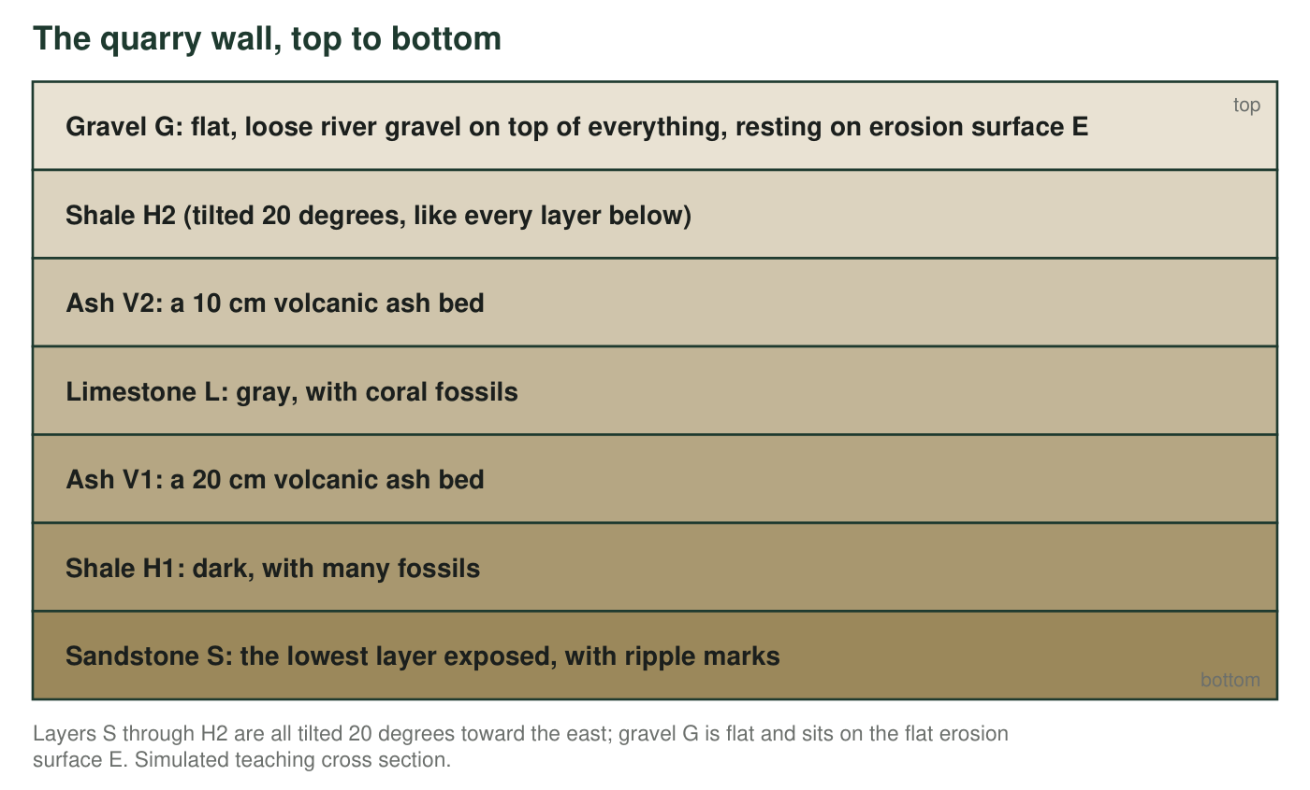
Read the stack from the bottom up. The six tilted layers are drawn in their true order; surface E lies between H2 and G, and it, the tilt and the other cutting features are described on the cards and in the next figure.
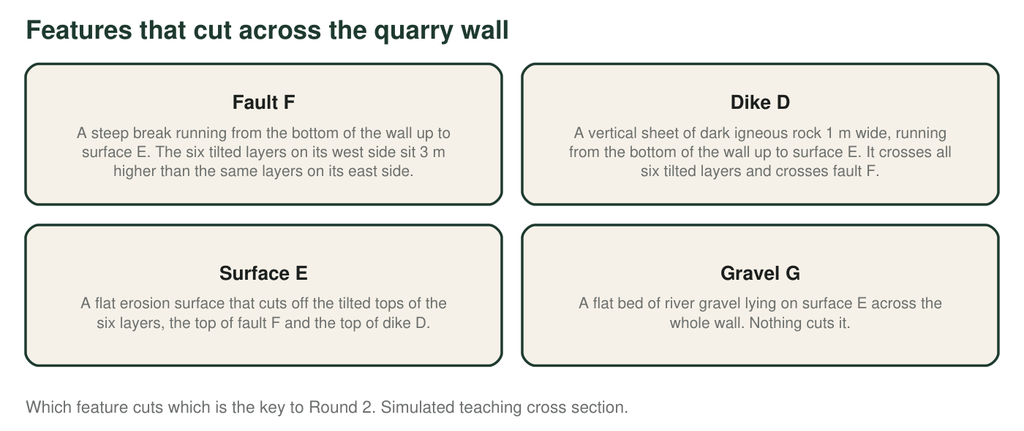
Evidence cards (Round 1: cards 1 to 7; Round 2: cards 8 to 12)
Card 1. Sandstone S is the lowest layer exposed in the quarry. Its ripple marks have sharp crests that point upward, toward shale H1, the way ripples form on a sandy bottom. | Card 2. Shale H1 lies directly on sandstone S. It contains many small spiral-shelled fossils of type Q and some flat, clam-like fossils of type R.
Card 3. Ash V1 is a 20 cm bed of volcanic ash lying directly on shale H1. Zircon crystals from the ash gave a radiometric age of 150 million years, plus or minus 2 million. | Card 4. Limestone L lies directly on ash V1. It contains fossil corals and type R fossils, but no type Q.
Card 5. Ash V2 is a 10 cm bed of volcanic ash lying directly on limestone L. Its zircon crystals gave a radiometric age of 140 million years, plus or minus 2 million. | Card 6. Shale H2 lies directly on ash V2. It contains type R fossils and a different spiral-shelled fossil, type T. Type T has never been found in the same layer as type Q anywhere in the world.
Card 7. All six layers, from sandstone S up through shale H2, are tilted 20 degrees toward the east, and all by the same amount. | Card 8. Fault F is a steep break through all six tilted layers. The layers on its west side sit 3 m higher than the matching layers on its east side. The fault stops at surface E.
Card 9. Dike D is a vertical sheet of dark igneous rock 1 m wide. It cuts straight through all six tilted layers and is not tilted itself. Where it crosses fault F, the dike is continuous and not shifted. A mineral from the dike gave a radiometric age of 90 million years, plus or minus 1 million. | Card 10. Surface E is a flat erosion surface. It cuts off the tilted tops of all six layers, the top of fault F and the top of dike D.
Card 11. Gravel G is a flat bed of loose river gravel lying on surface E across the whole wall. It contains a bone of a land animal. Nothing cuts gravel G. | Card 12. In a quarry 300 km away, a dark shale containing fossil types Q and R lies below a limestone containing corals. No ash bed has been found there.

Sequence of events (fill in during Round 1, revise in Round 2)
Step (1 = oldest) | Event | Rule used | Card number(s) | Certain or uncertain?
1
2
3
4
5
6
7
8
9
10
11

Age brackets from the dated igneous features
Layer or event | Must be older than (million years) | Must be younger than (million years) | Reasoning and cards
Sandstone S
Shale H1
Limestone L
Shale H2
Tilting
Fault F
Dike D
Surface E and gravel G

1. Which pair of events could your group not put in order from the cards? Explain why no card settles it.
______________________________________________________________________________________
______________________________________________________________________________________
______________________________________________________________________________________
2. Which single card did the most work in Round 2, and what did it let you conclude?
______________________________________________________________________________________
______________________________________________________________________________________
______________________________________________________________________________________

Analysis questions
3. Which layer was deposited first? Give the rule, and give the evidence from card 1 that shows the stack is not upside down.
______________________________________________________________________________________
______________________________________________________________________________________
______________________________________________________________________________________
4. Explain how you placed dike D relative to the tilting and relative to fault F. Quote the specific observations from card 9 that each placement rests on.
______________________________________________________________________________________
______________________________________________________________________________________
______________________________________________________________________________________
______________________________________________________________________________________
______________________________________________________________________________________
______________________________________________________________________________________
5. What is the age bracket for limestone L? Write it as 'between ___ and ___ million years' and show how the two ash dates and superposition give it.
______________________________________________________________________________________
______________________________________________________________________________________
______________________________________________________________________________________
6. Dike D is 90 million years old. The half-life of uranium-235 is about 704 million years. What fraction of one half-life has passed since the dike formed? Has more or less than half of the dike's uranium-235 decayed? Show your reasoning.
______________________________________________________________________________________
______________________________________________________________________________________
______________________________________________________________________________________
______________________________________________________________________________________
7. Fossil type Q is found only in shale H1; type R is found in H1, L and H2. Which is the better index fossil, and why? What does card 6 tell you about type T compared with type Q?
______________________________________________________________________________________
______________________________________________________________________________________
______________________________________________________________________________________
______________________________________________________________________________________
8. Use card 12. Which layer in your quarry does the distant shale most likely match, and what can you say about its age in years? How confident are you, and what would raise your confidence?
______________________________________________________________________________________
______________________________________________________________________________________
______________________________________________________________________________________
______________________________________________________________________________________
______________________________________________________________________________________
9. The lower layers hold corals and sea-floor fossils; gravel G holds a land animal's bone. What change does the wall record, and where in your sequence can you place it? What can the evidence not tell you about how long the change took?
______________________________________________________________________________________
______________________________________________________________________________________
______________________________________________________________________________________
______________________________________________________________________________________
______________________________________________________________________________________
10. A classmate argues that dike D must be the oldest feature because it reaches the bottom of the quarry wall. Write a two-sentence response that uses the correct rule and cites two cards.
______________________________________________________________________________________
______________________________________________________________________________________
______________________________________________________________________________________
______________________________________________________________________________________

