Angela's Tools · Chapter 8: Investigating Rock Strata · Worksheet 1 of 10

The Sea Cliff That Keeps a Diary (Teacher answer key)
Learning target: I can observe a layered cliff, record what I notice and wonder, and write a first explanation of how its layers, tilt and crack came to be.
Phenomenon exploration · about 30 minutes · pairs · Standards: MS-ESS1-4 (practice), MS-ESS2-2 (supports)

Standards connections
MS-ESS1-4 (practice): MS-ESS1-4 sits in California Grade 8 in the Preferred Integrated model; this Grade 7 lesson previews it. Students begin building explanations from the order and features of rock layers, which is the evidence base the PE asks for.
MS-ESS2-2 (supports): The cliff shows deposition, tilting, faulting and erosion acting at different time scales. Noticing those processes in one place is background for explaining how geoscience processes change Earth's surface.

Answers with reasoning

The phenomenon
Pelican Point is a stretch of sea cliff on the central California coast. (The place is invented for this worksheet, but every feature in it is the kind geologists see in real cliffs.) A geology student named Maya spent a low tide measuring the cliff with a tape and a hand lens. The cliff is about seven meters tall. From the beach it looks like a stack of striped blankets, except that the whole stack leans to one side, and a thin crack runs up through most of it. Her notes are below.
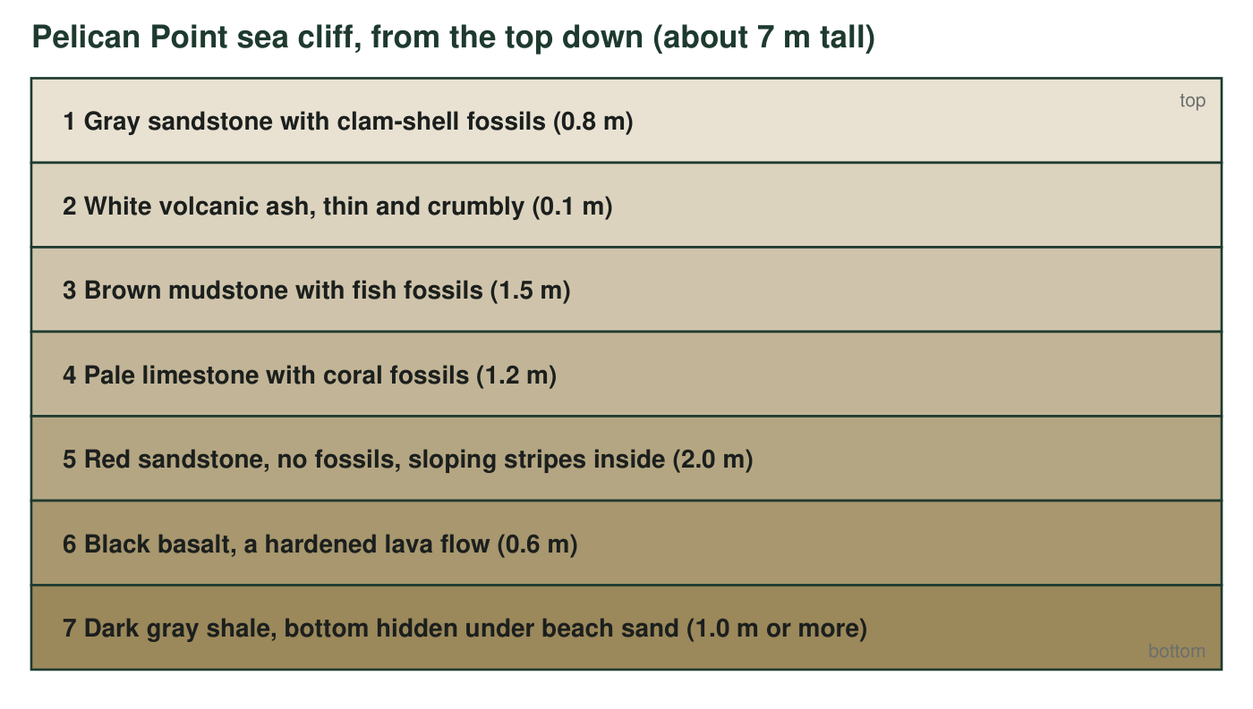
The entire stack leans about 15 degrees, so every layer slopes the same way. A narrow crack runs up through layers 3 to 7. On the left side of the crack, each of those layers sits 40 cm lower than its match on the right side. Layers 1 and 2 run straight across the top of the crack without any break.
Maya's field notes
Layer | Rock | What is in it | Other notes
1 | Gray sandstone | Clam shells, some still closed | Grains are sand-sized; crumbles in the hand
2 | White ash | Nothing visible | Soft; smells like chalk when wet
3 | Brown mudstone | Fish skeletons, flattened | Splits into thin sheets
4 | Pale limestone | Coral pieces and tiny shells | Fizzes with a drop of vinegar
5 | Red sandstone | No fossils | Thin stripes inside the layer slope in one direction, like dunes
6 | Black basalt | Small bubble holes near the top | Hard; rings when tapped with a hammer
7 | Dark gray shale | A few shell fragments | Bottom cannot be seen; the beach sand covers it

Part A: Notice and wonder
1. Fill in the table. In the middle column write only facts you can read from the figure or the notes (no guesses). In the right column turn each fact into a question that starts with how, why or when.
Answer: Notices (any accurate facts): sea fossils (clams, fish, coral) in layers 1, 3 and 4 but none in 5; two igneous layers (ash in 2, basalt in 6) between sedimentary ones; colors change layer to layer; the whole stack leans 15 degrees; the crack cuts layers 3 to 7, offsets them 40 cm, and stops below layers 1 and 2. Wonders (any how/why/when question tied to a fact): How did sea animals end up above the beach? Why is there no fossil in the red sandstone? When did the ash fall? Why does the crack stop under layer 2?
Reasoning: This item checks that students separate observation from inference. 'The layers were tilted by an earthquake' is a guess, not a notice; redirect it to the wonder column.
Also acceptable: A student may notice the 40 cm offset or the sloping stripes in layer 5 instead of the items listed; any true observation earns credit.
Full credit must include:
• Each notice is a fact readable from the figure, caption or notes
• Each wonder is a question beginning with how, why or when
• All four rows completed

Part B: What you already know
2. Think of a place where things pile up in order over time: snow after several storms, papers on a desk, trash in a can, laundry in a basket. Describe one. If you dug down through the pile, would you reach the newest item or the oldest item first? Explain why.
Answer: Example: snow after three storms. The first storm's snow is on the bottom, the last storm's on top. Digging down from the surface, you reach the newest snow first and the oldest last, because each new layer lands on top of whatever is already there.
Reasoning: The point is the everyday version of superposition: new material lands on top, so depth means age. The pile must be one where things are added on top and not stirred.
Also acceptable: Trash cans, inboxes and stacked dishes all work. A student who picks a pile that gets stirred (a toy box) and notices that this breaks the rule has made an excellent point about the word 'undisturbed'.
Full credit must include:
• Describes a real pile that grows by adding on top
• States that digging down reaches newest first, oldest last
• Explains that each addition lands on what is already there
3. Using the same thinking, which layer in the cliff do you think formed first, and which formed last? What makes you think so?
Answer: Layer 7 (the shale at the bottom) formed first and layer 1 (the sandstone on top) formed last, because each layer of sediment or lava was laid down on top of the ones before it, just like the pile in q2.
Reasoning: Students apply the stacking idea to the cliff. The lean does not reverse the order here because 15 degrees is far from upside down; accept answers that notice the lean and still choose 7 and 1.
Also acceptable: A student who says 'the bottom one, but I am not sure because the stack leans' is reasoning well; the chapter will confirm that gentle tilt does not flip the order.
Full credit must include:
• Names layer 7 as first and layer 1 as last
• Reason connects to stacking or 'new on top of old'

Part C: First explanations (complete alone)
4. Layers 1, 3 and 4 hold fossils of animals that live in the sea, yet today those layers sit several meters above the beach. Write your first explanation for how that could happen.
Answer: The sediment that became those layers collected on a sea floor while clams, fish and corals lived and died there. Later the sea level fell, or the land was pushed up (or both), so the old sea floor is now above the beach.
Reasoning: Either change in sea level or uplift of the land is a reasonable first explanation; both occur in California. Full credit needs the idea that the layers formed under water and that something changed afterward.
Also acceptable: 'A flood put them there' is a common first idea; accept it as a recorded initial explanation and plan to revisit it with the evidence that the layers are thick, orderly and contain animals that lived where they were buried.
Full credit must include:
• States that the layers formed under the sea
• Offers a mechanism for why they are now above the beach (land rose, sea fell, or both)
5. The whole stack leans 15 degrees. Do you think the sediment was laid down leaning, or did something tip the layers later? Give one reason for your choice.
Answer: Something tipped the layers later. Sediment settling through water spreads out in flat or nearly flat sheets under gravity, so a stack that leans as one unit was most likely tilted after it formed, for example by forces that push on the crust.
Reasoning: This is the principle of original horizontality in student words. The reason should connect to how sediment settles (flat) or to the fact that all seven layers lean together.
Also acceptable: A student who argues the sediment was deposited on a sloping sea floor has a defensible idea; note that a 15-degree slope for seven different layers, including a lava flow, is unlikely, and that geologists allow gentle original slopes but not this.
Full credit must include:
• Chooses 'tilted later'
• Gives a reason based on how sediment settles or on all layers leaning the same amount
6. Which came first, the crack or layers 1 and 2? Choose the best answer.
Answer: C. The crack formed after layers 3 to 7 but before layers 1 and 2, because it breaks 3 to 7 and does not break 1 and 2.
Reasoning: A break can only cut rock that already exists, so the crack is younger than 3 to 7. Layers 1 and 2 lie across the crack unbroken, so they were deposited after the crack stopped moving. Option A invents a rule; option B confuses 'on top' with 'first'; option D ignores the evidence in the caption.
Also acceptable: None; this is the one answer supported by the caption.
7. Write a first version of the cliff's story as a numbered list of events in order, from the first thing that happened to the last. Include at least five events (think about the sea, the lava, the ash, the tilt and the crack). Put a star next to any event you feel sure about and a question mark next to any event that is a guess.
Answer: A strong first story: (1) mud settled on a sea floor and became shale (layer 7); (2) lava flowed over it and hardened into basalt (6); (3) sand piled up, perhaps as dunes, forming red sandstone with no fossils (5); (4) the sea covered the area and corals grew, forming limestone (4); (5) mud with fish settled, forming mudstone (3); (6) the crack formed and the left side dropped 40 cm; (7) a volcano dropped ash (2); (8) sand with clams was deposited (1); (9) the whole stack was tilted; (10) the sea cliff was carved and the beach formed. Stars are expected on the stacking order; question marks on the timing of the tilt and on what caused the crack.
Reasoning: Score the order, not the details. The crack must come after layer 3 and before layer 2. The tilt can go anywhere after layer 1 in a first story; a student who places it earlier should be asked whether layers 1 and 2 would then lean too (they do, so the tilt came after them). The cliff-carving step is a bonus.
Also acceptable: Accept any order for the tilt at this stage, but note for later: the cliff does fix it. Layers 1 and 2 lie unbroken across the crack, so they came after it, and they lean with everything else, so the tilt came after them. The tilt therefore came after the crack. Students who already see this have used two rules the chapter will name.
Full credit must include:
• At least five events in a defensible order
• Bottom layer first and top layer last
• Crack placed after layer 3 and before layer 2
• Sure and unsure events marked
8. Write three questions you would ask a geologist to test your story. At least one must be a question that a measurement could answer.
Answer: Examples: How old is the ash in years, and how did you measure it? Did the land rise or did the sea fall? Is the crack still moving? Do the same layers appear on the other side of the cove? What animal left the fossils in layer 3? Measurable examples include the ash age, the amount the crack moved, or whether the layers match across the cove.
Reasoning: Any three genuine questions earn credit as long as one could be settled by a measurement rather than an opinion.
Also acceptable: Questions about the beach sand hiding layer 7 ('how deep does it go?') are measurable and count.
Full credit must include:
• Three questions related to the cliff
• At least one is answerable by a measurement (an age, a distance, a count, a comparison)

Teacher notes
Pelican Point is fictional; the layer set was designed so that every rule in the lesson has a hook in it: superposition (the stack), original horizontality (the 15-degree lean), cross-cutting relationships (the crack, which is a small fault), igneous layers that can be dated in years (ash and basalt), and marine fossils for fossil succession later. Keep students' q7 stories; W10's synthesis asks them to revise the same story with the lesson's vocabulary. Common first ideas worth collecting on the board: 'the thick layer took longest' (thickness is not time), 'the crack is old because it is deep', and 'a flood stacked all the layers at once'. Do not correct them yet; the chapter's evidence will. Source pages for the ideas previewed here: lesson introduction and Section 1 (printed 90-92, PDF 126-128).

