Angela's Tools · Chapter 8: Investigating Rock Strata · Worksheet 1 of 10

The Sea Cliff That Keeps a Diary
Learning target: I can observe a layered cliff, record what I notice and wonder, and write a first explanation of how its layers, tilt and crack came to be.
Phenomenon exploration · about 30 minutes · pairs · Standards: MS-ESS1-4 (practice), MS-ESS2-2 (supports)
Name: ____________________________ Date: ____________ Period: ______

Directions
Read the field notes and study the figure and table. In Part A, write only what you can see, then turn each observation into a question. In Part B, connect the cliff to things you already know. In Part C, write your first explanations. Nobody expects these to be perfect; the point is to write down your thinking now so you can compare it with your thinking at the end of the chapter. Work with a partner on Parts A and B and alone on Part C.

The phenomenon
Pelican Point is a stretch of sea cliff on the central California coast. (The place is invented for this worksheet, but every feature in it is the kind geologists see in real cliffs.) A geology student named Maya spent a low tide measuring the cliff with a tape and a hand lens. The cliff is about seven meters tall. From the beach it looks like a stack of striped blankets, except that the whole stack leans to one side, and a thin crack runs up through most of it. Her notes are below.
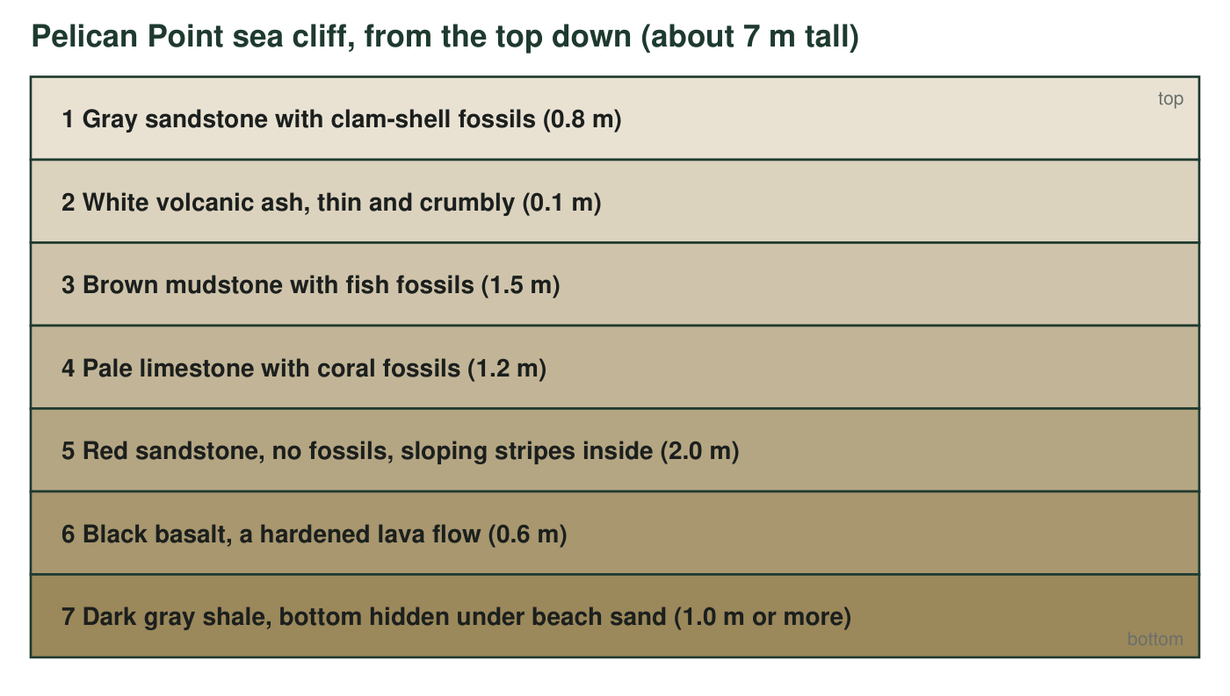
The entire stack leans about 15 degrees, so every layer slopes the same way. A narrow crack runs up through layers 3 to 7. On the left side of the crack, each of those layers sits 40 cm lower than its match on the right side. Layers 1 and 2 run straight across the top of the crack without any break.
Maya's field notes
Layer | Rock | What is in it | Other notes
1 | Gray sandstone | Clam shells, some still closed | Grains are sand-sized; crumbles in the hand
2 | White ash | Nothing visible | Soft; smells like chalk when wet
3 | Brown mudstone | Fish skeletons, flattened | Splits into thin sheets
4 | Pale limestone | Coral pieces and tiny shells | Fizzes with a drop of vinegar
5 | Red sandstone | No fossils | Thin stripes inside the layer slope in one direction, like dunes
6 | Black basalt | Small bubble holes near the top | Hard; rings when tapped with a hammer
7 | Dark gray shale | A few shell fragments | Bottom cannot be seen; the beach sand covers it

Part A: Notice and wonder
1. Fill in the table. In the middle column write only facts you can read from the figure or the notes (no guesses). In the right column turn each fact into a question that starts with how, why or when.
Feature | What I notice (facts only) | What I wonder (a question)
The fossils
The colors and rock types
The lean of the stack
The crack

Part B: What you already know
2. Think of a place where things pile up in order over time: snow after several storms, papers on a desk, trash in a can, laundry in a basket. Describe one. If you dug down through the pile, would you reach the newest item or the oldest item first? Explain why.
______________________________________________________________________________________
______________________________________________________________________________________
______________________________________________________________________________________
______________________________________________________________________________________
______________________________________________________________________________________
3. Using the same thinking, which layer in the cliff do you think formed first, and which formed last? What makes you think so?
______________________________________________________________________________________
______________________________________________________________________________________
______________________________________________________________________________________

Part C: First explanations (complete alone)
4. Layers 1, 3 and 4 hold fossils of animals that live in the sea, yet today those layers sit several meters above the beach. Write your first explanation for how that could happen.
______________________________________________________________________________________
______________________________________________________________________________________
______________________________________________________________________________________
5. The whole stack leans 15 degrees. Do you think the sediment was laid down leaning, or did something tip the layers later? Give one reason for your choice.
______________________________________________________________________________________
______________________________________________________________________________________
______________________________________________________________________________________
6. Which came first, the crack or layers 1 and 2? Choose the best answer.
○ A. The crack formed first, because cracks start at the bottom of a cliff.
○ B. Layers 1 and 2 formed first, because they are on top of everything.
○ C. The crack formed after layers 3 to 7 but before layers 1 and 2, because it breaks 3 to 7 and does not break 1 and 2.
○ D. There is no way to tell from the cliff.
7. Write a first version of the cliff's story as a numbered list of events in order, from the first thing that happened to the last. Include at least five events (think about the sea, the lava, the ash, the tilt and the crack). Put a star next to any event you feel sure about and a question mark next to any event that is a guess.
______________________________________________________________________________________
______________________________________________________________________________________
______________________________________________________________________________________
______________________________________________________________________________________
______________________________________________________________________________________
______________________________________________________________________________________
______________________________________________________________________________________
______________________________________________________________________________________
8. Write three questions you would ask a geologist to test your story. At least one must be a question that a measurement could answer.
______________________________________________________________________________________
______________________________________________________________________________________
______________________________________________________________________________________

Sentence starters for Part C
If a blank page is hard to start, use these frames. For q4: 'These layers were once under the sea because ___. Since then, ___.' For q5: 'I think the layers were ___ because sediment usually ___.' For q7: 'First, ___ settled on the sea floor. Next, ___. Then ___. After that, ___. Finally, ___.' You can also sketch the cliff on scrap paper and number the events right on the sketch before writing the list.

Two clocks in the cliff
Layer 2 (ash) and layer 6 (basalt) both formed from molten rock, so a lab can measure their ages in years. Suppose the lab reports that the basalt is about 20 million years old and the ash is about 12 million years old. Write what you could now say about the ages of layers 3, 4 and 5, and what you still could not say. Then explain why nobody can get an age in years from the clam shells in layer 1 just by looking at them.

