Angela's Tools · Chapter 8: Investigating Rock Strata · Worksheet 2 of 10

Rules, Features and Clocks: Sorting the Language of Strata (Teacher answer key)
Learning target: I can sort the vocabulary of rock strata into rules, features and methods, choose the right rule for a new situation, and use the terms correctly in my own sentences.
Vocabulary in action · about 35 minutes · individual · Standards: MS-ESS1-4 (supports)

Standards connections
MS-ESS1-4 (supports): MS-ESS1-4 is a California Grade 8 performance expectation that this Grade 7 lesson previews. Commanding the names of the dating rules is background for constructing the explanations from rock strata that the PE calls for.

Answers with reasoning

The terms
strata: Layers of rock, usually sedimentary rock. One layer is a stratum.
relative dating: Figuring out the order in which rocks formed and events happened (first, next, last) without giving ages in years.
absolute dating: Estimating how many years ago a rock formed or an event happened; for igneous rock this is done by measuring radioactive atoms and what they have decayed into.
law of superposition: In a stack of layers that has not been overturned or disturbed, each layer is younger than the one below it, so the bottom layer is the oldest.
principle of original horizontality: Gravity makes sediment settle into flat or nearly flat layers, so layers that are now steeply tilted or folded were bent after they formed.
principle of lateral continuity: A layer of sediment spreads sideways until something stops it or it thins out, so matching layers on two sides of a gap were once one continuous layer.
law of cross-cutting relationships: Anything that cuts across rock, such as an intrusion, a fault or a worn-down surface, must be younger than whatever it cuts through, because that rock had to exist first.
intrusion: A body of igneous rock that formed when magma pushed into cracks or weak spots in existing rock and then cooled. A thin sheet-shaped intrusion is called a dike.
fault: A break in rock along which the rock on the two sides has moved, so layers no longer line up.
law of fossil succession: Fossil species appear in rock layers in the same order everywhere on Earth, because life changed over time in one sequence.
index fossil: A fossil of a species that lived for a short span of geologic time, spread over a wide area, and is easy to recognize, which makes it a good marker for matching layers of about the same age.
half-life: The time needed for half of a sample's radioactive atoms to decay into a different kind of atom; each half-life halves what is left.

Part A: Three bins
1. Every term above belongs in exactly one bin. Write each term in its bin. (Hint: five terms are rules, four are things you can point to in rock, and three are methods or numbers that come from a method.)
Answer: Rules: law of superposition, principle of original horizontality, principle of lateral continuity, law of cross-cutting relationships, law of fossil succession. Features: strata, intrusion, fault, index fossil. Methods or numbers: relative dating, absolute dating, half-life.
Reasoning: The hint gives the counts (5, 4, 3). Index fossil is a feature because it is a thing found in rock; half-life is a number produced by a method.
Also acceptable: A student who argues that an index fossil is 'used as a method' and places it in bin 3 has a reasonable point; accept with the note that the fossil itself is the feature and matching layers is the method.
Full credit must include:
• All twelve terms placed
• Five rules, four features, three methods

Part B: Which rule or method fits?
For each field situation, write the one term from the list that a geologist would use, and finish the sentence with what it lets the geologist conclude.
2. A dark band of hardened magma, one meter wide, cuts straight across three sandstone layers. Term: ______. So the geologist concludes that ______.
Answer: Law of cross-cutting relationships; the dark band (an intrusion, or dike) is younger than the three sandstone layers it cuts.
Reasoning: Magma can only push into rock that already exists.
Also acceptable: Accept 'intrusion' as the feature if the rule is also named.
3. On both sides of a dry streambed, the same pink layer sits on the same gray layer, with the same thickness. Term: ______. So the geologist concludes that ______.
Answer: Principle of lateral continuity; the pink and gray layers on the two sides were once one continuous pair of layers, so matching layers are the same age, and the streambed cut them later.
Reasoning: Matching color, thickness and order across a gap is the signature of lateral continuity.
Also acceptable: A student who adds that the streambed is younger than the layers (cross-cutting) has gone beyond what was asked and should be credited.
4. In a quarry the layers stand nearly on end, like books on a shelf. Term: ______. So the geologist concludes that ______.
Answer: Principle of original horizontality; the layers were deposited flat or nearly flat and were tilted to this position afterward, so the tilting is younger than the layers.
Reasoning: Layers standing on end cannot have settled that way under gravity.
Also acceptable: None; superposition does not fit because the clue is about tilt, not order.
5. A cliff shows twelve flat layers that have never been bent or broken; the geologist wants the youngest. Term: ______. So the geologist concludes that ______.
Answer: Law of superposition; the top layer is the youngest (and the bottom layer the oldest) because the stack is undisturbed.
Reasoning: The clue explicitly says never bent or broken, which satisfies the 'undisturbed' condition.
Also acceptable: None.
6. In Ohio and in Morocco, the same three shell species appear in the same order from bottom to top, even though the rocks look different. Term: ______. So the geologist concludes that ______.
Answer: Law of fossil succession; the layers holding the same species in Ohio and Morocco formed during about the same span of time, even though the rocks look different.
Reasoning: Same species in the same order in distant places is the law's defining observation. 'About the same age' is the accurate phrasing; fossils give a time span, not an exact year.
Also acceptable: Accept 'index fossil' only if the student explains that the species would need to be short-lived and widespread; the clue is about order, so fossil succession is the better fit.
7. A lab crushes a piece of volcanic rock, measures its uranium and lead, and reports 1,408 million years. Term: ______. So the geologist concludes that ______.
Answer: Absolute dating (radiometric dating); the volcanic rock formed about 1,408 million years ago, which is two half-lives of uranium-235.
Reasoning: An age in years from measuring radioactive atoms and their decay products is absolute dating. The half-life connection is a bonus.
Also acceptable: 'Half-life' alone is not the method; it is the number used in the method.

Part C: Complete the concept map
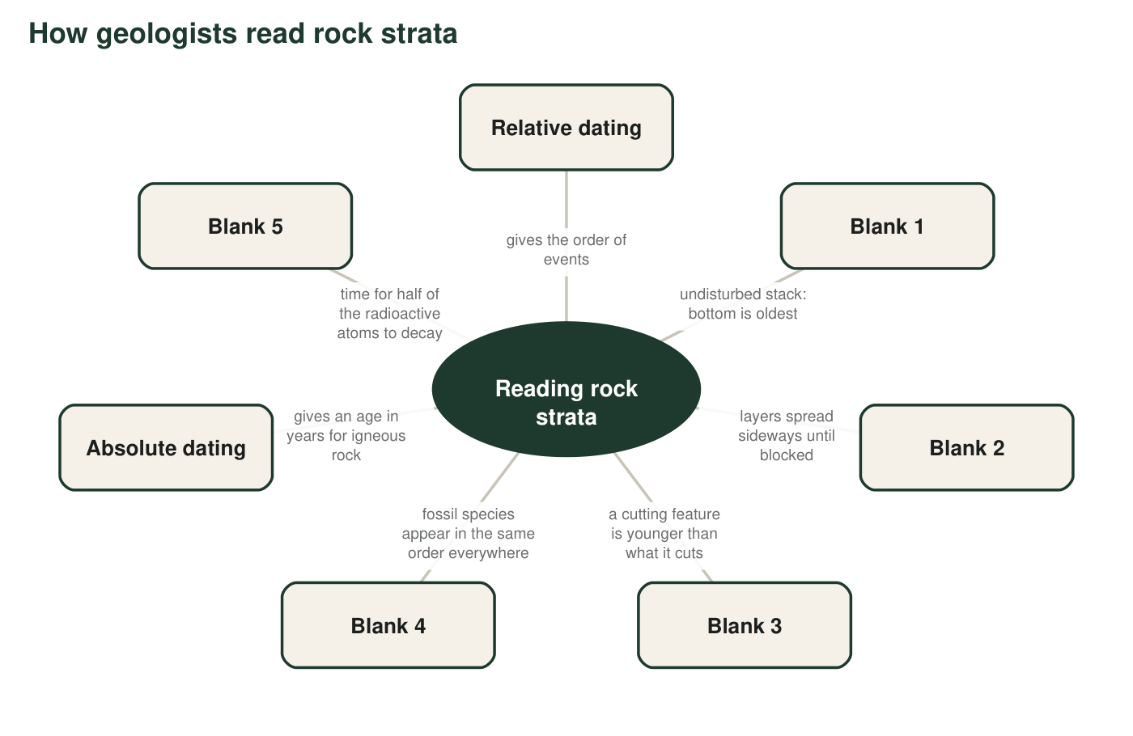
Five boxes have lost their terms. Each box keeps a short description. Use Part C's table to name the missing terms.
8. Write the term for each blank, then write the number of the Part B situation (q2 to q7) that used that same term. One blank has no Part B match; write 'none' for it.
Answer: Blank 1: law of superposition, matches q5. Blank 2: principle of lateral continuity, matches q3. Blank 3: law of cross-cutting relationships, matches q2. Blank 4: law of fossil succession, matches q6. Blank 5: half-life, none (q7 used absolute dating, not half-life).
Reasoning: The descriptions in the map restate the definitions. Original horizontality is absent from the map, so q4 has no blank, and half-life has no Part B situation.
Also acceptable: If a student matches Blank 5 to q7 and explains that the lab used half-lives to get the age, give credit; the intended answer is 'none' because q7's term is absolute dating.
Full credit must include:
• All five terms correct
• Matches q5, q3, q2, q6 and 'none' in order

Part D: Tell them apart
9. Relative dating and absolute dating both answer 'how old?' Write one sentence for each that shows how their answers are different in kind.
Answer: Relative dating answers with an order, such as 'the limestone is older than the sandstone.' Absolute dating answers with a number of years, such as 'the basalt is about 20 million years old.'
Reasoning: The difference in kind is order versus years. Both sentences should be about rock to show understanding.
Also acceptable: A sentence such as 'absolute dating works only on igneous rock' is true and relevant but does not answer the question unless the years idea is present.
Full credit must include:
• Relative sentence gives an order with no number
• Absolute sentence gives an age in years
10. A certain clam species lived for 300 million years, was found on every continent, and has an easy-to-spot ribbed shell. Explain, using the definition, why it is still a poor index fossil.
Answer: An index fossil must come from a species that lived for a short span of geologic time. This clam lasted 300 million years, so finding it only tells you a layer formed sometime within a 300-million-year window, which is not useful for telling one layer from the next. Being widespread and easy to recognize is not enough.
Reasoning: Students must identify the short-time-span requirement as the one the clam fails.
Also acceptable: Accept 'it appears in too many layers' as the same idea.
Full credit must include:
• Names the short-lifespan requirement
• Explains that a long span makes the age window too wide to be useful
11. An intrusion and a fault are both features that cut across rock. Write one way they are alike in what they tell a geologist, and one way they are different in what they are made of or how they form.
Answer: Alike: both are younger than the rock they cut across, so both tell a geologist the order of events (law of cross-cutting relationships). Different: an intrusion is new igneous rock that formed from magma that pushed into cracks; a fault is a break along which existing rock moved, and no new rock is added.
Reasoning: The similarity is in what they tell (order); the difference is in what they are.
Also acceptable: 'An intrusion can be dated in years and a fault cannot' is a correct extra difference.
Full credit must include:
• Similarity: both younger than what they cut
• Difference: new igneous rock versus a break with movement

Part E: The terms on a birthday cake
12. A baker builds a four-layer cake one layer at a time, then pushes a candle down through the top three layers, then cuts out one slice and lifts it away. Write a short paragraph describing the cake using law of superposition, law of cross-cutting relationships and principle of lateral continuity correctly (bold or underline each term). Then write one sentence explaining which real rock feature the candle is most like, and why.
Answer: Example: The baker stacks the layers one at a time, so by the law of superposition the bottom layer was made first and the top layer last. The candle is pushed through the top three layers after they were stacked, so by the law of cross-cutting relationships the candle is younger than those layers (and it does not reach the bottom layer, which tells us nothing about when that layer was made compared with the candle). When a slice is removed, the layers on both sides of the gap match in color and thickness; by the principle of lateral continuity they were once continuous, so matching layers on each side are the same age and the gap is newer than all of them. The candle is most like an intrusion (a dike), because it is a new object pushed down into existing layers, cutting across them.
Reasoning: Each term must be used correctly in the cake context, and the candle comparison should be to an intrusion or dike with the reason that it is new material cutting across existing layers. A comparison to a fault is weaker because nothing in the cake moved past itself.
Also acceptable: A student who compares the cut slice to erosion carving a canyon has made a correct extra connection. Comparing the candle to a fault earns partial credit if the student notes that no layers moved.
Full credit must include:
• Superposition used for stacking order
• Cross-cutting used for the candle (younger than the layers it pierces)
• Lateral continuity used for the matching layers across the removed slice
• Candle compared to an intrusion or dike with a reason

Teacher notes
Definitions here are deliberately more careful than the textbook's: superposition carries the 'not overturned or disturbed' condition, original horizontality says 'flat or nearly flat', cross-cutting includes worn-down surfaces, and fossil matching gives 'about the same age' (the textbook's pages 98, 101 and 103 say 'the same age' without a qualifier). The p. 101 Key Science Concept callout states the cross-cutting rule backward; do not use it as a reference. Part B goes quickly for most students; the thinking is in Parts D and E. Vocabulary pages: printed 91 (PDF 127) for the boxed terms, 96-97 (132-133) for intrusion and fault, 99 (135) for index fossils, 102 (138) for half-life.

