Angela's Tools · Chapter 8: Investigating Rock Strata · Worksheet 2 of 10

Rules, Features and Clocks: Sorting the Language of Strata
Learning target: I can sort the vocabulary of rock strata into rules, features and methods, choose the right rule for a new situation, and use the terms correctly in my own sentences.
Vocabulary in action · about 35 minutes · individual · Standards: MS-ESS1-4 (supports)
Name: ____________________________ Date: ____________ Period: ______

Directions
Read the twelve definitions first; they are written in plain words and you may look back at them at any time. Part A asks you to sort the terms into three bins. Part B gives short field situations; name the one rule or method that fits each. Part C completes a concept map. Part D asks you to tell similar terms apart, and Part E asks you to use the terms on something that is not a rock at all. Work alone, then compare Part B with a partner before moving on.

The terms
strata: Layers of rock, usually sedimentary rock. One layer is a stratum.
relative dating: Figuring out the order in which rocks formed and events happened (first, next, last) without giving ages in years.
absolute dating: Estimating how many years ago a rock formed or an event happened; for igneous rock this is done by measuring radioactive atoms and what they have decayed into.
law of superposition: In a stack of layers that has not been overturned or disturbed, each layer is younger than the one below it, so the bottom layer is the oldest.
principle of original horizontality: Gravity makes sediment settle into flat or nearly flat layers, so layers that are now steeply tilted or folded were bent after they formed.
principle of lateral continuity: A layer of sediment spreads sideways until something stops it or it thins out, so matching layers on two sides of a gap were once one continuous layer.
law of cross-cutting relationships: Anything that cuts across rock, such as an intrusion, a fault or a worn-down surface, must be younger than whatever it cuts through, because that rock had to exist first.
intrusion: A body of igneous rock that formed when magma pushed into cracks or weak spots in existing rock and then cooled. A thin sheet-shaped intrusion is called a dike.
fault: A break in rock along which the rock on the two sides has moved, so layers no longer line up.
law of fossil succession: Fossil species appear in rock layers in the same order everywhere on Earth, because life changed over time in one sequence.
index fossil: A fossil of a species that lived for a short span of geologic time, spread over a wide area, and is easy to recognize, which makes it a good marker for matching layers of about the same age.
half-life: The time needed for half of a sample's radioactive atoms to decay into a different kind of atom; each half-life halves what is left.

Part A: Three bins
1. Every term above belongs in exactly one bin. Write each term in its bin. (Hint: five terms are rules, four are things you can point to in rock, and three are methods or numbers that come from a method.)
Bin | Terms that belong here
A rule geologists use to put events in order
A thing you can see or point to in the rock
A method, or a number that comes from a method

Part B: Which rule or method fits?
For each field situation, write the one term from the list that a geologist would use, and finish the sentence with what it lets the geologist conclude.
2. A dark band of hardened magma, one meter wide, cuts straight across three sandstone layers. Term: ______. So the geologist concludes that ______.
______________________________________________________________________________________
______________________________________________________________________________________
3. On both sides of a dry streambed, the same pink layer sits on the same gray layer, with the same thickness. Term: ______. So the geologist concludes that ______.
______________________________________________________________________________________
______________________________________________________________________________________
4. In a quarry the layers stand nearly on end, like books on a shelf. Term: ______. So the geologist concludes that ______.
______________________________________________________________________________________
______________________________________________________________________________________
5. A cliff shows twelve flat layers that have never been bent or broken; the geologist wants the youngest. Term: ______. So the geologist concludes that ______.
______________________________________________________________________________________
______________________________________________________________________________________
6. In Ohio and in Morocco, the same three shell species appear in the same order from bottom to top, even though the rocks look different. Term: ______. So the geologist concludes that ______.
______________________________________________________________________________________
______________________________________________________________________________________
7. A lab crushes a piece of volcanic rock, measures its uranium and lead, and reports 1,408 million years. Term: ______. So the geologist concludes that ______.
______________________________________________________________________________________
______________________________________________________________________________________

Part C: Complete the concept map
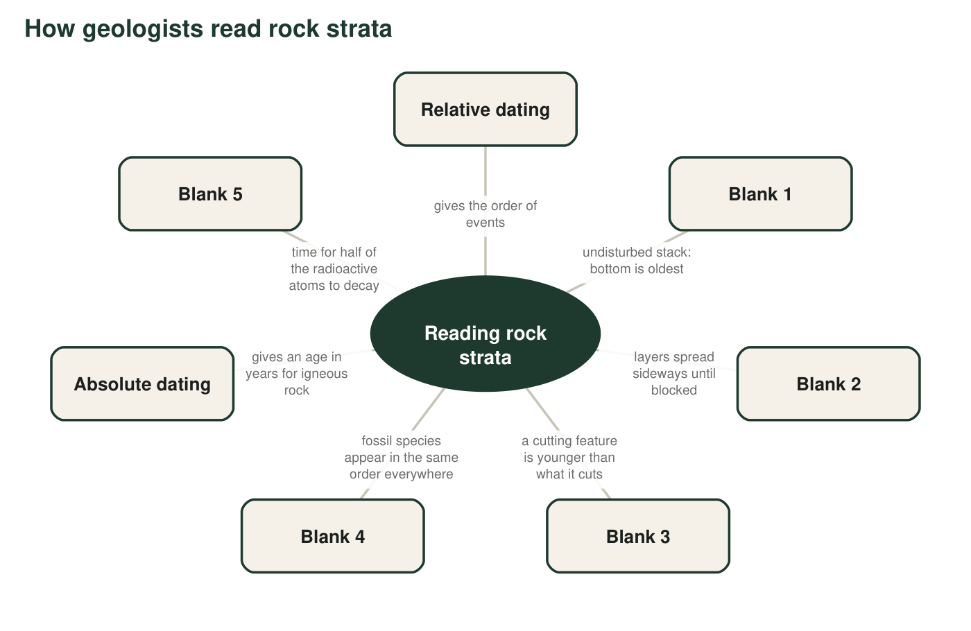
Five boxes have lost their terms. Each box keeps a short description. Use Part C's table to name the missing terms.
8. Write the term for each blank, then write the number of the Part B situation (q2 to q7) that used that same term. One blank has no Part B match; write 'none' for it.
Blank | Term | Matching Part B situation
Blank 1
Blank 2
Blank 3
Blank 4
Blank 5

Part D: Tell them apart
9. Relative dating and absolute dating both answer 'how old?' Write one sentence for each that shows how their answers are different in kind.
______________________________________________________________________________________
______________________________________________________________________________________
______________________________________________________________________________________
10. A certain clam species lived for 300 million years, was found on every continent, and has an easy-to-spot ribbed shell. Explain, using the definition, why it is still a poor index fossil.
______________________________________________________________________________________
______________________________________________________________________________________
______________________________________________________________________________________
11. An intrusion and a fault are both features that cut across rock. Write one way they are alike in what they tell a geologist, and one way they are different in what they are made of or how they form.
______________________________________________________________________________________
______________________________________________________________________________________
______________________________________________________________________________________

Part E: The terms on a birthday cake
12. A baker builds a four-layer cake one layer at a time, then pushes a candle down through the top three layers, then cuts out one slice and lifts it away. Write a short paragraph describing the cake using law of superposition, law of cross-cutting relationships and principle of lateral continuity correctly (bold or underline each term). Then write one sentence explaining which real rock feature the candle is most like, and why.
______________________________________________________________________________________
______________________________________________________________________________________
______________________________________________________________________________________
______________________________________________________________________________________
______________________________________________________________________________________
______________________________________________________________________________________
______________________________________________________________________________________

Term families
If the sorting in Part A is hard, start with the names. Terms that begin with 'law of' or 'principle of' are rules. Terms you could point at in a photograph (a layer, a crack, a body of hardened magma, a fossil) are features. What is left is about methods and the numbers they produce. For Part B, ask yourself: is the clue about stacking, spreading sideways, cutting across, fossils in order, or counting atoms?

Write the rule for a worn-down surface
In many cliffs there is a surface where tilted layers were worn flat before new flat layers were laid on top. No single term in the list names that surface, but the law of cross-cutting relationships covers it. Write, in your own words, a one-sentence rule for a worn-down surface that says what it is younger than and what it is older than. Then explain why such a surface always means that some amount of time is missing from the record.

