Angela's Tools · Chapter 8: Investigating Rock Strata · Worksheet 4 of 10

Reading the Pine Hollow Road Cut: Eight Events in Stone (Teacher answer key)
Learning target: I can use superposition, original horizontality and cross-cutting relationships to put the events recorded in a road cut in order, and I can draw the road cut as it looked at an earlier moment.
Diagrams and models · about 40 minutes · individual · Standards: MS-ESS1-4 (practice), MS-ESS2-2 (practice)

Standards connections
MS-ESS1-4 (practice): MS-ESS1-4 is placed in California Grade 8; this Grade 7 lesson previews it. Ordering the events in a cross-section from the arrangement of its layers and cutting features is the core practice of reading rock strata that the PE's explanation rests on.
MS-ESS2-2 (practice): Tilting, faulting, erosion and deposition each appear as a separate event in the road cut. Naming them in order builds toward explaining how geoscience processes change Earth's surface at different time scales.

Answers with reasoning

The road cut
When a highway was widened near Pine Hollow (an invented place), bulldozers sliced a hillside open and exposed about nine meters of rock. A geologist logged the cut from top to bottom. The three lowest layers (A, B and C) lean 20 degrees to the east. Above them is a flat surface, labeled U, and above that two flat layers (D and E). Two features cut through the stack: a fault, F, and a dike, G.
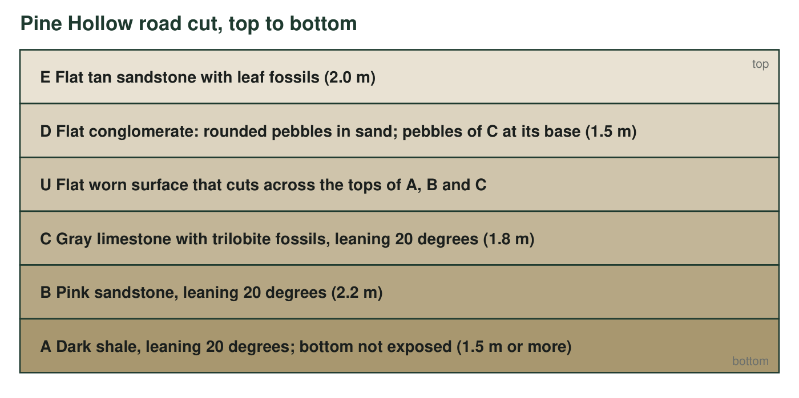
Layers are listed from the top of the cut downward. Layers A, B and C lean 20 degrees; D and E are flat. The dike G and fault F are described in the next figure and the clue table.
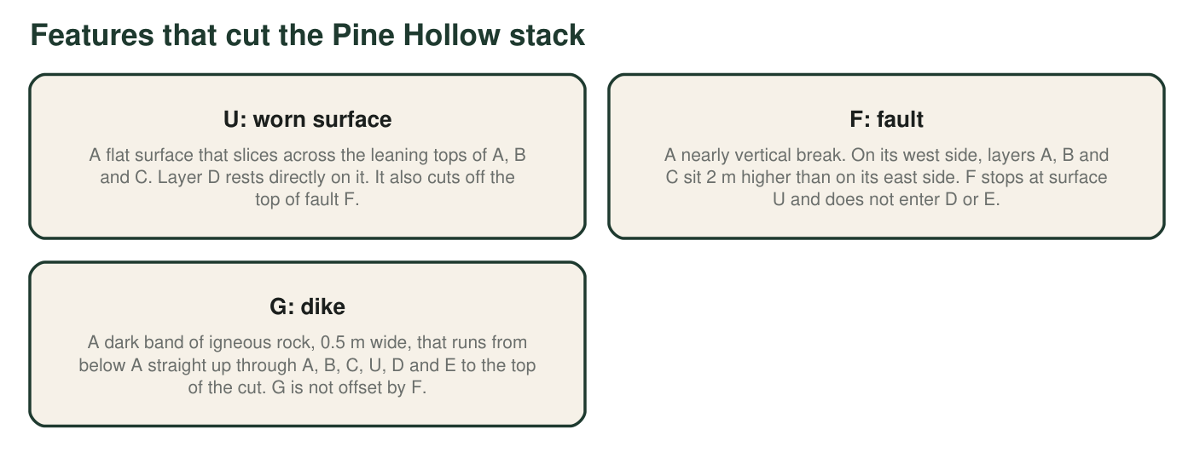
The three features that are not layers.
Clue table
Clue | Where it is seen | What you can see
1 | Layers A, B, C | All three lean the same 20 degrees; A is below B, and B is below C.
2 | Surface U | Flat, with a few centimeters of broken rock just below it.
3 | Base of layer D | Rounded pebbles made of layer C's gray limestone, mixed into D's sand.
4 | Layers D and E | Flat; D is below E; neither is offset by F.
5 | Fault F | Offsets A, B and C by 2 m; stops at U; does not offset G.
6 | Dike G | Cuts A through E and the surface U; its edges are baked and glassy where they touch each layer.

Part A: Put the events in order
1. Complete the event table. The eight events, out of order, are: A deposited; B deposited; C deposited; A, B and C tilted; fault F moves; surface U worn flat; D and E deposited (count this as one step, D then E); dike G intrudes. For each step write the rule that proves its position: superposition, original horizontality, cross-cutting, or 'pebble clue'.
Answer: 1: A deposited (superposition: lowest). 2: B deposited (superposition). 3: C deposited (superposition: highest of the leaning set). 4: A, B and C tilted (original horizontality: they were flat when deposited). 5: Fault F moves (cross-cutting: it offsets A, B and C; it is cut off by U, so it comes before U). 6: Surface U worn flat (cross-cutting: it slices the tilted layers and the fault; pebble clue: D's pebbles of C show C was exposed and broken up before D). 7: D then E deposited (superposition: D below E; both rest on U). 8 (last): Dike G intrudes (cross-cutting: it cuts everything including E).
Reasoning: Eight rows are provided for eight steps; the fault and the tilt are the two steps whose relative order the road cut does not fix (see q7). The key accepts fault before tilt (as listed) or tilt before fault, as long as both come after C and before U. 'D and E' counts as one step because superposition alone orders them.
Also acceptable: Swapping steps 4 and 5 (tilt and fault) is fully correct. Students who name 'pebble clue' for U or for D are both acceptable.
Full credit must include:
• A, B, C in order at the start, D then E after U, G last
• Tilt placed after C and before U
• F placed after C and before U
• A rule or clue named for every step
2. Which rule tells you that layers A, B and C were tilted after they formed, not deposited on a slope? State the rule in your own words.
Answer: The principle of original horizontality: sediment settles under gravity into flat or nearly flat layers, so three layers that now lean 20 degrees together were tilted after they had formed.
Reasoning: The 'together' detail is strong evidence: three different layers deposited on a slope would not share the exact same lean.
Also acceptable: Accept 'nearly flat' with a note that gentle original slopes are possible but 20 degrees for a whole stack is not.
Full credit must include:
• Names original horizontality
• Restates it as 'deposited flat, tilted later'
3. Clue 3 says the base of D contains rounded pebbles of C. Explain what had to happen to C before those pebbles could end up inside D, and what that tells you about the order of C, U and D.
Answer: C had to be solid rock, then exposed at the surface, broken up and rounded by water before its pieces could be washed into the sand that became D. So C formed first, then it was worn down (that is surface U), and then D was deposited on top with the pebbles inside. Order: C, then U, then D.
Reasoning: This is the pebble (inclusion) clue: a rock containing pieces of another rock is younger than the rock the pieces came from.
Also acceptable: Accept 'the pebbles are older than D' as the core idea.
Full credit must include:
• C had to harden and be eroded before D
• Order stated as C, U, D
4. Explain why fault F must be younger than C but older than D. Name the rule you are using for each half of the answer.
Answer: Younger than C: the law of cross-cutting relationships, because F offsets A, B and C, and a break can only move rock that already exists. Older than D: cross-cutting again (or superposition applied to U), because F stops at surface U and D lies across the top of F without being offset, so D was deposited after F had stopped moving.
Reasoning: Both halves use cross-cutting; the second half can also be argued through U, which cuts F and lies under D.
Also acceptable: Naming superposition for the second half (D is above the fault's top) is acceptable if the student explains that D is unbroken.
Full credit must include:
• F offsets A-C, so it is younger than them
• D is not offset, so F is older than D
• Cross-cutting named
5. Dike G and fault F are both features that cut the stack. Which one is younger, and which two clues prove it?
Answer: Dike G is younger. Clue 6 shows G cuts through D and E, which F does not reach, so G is younger than D and E and therefore younger than F. Clue 5 shows F does not offset G: if the fault had moved after the dike formed, the dike would be broken into two offset pieces, and it is not.
Reasoning: Two independent lines of evidence: what G cuts (everything) and the fact that G is unbroken by F.
Also acceptable: A student who cites only clue 5 has the strongest single clue; give most of the credit.
Full credit must include:
• G is younger
• Cites that G cuts D and E (clue 6)
• Cites that G is not offset by F (clue 5)

Part B: Draw the road cut at an earlier moment
Draw a side view of the Pine Hollow site at the moment just after surface U was worn flat and before layer D was deposited. Your drawing must show: layers A, B and C leaning 20 degrees (use a ruler), fault F offsetting them by a small step, and the flat surface U cutting across the tops of the leaning layers and the top of F. Label every layer and feature with its letter. Do not draw D, E or G, because they do not exist yet. Add a one-sentence caption under the drawing that says what the land surface looked like at that moment.
Expected drawing: A side view showing three parallel bands (A at the bottom, B, C) leaning 20 degrees; a near-vertical fault line F with the bands on its west side stepped 2 m higher than on its east side; a flat line U across the top that truncates the leaning bands and the fault; everything above U erased. Labels A, B, C, F, U. Caption such as: 'A flat, worn-down land surface with stripes of A, B and C showing at the ground, and no sign of the fault except a shift in the stripes.'
Reasoning: The drawing tests whether students can reconstruct an earlier state from the final one. The most common errors are drawing D or G, leaving the layers flat, or forgetting that U cuts the fault.
6. In your drawing, which layer is exposed at the ground surface on the east side of the fault, and which on the west side? Explain using the 2 m offset.
Answer: Because the west side sits 2 m higher, the flat surface U cuts a lower layer on the west side than on the east side at any given spot. Right beside the fault, surface U exposes an older layer on the west (for example, B where the east side shows C). Any answer must show that the up-thrown (west) side exposes older rock at the same spot.
Reasoning: Students must reason that raising one side brings older layers up to the erosion surface. The exact layers depend on where the student looks along the cut, so accept any pair that is consistent with the drawing.
Also acceptable: A student whose drawing has the east side up should give the mirror answer; score for consistency with the drawing.
Full credit must include:
• West side exposes older rock than the east side at the same spot
• Explanation uses the 2 m offset

Part C: What the evidence cannot say
7. Can you tell from the road cut whether fault F moved before or after layers A, B and C were tilted? Explain what evidence would be needed to decide.
Answer: No. The fault cuts the tilted layers, which only proves F is younger than the layers, not younger than the tilt. To decide, a geologist would need evidence such as whether the fault surface itself is tilted by the same 20 degrees (then faulting came before tilting) or cuts the tilt at a different angle, or a dike like the extension's H that was both offset and tilted.
Reasoning: This is the limit-of-evidence question; it checks that students do not over-read cross-cutting. Any sensible piece of missing evidence earns credit.
Also acceptable: Accept 'we would need to know whether the fault is tilted too' or 'find another feature that is cut by only one of them'.
Full credit must include:
• States that the order of tilt and fault cannot be fixed from the given clues
• Proposes evidence that would decide it
8. Only one part of this road cut can be given an age in years directly. Which part is it, why, and what would its age tell you about every layer in the cut?
Answer: Dike G, because it is igneous rock: its radioactive clock started when the magma cooled, so a lab can measure how much of the radioactive atoms have decayed and report an age in years. Since G cuts every layer, every layer is older than G's age. The age gives a minimum age for the whole cut but not the age of any individual layer.
Reasoning: Students should connect 'igneous' with 'datable in years' and then use cross-cutting to turn the dike's age into a bound for the rest.
Also acceptable: A student who notes that G's age sets no maximum age for any layer, or that dating D's limestone pebbles would give C's age rather than D's, is extending correctly.
Full credit must include:
• Picks dike G
• Reason: igneous rock can be dated in years
• Conclusion: all layers are older than G's age (a minimum age)

Teacher notes
The cut is designed so that every rule in the lesson is needed once and so that one question (q7) has no answer; make a point of the difference. The textbook's p. 101 Key Science Concept callout states the cross-cutting rule backward (it says a cutting feature is older); the lesson's own pp. 96-97 and the p. 103 summary have it right, and this worksheet follows them, including the worn surface U, which the textbook does not treat as a cutting feature but which geologists do. The baked edges on dike G (clue 6) are the real-world sign that the magma was hot when it entered already-solid rock, which rules out the dike being an older layer. Pages used: Sections 2-5 (printed 93-97, PDF 129-133) and the Key Science Concept spread (100-101, PDF 136-137).

