Angela's Tools · Chapter 8: Investigating Rock Strata · Worksheet 4 of 10

Reading the Pine Hollow Road Cut: Eight Events in Stone
Learning target: I can use superposition, original horizontality and cross-cutting relationships to put the events recorded in a road cut in order, and I can draw the road cut as it looked at an earlier moment.
Diagrams and models · about 40 minutes · individual · Standards: MS-ESS1-4 (practice), MS-ESS2-2 (practice)
Name: ____________________________ Date: ____________ Period: ______

Directions
Study the layer diagram, the feature boxes and the clue table before writing anything. The road cut records eight events. In Part A you will work out their order and the rule that proves each step. In Part B you will draw the road cut as it looked part-way through its history. In Part C you will say what the evidence cannot tell you. Use the layer letters (A to E) and feature names (U, F, G) exactly as given.

The road cut
When a highway was widened near Pine Hollow (an invented place), bulldozers sliced a hillside open and exposed about nine meters of rock. A geologist logged the cut from top to bottom. The three lowest layers (A, B and C) lean 20 degrees to the east. Above them is a flat surface, labeled U, and above that two flat layers (D and E). Two features cut through the stack: a fault, F, and a dike, G.
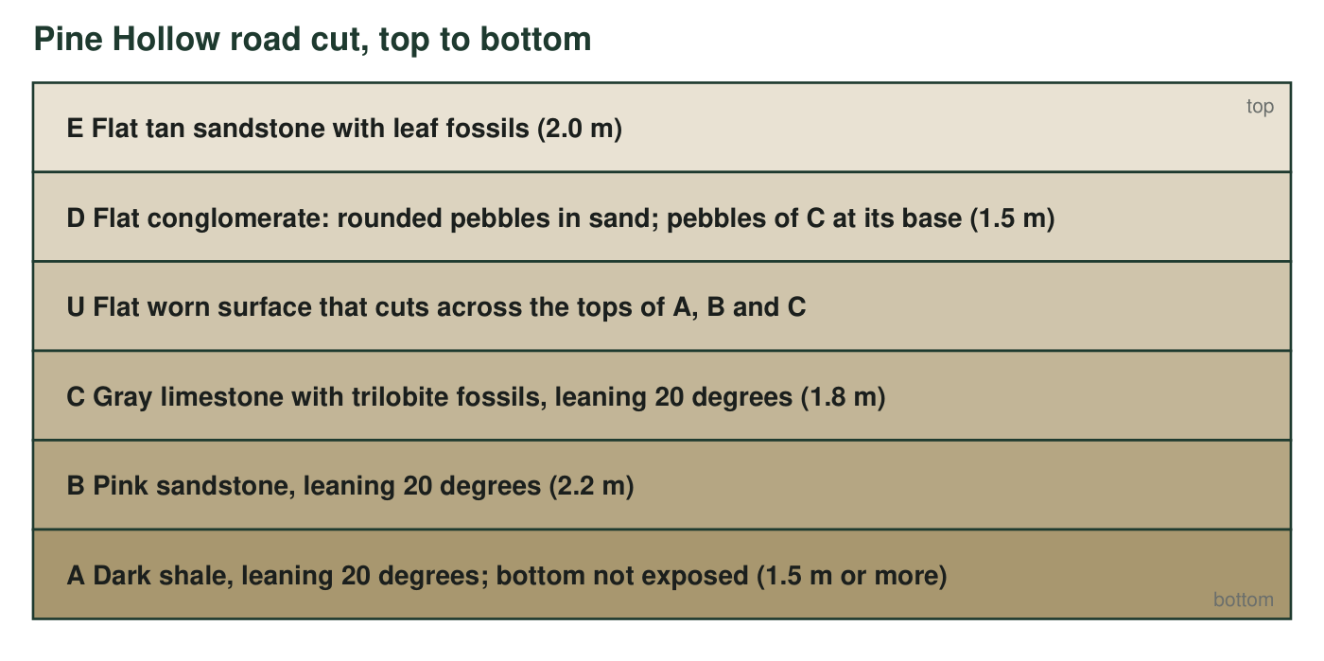
Layers are listed from the top of the cut downward. Layers A, B and C lean 20 degrees; D and E are flat. The dike G and fault F are described in the next figure and the clue table.
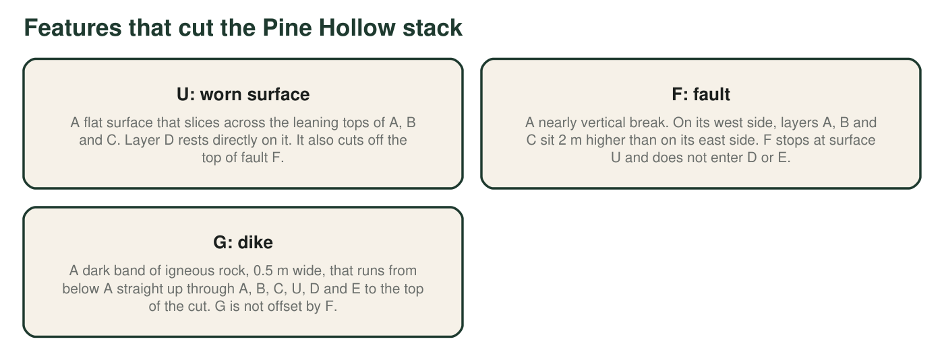
The three features that are not layers.
Clue table
Clue | Where it is seen | What you can see
1 | Layers A, B, C | All three lean the same 20 degrees; A is below B, and B is below C.
2 | Surface U | Flat, with a few centimeters of broken rock just below it.
3 | Base of layer D | Rounded pebbles made of layer C's gray limestone, mixed into D's sand.
4 | Layers D and E | Flat; D is below E; neither is offset by F.
5 | Fault F | Offsets A, B and C by 2 m; stops at U; does not offset G.
6 | Dike G | Cuts A through E and the surface U; its edges are baked and glassy where they touch each layer.

Part A: Put the events in order
1. Complete the event table. The eight events, out of order, are: A deposited; B deposited; C deposited; A, B and C tilted; fault F moves; surface U worn flat; D and E deposited (count this as one step, D then E); dike G intrudes. For each step write the rule that proves its position: superposition, original horizontality, cross-cutting, or 'pebble clue'.
Step | Event | Rule or clue that fixes its place
1 (first)
2
3
4
5
6
7
8 (last)

2. Which rule tells you that layers A, B and C were tilted after they formed, not deposited on a slope? State the rule in your own words.
______________________________________________________________________________________
______________________________________________________________________________________
______________________________________________________________________________________
3. Clue 3 says the base of D contains rounded pebbles of C. Explain what had to happen to C before those pebbles could end up inside D, and what that tells you about the order of C, U and D.
______________________________________________________________________________________
______________________________________________________________________________________
______________________________________________________________________________________
4. Explain why fault F must be younger than C but older than D. Name the rule you are using for each half of the answer.
______________________________________________________________________________________
______________________________________________________________________________________
______________________________________________________________________________________
5. Dike G and fault F are both features that cut the stack. Which one is younger, and which two clues prove it?
______________________________________________________________________________________
______________________________________________________________________________________
______________________________________________________________________________________

Part B: Draw the road cut at an earlier moment
Draw a side view of the Pine Hollow site at the moment just after surface U was worn flat and before layer D was deposited. Your drawing must show: layers A, B and C leaning 20 degrees (use a ruler), fault F offsetting them by a small step, and the flat surface U cutting across the tops of the leaning layers and the top of F. Label every layer and feature with its letter. Do not draw D, E or G, because they do not exist yet. Add a one-sentence caption under the drawing that says what the land surface looked like at that moment.

6. In your drawing, which layer is exposed at the ground surface on the east side of the fault, and which on the west side? Explain using the 2 m offset.
______________________________________________________________________________________
______________________________________________________________________________________

Part C: What the evidence cannot say
7. Can you tell from the road cut whether fault F moved before or after layers A, B and C were tilted? Explain what evidence would be needed to decide.
______________________________________________________________________________________
______________________________________________________________________________________
______________________________________________________________________________________
8. Only one part of this road cut can be given an age in years directly. Which part is it, why, and what would its age tell you about every layer in the cut?
______________________________________________________________________________________
______________________________________________________________________________________
______________________________________________________________________________________

Work from the bottom and from the cuts
Fill the event table in two passes. First pass: list the layers from the bottom up (A, B, C, then D and E); superposition fixes their order. Second pass: place each cutting feature just after the youngest thing it cuts and just before the oldest thing it does not cut. For example, surface U cuts C and F but not D, so U goes between F and D. For the drawing, start with three parallel tilted lines, then add the fault step, then rule a flat line across the top and erase everything above it.

A second dike
Suppose a second dike, H, is found that cuts A, B and C, is offset 2 m by fault F, and is cut off by surface U. Add H to your event list and explain exactly where it fits and why. Then explain whether H could help answer q7, and what you would need to see at H's edges to decide if it was tilted along with the layers.

