Angela's Tools · Chapter 9: Reconstructing Earth's History · Worksheet 4 of 10

Two Cliffs and an Ash Band: Build One Column of Time (Teacher answer key)
Learning target: I can read two rock-layer diagrams, match their shared layers, combine them into one model column, attach ages in years where the evidence allows, and mark where a boundary belongs.
Diagrams and models · about 40 minutes · individual · Standards: MS-ESS1-4 (practice), MS-LS4-1 (supports)

Standards connections
MS-ESS1-4 (practice): MS-ESS1-4 is a California Grade 8 performance expectation. Here students do the hands-on half of it: use superposition, lateral continuity and two dated volcanic layers to combine strata from two sites into one ordered, partly dated record and decide where a boundary belongs. The sites and ages are invented, so no period names are needed, which respects the assessment boundary.
MS-LS4-1 (supports): MS-LS4-1 is a California Grade 8 performance expectation. The drop from thirty kinds of fossils to eleven across one line is a fossil-record pattern students interpret without naming any species or era.

Answers with reasoning

The evidence: two cliffs in the Hollow Creek region (a teaching example)
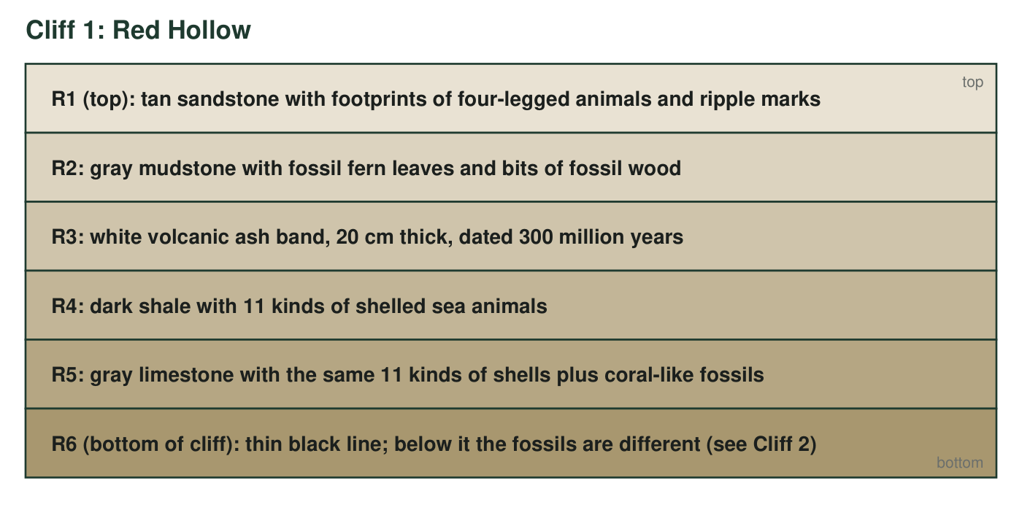
Cliff 1, Red Hollow. Six layers from the top of the cliff (R1) to the bottom (R6). The white ash band R3 is 20 cm thick; a lab dated its minerals at 300 million years.
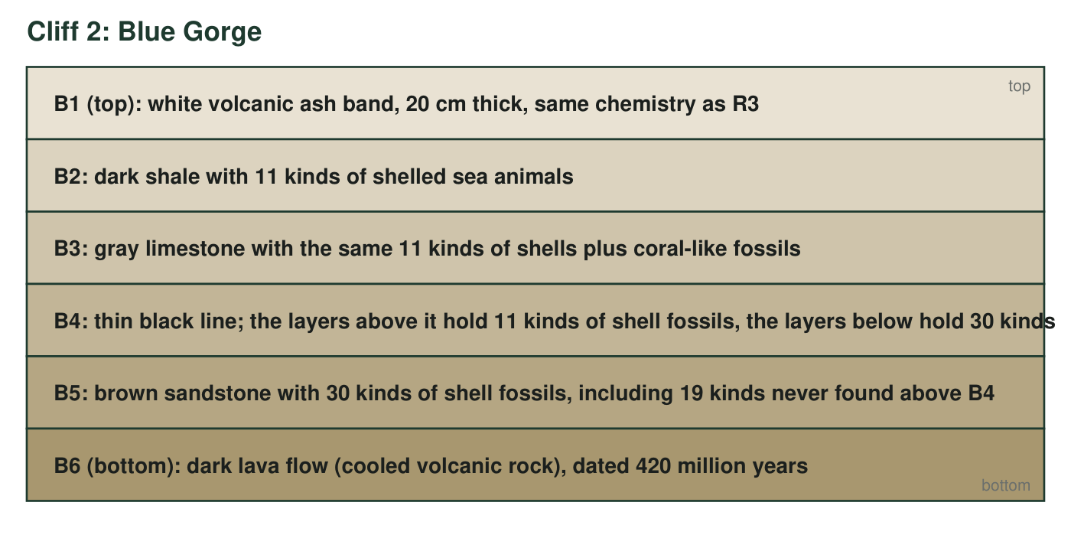
Cliff 2, Blue Gorge, 45 km away. Six layers from top (B1) to bottom (B6). The ash band B1 has the same thickness and the same chemical fingerprint as R3. The lava flow B6 was dated at 420 million years.
Two rules you will need
Superposition: in undisturbed layers, the lowest layer is the oldest. Lateral continuity: a layer spreads sideways as a sheet, so the same layer can show up in two cliffs far apart. A volcanic ash band or a lava flow can be dated in years; a shale, sandstone or limestone usually cannot.

Part A: Read before you draw
1. Which layer is the oldest at Red Hollow, and which rule tells you so?
Answer: R6, the thin black line at the bottom of the cliff, is the oldest exposed layer at Red Hollow. Superposition: in undisturbed layers the lowest one settled first.
Reasoning: Students sometimes choose R5 because it is the lowest thick rock; R6 is listed as a layer and is lower.
Also acceptable: Accept 'R6, or R5 if the line does not count as a layer' with the rule named.
Full credit must include:
• Names R6 (accept R5 if the student argues the black line is a surface, not a layer, and says R5 is the lowest rock)
• Names superposition
2. Match every Blue Gorge layer that has a twin at Red Hollow (write the pairs, for example 'B? = R?'). Then explain which rule lets you treat the two ash bands as the same layer, and what evidence besides the rule supports the match.
Answer: Pairs: B1 = R3 (ash band), B2 = R4 (dark shale with 11 kinds of shells), B3 = R5 (limestone with the same shells and coral-like fossils), B4 = R6 (thin black line). Lateral continuity lets the ash band be treated as one layer that spread across both sites. Supporting evidence: the two ash bands have the same thickness (20 cm) and the same chemical fingerprint, and the layers directly beneath them match in rock type and in fossil content, in the same order.
Reasoning: Four matches, the rule, and independent evidence (chemistry, thickness, matching sequence below) are all needed for full credit.
Also acceptable: Accept three pairs plus the rule and evidence for most of the credit if B4 = R6 is missed.
Full credit must include:
• All four pairs
• Names lateral continuity
• Gives at least one piece of supporting evidence (chemistry, thickness, or the matching sequence below the ash)
3. Which cliff reaches further back in time? Which layers in the combined column appear at only one of the two sites? List them.
Answer: Blue Gorge reaches further back in time, down to the 420-million-year lava flow. Layers found at only one site: R1 and R2 (only at Red Hollow, above the ash) and B5 and B6 (only at Blue Gorge, below the black line).
Reasoning: Red Hollow adds the younger top; Blue Gorge adds the older bottom.
Also acceptable: None.
Full credit must include:
• Blue Gorge reaches further back
• Lists R1, R2, B5, B6

Part B: Build the model
Draw one combined column for the Hollow Creek region with the oldest layer at the bottom. Draw every distinct layer once (matched twins count as one layer) and label each with its name(s), for example 'R4 = B2'. Shade the ash band and the lava flow and write their ages beside them. Draw the thin black line and label it 'fossil change: 30 kinds below, 11 above.' Finally, bracket the layers that lie between the two dated layers and write the range of ages they could have.
Expected drawing: From top to bottom: R1 sandstone (footprints); R2 mudstone (ferns); R3 = B1 ash band, shaded, '300 million years'; R4 = B2 dark shale; R5 = B3 limestone; R6 = B4 thin black line, labeled 'fossil change: 30 kinds below, 11 above'; B5 brown sandstone (30 kinds of shells); B6 lava flow, shaded, '420 million years'. A bracket spans R4, R5, the black line and B5 with the label 'between 420 and 300 million years.'
Reasoning: Eight distinct layers in the correct order, both dated layers shaded with ages, the black line labeled with the fossil counts, and the bracket on the four undated layers between the two dates.

Part C: Use the model
4. Give the age range for the dark shale (R4 = B2) and explain how you know. Then explain why you cannot give a single age for it.
Answer: The dark shale is between 300 and 420 million years old: it lies above the 420-million-year lava flow, so it is younger than 420, and below the 300-million-year ash band, so it is older than 300. No single age is possible because the shale itself cannot be dated; only the volcanic layers can, and they bracket it.
Reasoning: This is the bookmark idea: dated layers bracket undated ones.
Also acceptable: Accept 'younger than 420, older than 300.'
Full credit must include:
• Range 300 to 420 million years
• Reason from the positions of the two dated layers
• States that shale cannot be dated directly
5. What can you say about the ages of R1 and R2? What can you not say, and what new evidence would fix that?
Answer: R1 and R2 are younger than 300 million years because they lie above the dated ash band. You cannot say how much younger: there is no dated layer above them, so they could be 299 million years old or far younger. A datable layer above them (another ash band or lava flow) would set an upper bracket.
Reasoning: The point is that a column with a date only at the bottom of a stretch gives a one-sided bracket.
Also acceptable: Accept 'a fossil that is known elsewhere to belong to a certain time' as evidence that would narrow the age, since fossil correlation to dated sections elsewhere is a real method.
Full credit must include:
• Younger than 300 million years
• Cannot say how much younger
• Names a datable layer above as the fix
6. What happened at the thin black line (B4 = R6)? Use the fossil numbers in your answer and name the kind of event a geologist would suspect.
Answer: Across the black line the number of kinds of shell fossils drops from 30 below to 11 above, and 19 kinds that lived before the line are never found after it. A large share of the kinds of organisms disappeared in a short time, which is what a mass extinction looks like in strata. (A geologist would also check whether the line is a time gap with missing layers, because a gap can make a change look sudden.)
Reasoning: Full credit needs the numbers and the interpretation; the parenthetical caution is a bonus that the extension develops.
Also acceptable: A student who says 'either a mass extinction or a gap in the record' is reasoning carefully and earns full credit.
Full credit must include:
• Uses 30 and 11 (or 19 lost kinds)
• Names mass extinction or a sudden loss of many kinds of organisms
7. If a geologist divided the history of this region into two 'chapters,' she would put the boundary at the thin black line, not at the ash band, even though the ash band is the layer with a known age. Explain why, using what you know about how the geologic time scale is organized.
Answer: The geologic time scale is organized by events recorded in rocks and fossils, not by convenient dates. A boundary belongs where the record shows a major change, and the biggest change in this column is at the black line, where 19 kinds of organisms vanish and the fossil community is replaced. The ash band records an eruption that lasted days and did not change what lived in the region (the same 11 kinds of shells appear below it, and ferns and footprints above it show a slower environmental shift, not a sudden loss). The ash band's job is different: it is a bookmark that gives the boundary and the layers around it an age in years. First the chapter break is placed at the event; then the dated layers tell how old the break is (in this column, between 300 and 420 million years).
Reasoning: This is the heart of MS-ESS1-4: boundaries follow events in the strata; absolute dates are attached afterward. Students must separate 'where the boundary goes' from 'how we know its age.'
Also acceptable: A student who argues the boundary could go at the ash band because 'that is where land replaced sea' has noticed a real environmental change; give credit if the answer still recognizes the fossil loss as the larger event.
Full credit must include:
• States that time-scale boundaries are placed at major changes in the fossil or rock record
• Identifies the black line as the major change, with the fossil evidence
• Explains the ash band's role as a date marker, not an event boundary
• Gives the boundary's bracketed age
8. Describe how the environment at this spot changed from the time of R5 to the time of R1. What is the evidence for each environment?
Answer: At the time of R5 and R4 the spot was a shallow sea: limestone and shale with shelled sea animals and coral-like fossils. By the time of R2 it was wet land, probably a swampy lowland: mudstone with fern leaves and wood. By R1 it was land with shallow water or a shoreline: sandstone with ripple marks and the footprints of four-legged animals walking on it. The sea retreated and land took its place.
Reasoning: Each environment must be tied to its fossil or rock evidence.
Also acceptable: Accept 'river or lake shore' for R1.
Full credit must include:
• Sea for R5/R4 with shells or coral-like fossils as evidence
• Land for R2/R1 with ferns, wood, footprints or ripple marks as evidence
• States the direction of change (sea to land)
9. Which discovery would add a new age in years to the combined column?
Answer: B: Dating the minerals in a second ash band found inside layer B5.
Reasoning: Only volcanic layers give ages in years. Option A extends the matching (relative), C adds a fossil (relative information at best), D changes nothing about age.
Also acceptable: None.

Teacher notes
The Hollow Creek cliffs, their fossil counts and the dates 300 and 420 million years are invented for teaching and do not correspond to real sites or to a named real extinction; say so if students try to match them to the textbook's timelines. The design mirrors the textbook's Figure 1A (matching strata across canyons, p. 106) without using its rounded ages, which the prior review flagged as unreliable. The combined column should have eight units; the most common drawing error is drawing the ash band twice. In q6 and the extension, the idea that a sharp fossil change can also be a time gap is accurate and worth raising; it is how geologists test whether an extinction was truly sudden. Fossil 'kinds' is used in place of species or genera on purpose.

