Angela's Tools · Chapter 9: Reconstructing Earth's History · Worksheet 4 of 10

Two Cliffs and an Ash Band: Build One Column of Time
Learning target: I can read two rock-layer diagrams, match their shared layers, combine them into one model column, attach ages in years where the evidence allows, and mark where a boundary belongs.
Diagrams and models · about 40 minutes · individual · Standards: MS-ESS1-4 (practice), MS-LS4-1 (supports)
Name: ____________________________ Date: ____________ Period: ______

Directions
Study both cliff diagrams. The layers are listed from the top of each cliff to the bottom, the way you would see them standing in front of the rock. The two cliffs are 45 kilometers apart in the same region. Answer questions 1 to 3 before you draw, because they tell you how the two cliffs fit together. Then draw the combined column in the box, and finish with questions 4 to 9. Thickness in the drawings does not need to be to scale, but the order must be right.

The evidence: two cliffs in the Hollow Creek region (a teaching example)
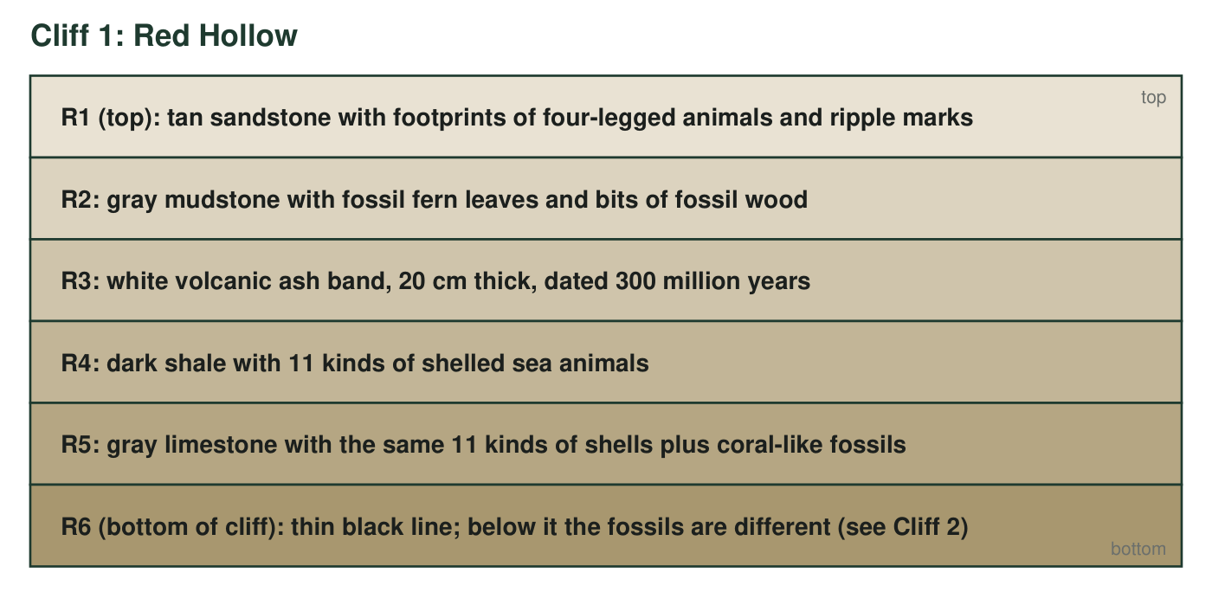
Cliff 1, Red Hollow. Six layers from the top of the cliff (R1) to the bottom (R6). The white ash band R3 is 20 cm thick; a lab dated its minerals at 300 million years.
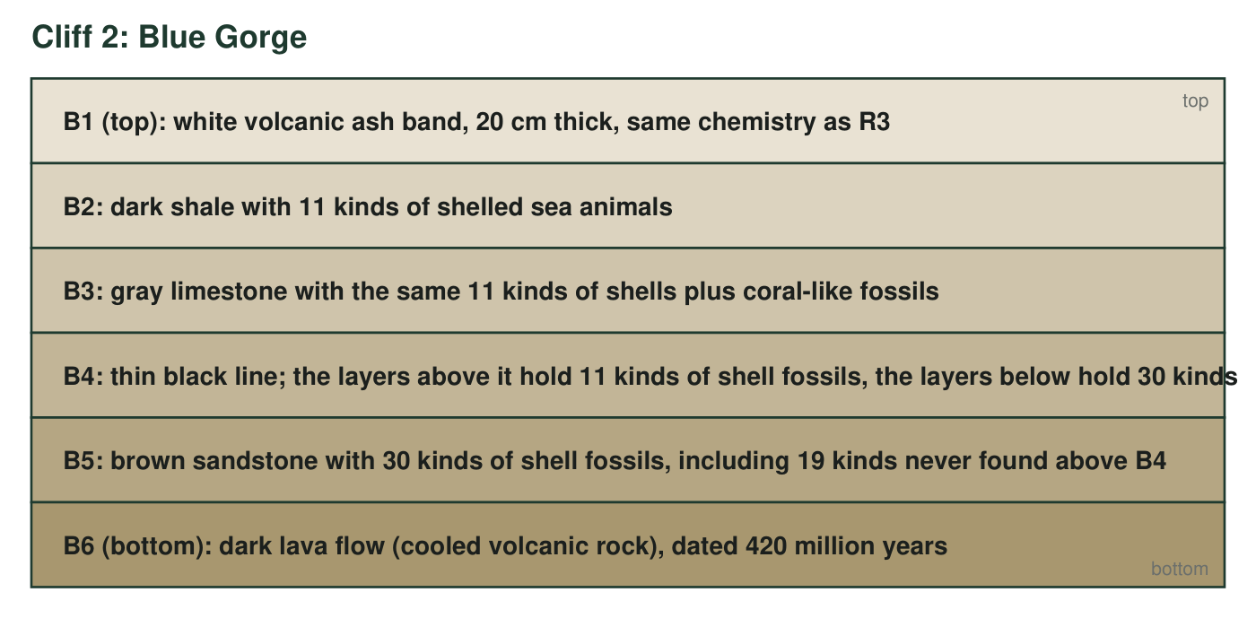
Cliff 2, Blue Gorge, 45 km away. Six layers from top (B1) to bottom (B6). The ash band B1 has the same thickness and the same chemical fingerprint as R3. The lava flow B6 was dated at 420 million years.
Two rules you will need
Superposition: in undisturbed layers, the lowest layer is the oldest. Lateral continuity: a layer spreads sideways as a sheet, so the same layer can show up in two cliffs far apart. A volcanic ash band or a lava flow can be dated in years; a shale, sandstone or limestone usually cannot.

Part A: Read before you draw
1. Which layer is the oldest at Red Hollow, and which rule tells you so?
______________________________________________________________________________________
______________________________________________________________________________________
2. Match every Blue Gorge layer that has a twin at Red Hollow (write the pairs, for example 'B? = R?'). Then explain which rule lets you treat the two ash bands as the same layer, and what evidence besides the rule supports the match.
______________________________________________________________________________________
______________________________________________________________________________________
______________________________________________________________________________________
______________________________________________________________________________________
3. Which cliff reaches further back in time? Which layers in the combined column appear at only one of the two sites? List them.
______________________________________________________________________________________
______________________________________________________________________________________
______________________________________________________________________________________

Part B: Build the model
Draw one combined column for the Hollow Creek region with the oldest layer at the bottom. Draw every distinct layer once (matched twins count as one layer) and label each with its name(s), for example 'R4 = B2'. Shade the ash band and the lava flow and write their ages beside them. Draw the thin black line and label it 'fossil change: 30 kinds below, 11 above.' Finally, bracket the layers that lie between the two dated layers and write the range of ages they could have.

Part C: Use the model
4. Give the age range for the dark shale (R4 = B2) and explain how you know. Then explain why you cannot give a single age for it.
______________________________________________________________________________________
______________________________________________________________________________________
______________________________________________________________________________________
5. What can you say about the ages of R1 and R2? What can you not say, and what new evidence would fix that?
______________________________________________________________________________________
______________________________________________________________________________________
______________________________________________________________________________________
6. What happened at the thin black line (B4 = R6)? Use the fossil numbers in your answer and name the kind of event a geologist would suspect.
______________________________________________________________________________________
______________________________________________________________________________________
______________________________________________________________________________________
7. If a geologist divided the history of this region into two 'chapters,' she would put the boundary at the thin black line, not at the ash band, even though the ash band is the layer with a known age. Explain why, using what you know about how the geologic time scale is organized.
______________________________________________________________________________________
______________________________________________________________________________________
______________________________________________________________________________________
______________________________________________________________________________________
______________________________________________________________________________________
______________________________________________________________________________________
8. Describe how the environment at this spot changed from the time of R5 to the time of R1. What is the evidence for each environment?
______________________________________________________________________________________
______________________________________________________________________________________
______________________________________________________________________________________
9. Which discovery would add a new age in years to the combined column?
○ A. Finding the same dark shale in a third cliff 100 km away
○ B. Dating the minerals in a second ash band found inside layer B5
○ C. Finding a new footprint in layer R1
○ D. Measuring the thickness of the limestone more carefully

Match first, then stack
Lay the two lists side by side and draw a line from R3 to B1, from R4 to B2, from R5 to B3 and from R6 to B4. Everything above R3 at Red Hollow goes on top of the combined column; everything below B4 at Blue Gorge goes on the bottom. The combined column should have eight labeled layers (counting the ash band, the black line and the lava flow). If your drawing has more than eight, you have drawn a twin twice.

A third cliff with a twist
A third cliff, Green Bench, shows the same ash band on top, then the dark shale, then the limestone, and then directly the lava flow dated 420 million years, with no black line and no brown sandstone between them. Explain what the missing layers mean for the history of Green Bench (think about layers that were never deposited or were worn away), and describe what you would expect to see in the fossils right at the contact between the limestone and the lava. Then redraw the combined column with Green Bench added and say whether it changes any of your age brackets.

