Angela's Tools · Chapter 9: Reconstructing Earth's History · Worksheet 7 of 10

Fix Dario's Exhibit: Finding the Errors in a Timeline of Earth
Learning target: I can find the errors in another student's explanation of Earth's history, explain what went wrong in each one, and rewrite the statements so they are accurate.
Error analysis · about 40 minutes · individual · Standards: MS-ESS1-4 (practice), MS-LS4-1 (supports)
Name: ____________________________ Date: ____________ Period: ______

Directions
Dario wrote the text and the timeline below for a hallway exhibit called 'Earth: The Whole Story.' Some of his sentences are correct; most contain an error. Read everything once. Then complete the error table (q1) before you rewrite anything. For each rewrite, do two things: say what went wrong (the misunderstanding, not just 'it is wrong'), and write the corrected sentence in your own words. You may use any worksheet from this chapter.

Dario's exhibit text (sentences are numbered for you)
S1. Earth is about 4.6 billion years old; scientists measured this from the oldest rock ever found on Earth. S2. The Phanerozoic Eon takes up most of the chart on our classroom wall, so it covers most of Earth's history. S3. Volcanoes gave Earth its first atmosphere, which was full of oxygen because volcanoes release oxygen. S4. Scientists decided where to put the boundaries between eras by splitting Earth's history into equal lengths of time. S5. The dinosaurs died out 66 million years ago, and the first humans appeared soon after, so our early ancestors saw the last dinosaurs. S6. The ice age ended 11,700 years ago, which is why there is no ice at the poles today. S7. The same rock layer can be found in canyons far apart because a layer of sediment spreads sideways as a sheet. S8. Every rock layer takes about the same amount of time to form, so a layer that is twice as thick represents twice as much time.
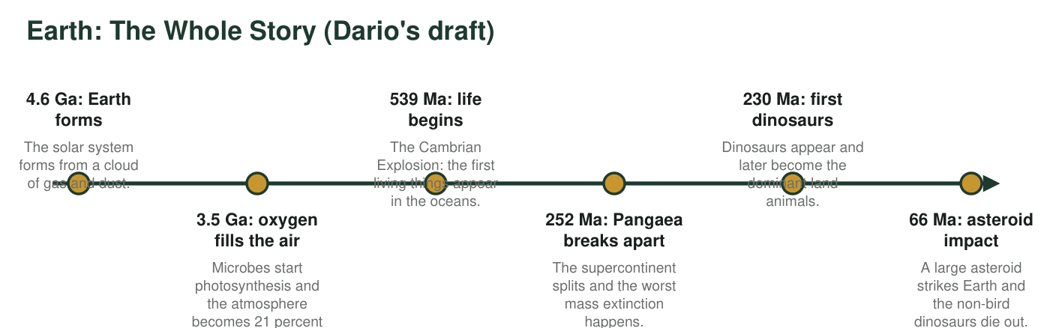
Dario's timeline for the exhibit. Three of the six entries contain an error in the event, the date, or both.

Part A: Diagnose
1. Mark each sentence as correct or error. For each error, write in a few words what is wrong. Exactly one sentence is fully correct.
Correct or error? | What is wrong, in a few words (leave blank if correct)
S1
S2
S3
S4
S5
S6
S7
S8

2. Which sentence is correct? Name the rule it describes and give one reason a student might wrongly mark it as an error.
______________________________________________________________________________________
______________________________________________________________________________________
______________________________________________________________________________________

Part B: Explain and rewrite
3. S1. Explain what Dario misunderstood about where Earth's age comes from, then rewrite the sentence correctly. Include the age of the oldest known Earth rock.
______________________________________________________________________________________
______________________________________________________________________________________
______________________________________________________________________________________
______________________________________________________________________________________
______________________________________________________________________________________
4. S2. Explain the misunderstanding, support your explanation with a calculation (the Phanerozoic began about 539 million years ago; Earth is about 4,540 million years old), and rewrite the sentence.
______________________________________________________________________________________
______________________________________________________________________________________
______________________________________________________________________________________
______________________________________________________________________________________
______________________________________________________________________________________
5. S3. Explain what is wrong, including where the oxygen in today's air actually came from and why it took so long to build up. Rewrite the sentence.
______________________________________________________________________________________
______________________________________________________________________________________
______________________________________________________________________________________
______________________________________________________________________________________
______________________________________________________________________________________
6. S4. Explain what rule scientists actually use to place boundaries on the time scale, and why that rule makes the units unequal in length. Rewrite the sentence.
______________________________________________________________________________________
______________________________________________________________________________________
______________________________________________________________________________________
______________________________________________________________________________________
______________________________________________________________________________________
7. S5. Calculate how many years separate the extinction of the non-bird dinosaurs (66 million years ago) from the appearance of modern humans (about 300,000 years ago). Explain Dario's misunderstanding and rewrite the sentence.
______________________________________________________________________________________
______________________________________________________________________________________
______________________________________________________________________________________
______________________________________________________________________________________
______________________________________________________________________________________
8. S6. Explain the difference between an ice age and an interglacial period, say what actually happened 11,700 years ago, and rewrite the sentence.
______________________________________________________________________________________
______________________________________________________________________________________
______________________________________________________________________________________
______________________________________________________________________________________
______________________________________________________________________________________
9. S8. Explain why thickness is not a clock, using an example of two layers that could form at very different rates. Rewrite the sentence so it says what thickness can and cannot tell you.
______________________________________________________________________________________
______________________________________________________________________________________
______________________________________________________________________________________
______________________________________________________________________________________
______________________________________________________________________________________

Part C: Fix the timeline
10. Three timeline entries are wrong. For each, say what is wrong and write a corrected entry. You may split an entry into two if two different events were mixed together.
What is wrong | Corrected entry (date and event)
Entry: 3.5 Ga oxygen fills the air
Entry: 539 Ma life begins
Entry: 252 Ma Pangaea breaks apart

11. Look back over all of Dario's errors. Describe one habit of thinking that caused more than one of them (for example, trusting how something looks on a chart, or assuming that steady rates apply everywhere). Give two sentences from the exhibit as examples.
______________________________________________________________________________________
______________________________________________________________________________________
______________________________________________________________________________________

A rewrite in three moves
For every rewrite, use three sentences. Move 1, the misunderstanding: 'Dario thinks ___.' Move 2, the evidence: 'But ___ shows ___' (use a number or a fact from the chapter). Move 3, the correction: 'A correct sentence would say: ___.' If you are stuck on where to find the facts, S1 and S2 are in Worksheets 1 and 5, S3 and the timeline are in the presentation, S4 and S8 are in Worksheet 6, and S5 and S6 are in Worksheet 2.

Write the exhibit Dario should have written
Using your corrected sentences and your corrected timeline, write a 120- to 150-word exhibit panel titled 'Earth: The Whole Story' for a hallway audience of sixth graders. It must include one number that shows how little of Earth's history humans have been part of, one sentence about where the age of Earth comes from, and one sentence about how the boundaries of the time scale are chosen. Then add one 'honest uncertainty' sentence: something about Earth's history that scientists are still working out (for example, exactly when oxygen-producing microbes first appeared).

