Angela's Tools · Chapter 10: Energy in Earth's Systems · Worksheet 1 of 10

The Jar That Stirs Itself: Warm Water Up, Cold Water Down (Teacher answer key)
Learning target: I can observe how warm and cold water move inside still water, record what I notice and wonder, and write a first explanation for why heating makes matter move.
Phenomenon exploration · about 30 minutes · individual · Standards: MS-ESS2-1 (practice)

Standards connections
MS-ESS2-1 (practice): Students meet the mechanism (heating lowers density, gravity sinks the denser fluid) that drives convection in the mantle, the energy flow this PE asks them to model. The rock-cycle processes named in the clarification statement come in a later lesson, so this sheet builds toward the PE rather than assessing it.

Answers with reasoning

The phenomenon
A science teacher fills a tall, clear glass jar with tap water and lets it sit on the desk for an hour so it is completely still and at room temperature (about 21 °C). In Trial 1 she lowers a small, thin plastic pouch of warm water (about 45 °C) dyed red to the bottom of the jar and snips it open with long scissors. In Trial 2, in a fresh jar of still room-temperature water, she opens a pouch of cold water (about 4 °C) dyed blue just under the surface. A student films both trials and writes down what the dye does at each time. Nothing stirs the jar in either trial.
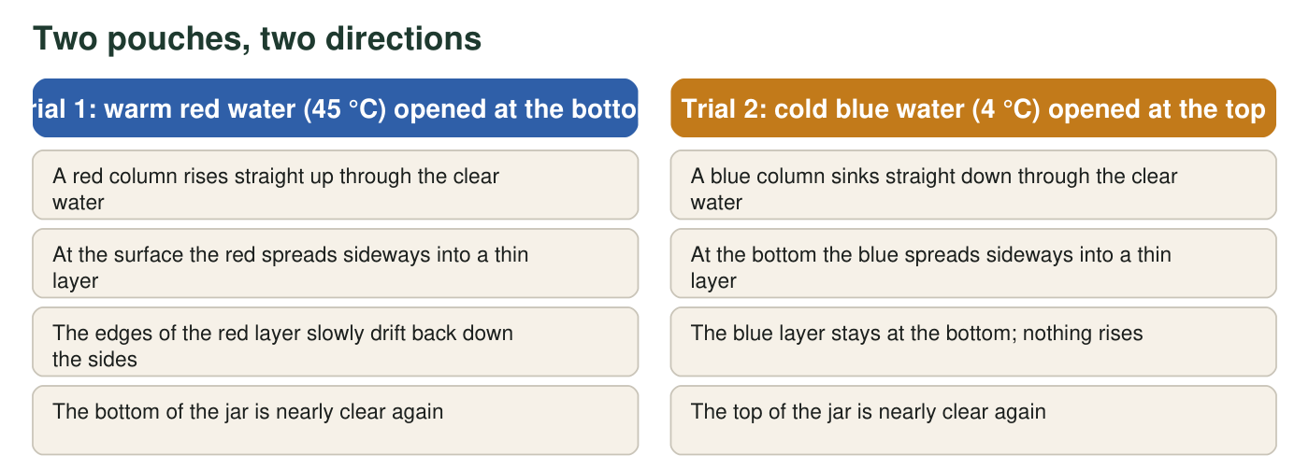
Where each dyed pouch was opened and what the water looked like 40 seconds later. The temperatures and times are a teaching scenario written to be realistic; they were not measured in a real lab.
Observation log (teaching scenario)
Simulated teaching dataset (not real measurements).
Time after opening the pouch | Trial 1: warm red water at the bottom | Trial 2: cold blue water at the top
0 s | Red cloud sits at the bottom of the jar | Blue cloud sits just under the surface
5 s | A red plume lifts off the bottom and heads upward | A blue plume drops away from the surface and heads downward
15 s | Plume reaches the surface and mushrooms sideways | Plume reaches the bottom and spreads sideways
40 s | Thin red layer across the top; edges start sliding down the sides | Thin blue layer across the bottom; top of jar clear
90 s | Faint pink streaks drifting down near the glass; red layer thinner | Blue layer unchanged; faint blue haze only near the bottom
180 s | Jar is a pale, even pink | Jar still has a clear top and a blue bottom

A teaching dataset: the times and descriptions were written to match what warm and cold water really do, but they are not measurements from a real jar.

Part A: Notice
1. Fill in the table using only the figure and the observation log. Use direction words (up, down, sideways) and times.
Answer: Trial 1: moved up first (plume at 5 s, reached the surface by 15 s); spread sideways into a thin layer at the top, then the edges slid down the sides (40 s to 90 s); at 180 s the jar was a pale, even pink. Trial 2: moved down first (plume at 5 s, reached the bottom by 15 s); spread sideways into a thin layer at the bottom; at 180 s the top was still clear and the bottom still blue.
Reasoning: Every cell can be read directly from the log; the point is careful observation with direction words and times.
Also acceptable: Accept 'rose' and 'sank' for up and down; accept 'mushroomed' for spread sideways.
Full credit must include:
• Correct first direction for each trial
• Sideways spreading at the far end of the jar
• Different end states at 180 s, with times cited
2. The two trials are almost mirror images of each other, but not quite. Describe one way the end of Trial 1 (180 s) is different from the end of Trial 2, using the log as evidence.
Answer: At 180 s Trial 1 had mixed into an even pink, but Trial 2 still had a clear top and a blue bottom. The log shows the red layer thinning and streaks drifting down (90 s), while the blue layer was 'unchanged.'
Reasoning: The warm water cooled as it sat at the top and then sank through the jar, mixing everything; the cold water at the bottom had nowhere colder to go, so it stayed. Students only need to describe the difference here; the cause comes later in the lesson.
Also acceptable: A student who notices that red streaks came back down while blue never went back up has found the same difference.
Full credit must include:
• Names the even pink versus the blue-bottom end state
• Cites a time or a quoted observation from the log

Part B: Wonder and connect
3. Write three questions you have about what you saw. At least one must begin with why and at least one with what would happen if.
Answer: Any three specific questions, one starting with 'why' and one with 'what would happen if.' Examples: Why did the red water stop rising at the surface instead of staying in a column? What would happen if the warm pouch were opened in the middle of the jar? Why did the red come back down but the blue did not? What would happen if the jar were full of oil instead of water?
Reasoning: Questions should be answerable by observation or a test, not yes/no trivia.
Also acceptable: Accept questions about the dye itself (does the dye change the water's behavior?) as good investigative questions.
Full credit must include:
• Three questions
• One 'why' and one 'what would happen if'
• Each question refers to something observable in the trials
4. Where have you seen something like this before? Describe one place outside the classroom where warm stuff goes up or cold stuff goes down (for example in a kitchen, a bathroom, a lake, or the sky), and say what you think it has in common with the jar.
Answer: Examples: steam and warm air rising above a pot or a shower; a hot-air balloon lifting; the warm top layer of a lake on a summer afternoon with cold water below; a lava lamp's blobs rising and falling; cold air pooling on the floor near an open freezer. The common feature: the warmer material is the one that goes up and the cooler material is the one that goes down, without anything pushing it.
Reasoning: This retrieves prior experience that the lesson will connect to density. Any true example counts if the student says what it shares with the jar.
Also acceptable: A radiator warming a room from the floor up is a strong example.
Full credit must include:
• A real example from outside the classroom
• A stated connection to warm-up or cold-down movement

Part C: Your first explanation
5. Explain, as well as you can right now, why the warm red water went up and the cold blue water went down. Nothing pushed either pouch. Your explanation should say what is different about warm water and cold water, and it should mention gravity somewhere.
Answer: Model response: Warm water takes up a little more space than the same amount of cold water, so a cupful of warm water has less mass than a cupful of cold water; it is less dense. Gravity pulls harder on the denser cold water, so the cold water sinks and squeezes the lighter warm water upward. That is why the red rose and the blue sank even though nothing pushed them. When the red water reached the top it lost heat to the air and the water around it, became denser again, and slid back down the sides, which is why the jar ended up evenly pink.
Reasoning: This is a first explanation, so credit any reasonable idea that (a) names a difference between warm and cold water and (b) uses gravity. Many students will write 'heat rises'; accept it here but mark it for revision, because it is matter, not heat, that rises. The 4 °C blue water is at about the temperature at which fresh water is densest (near 4 °C), so it is in fact denser than the 21 °C water around it.
Also acceptable: A student who says 'the warm water is lighter' without the word density has the right idea; ask what 'lighter' means for the same amount of water.
Full credit must include:
• States a difference between warm and cold water (density, spacing, 'lighter' per cup)
• Uses gravity in the explanation
• Explains both the rising and the sinking
6. Predict: in a third trial the teacher opens a pouch of warm red water just under the surface instead of at the bottom. What do you think the red will do, and why?
Answer: The warm red water would stay at the top and spread out sideways into a thin layer, because it is already in the place a less dense fluid ends up; it has nowhere higher to go. Over a few minutes it would cool and slowly mix downward.
Reasoning: A prediction consistent with the student's own explanation in q5 earns credit even if the student's model is incomplete.
Also acceptable: A student who predicts it 'floats like oil' has the idea; a student who predicts it sinks should be asked to compare with Trial 1.
Full credit must include:
• Predicts the red stays at the top and spreads
• Gives a reason tied to warm water being less dense or 'lighter'
7. Suppose the teacher kept a small heater under the center of the jar's bottom and an ice pack against the top of the glass the whole time. Describe the pattern of movement you would expect the water to settle into, and sketch it with arrows in the margin.
Answer: The water would settle into a loop: water warmed over the heater rises up the middle, spreads out across the top under the ice pack, cools, sinks down the sides, and slides back along the bottom toward the heater to be warmed again. The sketch should show a rising column in the center and sinking flow at the sides (or one big loop), with arrows that connect into a closed circuit.
Reasoning: This is the convection cell the lesson names later. Full credit needs a continuous loop, not just 'warm goes up, cold goes down.'
Also acceptable: Two symmetric loops (one each side of the center) is also correct.
Full credit must include:
• Rising over the heater and sinking under the ice
• Arrows form a closed loop
• Mentions the water being warmed again at the bottom
8. Scientists say that solid rock deep inside Earth slowly circulates in a pattern like the one in the jar, and that this is what feeds volcanoes and geysers. Write one question you would want answered before you could believe that, and say what kind of evidence might answer it.
Answer: Examples: How can rock move if it is solid? How fast does it move, and how would anyone measure that? How do scientists know what is deep underground when nobody can go there? Possible evidence: earthquake waves traveling through Earth, lava and hot springs reaching the surface, measurements of how continents drift a few centimeters each year.
Reasoning: The goal is a skeptical, testable question plus a sensible idea of evidence. Students are not expected to know the real methods yet.
Also acceptable: Accept 'How do we know it is hot down there?' with 'volcanoes and geysers' as evidence.
Full credit must include:
• A specific question about solid rock moving
• A plausible kind of evidence

Teacher notes
The trials are described, not performed, on this sheet; Lab 1 does a safe version with warm (not hot) water. The figure and log are a simulated scenario but match real behavior: warm water (45 °C) is less dense than 21 °C water and rises; 4 °C water is denser than 21 °C water and sinks (fresh water is densest near 4 °C, which is why the cold pouch is set at 4 °C rather than colder). Expect 'heat rises' in q5; do not correct it on this sheet, but record it as the misconception that W7 and the presentation address. The different endings of the two trials (even pink versus blue bottom) are the hook for Part C: the warm water loses energy at the surface and sinks, while the cold layer at the bottom has no colder place to go. Collect q5 answers; they are the 'before' explanation students revise in W10.

