Angela's Tools · Chapter 10: Energy in Earth's Systems · Worksheet 1 of 10

The Jar That Stirs Itself: Warm Water Up, Cold Water Down
Learning target: I can observe how warm and cold water move inside still water, record what I notice and wonder, and write a first explanation for why heating makes matter move.
Phenomenon exploration · about 30 minutes · individual · Standards: MS-ESS2-1 (practice)
Name: ____________________________ Date: ____________ Period: ______

Directions
Read the description of the two trials and study the figure and the observation log. Do not look anything up yet; this sheet is about what you notice and what you already think. Write in complete sentences. There are no wrong answers in Parts A and B, but every answer must be specific: name colors, directions and times from the log.

The phenomenon
A science teacher fills a tall, clear glass jar with tap water and lets it sit on the desk for an hour so it is completely still and at room temperature (about 21 °C). In Trial 1 she lowers a small, thin plastic pouch of warm water (about 45 °C) dyed red to the bottom of the jar and snips it open with long scissors. In Trial 2, in a fresh jar of still room-temperature water, she opens a pouch of cold water (about 4 °C) dyed blue just under the surface. A student films both trials and writes down what the dye does at each time. Nothing stirs the jar in either trial.
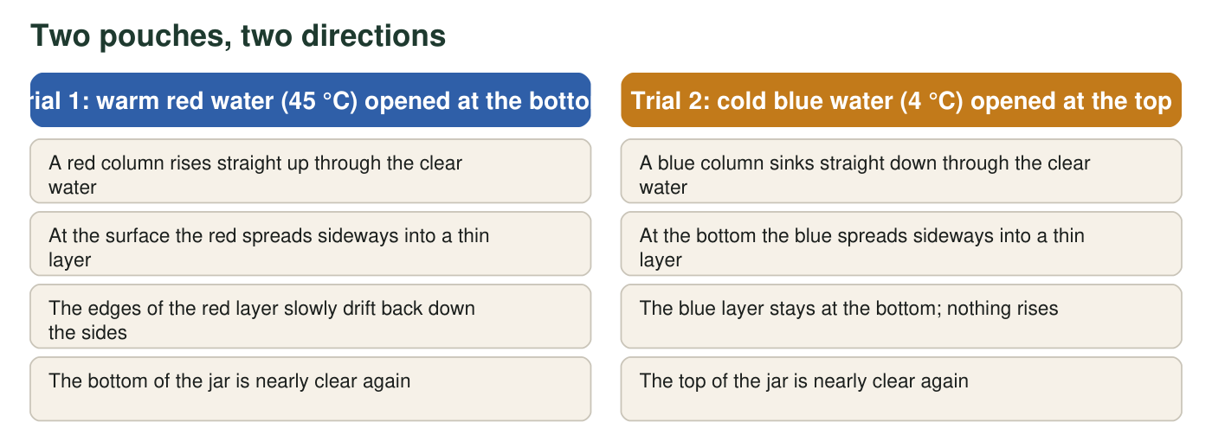
Where each dyed pouch was opened and what the water looked like 40 seconds later. The temperatures and times are a teaching scenario written to be realistic; they were not measured in a real lab.
Observation log (teaching scenario)
Simulated teaching dataset (not real measurements).
Time after opening the pouch | Trial 1: warm red water at the bottom | Trial 2: cold blue water at the top
0 s | Red cloud sits at the bottom of the jar | Blue cloud sits just under the surface
5 s | A red plume lifts off the bottom and heads upward | A blue plume drops away from the surface and heads downward
15 s | Plume reaches the surface and mushrooms sideways | Plume reaches the bottom and spreads sideways
40 s | Thin red layer across the top; edges start sliding down the sides | Thin blue layer across the bottom; top of jar clear
90 s | Faint pink streaks drifting down near the glass; red layer thinner | Blue layer unchanged; faint blue haze only near the bottom
180 s | Jar is a pale, even pink | Jar still has a clear top and a blue bottom

A teaching dataset: the times and descriptions were written to match what warm and cold water really do, but they are not measurements from a real jar.

Part A: Notice
1. Fill in the table using only the figure and the observation log. Use direction words (up, down, sideways) and times.
Which way did the dye move first? | What did it do when it reached the end of the jar? | What was the jar like at 180 s?
Trial 1 (warm red, bottom)
Trial 2 (cold blue, top)

2. The two trials are almost mirror images of each other, but not quite. Describe one way the end of Trial 1 (180 s) is different from the end of Trial 2, using the log as evidence.
______________________________________________________________________________________
______________________________________________________________________________________
______________________________________________________________________________________

Part B: Wonder and connect
3. Write three questions you have about what you saw. At least one must begin with why and at least one with what would happen if.
______________________________________________________________________________________
______________________________________________________________________________________
______________________________________________________________________________________
______________________________________________________________________________________
4. Where have you seen something like this before? Describe one place outside the classroom where warm stuff goes up or cold stuff goes down (for example in a kitchen, a bathroom, a lake, or the sky), and say what you think it has in common with the jar.
______________________________________________________________________________________
______________________________________________________________________________________
______________________________________________________________________________________

Part C: Your first explanation
5. Explain, as well as you can right now, why the warm red water went up and the cold blue water went down. Nothing pushed either pouch. Your explanation should say what is different about warm water and cold water, and it should mention gravity somewhere.
______________________________________________________________________________________
______________________________________________________________________________________
______________________________________________________________________________________
______________________________________________________________________________________
______________________________________________________________________________________
______________________________________________________________________________________
6. Predict: in a third trial the teacher opens a pouch of warm red water just under the surface instead of at the bottom. What do you think the red will do, and why?
______________________________________________________________________________________
______________________________________________________________________________________
______________________________________________________________________________________
7. Suppose the teacher kept a small heater under the center of the jar's bottom and an ice pack against the top of the glass the whole time. Describe the pattern of movement you would expect the water to settle into, and sketch it with arrows in the margin.
______________________________________________________________________________________
______________________________________________________________________________________
______________________________________________________________________________________
8. Scientists say that solid rock deep inside Earth slowly circulates in a pattern like the one in the jar, and that this is what feeds volcanoes and geysers. Write one question you would want answered before you could believe that, and say what kind of evidence might answer it.
______________________________________________________________________________________
______________________________________________________________________________________
______________________________________________________________________________________

Sentence frames for the explanation
If Part C feels hard, build your explanation from these frames: 'Warm water is different from cold water because ______.' 'Gravity pulls ______ down more strongly than ______.' 'So the warm red water was pushed ______ while the cold blue water ______.' 'At the top the red water ______, which is why by 180 s the jar was ______.' You can change any frame that does not match your idea.

Design the fourth trial
The log shows that Trial 1 ended with an even pink jar while Trial 2 ended with a blue layer still at the bottom. Design a fourth trial that would test whether this difference is caused by the temperature of the dyed water or by where the pouch was opened. State what you would change, what you would keep the same, what you would measure or film, and what result would support each explanation. Then explain why a single trial can never settle the question.

