Angela's Tools · Chapter 10: Energy in Earth's Systems · Worksheet 2 of 10

Four Spheres, Three Ways to Move Energy: Sorting the Terms (Teacher answer key)
Learning target: I can sort parts of Earth into the systems they belong to, tell conduction, convection and radiation apart in new situations, and use density and gravity to explain why heated matter moves.
Vocabulary in action · about 35 minutes · individual · Standards: MS-ESS2-1 (practice)

Standards connections
MS-ESS2-1 (practice): The terms sorted here (conduction, convection, density, the layers of the geosphere) are the labels students will put on their model of energy flow in the mantle. The sheet builds the vocabulary for the model without producing the model itself.

Answers with reasoning
geosphere: All of Earth's rock and metal, from the ground under your feet down to the center of the planet.
hydrosphere: All of Earth's water in every form: oceans, lakes, rivers, ice, water underground, and water vapor in the air.
atmosphere: The blanket of gases that gravity holds around Earth, mostly nitrogen and oxygen, which thins out gradually with height.
biosphere: Every living thing on Earth plus the places in rock, water and air where living things can survive.
crust: The geosphere's outermost layer: a cool, brittle shell of rock, thin next to the layers under it and the least dense of the three.
mantle: The thick, hot rock layer between the crust and the core; solid, yet able to creep very slowly over millions of years.
core: Earth's hot, very dense center, made mostly of the metals iron and nickel; its outer part is liquid and its inner part is solid.
density: How much mass is packed into a given volume. Heating most materials makes them expand, so their density drops.
conduction: Energy passing from particle to particle through a material, or between two things that touch, always from the warmer one to the cooler one.
convection: Energy carried along by moving matter: warmer, less dense material rises while cooler, denser material sinks.
radiation: Energy traveling as light (including invisible light such as infrared), which can cross empty space.
convection cell: The closed loop that forms when a fluid is warmed in one place and cooled in another: rise, spread, sink, return.
physical model: A real object or setup built to behave like a system, usually smaller and simpler, so it can be tested.
conceptual model: A drawing, diagram or equation that represents how a system works.
closed system: A system that matter cannot enter or leave. Energy can still cross its boundary.

Part A: Which sphere? (Some belong to more than one.)
1. For each item, write the system or systems it belongs to and a one-sentence reason. If an item belongs to two or more systems, name all of them.
Answer: Glacier: hydrosphere (frozen water is still water; it also rests on the geosphere). Water vapor in a cloud: hydrosphere and atmosphere (it is water, and it is a gas mixed into the air). Granite boulder: geosphere (rock). Bacterium 2 km underground: biosphere, living inside the geosphere (a living thing in a place where life survives). Magma: geosphere (melted rock is still rock material). Nitrogen you breathe: atmosphere (a gas of the air). Groundwater in sandstone: hydrosphere, held inside the geosphere. Gull: biosphere, moving through the atmosphere. Garden soil: geosphere (rock bits), hydrosphere (soil water), atmosphere (soil air) and biosphere (roots, worms); soil is where all four meet.
Reasoning: The systems overlap; the test is whether the reason matches the definition. Students should name at least the primary system for each item and both systems for water vapor, the bacterium, groundwater, the gull and soil.
Also acceptable: Accept 'the glacier is part of the hydrosphere sitting on the geosphere.' Accept biosphere-only answers for the bacterium and gull if the reason is sound, but prompt for the second system.
Full credit must include:
• Each item placed in a system with a reason
• Water vapor placed in both hydrosphere and atmosphere
• At least two other overlapping items identified
2. Pick one item from the table that belongs to two systems. Explain why scientists are comfortable with one thing belonging to two systems at once, and what that tells you about the boundaries between the spheres.
Answer: Example: water vapor is water (hydrosphere) and it is a gas in the air (atmosphere). The spheres are categories scientists made to organize the planet, not walls; the same piece of matter can fit two definitions at once. That means the boundaries are fuzzy and matter crosses them constantly, which is exactly why the lesson studies how energy and matter move between the systems.
Reasoning: The key idea is that the systems are overlapping categories, not sealed containers.
Also acceptable: Accept 'the systems are a model and models simplify.'
Full credit must include:
• Names a valid two-system item
• States that the spheres overlap or have fuzzy boundaries
• Connects this to matter moving between systems

Part B: Complete the concept map
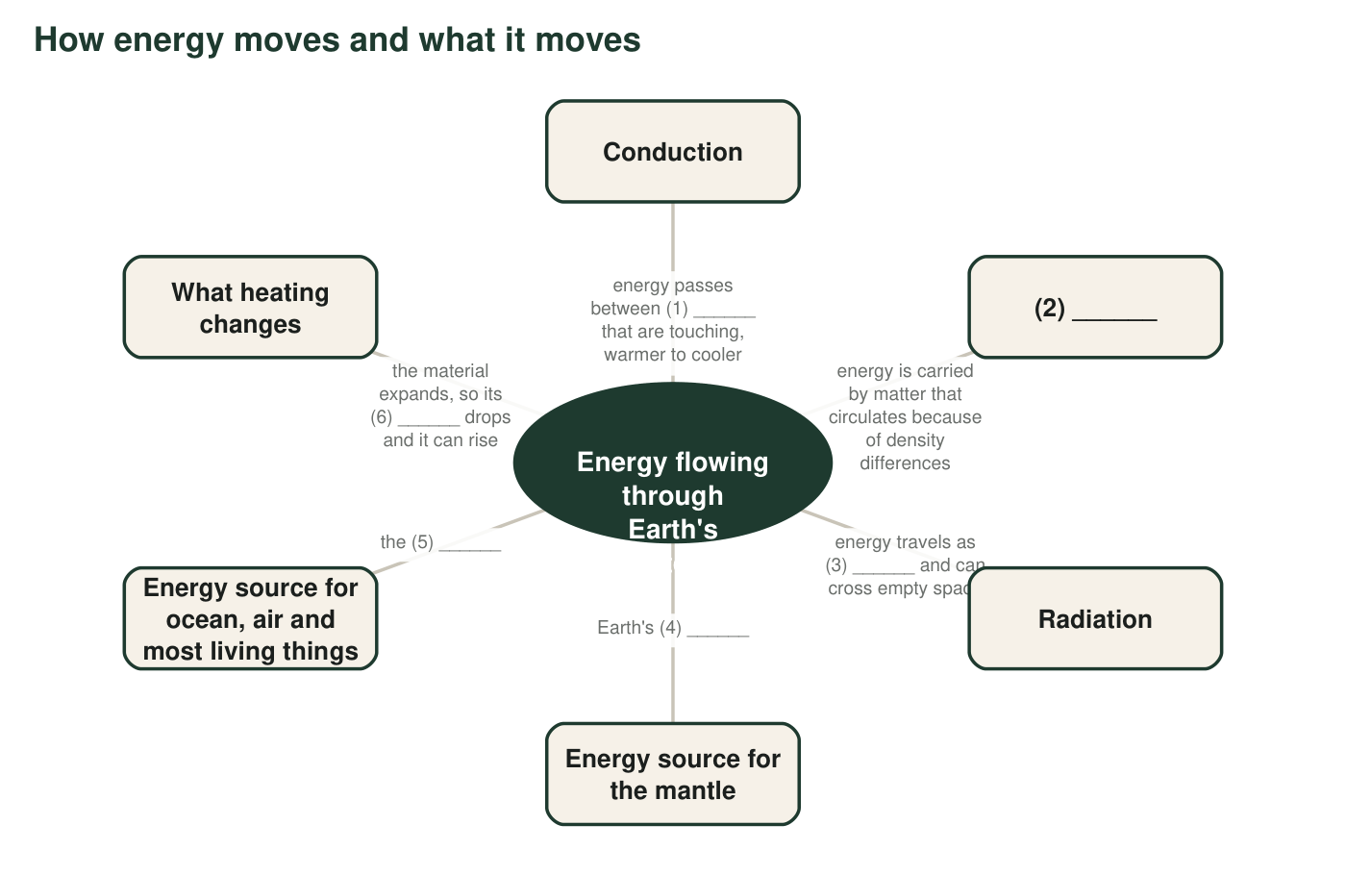
Six labels are missing, numbered (1) to (6). Fill them in using the word bank in q3.
3. Write the missing labels. Word bank: convection, density, hot interior, light, objects (or particles), sun. (1) ______ (2) ______ (3) ______ (4) ______ (5) ______ (6) ______
Answer: (1) objects (or particles) (2) convection (3) light (4) hot interior (5) sun (6) density
Reasoning: Each blank matches the word-bank definition of the term; (1) accepts either 'objects' or 'particles' because conduction happens between touching objects and between neighboring particles.
Also acceptable: Accept 'core' for (4) since the interior's heat comes from the core and mantle; accept 'sunlight' for (5).
4. Two of the branches on the map name energy sources and three name ways energy travels. Explain the difference between a source and a way of traveling, using one example of each from the map.
Answer: A source is where the energy comes from, such as the sun or Earth's hot interior. A way of traveling is how that energy gets from one place to another, such as radiation carrying sunlight across space or conduction carrying energy from the core into the mantle rock. A source supplies; a transfer method delivers.
Reasoning: Students often merge the two ideas ('the sun is radiation'). The distinction matters for the model in W4 and W8.
Also acceptable: Accept the analogy 'a power plant versus the wires.'
Full credit must include:
• Defines source as origin and transfer as method
• One correct example of each from the map

Part C: Which term fits?
5. For each situation, write the one term that best describes how energy is moving, and the clue that decided it (touching? matter circulating? light crossing space?).
Answer: a. conduction (the spoon touches the soup; energy passes along the metal). b. radiation (warmth crosses the air without the air being hot; infrared light from the fire). c. convection (warm, less dense air rises as a moving column carrying energy with it). d. radiation (sunlight crosses space and the transparent air as light). e. convection (denser water sinks and flows; matter circulates). f. conduction (the mantle rock touches the core; energy passes across the contact). g. conduction (the air layer is touching the hot sidewalk; the air itself is not yet circulating).
Reasoning: Each decision depends on the clue: touching means conduction, circulating matter means convection, light crossing space or air means radiation. Item g is the trickiest; the air is touching the ground and only later rises (that later rise is situation c).
Also acceptable: Accept 'convection' for g only if the student explains that the warmed air then rises; otherwise the touching clue makes it conduction.
Full credit must include:
• All seven terms correct
• Each clue names touching, circulating matter or light
6. Situations f and c are two steps of the same story in different places: first energy enters by one method, then matter starts to move by another. Explain why conduction usually comes before convection when a fluid is heated from below.
Answer: The energy has to get into the fluid before the fluid can carry it anywhere. The heat source touches only the bottom layer, so energy enters that layer by conduction. Once the bottom layer has warmed and become less dense, gravity pulling the denser fluid above it down makes the warm layer rise, and convection begins. Conduction loads the fluid; convection moves it.
Reasoning: The sequence (conduction at the contact, then convection) is the mechanism behind every convection cell in the lesson.
Also acceptable: Accept 'the fluid has to warm up first, and warming happens by touching.'
Full credit must include:
• Conduction enters at the contact surface
• Density change comes before the rise
• Convection is the movement that follows

Part D: Layers and models
7. Write crust, mantle or core for each clue. The densest layer: ______. The thinnest layer: ______. Solid rock that still creeps slowly: ______. Made mostly of iron and nickel: ______. Where you are standing: ______. The layer that is about 2,865 km thick: ______.
Answer: Densest: core. Thinnest: crust. Solid rock that creeps: mantle. Iron and nickel: core. Where you stand: crust. About 2,865 km thick: mantle.
Reasoning: Direct application of the layer definitions and the thickness figure from the lesson.
Also acceptable: None.
8. Label each of these as a physical model or a conceptual model and give a one-phrase reason: (a) a classroom globe; (b) a cutaway drawing of Earth's three layers; (c) the rule density = mass ÷ volume; (d) a tank of water heated at one end and chilled at the other to study ocean currents.
Answer: (a) physical model: a built object shaped like Earth. (b) conceptual model: a drawing that represents the layers. (c) conceptual model: an equation that represents a relationship. (d) physical model: a real setup built to behave like the ocean so it can be tested.
Reasoning: The distinction is built versus represented. A globe is physical even though it does not 'work'; it is still an object that copies the system's shape.
Also acceptable: A student who argues that the globe is both (a physical object carrying a conceptual map) is thinking carefully; accept with that explanation.
Full credit must include:
• All four classified correctly
• Reasons use built or represented
9. A hot-air balloon lifts off when the pilot heats the air inside it with a burner. Write a short explanation of why the balloon rises that uses all four of these terms correctly: density, gravity, conduction, convection. Underline each term.
Answer: Model response: The burner's flame touches the air at the mouth of the balloon, so energy enters that air by conduction. The warmed air expands, so the same mass fills more space and its density drops below the density of the cooler air outside. Gravity pulls harder on the denser outside air, which sinks under the balloon and pushes the less dense balloon upward. Inside the envelope the warm air rises and the cooler air near the top sinks toward the burner, a small convection loop that keeps the whole envelope warm.
Reasoning: All four terms must be used correctly, not just present. The most common slip is 'heat rises'; the correct statement is that the less dense warm air is pushed up because gravity pulls the denser air down.
Also acceptable: Accept radiation from the flame as an additional transfer if conduction is also used correctly. Also accept a student who says the burner's hot exhaust gases mix into the envelope (convection) as the way energy enters, since that is how real burners work; conduction must then appear somewhere else correctly, such as between the warm air and the fabric.
Full credit must include:
• Conduction at the flame-to-air contact
• Density falls when air is heated
• Gravity acting on the denser outside air explains the lift
• Convection used for moving air, not for the flame itself
10. A sealed glass terrarium with soil, plants and a little water sits on a sunny windowsill. Is it a closed system? Explain by naming one thing that cannot cross the glass and one thing that can.
Answer: It is closed to matter but not to energy. Water, air and soil cannot cross the glass (water that evaporates condenses on the glass and drips back). Sunlight passes in through the glass, and heat passes out through it at night, so energy crosses freely.
Reasoning: This is the accurate meaning of closed system that the lesson's Biosphere 2 section needs; Biosphere 2 was likewise closed to matter and open to energy.
Also acceptable: Accept 'closed for matter, open for energy.'
Full credit must include:
• Says matter cannot cross
• Says energy (light or heat) can cross
• Uses the word closed correctly or explains the limit of the term

Teacher notes
The word bank's definitions correct two textbook simplifications on purpose: the core is described as metal (iron and nickel) with a liquid outer part, not as a 'rock layer,' and a closed system is defined as closed to matter only. The hot-air balloon in q9 is a good place to replace 'heat rises' with 'less dense air is pushed up by denser air that gravity pulls down.' Item q5g is designed to be argued: the air layer touching the sidewalk warms by conduction first; the rise that follows (q5c) is convection. If students ask about the 4 °C behavior of fresh water (it becomes less dense as it cools below 4 °C), confirm it and say the lesson's rule 'warmer is less dense' holds for the temperatures in this lesson's examples.

