Angela's Tools · Chapter 10: Energy in Earth's Systems · Worksheet 2 of 10

Four Spheres, Three Ways to Move Energy: Sorting the Terms
Learning target: I can sort parts of Earth into the systems they belong to, tell conduction, convection and radiation apart in new situations, and use density and gravity to explain why heated matter moves.
Vocabulary in action · about 35 minutes · individual · Standards: MS-ESS2-1 (practice)
Name: ____________________________ Date: ____________ Period: ______

Directions
This sheet is not a matching column. Every part asks you to decide where a term belongs or which term fits a situation, and to give a reason. Use the word bank below when a part asks for it. Several items belong to more than one Earth system; say so and explain. Write reasons as full sentences.
geosphere: All of Earth's rock and metal, from the ground under your feet down to the center of the planet.
hydrosphere: All of Earth's water in every form: oceans, lakes, rivers, ice, water underground, and water vapor in the air.
atmosphere: The blanket of gases that gravity holds around Earth, mostly nitrogen and oxygen, which thins out gradually with height.
biosphere: Every living thing on Earth plus the places in rock, water and air where living things can survive.
crust: The geosphere's outermost layer: a cool, brittle shell of rock, thin next to the layers under it and the least dense of the three.
mantle: The thick, hot rock layer between the crust and the core; solid, yet able to creep very slowly over millions of years.
core: Earth's hot, very dense center, made mostly of the metals iron and nickel; its outer part is liquid and its inner part is solid.
density: How much mass is packed into a given volume. Heating most materials makes them expand, so their density drops.
conduction: Energy passing from particle to particle through a material, or between two things that touch, always from the warmer one to the cooler one.
convection: Energy carried along by moving matter: warmer, less dense material rises while cooler, denser material sinks.
radiation: Energy traveling as light (including invisible light such as infrared), which can cross empty space.
convection cell: The closed loop that forms when a fluid is warmed in one place and cooled in another: rise, spread, sink, return.
physical model: A real object or setup built to behave like a system, usually smaller and simpler, so it can be tested.
conceptual model: A drawing, diagram or equation that represents how a system works.
closed system: A system that matter cannot enter or leave. Energy can still cross its boundary.

Part A: Which sphere? (Some belong to more than one.)
1. For each item, write the system or systems it belongs to and a one-sentence reason. If an item belongs to two or more systems, name all of them.
System or systems | Reason (one sentence)
A glacier on a mountain
Water vapor inside a cloud
A granite boulder
A bacterium living in cracks of rock 2 km underground
Magma beneath a volcano
The nitrogen you breathe in
Groundwater in the tiny spaces of sandstone
A gull flying over the beach
Garden soil (rock bits, water, air, roots, worms)

2. Pick one item from the table that belongs to two systems. Explain why scientists are comfortable with one thing belonging to two systems at once, and what that tells you about the boundaries between the spheres.
______________________________________________________________________________________
______________________________________________________________________________________
______________________________________________________________________________________

Part B: Complete the concept map
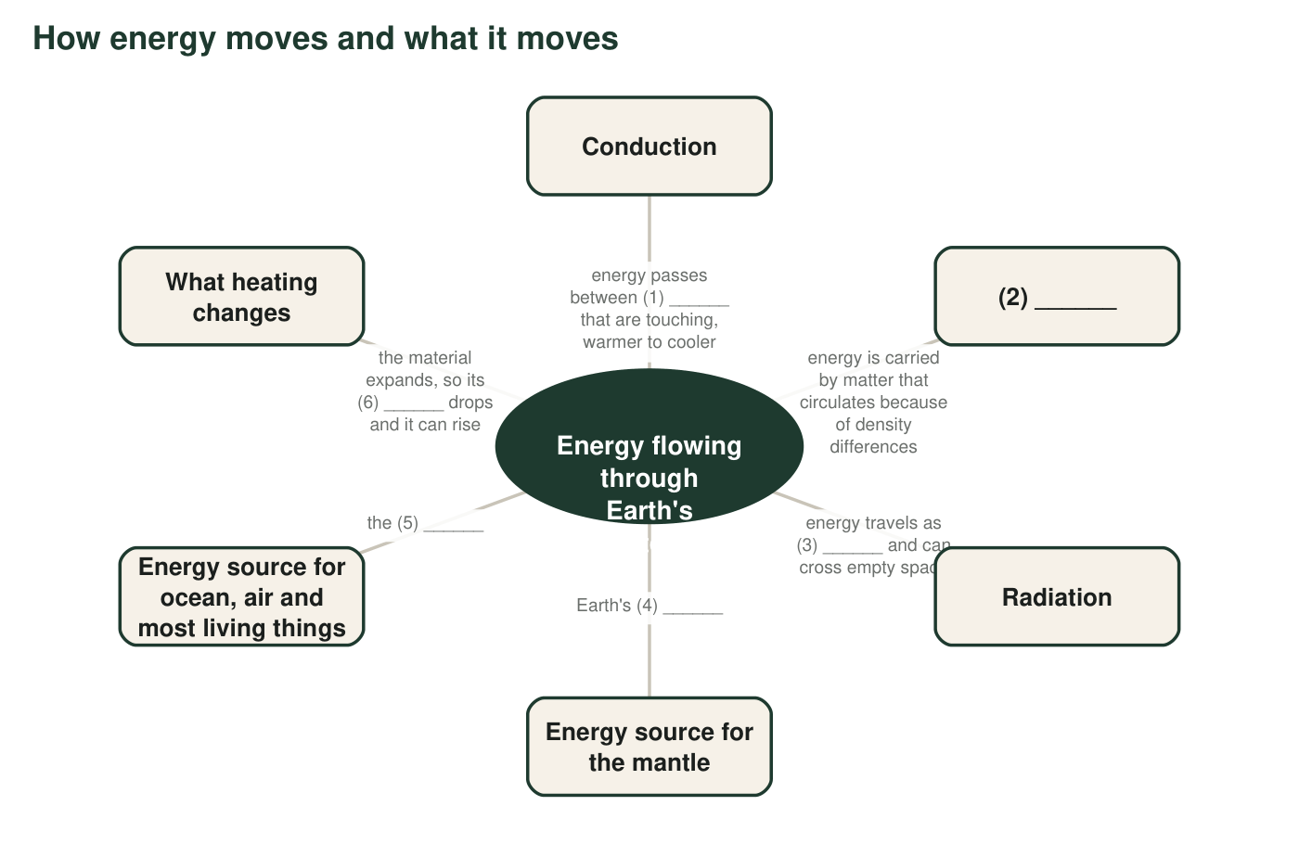
Six labels are missing, numbered (1) to (6). Fill them in using the word bank in q3.
3. Write the missing labels. Word bank: convection, density, hot interior, light, objects (or particles), sun. (1) ______ (2) ______ (3) ______ (4) ______ (5) ______ (6) ______
______________________________________________________________________________________
______________________________________________________________________________________
______________________________________________________________________________________
4. Two of the branches on the map name energy sources and three name ways energy travels. Explain the difference between a source and a way of traveling, using one example of each from the map.
______________________________________________________________________________________
______________________________________________________________________________________
______________________________________________________________________________________

Part C: Which term fits?
5. For each situation, write the one term that best describes how energy is moving, and the clue that decided it (touching? matter circulating? light crossing space?).
Term (conduction, convection or radiation) | Clue in the situation that decided it
a. The metal handle of a spoon left in hot soup becomes too hot to hold.
b. Standing a few meters from a campfire, you feel warmth on your face even though the air between is cool.
c. On a sunny afternoon a column of warm air rises over a dark parking lot, and a hawk circles upward in it without flapping.
d. Sunlight warms the surface of the ocean.
e. Cold, salty water at the ocean surface near the poles sinks and creeps along the sea floor toward the equator.
f. Rock at the very bottom of the mantle is warmed by the hot core it rests on.
g. The thin layer of air resting on a hot sidewalk becomes warm.

6. Situations f and c are two steps of the same story in different places: first energy enters by one method, then matter starts to move by another. Explain why conduction usually comes before convection when a fluid is heated from below.
______________________________________________________________________________________
______________________________________________________________________________________
______________________________________________________________________________________

Part D: Layers and models
7. Write crust, mantle or core for each clue. The densest layer: ______. The thinnest layer: ______. Solid rock that still creeps slowly: ______. Made mostly of iron and nickel: ______. Where you are standing: ______. The layer that is about 2,865 km thick: ______.
______________________________________________________________________________________
______________________________________________________________________________________
______________________________________________________________________________________
8. Label each of these as a physical model or a conceptual model and give a one-phrase reason: (a) a classroom globe; (b) a cutaway drawing of Earth's three layers; (c) the rule density = mass ÷ volume; (d) a tank of water heated at one end and chilled at the other to study ocean currents.
______________________________________________________________________________________
______________________________________________________________________________________
______________________________________________________________________________________
______________________________________________________________________________________
9. A hot-air balloon lifts off when the pilot heats the air inside it with a burner. Write a short explanation of why the balloon rises that uses all four of these terms correctly: density, gravity, conduction, convection. Underline each term.
______________________________________________________________________________________
______________________________________________________________________________________
______________________________________________________________________________________
______________________________________________________________________________________
______________________________________________________________________________________
10. A sealed glass terrarium with soil, plants and a little water sits on a sunny windowsill. Is it a closed system? Explain by naming one thing that cannot cross the glass and one thing that can.
______________________________________________________________________________________
______________________________________________________________________________________
______________________________________________________________________________________

Three questions that sort the three transfers
When you are stuck on Part C, ask in order: (1) Is energy crossing empty space or passing through something transparent as light? If yes, radiation. (2) Is matter itself moving and carrying the energy along, with warm stuff rising and cool stuff sinking? If yes, convection. (3) Are two things touching, or is energy creeping through one material without the material going anywhere? If yes, conduction. Most everyday stories use two of the three, one after the other.

Write the fourth transfer story
Write an original paragraph about one real place (a kitchen, a beach, a volcano, a greenhouse) in which radiation, conduction and convection all happen in a chain, in that order. Each sentence should hand the energy to the next step. Then add one sentence naming which Earth systems the energy crossed between, and one sentence explaining what would stop the chain if the energy source were switched off.

