Angela's Tools · Chapter 10: Energy in Earth's Systems · Worksheet 4 of 10

Reading the Loop: A Model of Convection in the Mantle (Teacher answer key)
Learning target: I can read a layered model of the geosphere and a convection-cell model, explain where energy enters and where gravity acts, and draw my own model of mantle convection beneath a volcano.
Diagrams and models · about 40 minutes · individual · Standards: MS-ESS2-1 (assesses)

Standards connections
MS-ESS2-1 (assesses): The drawing task produces a labeled model of energy flowing from Earth's interior and of mantle rock cycling by convection, which is direct evidence toward this PE. The rock-cycle processes in the clarification statement (melting, crystallization, weathering, sedimentation) belong to a later lesson and are not assessed here.

Answers with reasoning
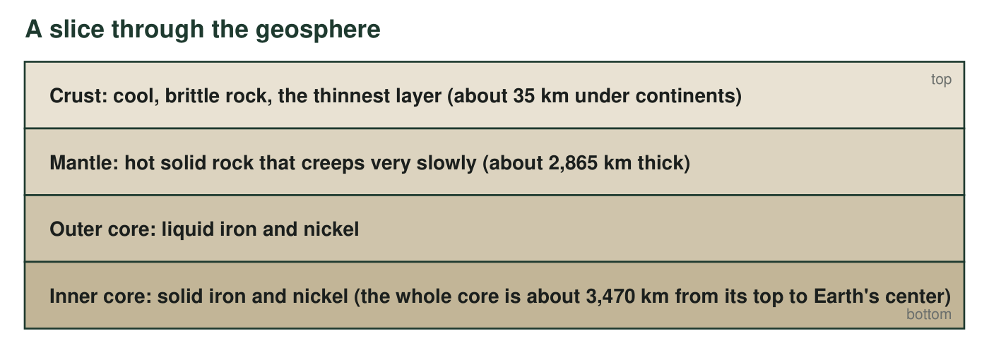
Figure A. The geosphere's three main layers, top to bottom. Thicknesses are the rounded model values used in this lesson; the core's two parts are shown because the outer core is liquid metal and the inner core is solid metal.
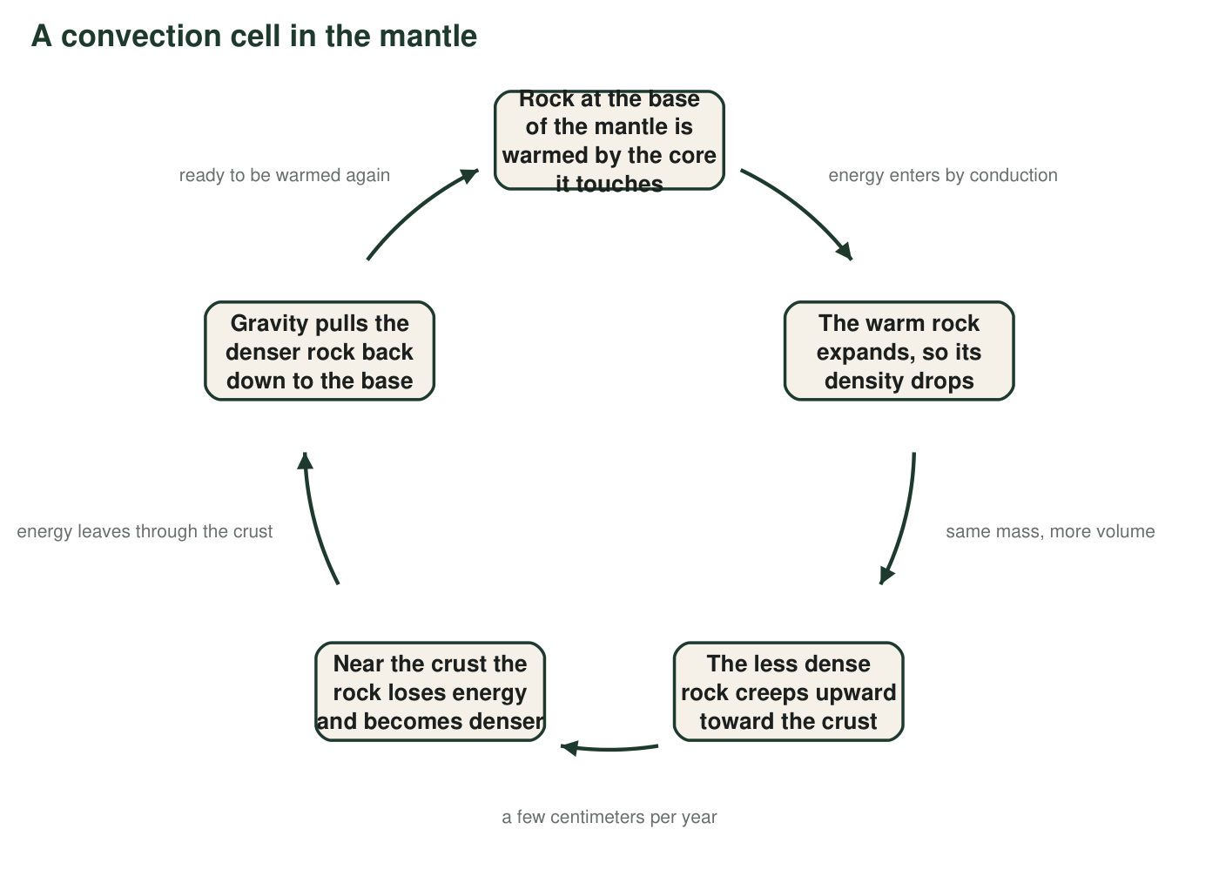
Figure B. One trip around a convection cell in the mantle. The loop repeats for as long as the core stays hotter than the crust. One full trip takes many millions of years.

Part A: Read the figures
1. Using Figure A, name the least dense layer and the densest layer, and describe the pattern in density from the surface to the center. Why does that pattern make sense if denser material is pulled more strongly toward the center?
Answer: Least dense: the crust. Densest: the core. Density increases from the surface to the center. This makes sense because gravity pulls harder on denser material, so over Earth's history the densest material (iron and nickel) settled toward the center and the least dense rock ended up on top, like layers sorting in a jar.
Reasoning: The density order is stated in the lesson; the explanation connects it to the same gravity-and-density idea that drives convection.
Also acceptable: Accept 'heavy stuff sank to the middle' as the gravity idea.
Full credit must include:
• Crust least dense, core densest
• Density increases with depth
• Connects the order to gravity pulling denser material inward
2. In Figure B, at which step does energy enter the loop, and by which transfer method? At which step does energy leave the loop, and where does it go?
Answer: Energy enters at step 1 (rock at the base of the mantle warmed by the core) by conduction, because the rock is touching the core. Energy leaves at step 4 (near the crust the rock loses energy), passing by conduction into the crust and eventually reaching the surface, where it is radiated into space (or carried out by volcanoes and hot springs).
Reasoning: The edge labels 'energy enters by conduction' and 'energy leaves through the crust' point to the two steps.
Also acceptable: Accept 'goes into the crust and out to the surface' without mentioning space.
Full credit must include:
• Entry at step 1 by conduction
• Exit at step 4 through the crust
• Says where the energy goes afterward
3. Which step in Figure B is caused directly by gravity? Explain why the loop could not keep turning if gravity were switched off, even if the core stayed hot.
Answer: Step 5, where gravity pulls the denser rock back down. Without gravity, denser rock would not sink, so it would not push less dense rock upward either; the warm rock would simply sit at the base and get warmer. Convection needs a force that treats denser and less dense material differently, and that force is gravity.
Reasoning: Students often credit the rise to 'heat rising' and forget that the sinking is the driver. Gravity acts on both, but it is the sinking of denser rock that forces the rise.
Also acceptable: Accept 'the loop needs a down to have an up.'
Full credit must include:
• Identifies the sinking step
• Explains that without gravity nothing sinks, so nothing is pushed up
4. The mantle is solid rock, yet Figure B shows it moving in a loop. Use the edge labels to explain how both statements can be true at the same time.
Answer: The rock stays solid the whole time; it does not melt into a liquid. But over very long times hot solid rock can slowly change shape and creep, as the edge label 'a few centimeters per year' shows. At that speed the loop takes many millions of years, so the rock is solid and moving at the same time, like a glacier that is solid ice yet flows downhill.
Reasoning: This is the accurate version of the textbook's batter comparison: plastic creep of solid rock, not liquid flow.
Also acceptable: Accept the glacier or putty comparison if the student says it stays solid.
Full credit must include:
• Rock remains solid
• Moves very slowly (cm per year, millions of years per loop)
5. Using the thicknesses in Figure A, calculate how many times thicker the mantle is than the continental crust. Show the division and round to the nearest whole number.
Answer: 2,865 km ÷ 35 km ≈ 81.9, so the mantle is about 82 times thicker than the continental crust.
Reasoning: Simple ratio of the two model thicknesses; the kilometers cancel.
Also acceptable: Accept 82 or 'about 80' with the division shown.
6. Every model leaves things out. Name two real features of the mantle that Figure B does not show, and explain why leaving them out could mislead someone.
Answer: Any two: (1) time scale, since the loop looks quick but takes millions of years; (2) the mantle has many cells in three dimensions, not one loop; (3) the real shape and size of the cells (thousands of kilometers across); (4) temperatures and pressures; (5) the plates of crust that the moving mantle drags along; (6) the fact that the rock is solid, since loops of arrows look like liquid. Each omission can mislead: a reader might think the mantle is a liquid that stirs quickly, or that there is only one cell.
Reasoning: Naming limits of a model is part of the modeling practice. Any accurate omission with a plausible 'how it could mislead' earns credit.
Also acceptable: Accept 'it does not show the outer core being liquid' as an omission from Figure B.
Full credit must include:
• Two real features not shown
• Explains how each omission could mislead

Part B: Build your own model
Draw a cutaway model of Earth beneath a volcano. Include, top to bottom: the crust with one volcano on its surface, the mantle, and the top of the core. Inside the mantle draw TWO convection cells side by side, one on each side of the spot under the volcano, using arrows that form closed loops. Label: (1) where rock rises and where it sinks; (2) the word 'conduction' at the place where energy enters the mantle from the core; (3) 'gravity' with an arrow at the place where it pulls denser rock down; (4) 'less dense' and 'denser' on the correct parts of the loop; (5) the heat source; (6) a pocket of magma rising toward the volcano where the two cells rise together. Add a title and a key explaining what your arrow colors or styles mean.
Expected drawing: A full-credit model shows: a thin crust with a volcano, a thick mantle, and the core at the bottom; two closed arrow loops in the mantle that rise together beneath the volcano and sink on the outer sides; 'conduction' written at the mantle-core contact where energy enters; 'gravity' with a downward arrow on a sinking limb; 'less dense' on the rising limbs and 'denser' on the sinking limbs; the core marked as the heat source; a magma pocket drawn above the shared rising zone leading to the volcano; a title and a key for arrow styles.
Reasoning: This is the solved model. The pairing of a rising zone with the volcano is the physical link between mantle convection and surface eruptions in the lesson; the sinking limbs must be on the outer sides so the two loops turn in opposite directions.
7. Look at your model. Trace one piece of energy from the core to the surface: list each place it goes and the method it uses at each step. End with where the energy goes after it reaches the surface.
Answer: Example trace: energy in the core passes by conduction into the rock at the base of the mantle; that rock, now less dense, carries the energy upward by convection as it creeps toward the crust; near the crust the energy passes by conduction into the crust (some travels up with magma); at the surface the energy warms the ground and air and finally leaves Earth as infrared radiation into space.
Reasoning: Students should name a method at each hand-off: conduction, convection, conduction, radiation.
Also acceptable: Accept 'escapes through a volcano or hot spring' as the surface exit.
Full credit must include:
• Conduction at the core contact
• Convection through the mantle
• Conduction (or magma) into the crust
• Ends with the energy leaving the surface
8. Why did the prompt ask you to place the volcano where the two cells rise together rather than where they sink? Use density in your answer.
Answer: Where the cells rise together, hot, less dense rock is arriving from below, and some of it melts into magma, which is even less dense than the solid rock around it, so it keeps rising toward the surface. Where cells sink, cooler, denser rock is moving down, carrying material away from the surface rather than toward it.
Reasoning: Melted rock has a lower density than the solid rock around it, so it rises; rising limbs bring the hottest rock closest to the crust.
Also acceptable: Accept 'the hottest rock is under the rising zone, so that is where melting happens.'
Full credit must include:
• Rising limbs bring hot, less dense rock up
• Magma is less dense and rises
• Sinking zones move material down
9. Explain how you would change your model to show convection in the atmosphere between the equator and the North Pole instead of in the mantle. State the heat source, where the rising happens, where the sinking happens, and the one transfer method that would be new because it is not in the mantle model.
Answer: Model response: The heat source becomes the sun, and its energy arrives by radiation (the new method, since no light is involved in the mantle model). Sunlight warms the ground and sea most strongly near the equator; that surface warms the air touching it by conduction, the warm, less dense air rises over the equator, flows toward the pole at high altitude, cools and becomes denser, sinks, and flows back along the surface toward the equator. So the rising is at the equator (warm end) and the sinking is toward the pole (cold end), with gravity still doing the pulling on the denser air.
Reasoning: The transfer should keep the same loop logic (warm end rises, cold end sinks) with the energy source moved to the top and radiation added. Real atmospheric circulation breaks into three cells per hemisphere; one cell is acceptable at this level.
Also acceptable: A student who draws or describes several cells per hemisphere is going beyond the lesson in a valid way.
Full credit must include:
• Sun named as the source
• Radiation named as the new method
• Rising at the equator, sinking toward the pole
• Gravity still pulls the denser air down
10. A classmate says, 'The arrows in Figure B show energy moving, not rock.' Is the classmate right, wrong, or partly right? Explain using the meaning of convection.
Answer: Partly right, but mostly wrong: in convection the arrows show rock moving, and the rock carries energy with it, so the arrows show both at once. Convection means energy is transferred by matter that circulates. The classmate would be right only for conduction, where energy moves through material that stays put.
Reasoning: This checks the definition of convection against conduction.
Also acceptable: Accept 'both' with the correct definition.
Full credit must include:
• Says the arrows show rock (matter) moving
• Says the moving rock carries the energy
• Contrasts with conduction

Teacher notes
Figure A deliberately splits the core into a liquid outer core and a solid inner core and calls both metal; the textbook calls the core a 'rock layer,' which students may repeat. Figure B's edge label 'a few centimeters per year' is the realistic order of magnitude for mantle flow and plate motion. The drawing's two cells rising together beneath a volcano is a simplified picture of a spreading zone; do not tell students it is the only way volcanoes form (many sit above sinking zones, where water lowers the melting point of the rock, which is beyond this lesson). Check drawings for the most common error: a single loop with the volcano over a sinking limb, or arrows that do not close. For q5, 2,865 ÷ 35 = 81.86.

