Angela's Tools · Chapter 10: Energy in Earth's Systems · Worksheet 4 of 10

Reading the Loop: A Model of Convection in the Mantle
Learning target: I can read a layered model of the geosphere and a convection-cell model, explain where energy enters and where gravity acts, and draw my own model of mantle convection beneath a volcano.
Diagrams and models · about 40 minutes · individual · Standards: MS-ESS2-1 (assesses)
Name: ____________________________ Date: ____________ Period: ______

Directions
Study both figures before writing anything. Figure A shows the layers of the geosphere; Figure B shows one trip around a convection cell in the mantle. Answer the questions about the figures first, then build your own model in the drawing box, following every instruction in the prompt. Finish with the questions about your model. Use a pencil so you can revise your drawing.
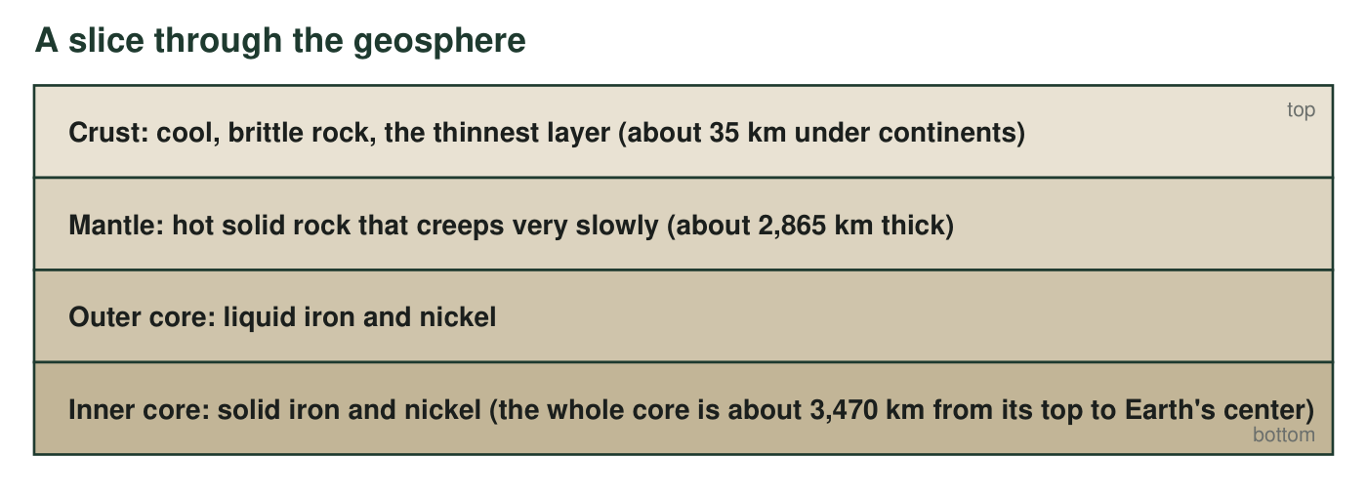
Figure A. The geosphere's three main layers, top to bottom. Thicknesses are the rounded model values used in this lesson; the core's two parts are shown because the outer core is liquid metal and the inner core is solid metal.
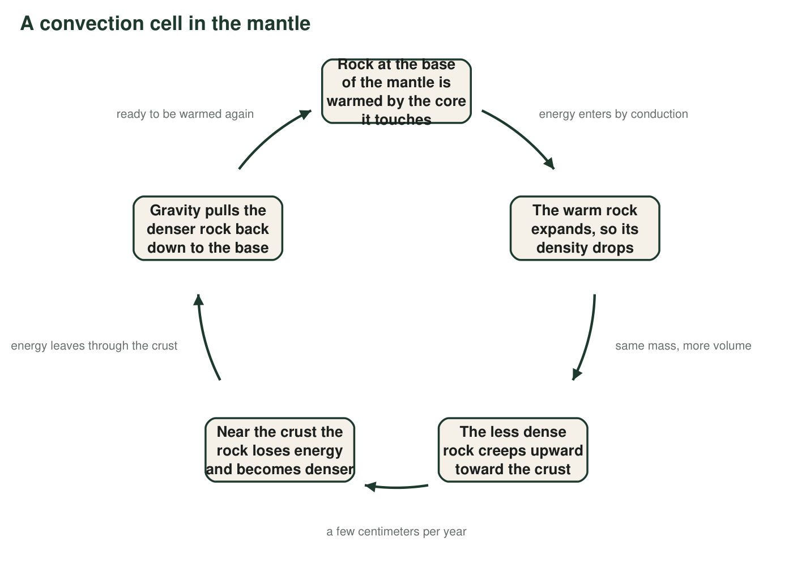
Figure B. One trip around a convection cell in the mantle. The loop repeats for as long as the core stays hotter than the crust. One full trip takes many millions of years.

Part A: Read the figures
1. Using Figure A, name the least dense layer and the densest layer, and describe the pattern in density from the surface to the center. Why does that pattern make sense if denser material is pulled more strongly toward the center?
______________________________________________________________________________________
______________________________________________________________________________________
______________________________________________________________________________________
2. In Figure B, at which step does energy enter the loop, and by which transfer method? At which step does energy leave the loop, and where does it go?
______________________________________________________________________________________
______________________________________________________________________________________
______________________________________________________________________________________
3. Which step in Figure B is caused directly by gravity? Explain why the loop could not keep turning if gravity were switched off, even if the core stayed hot.
______________________________________________________________________________________
______________________________________________________________________________________
______________________________________________________________________________________
4. The mantle is solid rock, yet Figure B shows it moving in a loop. Use the edge labels to explain how both statements can be true at the same time.
______________________________________________________________________________________
______________________________________________________________________________________
______________________________________________________________________________________
5. Using the thicknesses in Figure A, calculate how many times thicker the mantle is than the continental crust. Show the division and round to the nearest whole number.
______________________________________________________________________________________
______________________________________________________________________________________
______________________________________________________________________________________
6. Every model leaves things out. Name two real features of the mantle that Figure B does not show, and explain why leaving them out could mislead someone.
______________________________________________________________________________________
______________________________________________________________________________________
______________________________________________________________________________________

Part B: Build your own model
Draw a cutaway model of Earth beneath a volcano. Include, top to bottom: the crust with one volcano on its surface, the mantle, and the top of the core. Inside the mantle draw TWO convection cells side by side, one on each side of the spot under the volcano, using arrows that form closed loops. Label: (1) where rock rises and where it sinks; (2) the word 'conduction' at the place where energy enters the mantle from the core; (3) 'gravity' with an arrow at the place where it pulls denser rock down; (4) 'less dense' and 'denser' on the correct parts of the loop; (5) the heat source; (6) a pocket of magma rising toward the volcano where the two cells rise together. Add a title and a key explaining what your arrow colors or styles mean.

7. Look at your model. Trace one piece of energy from the core to the surface: list each place it goes and the method it uses at each step. End with where the energy goes after it reaches the surface.
______________________________________________________________________________________
______________________________________________________________________________________
______________________________________________________________________________________
8. Why did the prompt ask you to place the volcano where the two cells rise together rather than where they sink? Use density in your answer.
______________________________________________________________________________________
______________________________________________________________________________________
______________________________________________________________________________________
9. Explain how you would change your model to show convection in the atmosphere between the equator and the North Pole instead of in the mantle. State the heat source, where the rising happens, where the sinking happens, and the one transfer method that would be new because it is not in the mantle model.
______________________________________________________________________________________
______________________________________________________________________________________
______________________________________________________________________________________
______________________________________________________________________________________
______________________________________________________________________________________
10. A classmate says, 'The arrows in Figure B show energy moving, not rock.' Is the classmate right, wrong, or partly right? Explain using the meaning of convection.
______________________________________________________________________________________
______________________________________________________________________________________
______________________________________________________________________________________

Build the drawing in four passes
Pass 1: draw three horizontal bands (crust thin at the top, mantle thick, core at the bottom) and a volcano on the crust. Pass 2: lightly draw two circles in the mantle that touch under the volcano, then turn each circle into arrows: both go UP where they touch under the volcano and DOWN on the outer sides. Pass 3: add the six labels from the prompt, one at a time, checking each against Figure B. Pass 4: title, key, and darken your lines.

Where would a second volcano go?
Your model has two cells rising together under one volcano. Extend the model sideways to add a third cell. Decide whether the new boundary between the second and third cells is a rising or a sinking zone, and explain what you would expect at the surface there (a volcano, or something else?). Then research one real example of a place on Earth where mantle rock is rising beneath the crust and one where crust is sinking back into the mantle, and label your extended model with their names.

