Angela's Tools · Chapter 11: Scales of Change on Earth's Surface · Worksheet 2 of 10

Break, Carry, Drop, Lift: Putting the Scale Words to Work (Teacher answer key)
Learning target: I can tell weathering, erosion, deposition and uplift apart in real situations, name the agent doing the work, and use the words for time scale, spatial scale and uniformitarianism correctly.
Vocabulary in action · about 30 minutes · individual · Standards: MS-ESS2-2 (supports), MS-ESS2-1 (supports)

Standards connections
MS-ESS2-2 (supports): Every explanation of surface change at varying scales uses these process words and the two scale words. This sheet makes sure students can apply them to new situations before they are asked to explain evidence with them.
MS-ESS2-1 (supports): Weathering, erosion, deposition and the burial of sand into sandstone are steps in the cycling of Earth's materials; the final paragraph item traces one grain through those steps as background for the rock-cycle model.

Answers with reasoning
weathering: The breaking down of rock where it sits, either into smaller pieces by physical forces (frost, roots, grinding) or by chemical reactions that dissolve or change it. Weathering does not carry anything away.
erosion: The picking up and carrying away of loosened rock material by moving water, wind, ice or gravity.
deposition: The settling and piling up of carried rock material in a new place when the water, wind or ice slows down or the material stops sliding.
uplift: The raising of a large area of Earth's crust by forces deep underground. Usually very slow, though an earthquake can lift ground by several meters within minutes.
agent: Whatever does the work of weathering or erosion: water, ice, wind, gravity, living things or a chemical reaction.
spatial scale: How much space a change covers, from a single sand grain to the whole planet.
time scale: How long a change takes, from a fraction of a second to billions of years.
gradual change: A change that happens a little at a time over a long period, such as a river slowly deepening its channel.
sudden (catastrophic) event: A change that happens within seconds to weeks and can reshape a landscape quickly, such as a landslide, flash flood, eruption or asteroid impact. The conditions that make it possible often take a long time to build up.
uniformitarianism: The principle that the same kinds of natural processes we can observe today, following the same natural laws, also acted in the past and will act in the future. It does not say the processes always ran at the same speed.

Part A: Which process, and what is doing the work?
Each row below describes something happening to rock. Decide whether it is weathering, erosion, deposition or uplift, and name the agent (water, ice, wind, gravity, living things, a chemical reaction, or forces beneath the crust).
1. Complete the table. One row describes a chemical change; the other weathering rows describe physical changes. Mark the chemical one with a star.
Answer: 1. Weathering; living things (roots). 2. Erosion; water. 3. Deposition; water. 4. Uplift; forces beneath the crust. 5. Weathering (chemical, starred); water carrying a chemical reaction (weakly acidic water). 6. Deposition; wind. 7. Erosion; gravity. 8. Weathering (physical); ice.
Reasoning: Rows 1, 5 and 8 break rock in place; rows 2 and 7 move material; rows 3 and 6 settle it; row 4 raises crust. Row 5 is the only chemical change; the others are physical.
Also acceptable: For row 7 accept 'erosion by gravity' or 'mass movement.' A student who writes 'water' as the agent for row 5 and explains that the water is acidic is correct; the star is required to show it is chemical.
2. Rows 1 and 2 happen in that order in nature. Explain why erosion of a boulder is impossible until weathering has done its job first.
Answer: A boulder is too big and too firmly attached for water, wind or ice to carry. Weathering first breaks it into pieces small and loose enough to be picked up; only then can erosion move them. Weathering makes the material; erosion moves it.
Reasoning: The core distinction of the chapter: weathering does not transport, erosion does not break.
Also acceptable: Accept 'gravity can roll a whole boulder' as an exception if the student notes it still had to come loose first.
Full credit must include:
• States that weathering produces loose, smaller pieces
• States that erosion can move only loose material

Part B: Complete the concept map
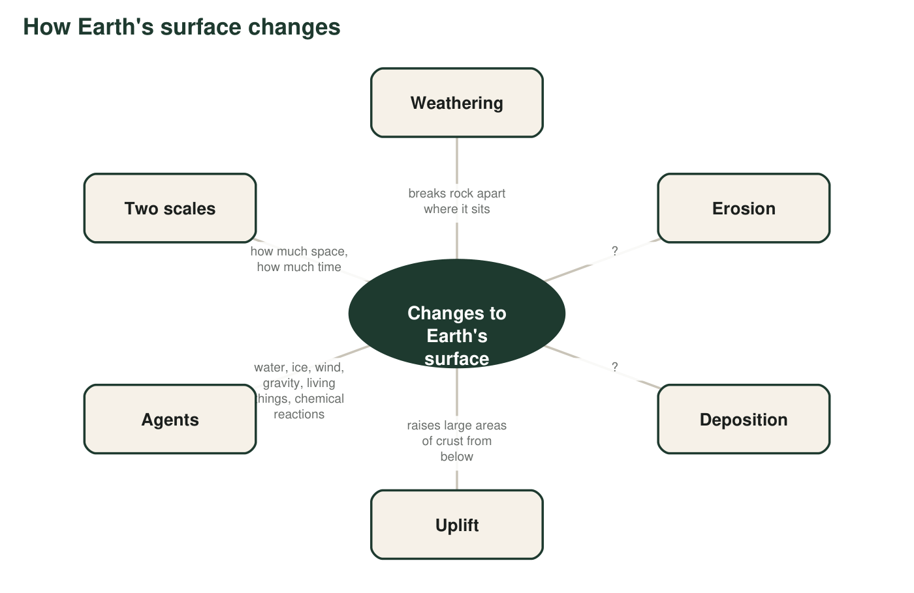
Two definitions are missing from the map. Write them in q3, then add the agents.
3. Write the two missing descriptions for Erosion and Deposition in your own words (not copied from the term box). Each must be short enough to fit in a map bubble.
Answer: Erosion: 'carries loose rock away' (or 'moves broken rock to a new place'). Deposition: 'drops carried rock in a new place' (or 'piles up moved material where it stops').
Reasoning: The descriptions must be original short phrases that capture moving versus settling.
Also acceptable: Any accurate short paraphrase.
Full credit must include:
• Erosion phrase includes carrying or moving
• Deposition phrase includes settling, dropping or piling up
• Phrases are the student's own words
4. Three of the bubbles (weathering, erosion, deposition) describe what happens to the same piece of rock at different moments. Which bubble is the 'before,' which is the 'during,' and which is the 'after'? Then explain why uplift does not belong in that chain.
Answer: Before: weathering (the rock is broken loose). During: erosion (the pieces are carried). After: deposition (the pieces settle). Uplift does not belong because it does not act on loose pieces at all; it raises a whole region of crust from below, which gives weathering and erosion new high ground to work on.
Reasoning: Students should see the three surface processes as a sequence for one piece of material and uplift as a different kind of process that feeds the sequence.
Also acceptable: Accept 'uplift is the thing that makes mountains for the other three to wear down.'
Full credit must include:
• Correct before/during/after order
• Explains uplift as acting on the whole crust from below, not on loose material

Part C: Which term fits?
5. Two students describe valleys. Nadia: 'Water dissolved the rock a little each year, and over 50,000 years the valley got deeper.' Theo: 'The natural dam broke, and in three hours the flood scoured a gorge.' Label each description gradual change or sudden event. Then explain what it means to say that the conditions for Theo's event 'took a long time to build up.'
Answer: Nadia describes a gradual change; Theo describes a sudden event. 'Conditions took a long time to build up' means the dam held back water for years or longer, and the water (or weak spot in the dam) grew over that time until the dam could no longer hold; the three-hour flood was the end of a long story, not a change that came from nowhere.
Reasoning: The second part targets the lesson's point that catastrophic events are usually prepared by slow processes.
Also acceptable: Accept 'the dam was weakening slowly' or 'the lake was filling for years.'
Full credit must include:
• Both labels correct
• Explains the build-up behind the sudden event
6. Which sentence uses uniformitarianism correctly? Circle one, then write one sentence explaining what is wrong with one of the other choices.
Answer: B. Because the same processes that act today also acted in the past, we can use rates we measure today to estimate how long past changes took. Example critique: A is wrong because uniformitarianism is about the same kinds of processes and laws, not identical speeds; rates can vary. C is wrong because the principle is about constant processes, not an unchanging landscape. D is wrong because sudden events are part of Earth's history and the principle does not exclude them.
Reasoning: B states the principle and its use. The critique may target any one of A, C or D as long as it names the actual error.
Also acceptable: Any accurate one-sentence critique of A, C or D earns the second part.
7. Three measurements: a boulder is 2 m across; a desert is 30,000 km² of sand; a grain of sand is 0.5 mm wide. Which ruler, spatial scale or time scale, does each one belong to? Do any of the three tell you anything about time? Then say which ruler this sentence uses, and why: 'The dune took 4,000 years to grow.'
Answer: All three (2 m boulder, 30,000 km² desert, 0.5 mm grain) describe spatial scale; none of them describes time. 'The dune took 4,000 years to grow' describes a time scale, because it tells how long the change took, not how big it is. (A full description of the dune needs both: its size and its time.)
Reasoning: This checks that students separate size from duration; none of the three sizes says anything about time, however large the desert is.
Also acceptable: A student who writes that the desert's size 'could describe both' because large things take long should be redirected: size and time are separate rulers, which is the point of Part D.
Full credit must include:
• Identifies all three as spatial scale
• Identifies the dune sentence as time scale
• Does not confuse the two

Part D: Two rulers, and a grain's story
8. Every change has a place on both rulers. Give one example for each combination. Do not use the same example twice.
Answer: Example answers: Small space, short time: a beetle's footprint pressing sand grains (weathering by a living thing). Small space, long time: a cave formation tens of centimeters long built by dripping water over thousands of years (deposition). Large space, short time: dust from an asteroid impact cooling the whole planet within days (sudden event). Large space, long time: a continent drifting thousands of kilometers over millions of years, or uplift of a mountain range (gradual change).
Reasoning: Any accurate example that fits the cell and names a process from the box earns credit. The large-fast cell is the one students find hardest; eruptions that bury many square kilometers in weeks, flash floods and impacts all work.
Also acceptable: A landslide (hundreds of meters, minutes) is acceptable as large-fast if the student explains it is large compared with a sand grain.
Full credit must include:
• Four distinct examples
• Each example fits its cell on both rulers
• Each names a process or event term
9. Write the life story of one grain of sand, from a mountain to a layer of sandstone, as a paragraph of 5-7 sentences. Use at least five terms from the box, and underline each one. Include what has to happen to a buried sand layer before it becomes rock (packing the grains together is only the first half).
Answer: Model paragraph: High on a mountain, frost pries a crack open winter after winter until a chip of rock breaks free (weathering by ice). Rain washes the chip into a stream, where it tumbles against other rocks and wears down into a rounded sand grain (erosion by water, with more weathering along the way). When the river reaches the sea it slows, and the grain settles with millions of others in a layer (deposition). Over thousands of years more layers bury it, and the weight packs the grains tightly together. Groundwater seeping between the grains leaves behind minerals that glue them into sandstone. Much later, uplift may raise that sandstone into a new mountain, and the story starts again.
Reasoning: Full credit requires at least five underlined terms used correctly, the packing-plus-cementing step, and a coherent sequence. The textbook implies weight alone turns sand to rock; the accurate account separates compaction (weight) from cementation (minerals left by groundwater).
Also acceptable: A story that begins with a sand dune instead of a stream is fine if the burial-and-cementing step is present.
Full credit must include:
• 5-7 sentences in a logical order
• At least five terms from the box, underlined and used correctly
• Names both compaction (packing) and cementation (mineral glue)
• Ends at sandstone (uplift optional)

Teacher notes
Definitions here are deliberately more precise than the textbook's: uplift is described as 'usually' slow because the 1964 Alaska earthquake raised ground about 11 m within minutes (U.S. Geological Survey), and uniformitarianism is defined as the same processes and laws, not the same rates. The sandstone paragraph (q9) is where students most often repeat the textbook's shortcut that weight alone cements sand; insist on both compaction and cementation. Row 7 of q1 is the one students debate; settle it by asking whether the rock is breaking (no) or moving (yes). Collect q8 examples on the board for Worksheet 4, where the same two rulers become a chart.

